Implementation of features of JPEG 2000

Rai Ammad Khan  13100205@lums.edu.pk | Muhammad Saqlain  13100170@lums.edu.pk

Abstract

This report is about the project of the course “Digital Image Processing”. And we are implementing some of features of JPEG-2000 for image compression. This includes format conversion, discrete wavelet transform, quantization followed by variable length coding (VLC).

Introduction
In the mid-1980s, joint work by the members of the International Telecommunication Union (Telegraphy section) (ITU-T) and the International Standards Organization (ISO) led to a standardization for compression of greyscale and color still images. This effort was then known as the Joint Photographic
Experts Group (JPEG). As it is apparent, the word joint refers to the collaboration between the ITU-T and ISO. The JPEG encoder is capable of coding full color images at an average compression ratio of 15:1 for subjectively transparent quality.
Its design meets special constraints, which make the standard very flexible. For example, the JPEG encoder can be parameterized so that the desired compression/quality trade-offs can be determined based on the application or the wishes of the user.
JPEG can also be used in coding of video; on the basis that video is a succession of still images. In this case, the process is called motion JPEG. Currently, motion JPEG has found numerous applications. The most notable one is video coding for transmission over packet networks with unspecified bandwidth or bit rates (UBR). A good example of UBR networks is the Internet where, because of unpredictability of the network load, congestion may last for a significant amount of time. Since in motion JPEG, each frame is independently coded, it is an ideal encoder of video for such a hostile environment.
Another application of motion JPEG is video compression for recording on magnetic tapes, where again the independent coding of pictures increases the
flexibility of the encoder for recording requirements, such as editing, pause, fast forward and fast rewind. Also, such an encoder can be very resilient to loss of information, since the channel error will not propagate through the image sequence.
However, since the coding of I-pictures in the MPEG-2 standard is similar to motion JPEG, normally video compression for recording purposes is carried out with the I-picture part of the MPEG-2 encoder. The I-pictures are encoded without reference to previous or subsequent pictures.
At the turn of the millennium, the JPEG committee decided to develop another standard for compression of still images, named the JPEG2000 standard. This was in response to growing demands for multimedia, Internet and a variety of digital imagery applications. However, in terms of compression methodology, these two standards are very different. Hence we are implementing some features of JPEG2000 for efficient compression. The block diagram is shown below:

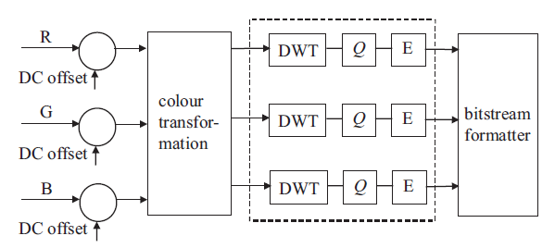

Tiling
We have introduced another feature called ‘tiling’ because of two reasons
- Memory requirements
- Region of interest

If we have a very large image, we can divide it into tiles.
And can workout DWT on individual tile. Thus we divide the data into chunks and treat each chunk separately. Hence, it is memory efficient.

We can coarsely quantize the region of less interest. Hence it enables more compression
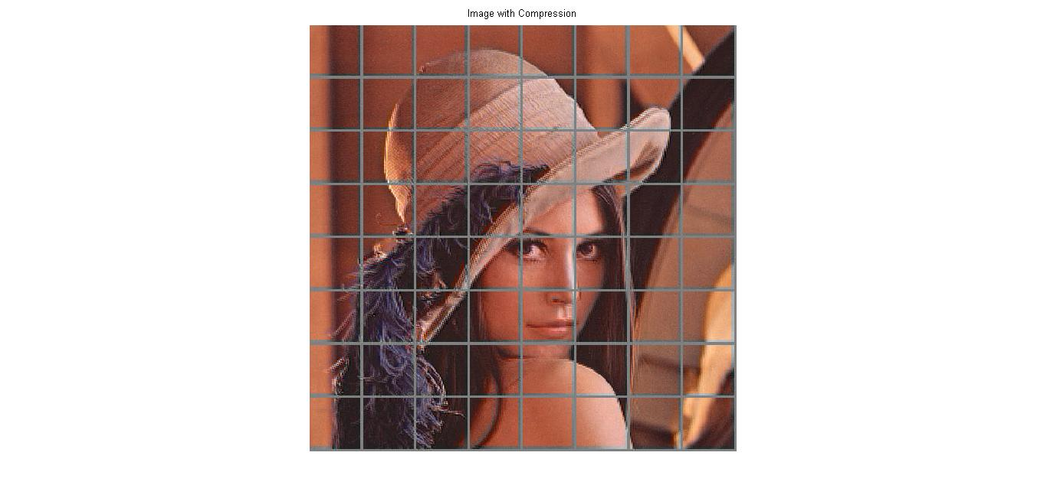

DC level Shifting
Similar to DC-level shifting in the JPEG standard values of the RGB color components within the tiles are DC shifted by 2B 1, for B bits per color component. Such an offset makes certain processing, such as numerical overflow, arithmetic coding and context specification, simpler. In particular, this allows the lowest sub-band, which is a DC signal, to be encoded along with the rest of the AC wavelet coefficients. At the decoder, the offset is added back to the color component values.
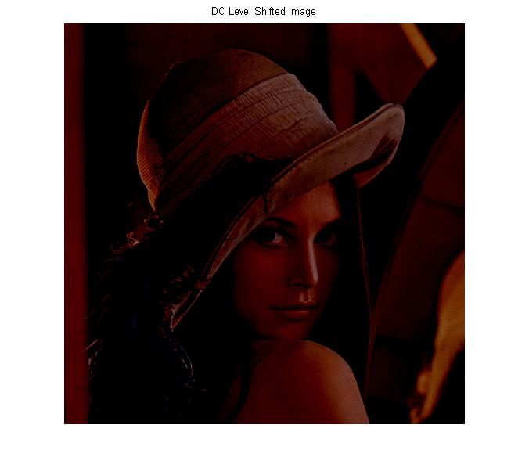

.

Color Transformation
There are significant correlations between the RGB color components. Hence, prior to compression by the core encoder, they are de-correlated by some form of transformation. In JPEG2000, two types of color de-correlation transforms are recommended.
In the first type, the de-correlated color components YCbCr, are derived from the three color primaries RGB according to
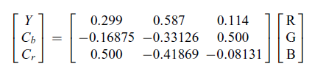
Note that since transformation matrix elements are approximated (not exact), the decoded RGB color components cannot be free from loss even if YCbCr are losslessly coded. Hence, this type of color transformation is irreversible, and it is called irreversible color transformation (ICT). ICT is used only for lossy compression.
The JPEG2000 standard also defines a color transformation for lossless compression. Therefore, the transformation matrix elements are required to be integer. In this mode, the transformed color components are referred to as YUV, and are defined as
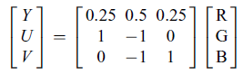
Here the color de-correlation is not as good as ICT, but it has the property that if YUV are losslessly coded, then the exact values of the original RGB can be retrieved. This type of transformation is called reversible color transformation (RCT). RCT may also be used for lossy coding, but since ICT has a better de-correlation property than RCT, use of RCT can reduce the overall compression efficiency.

Here is the image after color transformation (YUV).

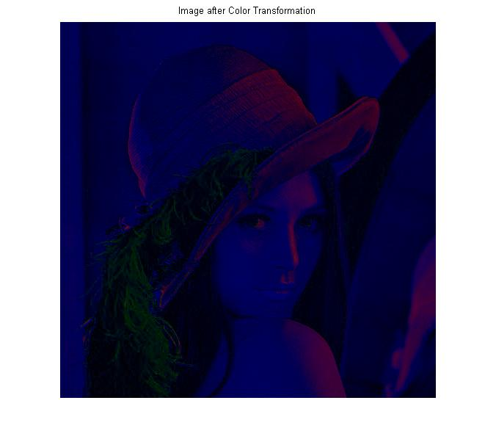

It is worth mentioning that in compression of color images, color fidelity may be traded for that of luminance. In the JPEG standard, this is done by subsampling the chrominance components Cb and Cr, or U and V, like the 4:2:2 and 4:2:0 image formats. In JPEG2000, image format is always 4:4:4 and the color subsampling is done by the wavelet transform of the core encoder. For example, in coding of a 4:4:4 image format, if the highest LH, HL and HH bands of Cb and Cr chrominance components are set to zero, it has the same effect as coding of a 4:2:0 image format.

The subsampling of chroma components into 4:2:0 gives us about 50 percent compression. Human eye is not sensitive to color components and thus we exploited this to achieve compression.

Discrete Wavelet Transform
In JPEG2000, transformation of pixels that in the JPEG standard was DCT has been replaced by the discrete wavelet transform (DWT). This has been chosen to fulfill some of the requirements set forth by the JPEG2000 committee:
● Multi-resolution image representation is an inherent property of the wavelet transform. This also provides simple signal-to-noise ratio (SNR) and spatial scalability without sacrificing compression efficiency.
● Since wavelet transform is a class of lapped orthogonal transform, it does not create blocking artifacts even for small tile sizes.
● For larger-dimension images, the number of sub-band decomposition levels can be increased. Hence, by exploiting a larger area of pixel inter-correlation, a higher compression gain can be achieved. Thus, for images coded at low bit rates, DWT is expected to produce better compression gain than the DCT, which only exploits correction with 8_8 pixels.
● DWT with integer coefficients, such as the tap wavelet filters, can be used for lossless coding. Note that in DCT, since the cosine elements of the transformation matrix are approximated, lossless coding is not possible.

Following are results after DWT

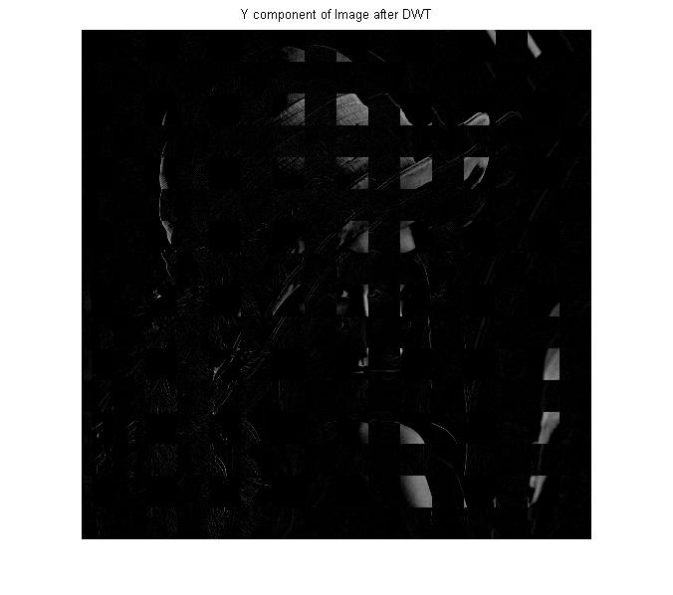

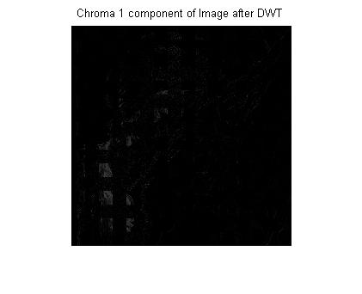
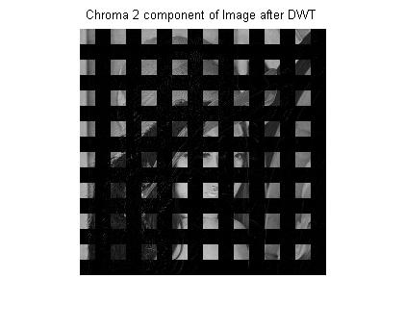

Quantization
After the wavelet transform, all the coefficients are quantized linearly with a dead band zone quantizer. The quantizer step size can vary from band to band, and since image tiles are coded independently, it can also vary from tile to tile. However, one quantiser step size is allowed per sub-band of each tile. The choice of the quantiser step size can be driven by the perceptual importance of that band on the HVS, similar to the quantization weighting matrix used in JPEG or by other considerations, such as the bit rate budget.

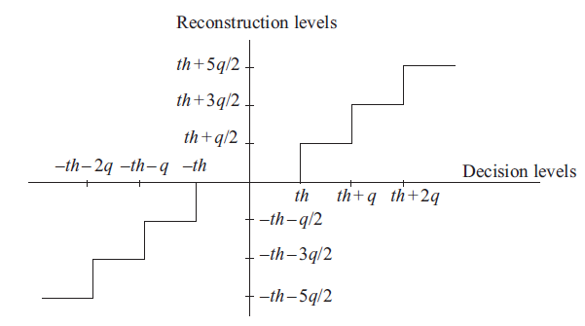

We have used linear quantizer with default dead-zone of 5.
And the user can vary the dead-zone according to the circumstances

Zero-Length Coding (ZLC)
After quantization we have done zero-length coding on each component (Y Cr Cb) of ‘Dove image’. We have gained a big compression. The stats are as follow

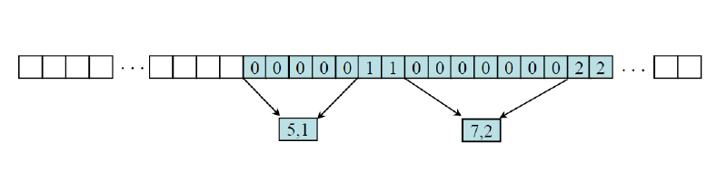

 | Before ZLC | After ZLC | Compression
Y | 168912 B | 82855 B | 50.9478 %
Cr | 42840 B | 13833 B | 67.7101 %
Cb | 42840 B | 19387 B | 54.7456 %

Huffman Coding (VLC)
Huffman coding uses a specific method for choosing the representation for each symbol, resulting in a prefix code (sometimes called "prefix-free codes", that is, the bit string representing some particular symbol is never a prefix of the bit string representing any other symbol) that expresses the most common source symbols using shorter strings of bits than are used for less common source symbols. Huffman was able to design the most efficient compression method of this type: no other mapping of individual source symbols to unique strings of bits will produce a smaller average output size when the actual symbol frequencies agree with those used to create the code. The running time of Huffman's method is fairly efficient; it takes O (n log n) operations to construct it.

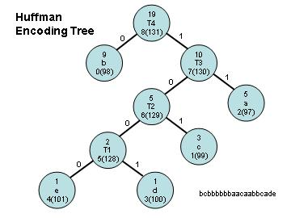

After that Huffman Coding of the components and achieved about 30-40% further compression. The details are given in the table below

 | Before VLC | After VLC | Compression
Y | 82855 B | 57825 B | 30.21 %
Cr | 13833 B | 8884 B | 35.75 %
Cb | 19387 B | 13590 B | 29.90 %

Inverse Zero-length Coding
Following are the results after Inverse Zero-length Coding

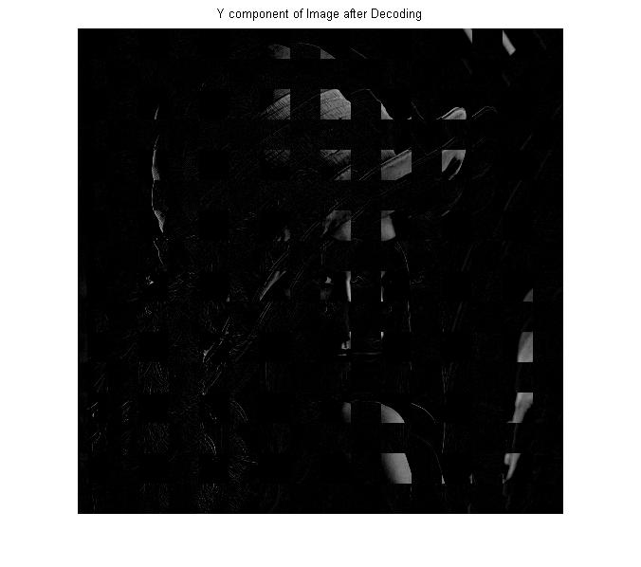

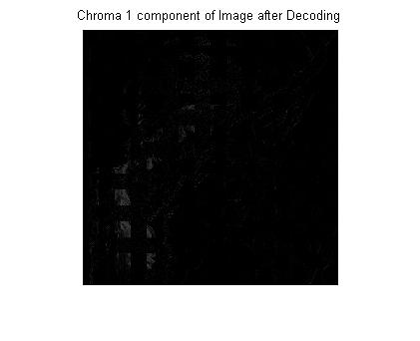

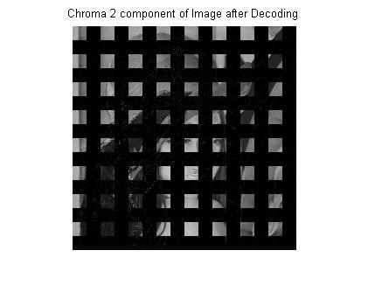

Inverse Wavelet Transform
We get our images components back by applying inverse wavelet transform. Note that if we increase the dead-zone of the quantizer we get the contouring effects in the reconstructed image. Larger dead-zone provide more compression but quality of image reduces because of loss of information.
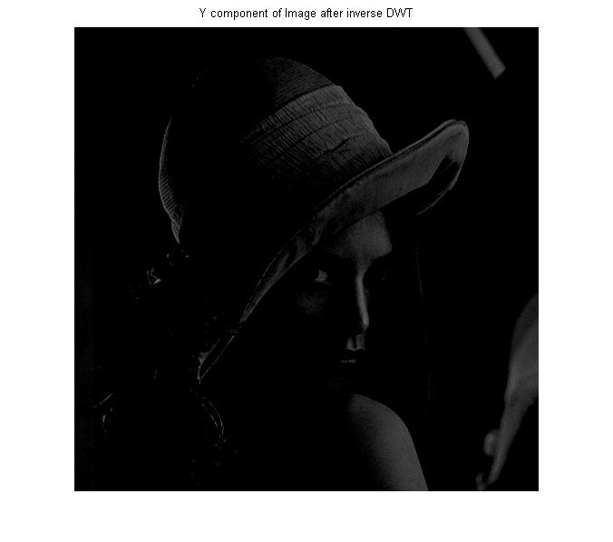

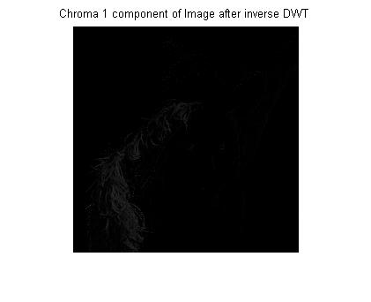

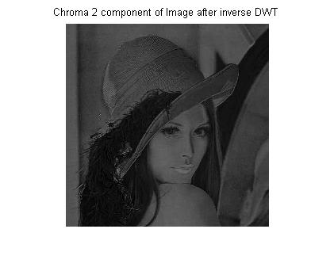

Inverse Color Transformation
Following is the image after inverse color transformation.

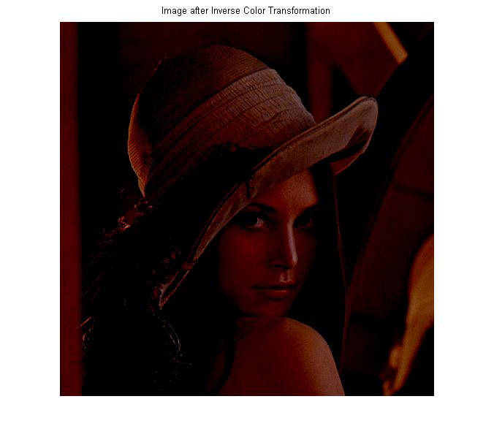

Inverse DC level Shifting
Following is the image after Inverse DC level-Shifting
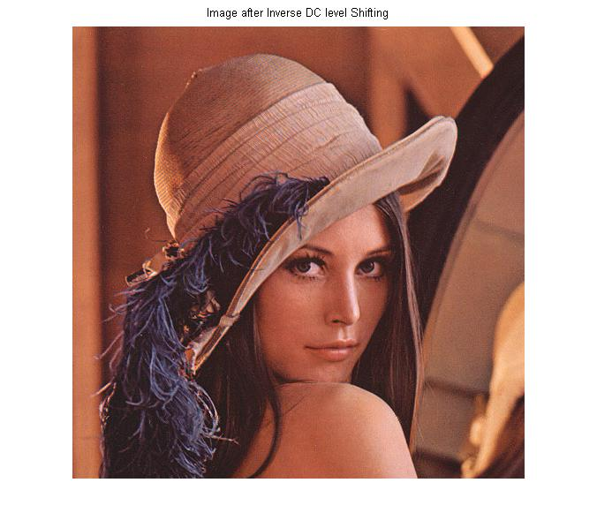

Comparison of Original and Compressed Image
Both the images look quite the same. However, larger quantizer step-size introduces block type artifacts.
Our algorithm gives 10-30 times compression depending upon the size of dead-zone.

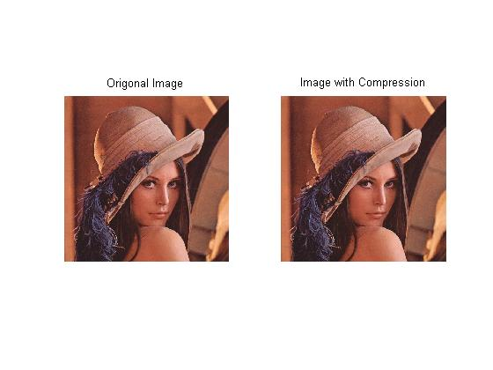
Original Compressed

NOTE
- Use “Run_Me.m” file to run the code.

- You can change the dead zone, DWT levels, color-transformation selection from the start of file “Encoder.m”

References
- M. Ghanbari. Standard Codecs-Image Compression to Advanced Video Coding. 3rd ed. N.p.: n.p., n.d. Print. Telecommunication Ser. 54.
- "Huffman Coding." Wikipedia. Wikimedia Foundation, 30 Apr. 2013. Web. 16 May 2013.

