OS project 1 documentation

Ahmed Ali [S22040155]

Team 6

Argument passing capability is added to the Pintos repo:

<https://gitlab.uwe.ac.uk/Ahmed2.Sharuvan/Pintos>

This project develops the existing Pintos to parse multiple command line arguments to pass into user programs.

# Developing process

Several auxiliary functions are added into process.c with their declarations in process.h:

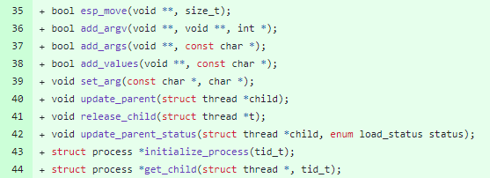

Changes are committed.

