OS project 2 documentation

Ahmed Ali [S22040155]

Team 6

System call functions are added to the Pintos repo:

<https://gitlab.uwe.ac.uk/Ahmed2.Sharuvan/Pintos>

This project develops the existing Pintos to design and implement system call functions defined in userprog/syscall.c.

# Developing system calls

Syscall functions sys_create and sys_remove is implemented. This is used to create and delete files in the filesystem.

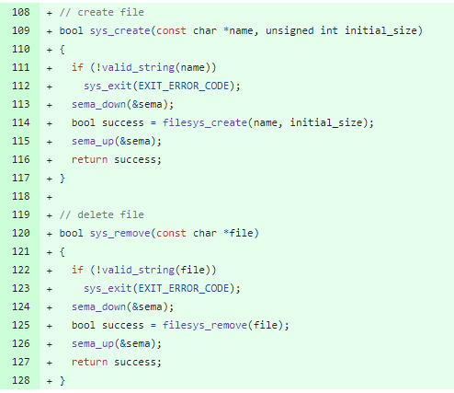

Changes are committed.

