In today's world if you say you don't interact application with microservices may not be true. Nowadays, every person has to interact with the microservices intentionally or unintentionally. The daily life use of microservices are following.

One of the most common taxi app uber is using microservice architecture

Netflix is one of the companies who is the first company to start using microservice and get an excellent result.

Before moving toward the microservices let's discuss the other software engineering Architecture.

# Layered Architecture

in this architecture, the application is divided into three layers as shown in the figure

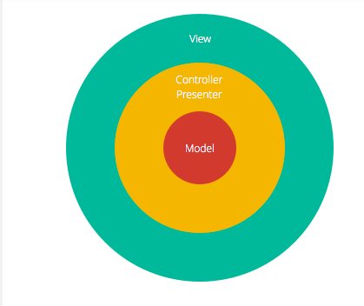The modal layer is simple the database. just above the database is the controller Presenter which contains business logic and information about the types of data in the database. furthermore, the top layer is view layer or presenter layer which is simple the frontend usually written in HTML, CSS, etc.

the biggest advantage of a layered architecture is each layer can focus on its role.

Event-driven Architecture

Program written with event-driven architecture mostly wait for an event to occur. when there is any need for the module to execute it is called otherwise it waits for the interruption. An example of this architecture can be on the web page where the small module reacts when the event occurs like a mouse click or keystroke. This module gets activated when the event concerning them is interrupted.