**Muhammad Ammad Zohair, 26277**

**Yağız Tüfek, 28412**

We created a movie website where people can register and view movie information from the database. Our first intention was to create a database about cinemas and movie studios however we changed our direction to create a database about movies where people can examine movies. By doing so we were able to concentrate more on movies and interactions. Admin can add new movies or delete the existing ones. Admins can also search for customers who are registered and add/delete records. Customers can search the database for movies and register. We used two tables: customers and movies.

**Main page** where you can view the movies and head to admin panel

**Register page**, a user can register thierself and his/her information is added to the customer table in the database. The customer ID (cid) is auto-incremented. Accessed by book now button.

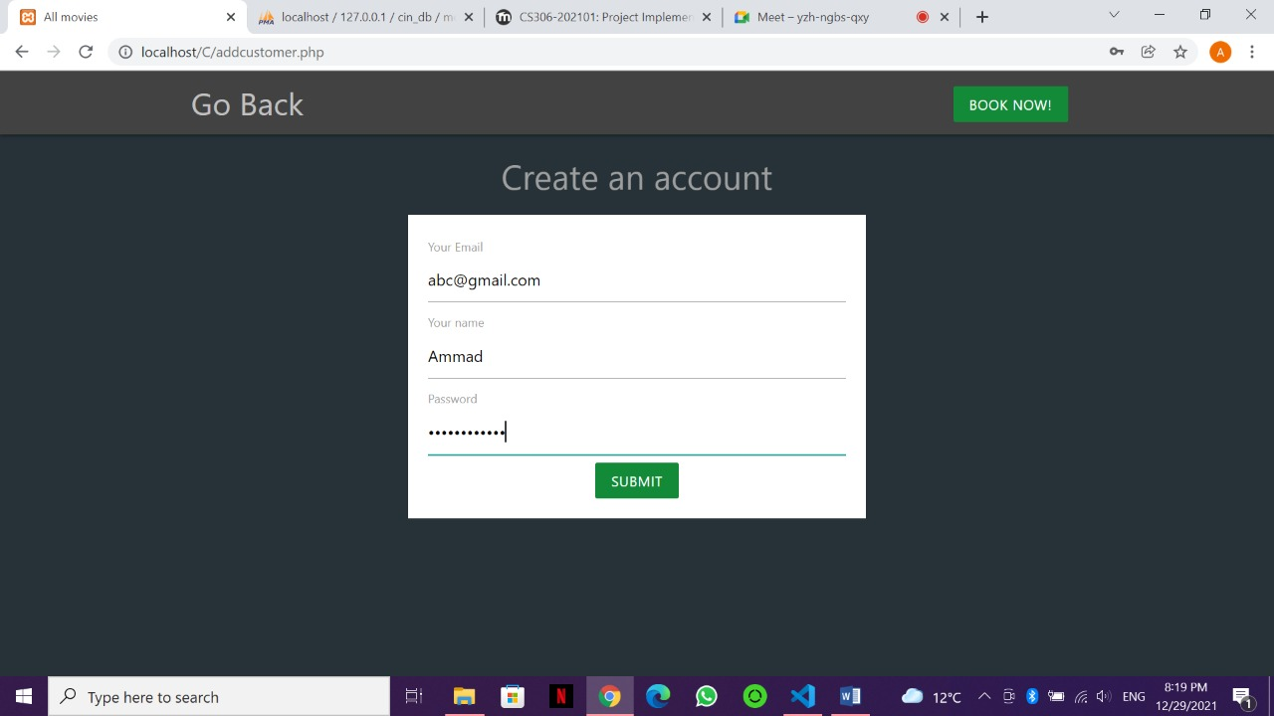

Page where you can see all the movies in the database. It is accessed by clicking on **movies** on the homepage.

Clicking on Go Back redirects user from any page they are currently on to the homepage.

**Admin panel** where you can add, delete, and search customers and movies. It is accessed by clicking admin panel from the homepage.

Searching customer Zohair

Deleting customer

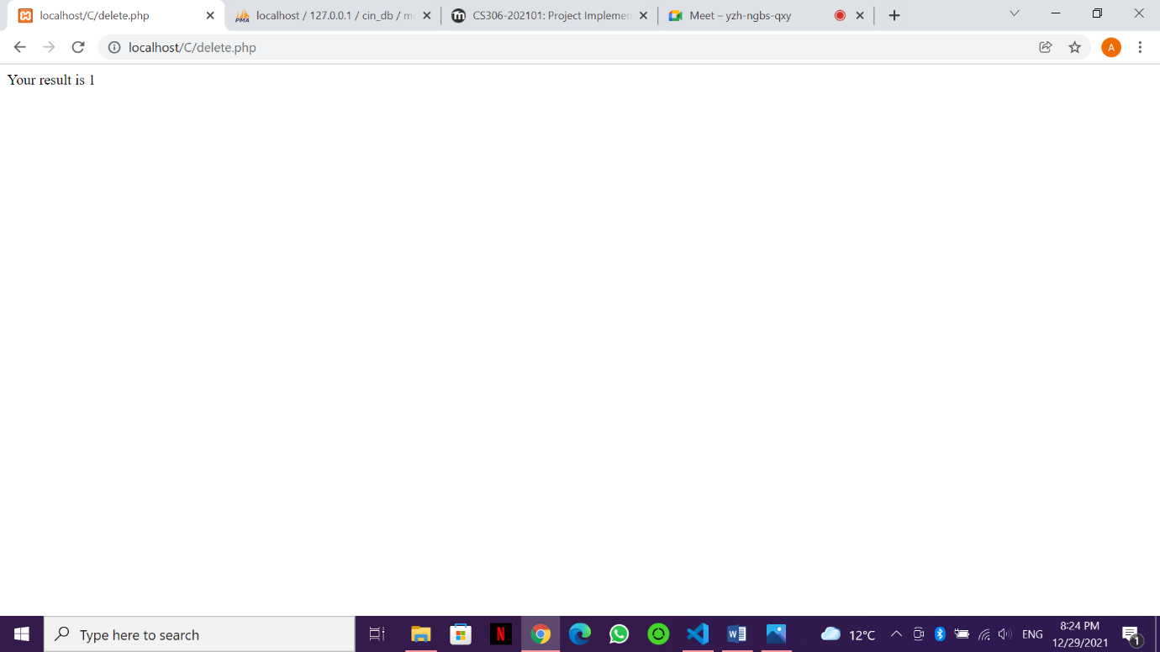

Deleting movie US

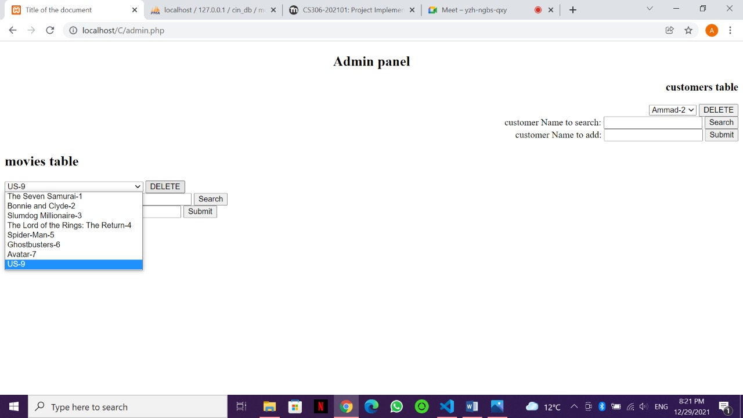

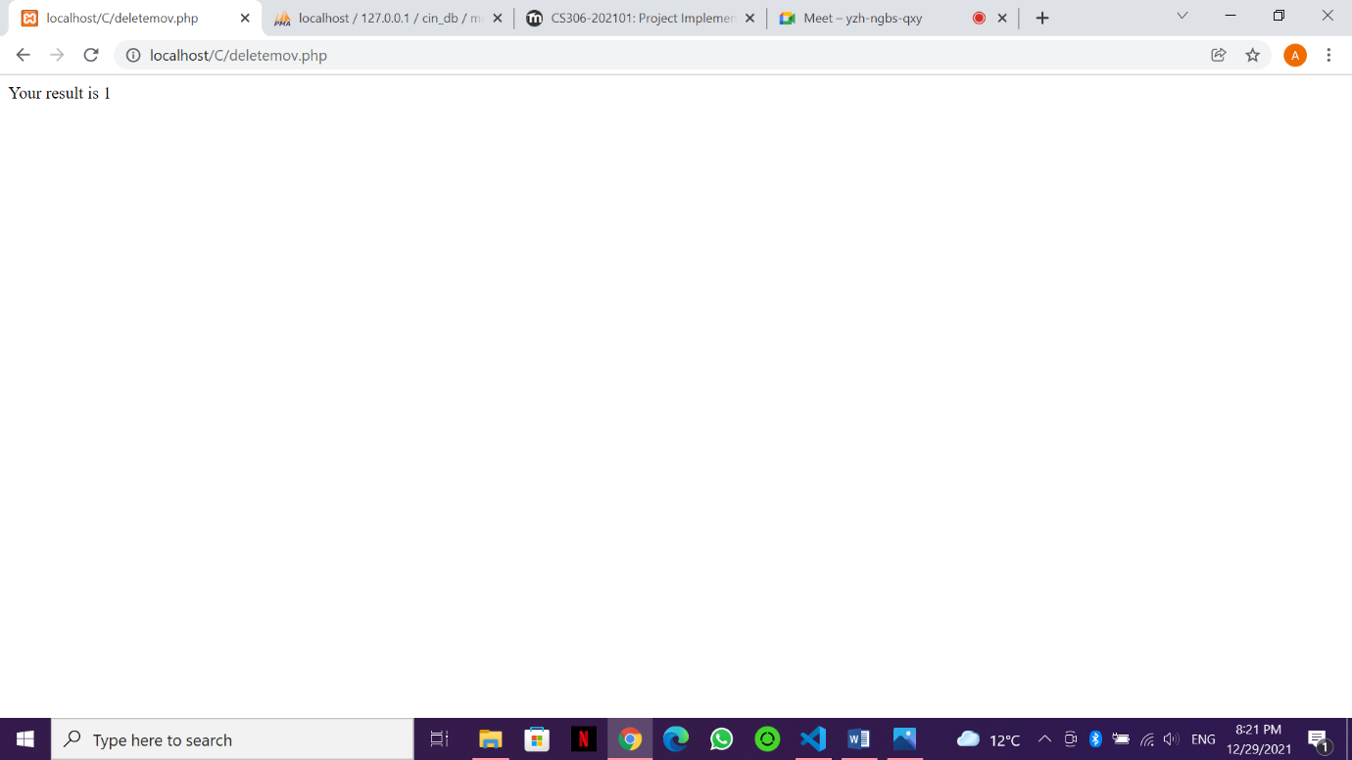

Adding movie ABC

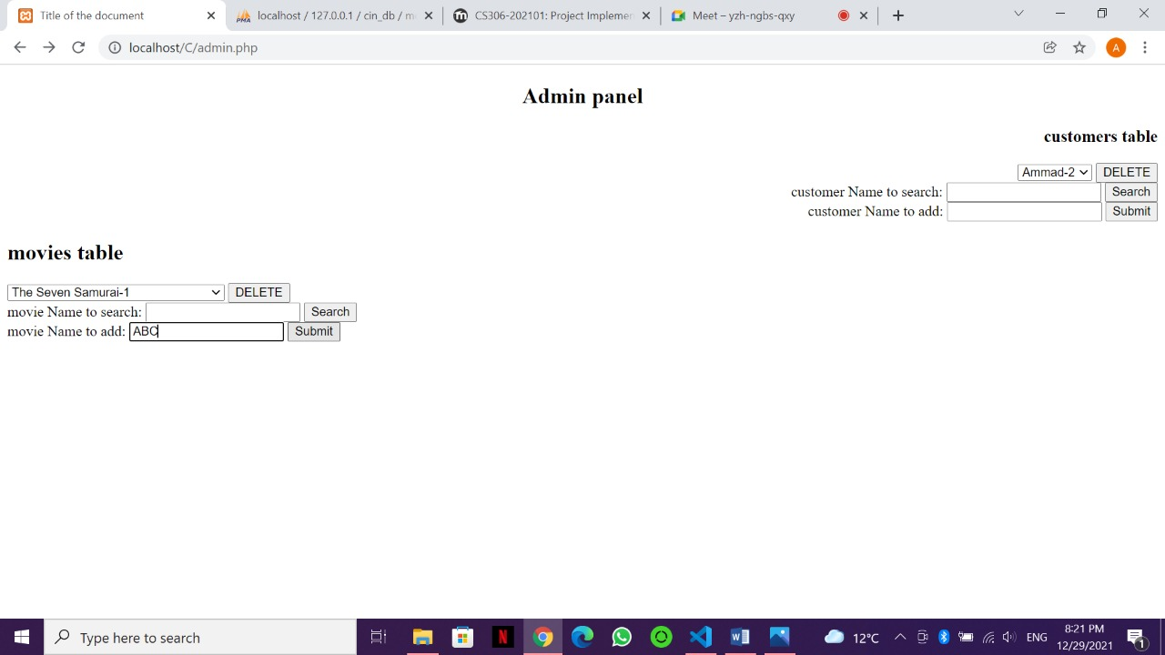

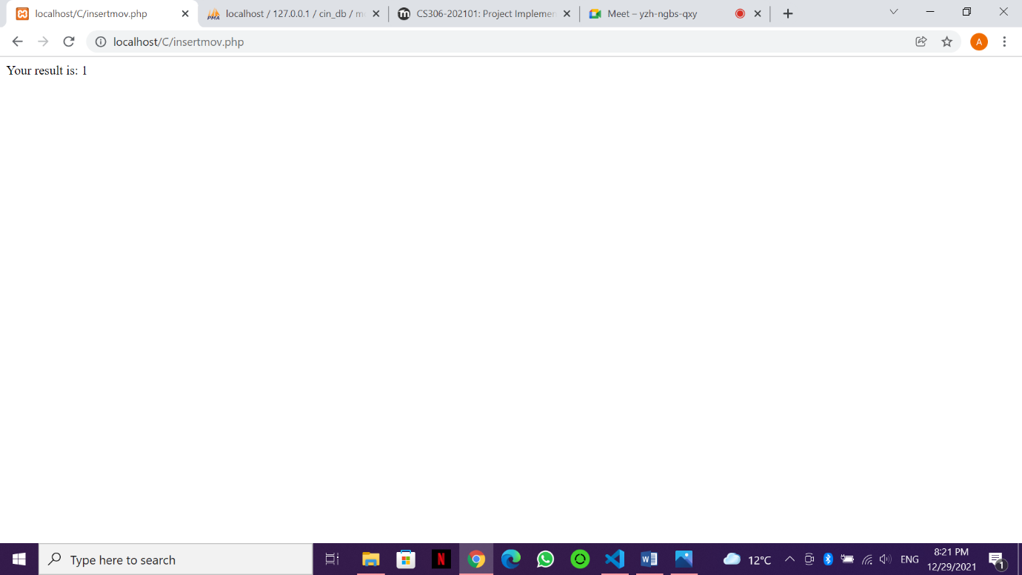

Adding customer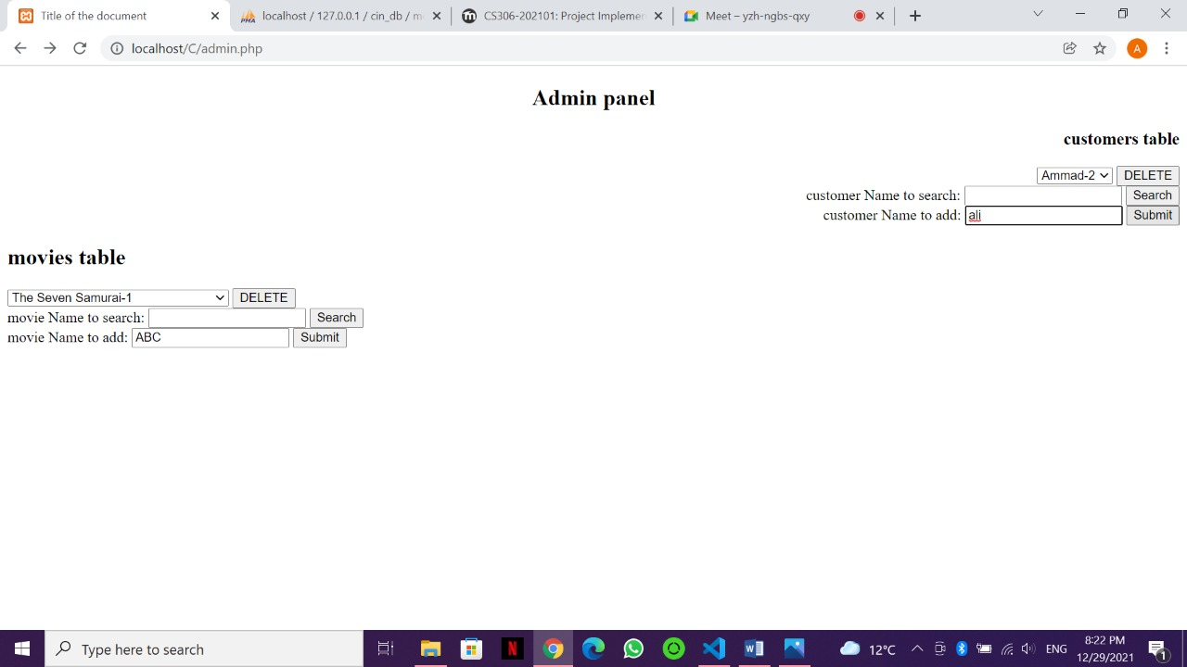

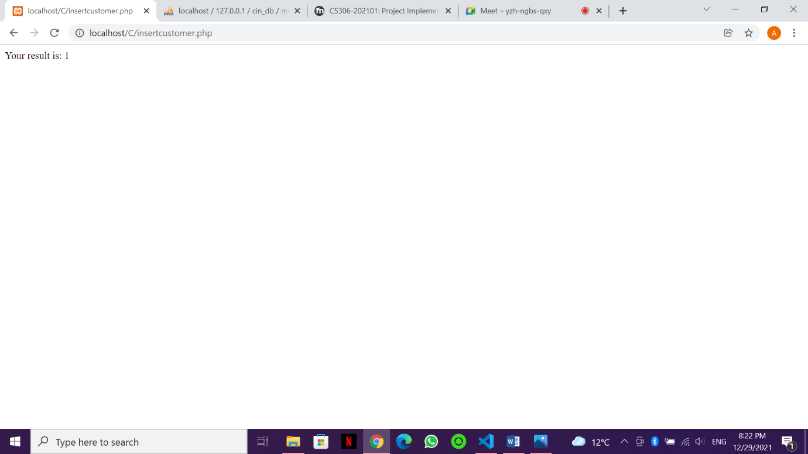

All of the changes made on the admin panel are also reflected on the database.