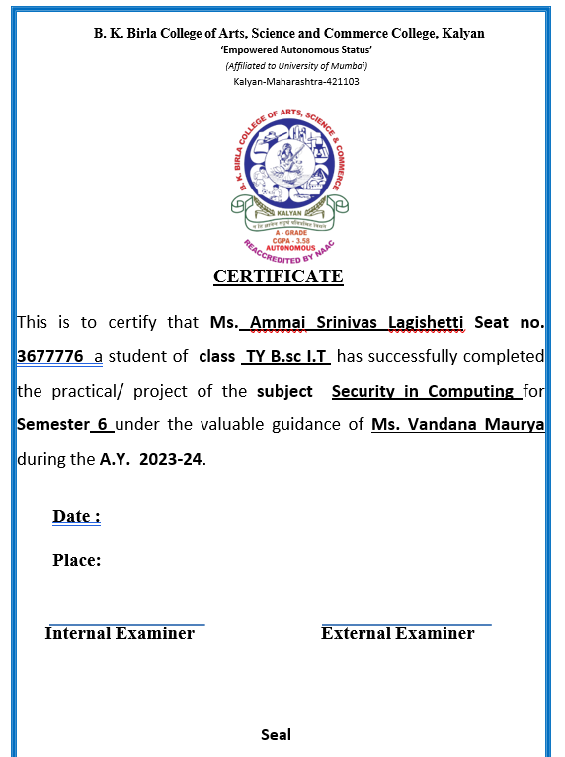

**INDEX**

|  |  |  |
| --- | --- | --- |
| **SR.NO** | **PRACTICALS** | **SIGN** |
| **1.** | **DESIGN A BASIC HOME NETWORK IN CISCO PACKET TRACER.** |  |
| **2.** | **IMPLEMENTATION OF CEASER CIPHER.** |  |
| **3.** | **IMPLEMENTATION OF WIRESHARK.** |  |
| **4.** | **IMPLEMETATION OF STATIC AND DYNAMIC ROUTING.** |  |
| **5.** | **FIREWALL CONFIGURATION IN CISCO PACKET TRACER.** |  |
| **6.** | **OSPF ROUTING PROTOCOL IN PACKET TRACER.** |  |
| **7.** | **DESIGN CAMPUS NETWORK IN CISCO PACKET TRACER.** |  |
| **8.** | **MINIPROJECT** |  |

**PRACTICAL NO.1]**

**DESIGN A BASIC HOME NETWORK IN CISCO PACKET TRACER.**

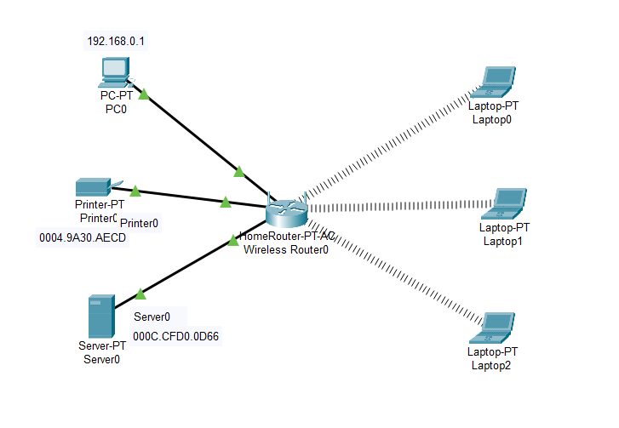

Click on Laptop0>physical>switch off button> remove ethernet> connect wireless> switch on the button

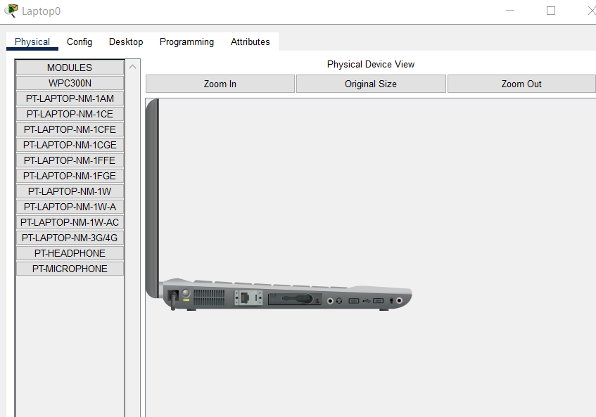

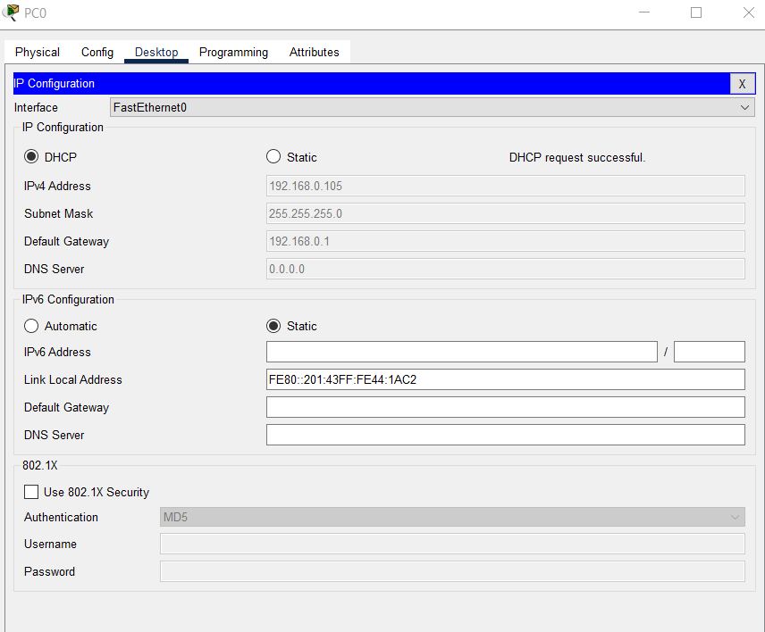

Check the IP address of pc0, server, and printer.

**PRACTICAL NO.2]**

**IMPLEMENTATION OF CEASER CIPHER.**

**#include <iostream>**

**#include <string>**

**using namespace std;**

**int main() {**

**int i, key;**

**string s, t;**

**cout << "Enter the message: ";**

**cin >> s;**

**cout << "Enter the Key: ";**

**cin >> key;**

**for (i = 0; i < s.size(); i++) {**

**t += (s[i] - 'A' + key) % 26 + 'A';**

**}**

**cout << "Encrypted Message is: " << t;**

**return 0;**

**}**

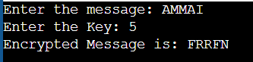

**PRACTICAL NO.3]**

**IMPLEMENTATION OF WIRESHARK.**

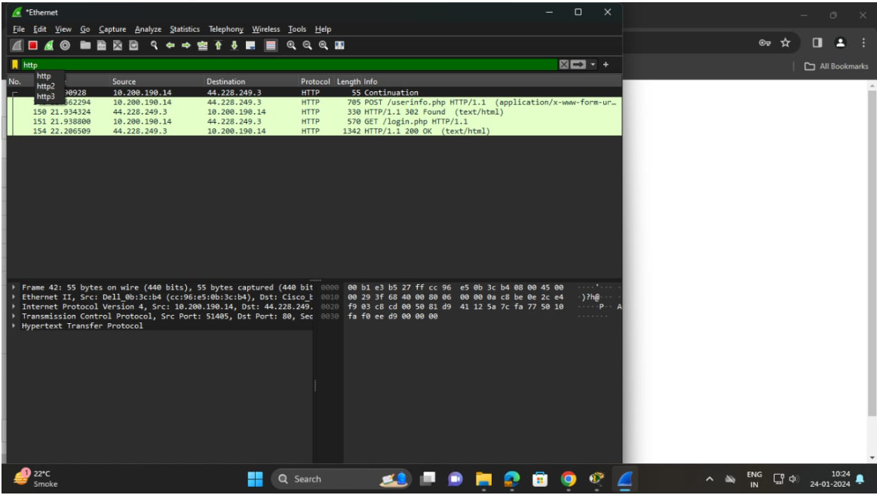

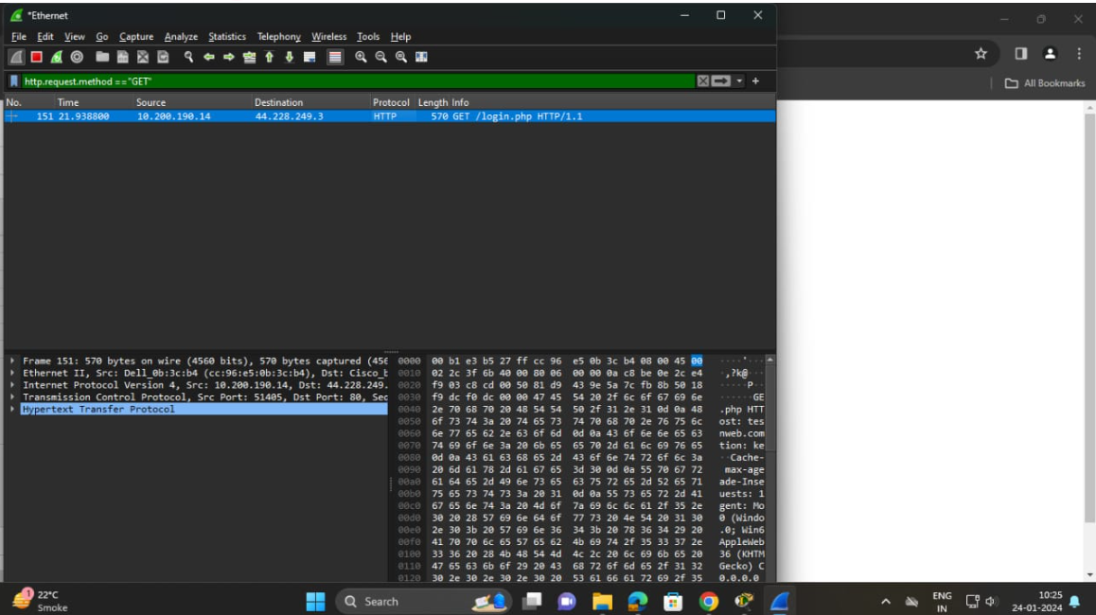

Next go to login pageof website enter login details

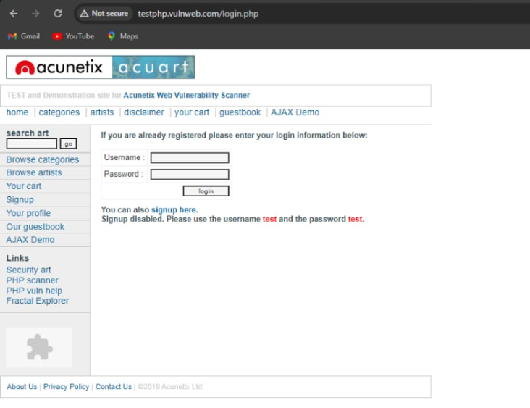

Next go to wire shark and stop capturing packets and in search type http.request.method==”POST”

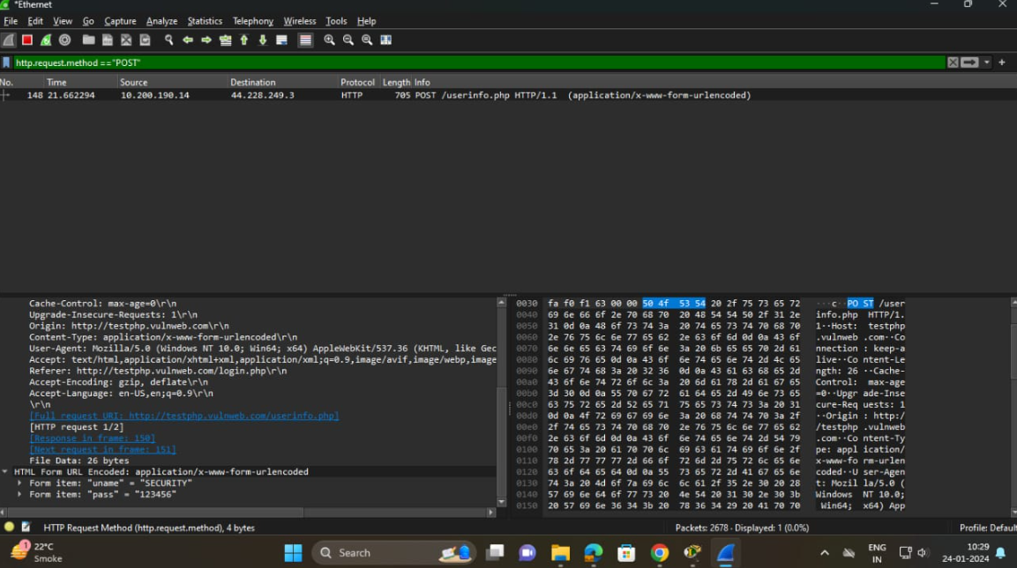

**PRACTICAL NO.4]**

**IMPLEMETATION OF STATIC AND DYNAMIC ROUTING.**

**STATIC ROUTING**

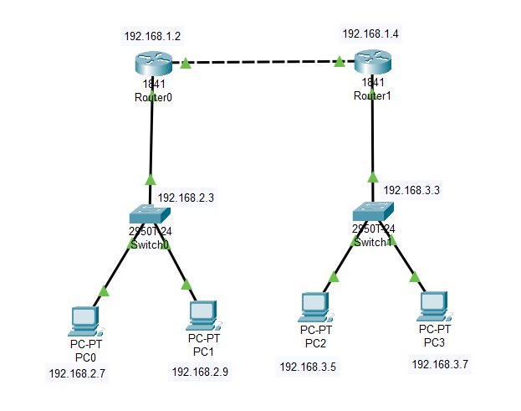

Go to Router0> set the ip address of FastEthernet0/0 and FastEthernet0/1. Then add the network address. Do same with Router1.

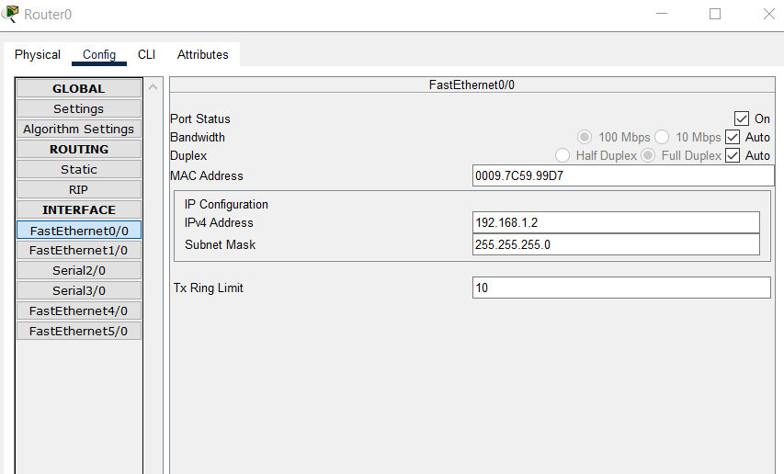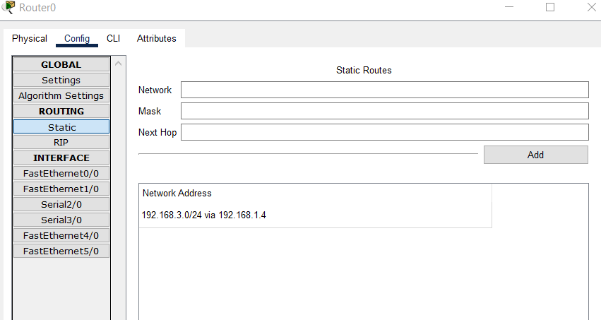

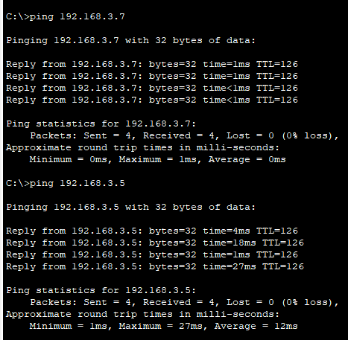

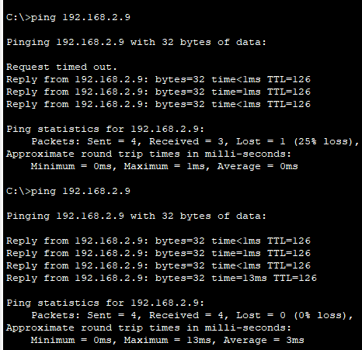

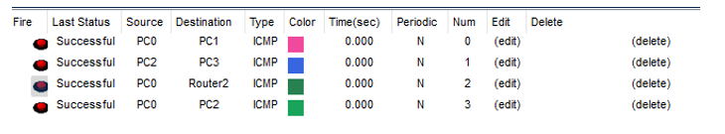

**DYNAMIC ROUTING**

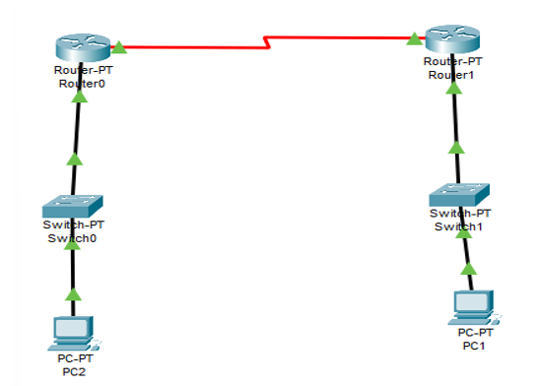

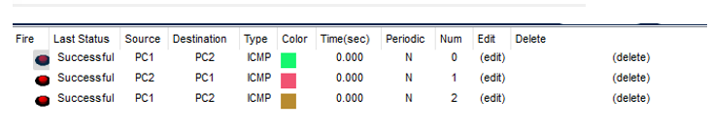

**PRACTICAL NO.5]**

**FIREWALL CONFIGURATION IN CISCO PACKET TRACER.**

Taking pc, server and switch and connecting them to each other

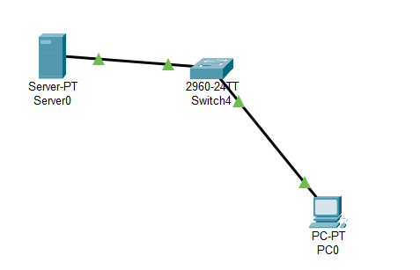

assign ip address to server and pc

Server 0

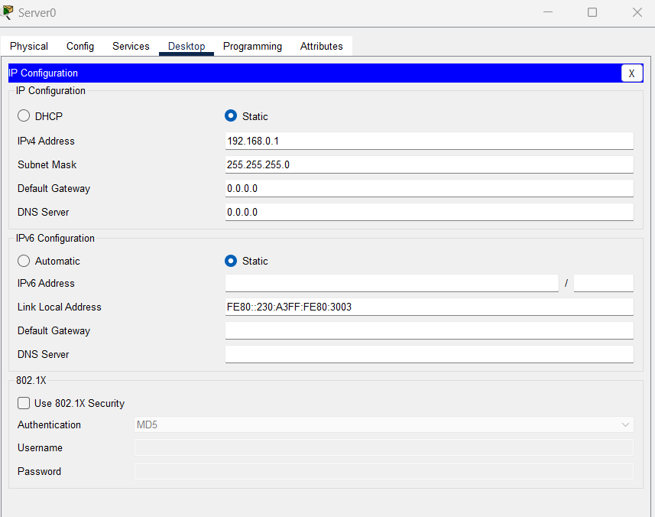

PC0

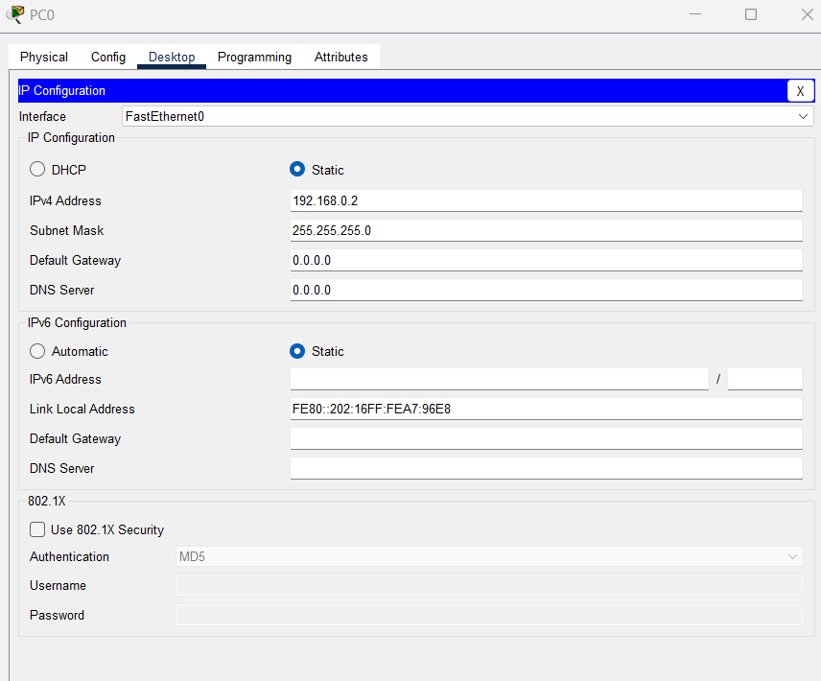

write a command in command prompt of pc

Pc 0

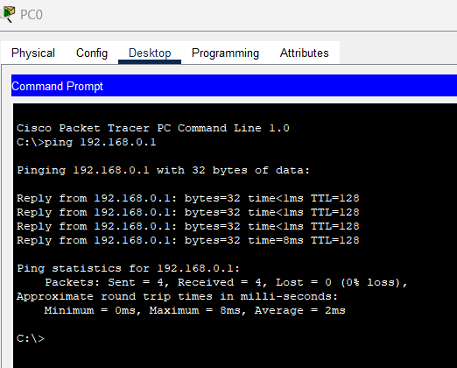

click on server go to desktop>firewall>click on on> add action,protocol,remote ip,remote wild card mask>save and add

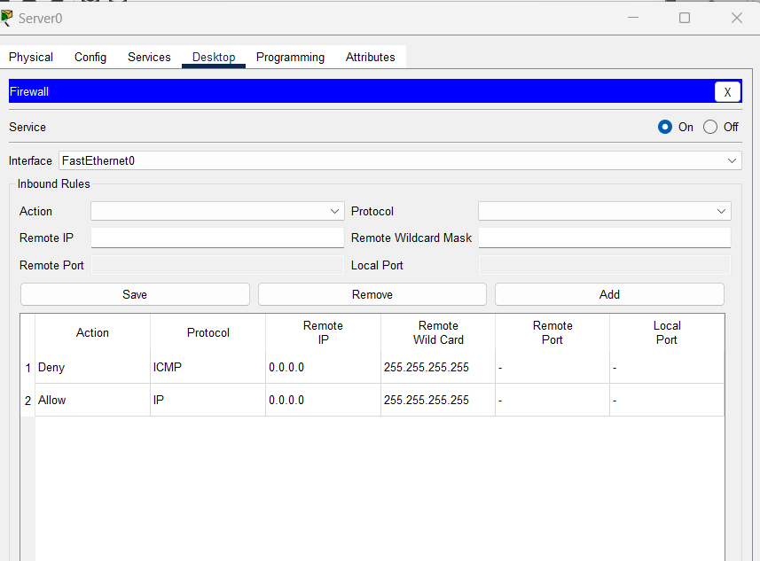

click on pc >command prompt>ping 192.168.0.1

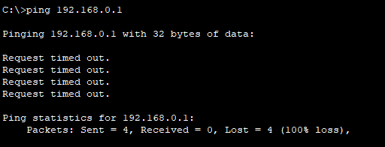

click on pc go to>web browser>add url>192.168.0.1>go

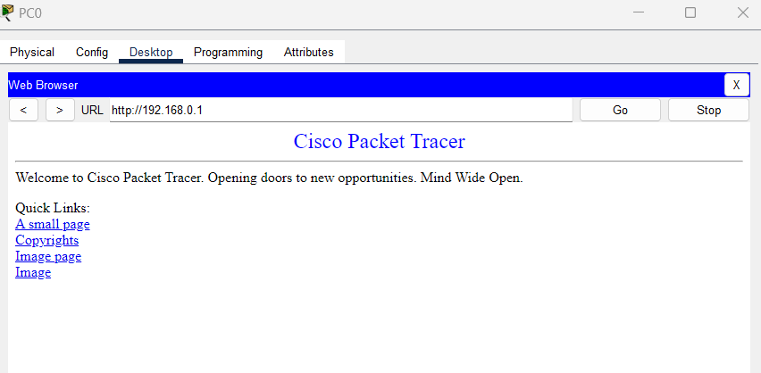

**PRACTICAL NO.6]**

**OSPF ROUTING PROTOCOL IN PACKET TRACER.**

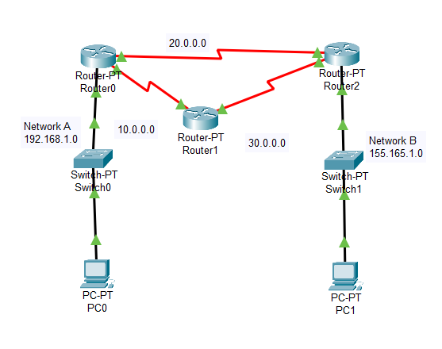

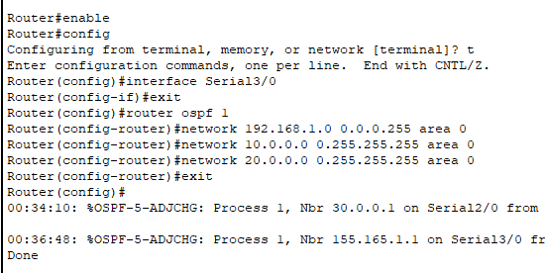

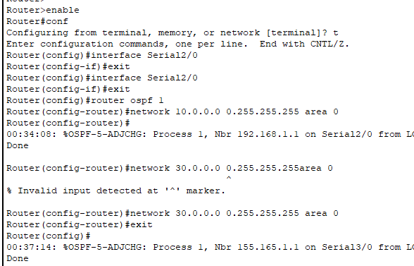

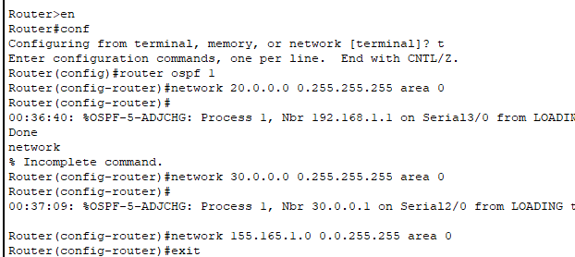

**PRACTICAL NO.7]**

**DESIGN CAMPUS NETWORK IN CISCO PACKET TRACER.**

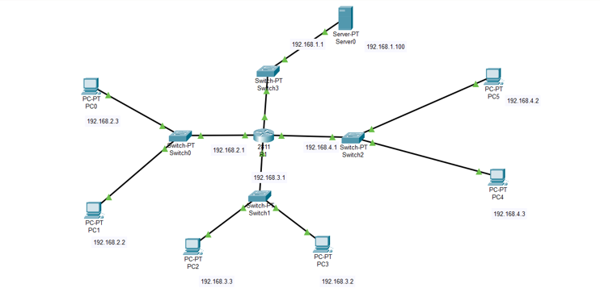

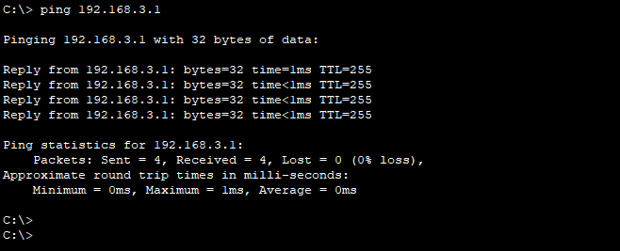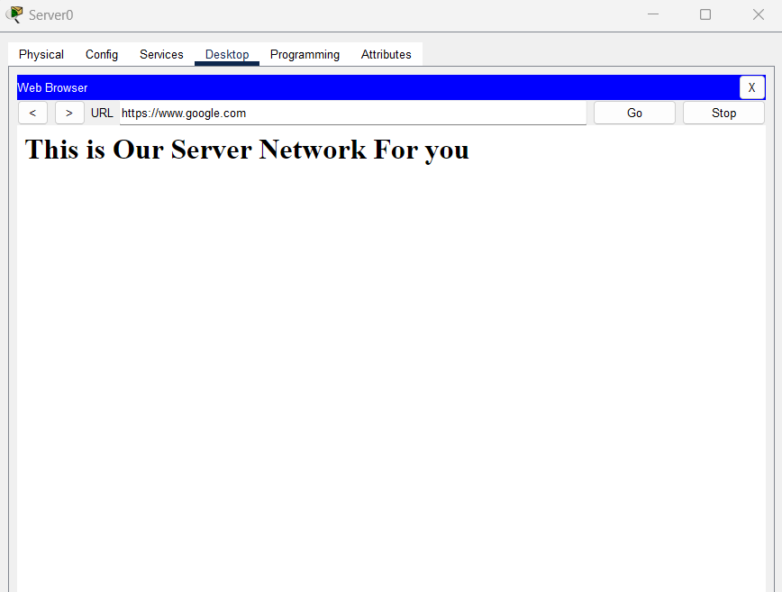

**PRACTICAL NO.8]**

**MINIPROJECT – HOTEL NETWORK MANAGEMENT SYSTEM**

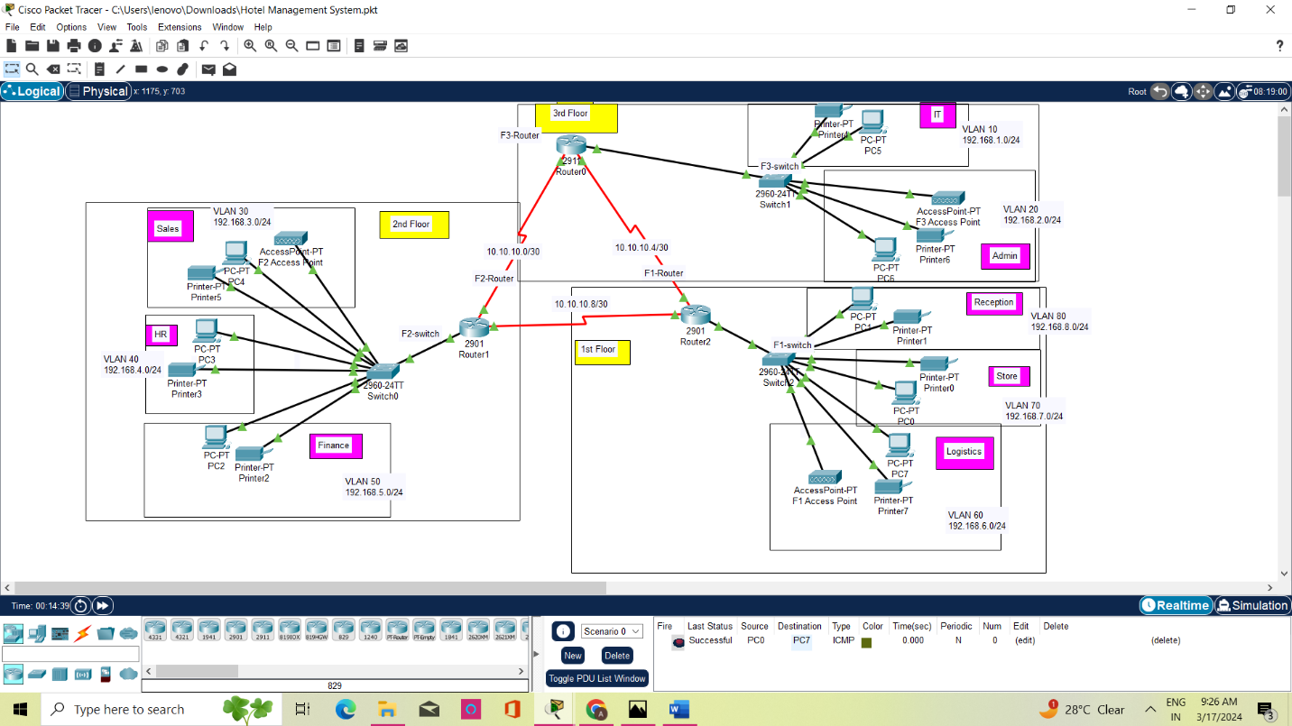

In above, there are three floors, 1st floor, 2nd floor and 3rd floor.

1st floor department: Reception, store, Logistic

2nd floor department: sales, hr, finance

3rd floor department: IT, admin

Each floor department can communicate with each other.

- Design the Network Topology with 3 routers, 6 switches, 3 servers and 20PC's in the workspace.

-Connect the routers to each other using serial interfaces.

-Connect cach switch to both routers for redundancy.

-Connect the PCs to the switches.

-Assign IP addresses to each network. Assign unique IP addresses to the PCs in each network.

-Divide each switch into VLANs corresponding to the different networks.

-Assign ports to VLANs based on the network segment they belong to.

-Configure subinterfaces on the routers' Ethernet interfaces for each VLAN.

-Assign IP addresses to these subinterfaces within the respective network segments.

- Enable routing on the routers to allow communication between VLANs.

- Test connectivity between PCs within the same network and between PCs in different networks.

- Ensure that all PCs can communicate with each other across the campus network.

