T-BAS *Phytophthora ramorum* Public Tree Placement Instructions

Original author: Allison Coomber

Modified by: Amada Mainello-Land

Note: For placing taxa into the tree for *P. ramorum* lineage identification, we recommend sequencing at least three loci. In Mainello-Land et al. (2025) *avh120, avh121,* and *gweuk* were selected because of the *P. ramorum* EU1 intralineage variation.

1. Google “TBAS NCSU” and navigate to the [T-BAS webpage](https://vclv99-239.hpc.ncsu.edu/tbas2_1/pages/tbas.php).
2. To view the tree Select the “T-BAS Trees” option:

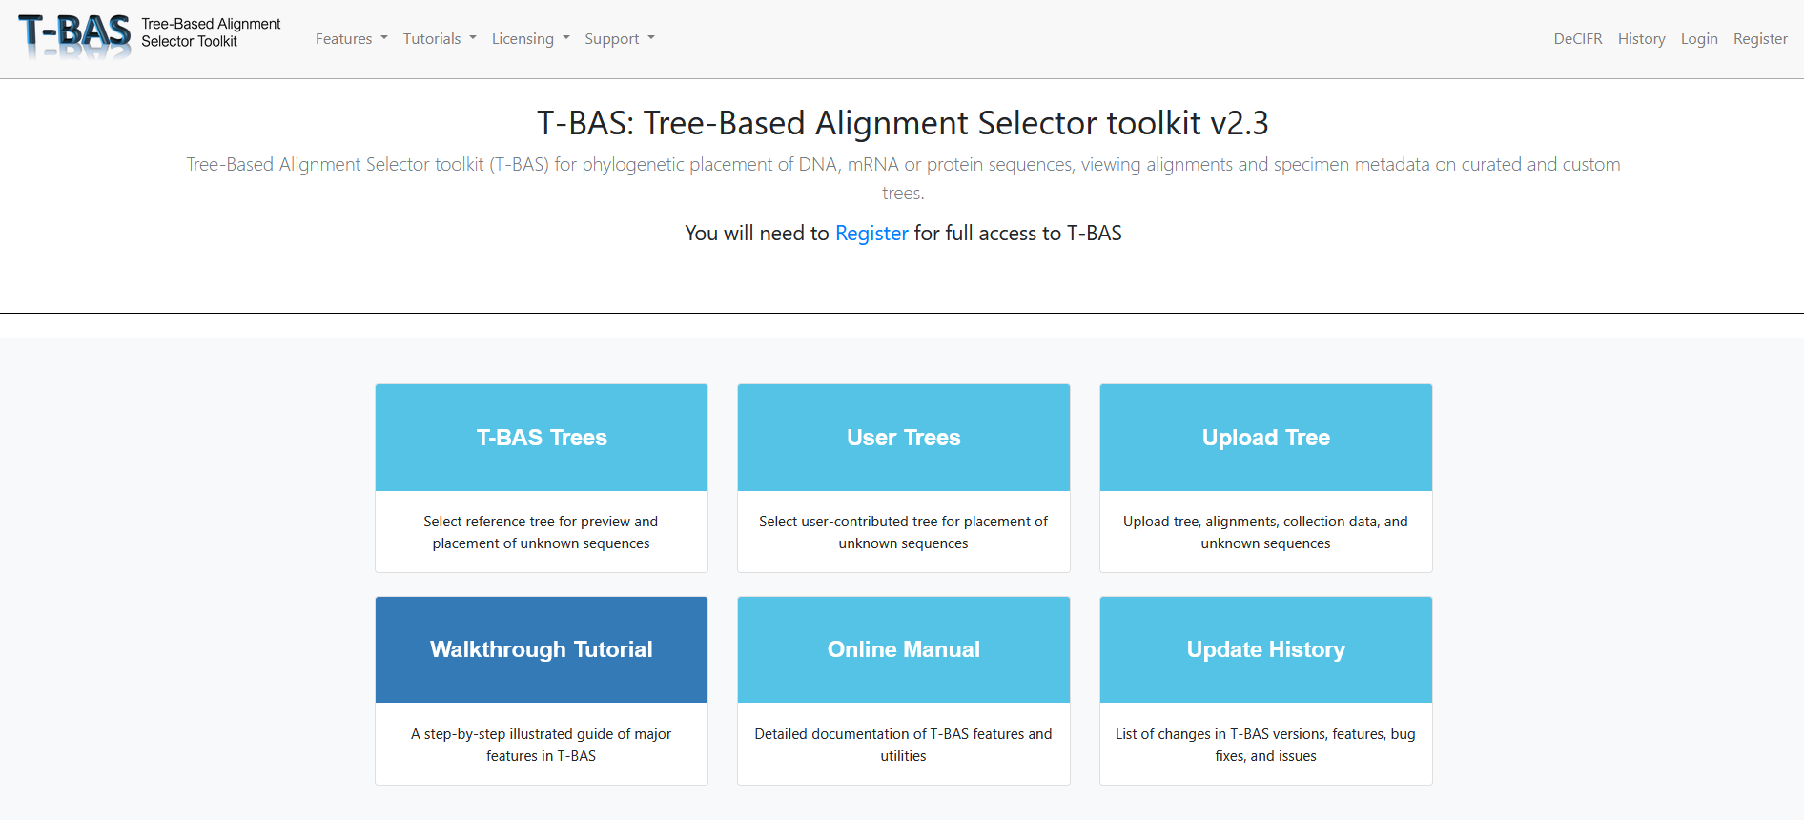

1. Select the **Phytophthora ramorum** Tree from the tree of life. This is the recommended tree for taxa placement.

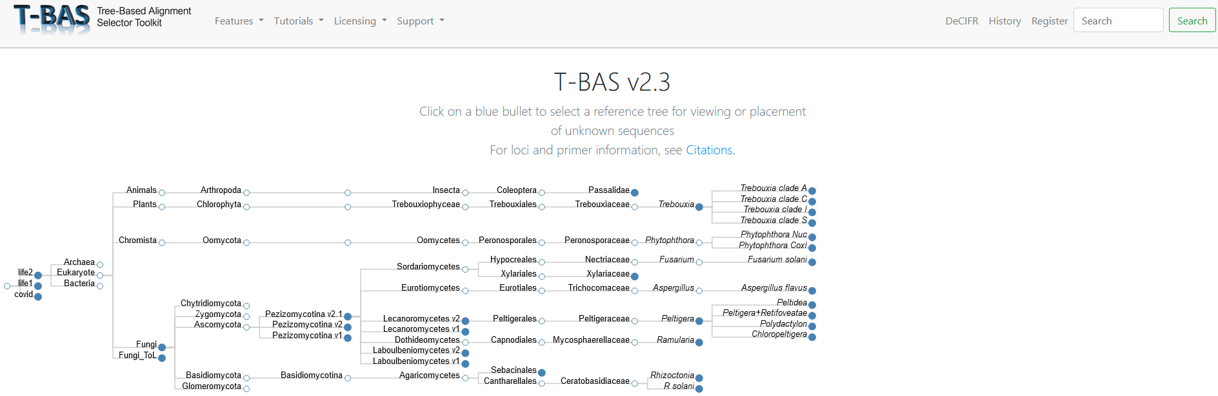

1. After selecting the tree, you should see two options. One for viewing the tree and one for placing taxa. Clicking view tree will open a new tab and load the tree, which takes a few moments. If you are interested in placing taxa, select “Place Unknowns”:

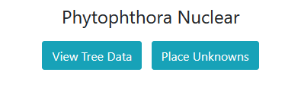

1. If you choose “Place Unknowns” a new screen will appear with several options. First, note the list of loci on the right (red box). These are the loci for which you can upload sequence data.

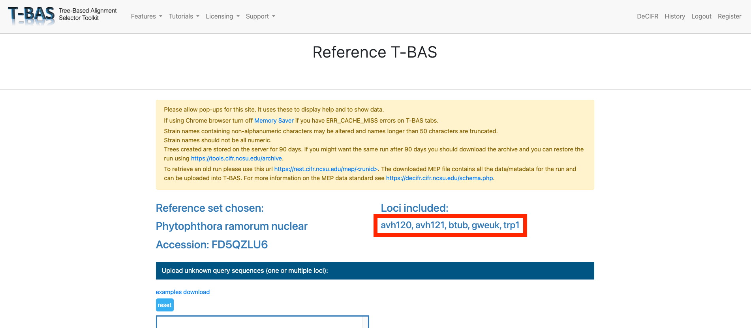

1. At the first input box, drag and drop sequence data in FASTA format for the taxa you would like to place. For this tutorial, example FASTA files have been provided in GitHub for each locus. They are named “locus_example.fasta” where ‘locus’ is the abbreviation for the relevant nuclear locus. Any or all of these files can be dragged and dropped into the Upload unknown query sequences box at this step.

**Tips if you are uploading your own FASTA files:**

A separate FASTA file must be provided for each locus you are including. If uploading multiple loci, make sure all isolates names are consistent across individual fasta files.

1. **Optional.** At the next dialog box, drag and drop a metadata file to overlay metadata on the final phylogeny. Metadata must be a CSV file, where the first column is your isolate names. An example of how to format the metadata, including the required headers, is available at the associated [GitHub](https://github.com/ammainello/Pramorum_tbas) page.

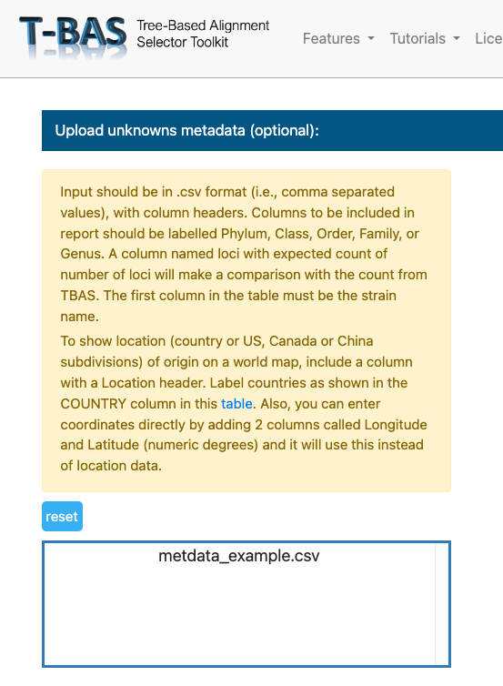

1. Scroll down and click “Submit.” None of the other options need to be selected or changed. If you are interested in exploring phylogeny-based placement using a backbone constraint tree with bootstraps and other options, the TBAS [Tutorials](https://vclv99-239.hpc.ncsu.edu/tbas2_1/pages/tbas-tutorial.php) and [Manual](https://vclv99-239.hpc.ncsu.edu/tbas2_1/pages/tbas-documentation.php) can help you navigate them.
2. After you click submit, a new webpage will appear where you can select which loci your FASTA files correspond to. Choose from the drop-down menu, then click submit again.

1. A loading bar will appear. Placement may take several minutes. When the tree placement is finished, several output files will be made available. Scroll down and click “View Tree.” This will open the tree in a new tab.

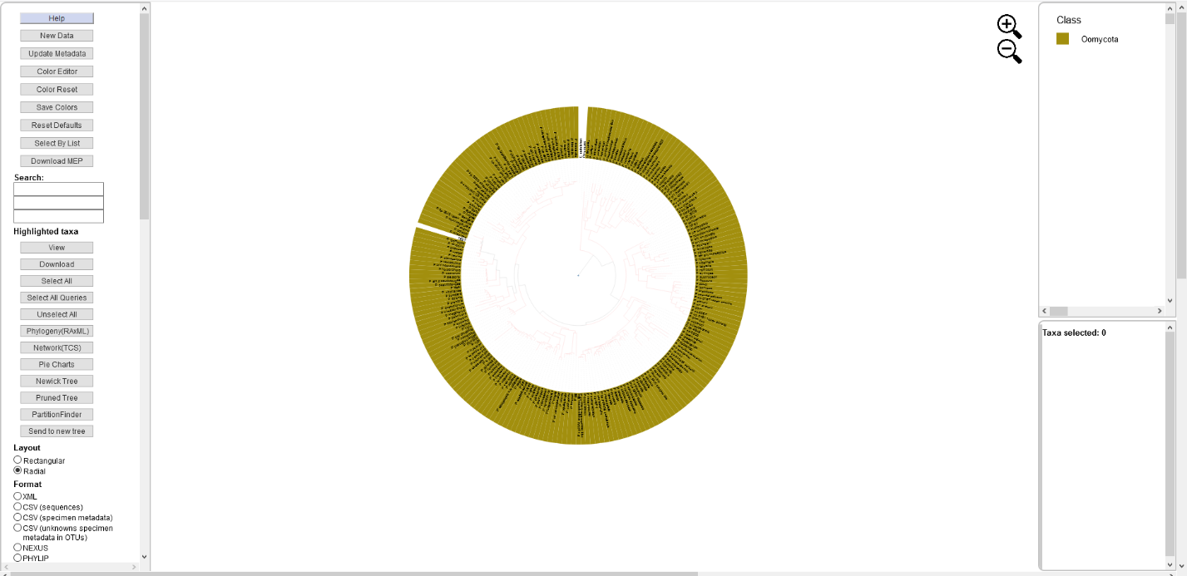

1. Select different options on the left as you choose to visualize the tree. We recommend colorizing leaves by different metadata, such as clade:

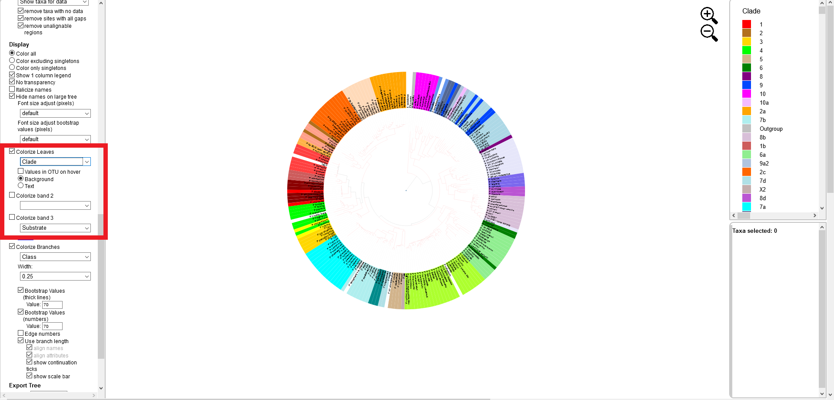

Citations:

Carbone, I., White, J. B., Miadlikowska, J., Arnold, A. E., Miller, M. A., Kauff, F., U'Ren, J. M., May, G. and F. Lutzoni. 2017. T-BAS: Tree-Based Alignment Selector toolkit for phylogenetic-based placement, alignment downloads, and metadata visualization; an example with the Pezizomycotina tree of life. Bioinformatics 33: 1160-1168. DOI: 10.1093/bioinformatics/btw808

Carbone, I., White, J. B., Miadlikowska, J., Arnold, A. E., Miller, M. A., Magain, N., U'Ren, J. M. and F. Lutzoni. 2019. T-BAS version 2.1: Tree-Based Alignment Selector toolkit for evolutionary placement of DNA sequences and viewing alignments and specimen metadata on curated and custom trees. Microbiology Resource Announcements Microbiol Resour Announc 8:e00328-19. https://doi.org/10.1128/MRA.00328-19.

Coomber, A., Saville, A., Carbone, I., & Ristaino, J. B. 2023. An open-access T-BAS phylogeny for emerging Phytophthora species. PLoS One, *18*(4), e0283540.

T-BAS v2.3 https://tbas.cifr.ncsu.edu/tbas2_3/pages/tbas.php