UNIVERSITY OF ENGINEERING AND TECHNOLOGY
OF LAHORE (NAROWAL CAMPUS)



Lab Manual

SUBMITTED TO:
MAM MADIHA
SUBMITTED BY:
AMAN FATIMA
REG NO #:
2022-CS-506
SECTION:
B
SUBJECT:
COMPILER CONSTRUCTION
TOPIC:
LAB 1
DEPARTMENT:
COMPUTER SCIENCE

Lexical Analyzer:

A lexical analyzer, often referred to as a Lexar or scanner, is a crucial component of a compiler or interpreter. Its primary function is to read the source code of a program and break it down into smaller units called tokens. These tokens are the basic building blocks of a programming language and represent the smallest meaningful units in the code, such as keywords, identifiers, literals, and operators.
It converts the High-level input program into a sequence of Tokens.
- Lexical Analysis can be implemented with the Deterministic finite Automata.
- The output is a sequence of tokens that is sent to the parser for syntax analysis

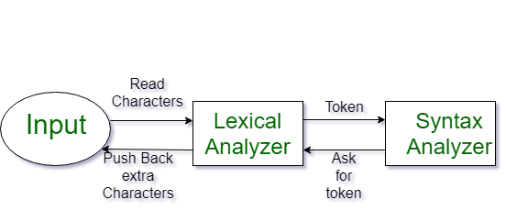

What is a token? A lexical token is a sequence of characters that can be treated as a unit in the grammar of the programming languages. Example of tokens:
- Type token (id, number, real, . . . )
- Punctuation tokens (IF, void, return, . . . )
- Alphabetic tokens (keywords)
Keywords; Examples-for, while, if etc.
Identifier; Examples-Variable name, function name, etc.
Operators; Examples '+', '++', '-' etc.
Separators; Examples ',' ';' etc
Example of Non-Tokens:
Comments, preprocessor directive, macros, blanks, tabs, newline, etc.
Lexeme: The sequence of characters matched by a pattern to form the corresponding token or a sequence of input characters that comprises a single token is called a lexeme. eg- “float”, “abs_zero_Kelvin”, “=”, “-”, “273”, “;” .

How Lexical Analyzer works:
- Input preprocessing: This stage involves cleaning up the input text and preparing it for lexical analysis. This may include removing comments, whitespace, and other non-essential characters from the input text.
- Tokenization: This is the process of breaking the input text into a sequence of tokens. This is usually done by matching the characters in the input text against a set of patterns or regular expressions that define the different types of tokens.
- Token classification: In this stage, the lexer determines the type of each token. For example, in a programming language, the lexer might classify keywords, identifiers, operators, and punctuation symbols as separate token types.
- Token validation: In this stage, the lexer checks that each token is valid according to the rules of the programming language. For example, it might check that a variable name is a valid identifier, or that an operator has the correct syntax.
- Output generation: In this final stage, the lexer generates the output of the lexical analysis process, which is typically a list of tokens. This list of tokens can then be passed to the next stage of compilation or interpretation.

Advantages:
- Efficiency
- Flexibility
- Error Detection

Recognition of operators/variables:

In a lexical analyzer or lexer, the recognition of operators and variables involves identifying and categorizing sequences of characters in the source code into tokens that represent operators and variables. Here's how this recognition typically works:

Operators Recognition:
Operators are symbols in the source code that represent various operations, such as addition, subtraction, multiplication, and comparison. To recognize operators, the lexer typically follows these steps:
- It scans the source code character by character.
- When it encounters a character that could be the start of an operator (e.g., "+", "-", "*", "="), it begins forming a token.
- The lexer continues scanning characters until it determines that the token is complete or until it encounters a character that cannot be part of the operator.
- Once the lexer identifies the operator token, it categorizes it as an operator token and records the specific operator it represents (e.g., "+" for addition, "=" for assignment).
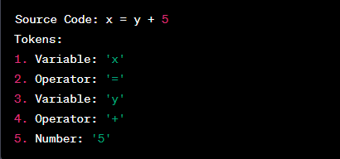

Variables Recognition:
Variables are names given to values or objects in the program. To recognize variables, the lexer generally follows these steps:
- It scans the source code character by character.
- When it encounters a character that could be the start of a variable name (e.g., a letter or an underscore), it begins forming a token.
- The lexer continues scanning characters until it determines that the token is complete or until it encounters a character that cannot be part of a variable name (e.g., a space or punctuation).
- Once the lexer identifies the variable token, it categorizes it as a variable token and records the variable's name.
Here's an example in C++:
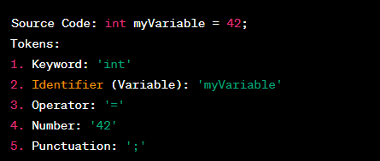

Recognition of keywords/constants:

Recognition of keywords and constants in a lexical analyzer follows a similar pattern to the recognition of operators and variables.

Keywords Recognition:

Keywords are reserved words in the programming language that have a special meaning. Examples of keywords include "if," "while," "int," "for," "return," etc. To recognize keywords, the lexer generally follows these steps:
- It scans the source code character by character, just like in the case of operators and variables.
- When it encounters a character that could be the start of a keyword (e.g., a letter), it begins forming a token.
- The lexer continues scanning characters until it determines that the token is complete or until it encounters a character that cannot be part of a keyword (e.g., a space or punctuation).
- Once the lexer identifies the keyword token, it categorizes it as a "Keyword" token and records the specific keyword it represents (e.g., "if" for conditional statements, "int" for declaring integer types).
Here's an example in C++:
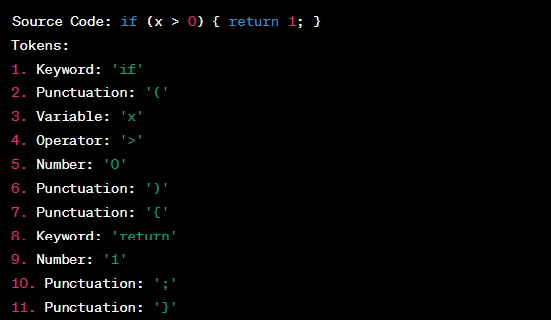

Constants Recognition:
Constants in a programming language can be numeric literals (integers or floating-point numbers), string literals, character literals, or other special values. To recognize constants, the lexer typically follows these steps:
- It scans the source code character by character, similar to the previous cases.
- When it encounters a character that could be the start of a constant (e.g., a digit for numeric literals or a quote for string literals), it begins forming a token.
- The lexer continues scanning characters until it determines that the token is complete or until it encounters a character that cannot be part of the constant (e.g., a space or punctuation).
- Once the lexer identifies the constant token, it categorizes it as a "Constant" token and records the specific value it represents (e.g., "42" for an integer literal, "Hello, World!" for a string literal).
Here's an example in Python:
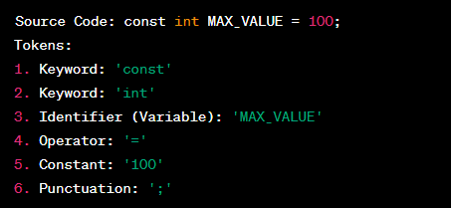

Statement:
C++ code to generate the lexical analyzer with the Recognition of operators/variables.

Code:

#include <iostream>
#include <string>
#include <cctype>
#include <vector>
#include <set>
using namespace std;

// Define C++ keywords
set<string> keywords = {
"int", "float", "double", "char", "if", "else", "while", "do", "for",
"break", "continue", "return", "void", "static", "struct", "switch", "case",
"long", "short", "typedef", "include", "main", "using", "namespace", "std"
};

// Function to check if a string is a keyword
bool isKeyword(const string& word) {
return keywords.find(word) != keywords.end();
}
// Function to check if a string is a valid identifier
bool isIdentifier(const string& word) {
if (!isalpha(word[0]) && word[0] != '_')
return false;
for (char c : word)
if (!isalnum(c) && c != '_')
return false;
return true;
}

// Function to check if a string is a numeric constant
bool isConstant(const string& word) {
for (char c : word) {
if (!isdigit(c) && c != '.')
return false;
}
return true;
}

// Function to check if a character is an operator
bool isOperator(char c) {
string operators = "+-*/=%><!";
return operators.find(c) != string::npos;
}

int main() {
string line;
cout << "Enter a line of code: ";
getline(cin, line);

vector<string> tokens;
string temp = "";

cout << "\nTokens recognized:\n";

for (size_t i = 0; i < line.size(); i++) {
char c = line[i];

// If it's an operator
if (isOperator(c)) {
if (!temp.empty()) {
tokens.push_back(temp);
temp = "";
}

string op(1, c);
// Handle double operators like ==, <=, >=, !=
if (i + 1 < line.size() && isOperator(line[i + 1])) {
op += line[i + 1];
i++;
}
cout << op << " --> Operator\n";
}
else if (isspace(c) || c == ';' || c == ',' || c == '(' || c == ')' || c == '{' || c == '}') {
if (!temp.empty()) {
tokens.push_back(temp);
temp = "";
}
}
else {
temp += c;
}
}

if (!temp.empty())
tokens.push_back(temp);

for (auto& token : tokens) {
if (isKeyword(token))
cout << token << " --> Keyword\n";
else if (isConstant(token))
cout << token << " --> Constant\n";
else if (isIdentifier(token))
cout << token << " --> Identifier\n";
else
cout << token << " --> Unknown\n";
}

return 0;
}

Output:

