Gym Membership and Fitness Tracking System

# Project Team Information:

Team Name: HexVision

# Team Logo:

# 1. System Functional Requirements

The system shall provide the following functionalities for each stakeholder:

## Gym Member: -

1. The system shall allow users to register and log into their account using secure authentication.  
2. The system shall allow users to view and manage their membership details, including start date, end date, and renewal options.  
3. The system shall allow users to book workout sessions with trainers based on their availability and expertise.  
4. The system shall allow users to log their workout progress, including exercise type, duration, and calories burned.  
5. The system shall provide users with a dashboard to view their fitness progress over time.

## Trainer: -

1. The system shall allow trainers to register and create a profile including their expertise, availability, and contact information.  
2. The system shall allow trainers to view and manage their assigned clients.  
3. The system shall allow trainers to update fitness plans and workout schedules for clients.  
4. The system shall allow trainers to view their schedule of booked workout sessions.  
5. The system shall allow trainers to provide feedback to users based on their workout progress.

## Admin: -

1. The system shall allow admins to manage user accounts by activating or deactivating them.  
2. The system shall allow admins to update membership plans, including pricing and features.  
3. The system shall allow admins to oversee the booking system and resolve conflicts if necessary.  
4. The system shall allow admins to generate system reports and analytics.  
5. The system shall allow admins to monitor the overall system performance and manage backup and recovery processes.

# 2. System Non-Functional Requirements

## 2.1 Product Requirements: -

1. The system shall be accessible to users, trainers, and admins via a web-based interface built with React.js.  
2. The system shall maintain availability 99% of the time, with downtime not exceeding 5 minutes per day.  
3. The system shall respond to user actions within 2 seconds under normal conditions.  
4. The system shall support up to 500 simultaneous users without significant performance degradation.

## 2.2 Organizational Requirements: -

1. The system shall be developed using React.js (Frontend), Node.js with Express.js (Backend), and MySQL (Database).  
4. Documentation for the system shall include installation, deployment, and maintenance guides.

## 2.3 External Requirements: -

1. The system shall comply with data privacy standards to protect user information.

# 3. Use Case Diagram: -

# 4.User Stories: -

1. As a user, I want to register and log in to my account so I can access my gym membership and fitness details.

* **Role:** User (Gym Member)
* **Goal:** To register and log in to their account.
* **Reason:** So, they can access their gym membership and fitness details.
* **Pre-condition:** User is not registered or is not logged in.
* **Post-condition:** User is successfully registered and logged in.

2. As a user, I want to subscribe to a membership tier so I can use its respective perks.

* **Role:** User (Gym Member)
* **Goal:** To subscribe to a membership tier.
* **Reason:** To gain access to its respective perks.
* **Pre-condition:** User is logged in but has no active membership.
* **Post-condition:** User is subscribed to a chosen membership plan.

3. As a user, I want to view my membership status so I can check my expiration date and renewal details.

* **Role:** User (Gym Member)
* **Goal:** To view their membership status.
* **Reason:** To check expiration date and renewal details.
* **Pre-condition:** User is logged in and has an active membership**.**
* **Post-condition:** User views membership status successfully.

4. As an admin, I want to manage user accounts (activate/deactivate) so I can control system access.

* **Role:** Admin
* **Goal:** To activate or deactivate user accounts.
* **Reason:** To control system access effectively.
* **Pre-condition:** 
  + 1. Admin is logged in with proper permissions.
    2. User accounts exist in the system.
* **Post-condition:** User account status is updated (activated or deactivated).

5. As an admin, I want to update gym membership plans and pricing so users see the latest options.

* **Role:** Admin
* **Goal:** To update gym membership plans and pricing.
* **Reason:** So, users see the latest options.
* **Pre-condition:** Admin is logged in and has permission to update plans.
* **Post-condition:** Membership plans and pricing are updated.

6. As a trainer, I want my profile to include my expertise and availability so users can choose me based on their needs.

* **Role:** Trainer
* **Goal:** To include expertise and availability in their profile.
* **Reason:** So, users can choose trainers based on their needs.
* **Pre-condition:** Trainer is not registered or has not created a profile.
* **Post-condition:** Trainer profile is successfully created and accessible.

7. As a trainer, I want to view a list of my assigned clients so I can manage their fitness plans.

* **Role:** Trainer
* **Goal:** To view a list of assigned clients.
* **Reason:** To manage clients' fitness plans effectively**.**
* **Pre-condition:** Trainer is logged in and has clients assigned.
* **Post-condition:** List of clients is successfully displayed.

8. As a trainer, I want to update workout plans for my clients so they have a structured fitness routine.

* **Role:** Trainer
* **Goal:** To update workout plans for clients.
* **Reason:** So, clients have a structured fitness routine.
* **Pre-condition:** Trainer is logged in and has clients assigned.
* **Post-condition:** Workout plans are successfully updated.

9. As a trainer, I want to see my schedule of booked sessions so I can plan my availability.

* **Role:** Trainer
* **Goal:** To see their schedule of booked sessions.
* **Reason:** To plan their availability**.**
* **Pre-condition:** 
  + 1. Trainer is logged in.
    2. Scheduled sessions are recorded in the system.
* **Post-condition:** Trainer’s schedule is successfully displayed.

10. As a user, I want to book a workout session with my trainer so I can work on my fitness goal.

* **Role:** User (Gym Member)
* **Goal:** To book a workout session with a trainer**.**
* **Reason:** To work on their fitness goals.
* **Pre-condition:**

1. User is logged in and has an active membership.
2. Available trainers and slots are listed.

* **Post-condition:** Workout session is successfully booked.

11. As a trainer, I want to view user progress reports so that I can provide better guidance.

* **Role:** Trainer
* **Goal:** To view user progress reports**.**
* **Reason:** To provide better guidance**.**
* **Pre-condition:**

1. Trainer is logged in and has assigned clients.
2. Progress reports are recorded in the system

* **Post-condition:** Progress reports are successfully displayed.

12. As a trainer, I want to receive feedback from clients so I can improve my training methods.

* **Role:** Trainer
* **Goal:** To receive feedback from clients.
* **Reason:** To improve training methods.
* **Pre-condition:** Trainer is logged in and has clients assigned.
* **Post-condition:** Feedback from clients is successfully received.

13. As a user, I want to track my fitness progress so that I can monitor improvements.

* **Role:** User (Gym Member)
* **Goal:** To track fitness progress.
* **Reason:** To monitor improvements.
* **Pre-condition:** User is logged in and has an active membership.
* **Post-condition:** Fitness progress is successfully recorded and stored.

14.As a user, I want to update my fitness goals as my progress improves.

* **Role:** User (Gym Member)
* **Goal:** To update fitness goals.
* **Reason:** To adjust goals as their progress improves.
* **Pre-condition:** User is logged in.
* **Post-condition:** Fitness goals are successfully updated.

15. As an admin, I want to view trainer performance reports to ensure quality service.

* **Role:** Admin
* **Goal:** To view trainer performance reports.
* **Reason:** To ensure quality service.
* **Pre-condition:**

1. Admin is logged in with proper permissions.
2. Trainer performance data exists in the system.

* **Post-condition:** Trainer performance reports are successfully displayed.

# 5. Sequence Diagrams: -

1. **Book Workout Session**

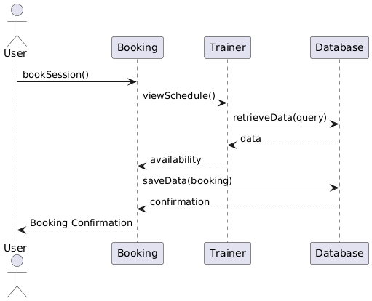

1. **Fitness Tracking**

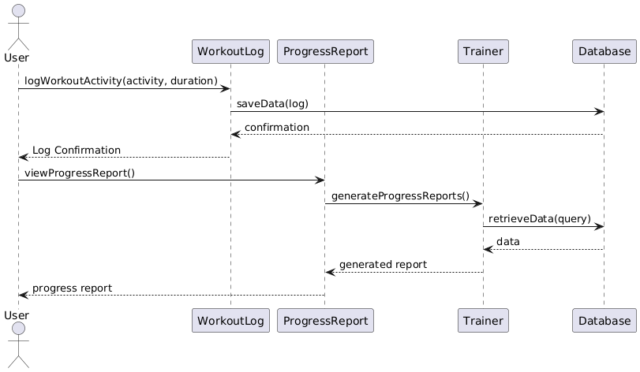

1. **Membership Subscription**

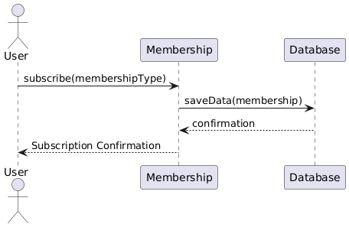

# 6. Class Diagram: -

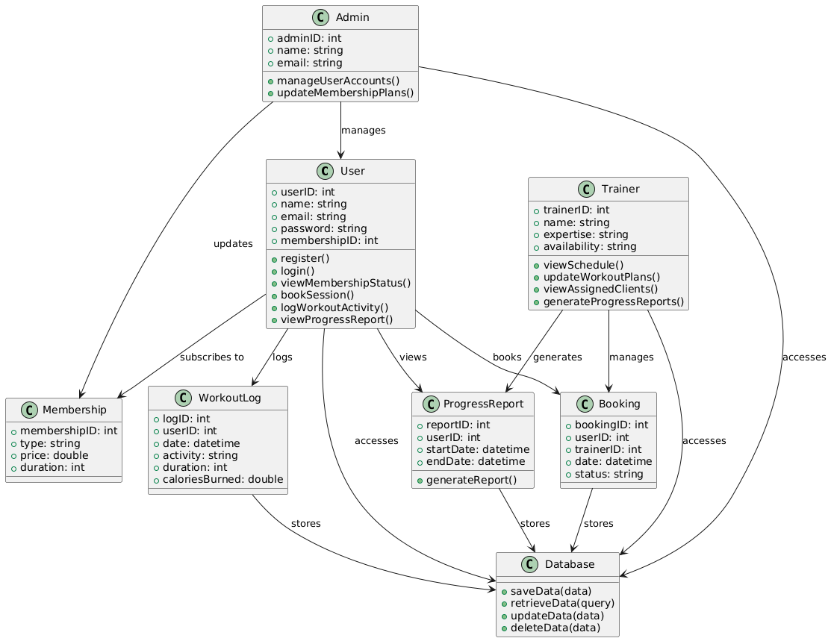

# 7.Trello Board: -

1. **Product Backlog**

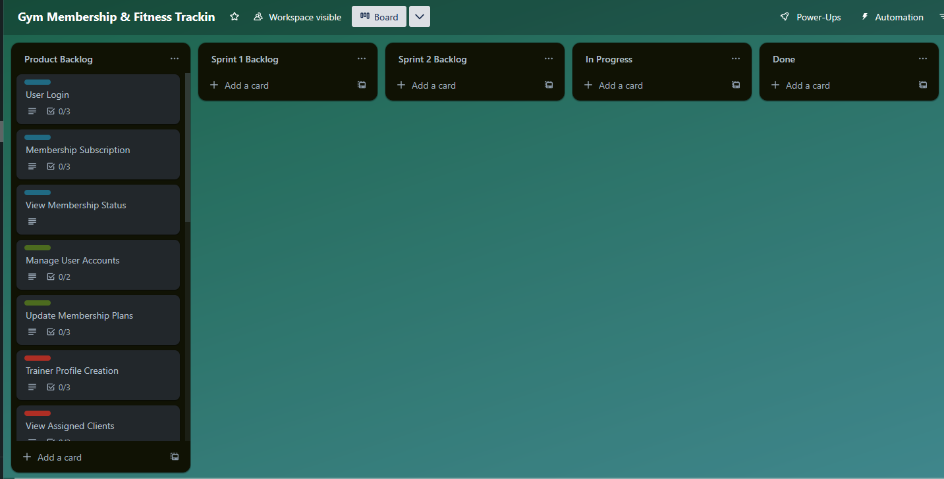

1. **Sprint 1 and Sprint 2 Backlog**

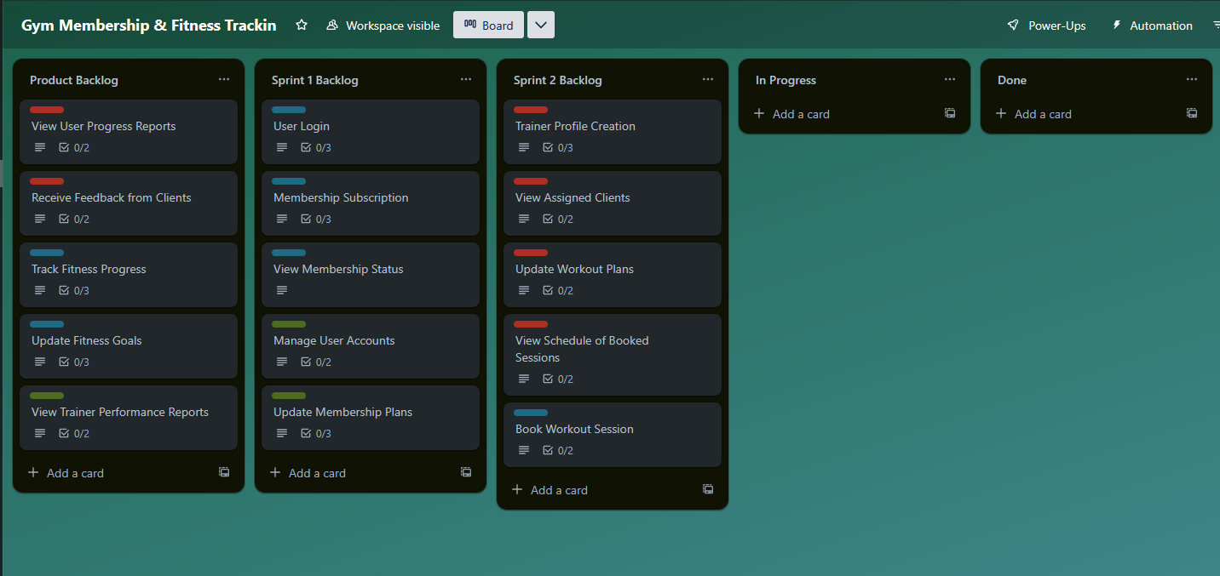

1. **Sprint 1 In Progress**

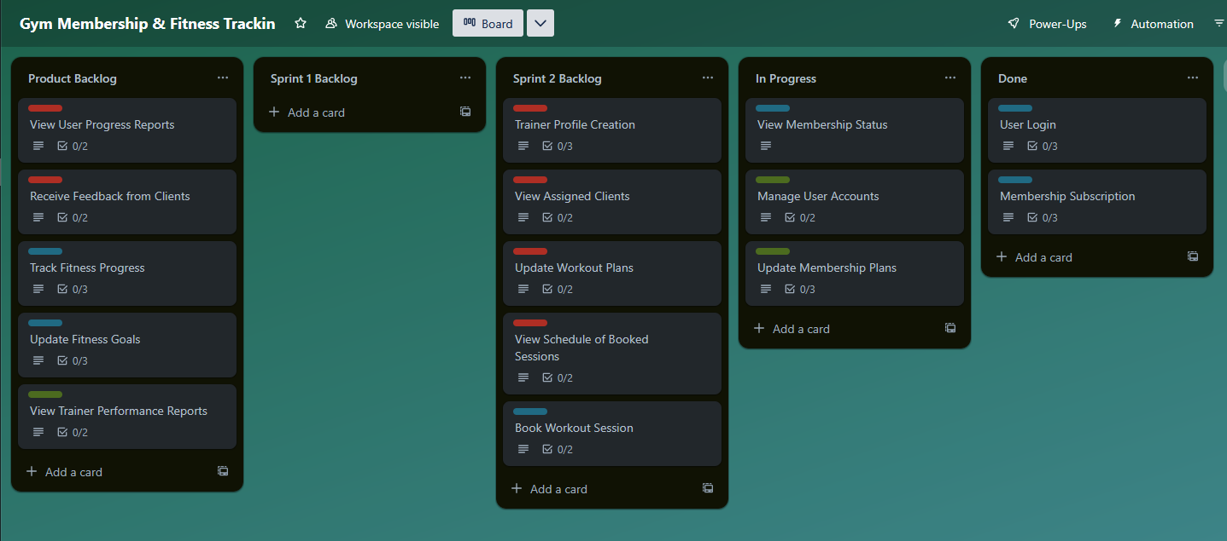

1. **Sprint 2 In Progress**

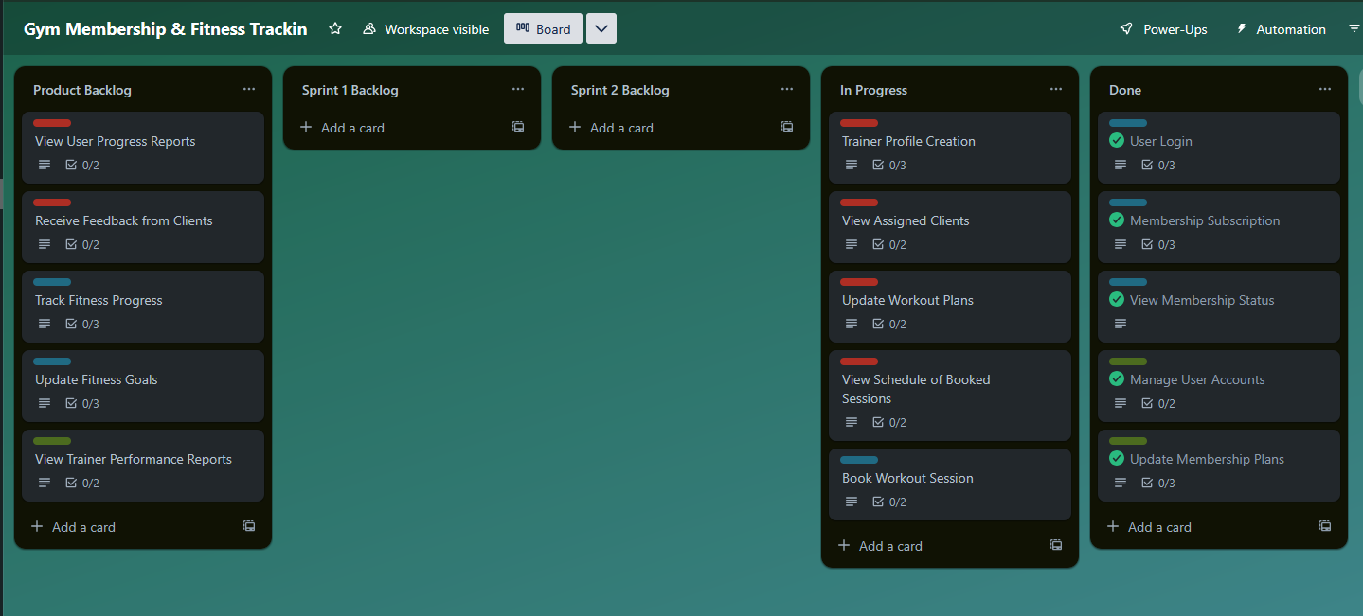

1. **Sprint 1 And Sprint 2 Done**

