Software Requirements and Design Document

for

**Mam Sidra Khalid**

Solar Energy Tracking System

**Prepared by <Amman Haroon 22i-0768>**

**<Abdul Samee 22i-1051>**

**<Abdul Rafay 22i-0843>**

**<HexVision>**

**<27-11-2024>**

**Table of Contents**

**Table of Contents ii**

**1.** **Introduction 1**

1.1 Purpose 1

1.2 Product Scope 1

1.3 Title 1

1.4 Objectives 1

1.5 Problem Statement 1

**2.** **Overall Description 1**

2.1 Product Perspective 1

2.2 Product Functions 2

2.3 List of Use Cases 2

2.4 Extended Use Cases 2

2.5 Use Case Diagram 2

**3.** **Other Nonfunctional Requirements 2**

3.1 Performance Requirements 2

3.2 Safety Requirements 2

3.3 Security Requirements 2

3.4 Software Quality Attributes 2

3.5 Business Rules 3

3.6 Operating Environment 3

3.7 User Interfaces 3

**4.** **Domain Model 3**

**5.** **System Sequence Diagram 3**

**6.** **Sequence Diagram 3**

**7.** **Class Diagram 4**

**8.** **Package Diagram 4**

**9.** **Deployment Diagram 4**

# Introduction

## Purpose

*A solution to track solar energy production and grid consumption while calculating*

*accurate net metering bills for homeowners.*

## Product Scope

*The project focuses on homeowners who use solar panels to generate electricity and rely on net*

*metering systems to manage their electricity consumption and bills.*

*This system will serve individual households, primarily in areas where solar energy is common, and will be adaptable to various net metering policies.*

*Existing tools in this domain include smart meter apps and energy dashboards, but most do not integrate solar production and consumption billing in an accessible format for end users.*

*The project will be limited to tracking energy usage and generating net metering bills based on standard tariffs.*

## Title

*Solar Energy Tracking and Net Metering System*

## Objectives

*The primary objective of this project is to develop a backend system that:*

*1. Tracks solar energy generation and grid electricity consumption.*

*2. Calculates net metering bills based on energy use and generation.*

*3. Offers an accessible platform for homeowners to monitor their solar energy usage.*

## Problem Statement

*As solar energy becomes increasingly popular, many homeowners struggle to understand how much*

*energy they are saving and what their electricity bill would be under net metering. Existing solutions*

*are often fragmented, focusing only on consumption or generation without providing an integrated*

*view. Manually calculating net metering bills is tedious, especially when utility rates are dynamic or*

*complex.*

*This project aims to automate the process of tracking solar energy production, grid electricity*

*consumption, and calculating the associated costs. The system will allow homeowners to easily*

*access information about their energy usage and bills without needing to manually interpret meter*

*readings or calculate tariffs. By automating bill generation and providing detailed usage reports, the*

*system reduces the time and effort required for homeowners to manage their energy consumption,*

*while promoting a clearer understanding of the financial benefits of solar energy.*

*This project is feasible within the course requirements, leveraging Java’s object-oriented*

*programming capabilities and building a backend with a structured, maintainable design. It will*

*integrate simple data storage and retrieval, offering a reliable, scalable solution to meet the growing demand for energy management tools.*

# Overall Description

## Product Perspective

*The Solar Energy Tracking and Net Metering System is a* ***new, self-contained product*** *designed specifically for homeowners using solar panels to track energy production, consumption, and calculate accurate net metering bills. This system does not replace an existing product but instead introduces an integrated, automated solution aimed at improving user understanding of solar energy savings.*

*It serves as an* ***independent module*** *but has potential integration capabilities with larger smart home systems or energy management platforms in the future. The product will rely on a preloaded database for weather data, grid consumption, and solar production, minimizing manual input from the user.*

## Product Functions

*The major functions provided by the system include:*

* ***Track Solar Energy Production****: Record and display daily, monthly, and annual solar energy output.*
* ***Monitor Grid Consumption****: Compare grid energy usage against solar energy production.*
* ***Calculate Net Metering Bills****: Automate bill calculations based on predefined energy rates and policies.*
* ***Generate Reports****: Create detailed monthly reports summarizing energy usage and savings.*
* ***Weather Data Integration****: Fetch sunlight hours to estimate solar production accurately.*
* ***User Management****:*
  + *Manage profiles, such as usernames and passwords.*
  + *Set notification preferences (e.g., bill alerts).*
* ***Data Visualization****:*
  + *Display energy usage and production comparisons through bar charts or graphs.*
* ***Error Handling****: Handle data inconsistencies or missing values gracefully with meaningful messages.*

## List of Use Cases

1. Create Account

2. Register Solar Device

3. View Solar Production

4. View Grid Consumption

5. Compare production v consumption

6. View Energy Prediction

7. View CO2 emissions saved

8. Monitor Solar Capacity

9. Change Account Details

10.Set Notifications Preferences

11. Delete Solar Device

12. Generate Bill

## Extended Use Cases

**1.View Solar Energy Production (Abdul Rafay)**

|  |  |
| --- | --- |
| **Use Case Name** | **View Solar Energy Production** |
| **Scope** | Solar Energy Tracking and Net Metering System |
| **Level** | User Goal |
| **Primary Actor** | Homeowner |
| **Stakeholders and Interests** | **Homeowner**: Wants to track real-time solar energy production and calculate his/her net-metering bill.    **System Administrator**: Needs to ensure smooth data collection from panels. |
| **Precondition** | Solar panels are installed, connected to the system, and generating energy. |
| **Postcondition** | Users gain insight into solar energy production trends. |
| **Main Success Scenario** | |  |  | | --- | --- | | **Actor** | **System** | | 1. User logs into the system. | 2. System verifies user credentials and grants access. | | 3. User selects "Solar Production" | 4. System retrieves real-time production data from the panels. | | 5. User chooses a specific period (daily, weekly, or monthly). | 6. System displays the selected period’s production data. | |  | 7. System presents the data. | |
| **Extensions** | 4a. If the system cannot fetch real-time data, an error message is displayed.  4b. If network connectivity is lost, a "Data unavailable" notification is sent. |

**2.View Grid Energy Consumption (Abdul Rafay)**

|  |  |
| --- | --- |
| **Use Case Name** | **View Grid Energy Consumption** |
| **Scope** | Solar Energy Tracking and Net Metering System |
| **Level** | User Goal |
| **Primary Actor** | Homeowner |
| **Stakeholders and Interests** | **Homeowner**: Wants to monitor grid energy usage.    **Utility Provider**: Needs accurate consumption data for billing. |
| **Precondition** | The system must be connected to the utility grid and track consumption data. |
| **Postcondition** | User understands and identifies opportunities to optimize energy usage. |
| **Main Success Scenario** | |  |  | | --- | --- | | **Actor** | **System** | | 1. User selects "Grid Consumption". | 2. The system retrieves energy consumption data from the utility connection. | | 3. User selects a custom time range (daily, weekly, monthly). | 4. System displays consumption data for the selected range. | |
| **Extensions** | 2a. If data is not available, the system displays "Unable to retrieve data. Please try again later". |

**3.Compare Solar Production vs Consumption (Amman Haroon)**

**a. Use Case: Compare Solar Production vs Consumption**

**b. Scope:** Solar Energy Tracking and Net Metering System

**c. Level:** User goal

**d. Primary actor:** Homeowner

**e. Stakeholders and interests:**

* Homeowner: Interested in understanding energy usage and making informed decisions.
* Solar Company: Interested in promoting solar efficiency and user engagement.

**f. Preconditions:**

* User is logged into the system.
* User has solar production and consumption data available.

**g. Postconditions:**

* User successfully compares solar production and consumption data.
* User gains insights into energy usage patterns.

**h. Main Success Scenario**

|  |  |
| --- | --- |
| User Actions | System Responses |
| 1. User logs in the system | 2. System verifies credentials and grants access |
| 3. User navigates to “Energy Comparison” section | 4. The system retrieves solar production and grid consumption data for the selected time frame. |
| 6. User analyzes the data to understand energy usage patterns and make informed decisions regarding energy consumption. | 5. The system displays a comparative chart/graph showing solar production vs. grid consumption. |

**i. Extensions**:

* The user can filter data for specific time ranges.
* Notifications are sent if production is significantly lower than consumption

**4.View Weather Based Energy Prediction (Amman Haroon)**

**a. Name**: View Weather Based Energy Prediction

**b. Scope**: Energy tracking and prediction system.

**c. Level**: User goal level.

**d. Primary Actor**: Homeowner.

**e. Stakeholders**:

· **Homeowner:** Wants to have a reliable energy production schedule

· **Utility Company:** Wants to ensure consumer gets an accurate forecast for their energy generation

· **System Admin:** Wants to maintain the system's reliability and accuracy in predicting solar energy

**f. Preconditions**:

Weather data and past solar production data are available.

**g**. **Postconditions**:

Energy prediction report based on weather forecasts is shown.

**h. Main Success Scenario**

|  |  |
| --- | --- |
| User Actions | System Responses |
| 1. User logs in the system | 2. System verifies credentials and grants access |
| 3. User navigates to “View Energy Production Predictions” | 4. The system retrieves weather forecast data |
| 6. User views energy production predictions | 5. System calculates potential solar energy production and displays the result |

**i. Extensions**:

* The user can see predictions for different timeframes (daily, weekly).

**5.Register Solar Device (Amman Haroon)**

**a. Use Case Name:** Register Solar Device

**b. Scope**: Solar Energy Tracking and Net Metering System.

**c. Level**: User Goal

**d. Primary Actor**: Homeowner (User)

**e. Stakeholders and Interests**:

* **Homeowner**: Wants to ensure that their solar devices are correctly registered so that the system can accurately track energy production and consumption.
* **Energy Company**: Needs accurate information about the installed devices for net metering calculations.
* **Solar Equipment Provider**: May want to track performance of their equipment.

**f. Preconditions**:

* The user has a solar energy system installed.
* The system is functional and can be connected to the Solar Energy Tracking system.

**g. Postconditions**:

* The solar devices are registered and connected to the system.
* The system is ready to monitor energy production and consumption from the registered devices.

**h. Main Success Scenario**:

|  |  |
| --- | --- |
| User Actions | System Responses |
| 1. User logs in the system | 2. System verifies credentials and grants access |
| 3. User navigates to the "Device Registration" section. | 4. System displays a form asking for device details (e.g., device type, capacity, manufacturer, etc.). |
| 5. User enters details about the solar panels, inverters, and energy meters. | 7. System validates the device details. |
| 6. User submits the registration form. | 8. System saves the registered devices in the database. |
|  | 9. System begins tracking energy data from the registered devices. |

**h. Extensions**:

* **Device already registered**:
  + System notifies the user that the device has already been registered.
* **Invalid device details**:
  + System notifies the user about missing or incorrect details and asks for corrections.
* **System error**:
  + If there’s an error in saving the device, the system displays an error message and asks the user to try again later

**6.Set Notification Preferences (Abdul Samee)**

* **Scope**: Solar Energy Tracking and Net Metering System
* **Level**: User Goal
* **Primary Actor**: Homeowner
* **Stakeholders and Interests**:
  + **Homeowner**: Wants to customize how they receive notifications (e.g., email, SMS).
  + **System Administrator**: Ensures proper notification delivery according to the homeowner's preferences.
* **Preconditions**:
  + The homeowner is logged in.
  + Notification options are available.
* **Postconditions**:
  + The notification preferences are successfully saved.
* **Main Success Scenario**:

|  |  |
| --- | --- |
| **Actor** | **System Response** |
| 1. Homeowner logs into the system. | 2. System verifies homeowner credentials and grants access. |
| 3. Homeowner navigates to "Notification Preferences." | 4. System displays available notification options (e.g., SMS, email). |
| 5. Homeowner selects notification preferences (e.g., Email for billing reminders). | 6. System stores the selected preferences. |
| 7. Homeowner clicks "Save Preferences." | 8. System confirms the preferences have been successfully updated. |
| 9. Homeowner sees the confirmation. | 10. System displays: "Notification preferences updated." |

* **Extensions**:
  + **4a**: If a selected notification method is unavailable, the system displays: "This notification method is temporarily unavailable."
  + **8a**: If saving fails, the system displays: "Unable to save preferences, please try again."

**7.Monitor System Capacity (Abdul Samee)**

* **Scope**: Solar Energy Tracking and Net Metering System
* **Level**: User Goal
* **Primary Actor**: Homeowner
* **Stakeholders and Interests**:
  + **Homeowner**: Wants to monitor system capacity to ensure proper energy production and usage.
  + **System Administrator**: Ensures accurate tracking of system capacity.
* **Preconditions**:
  + The system is operational and tracking capacity usage.
* **Postconditions**:
  + The homeowner successfully monitors system capacity metrics.
* **Main Success Scenario**:

|  |  |
| --- | --- |
| **Actor** | **System Response** |
| 1. Homeowner logs into the system. | 2. System verifies homeowner credentials and grants access. |
| 3. Homeowner selects "System Capacity" from the dashboard. | 4. System retrieves real-time system usage metrics (e.g., solar output, battery status). |
| 5. Homeowner reviews system capacity metrics. | 6. System displays a graphical representation of usage (e.g., chart). |
| 7. Homeowner checks for capacity warnings. | 8. System sends alerts if capacity usage exceeds predefined thresholds. |

* **Extensions**:
  + **4a**: If system metrics are unavailable, the system displays: "Unable to retrieve capacity data."
  + **8a**: If capacity exceeds limits, the system sends an alert: "System capacity approaching maximum.

**8. Create Account**

|  |  |  |  |  |  |  |  |  |  |  |  |  |  |  |  |  |  |  |  |  |  |
| --- | --- | --- | --- | --- | --- | --- | --- | --- | --- | --- | --- | --- | --- | --- | --- | --- | --- | --- | --- | --- | --- |
| |  |  |  | | --- | --- | --- | | **Use Case Name** |  | **Create Account** | | **Scope** |  | Solar Energy Tracking and Net Metering System | | **Level** |  | User Goal | | **Primary Actor** |  | Homeowner | | **Stakeholders and Interests** |  | **Homeowner**: Wants to create an account to track energy production and billing. **System Administrator**: Needs to ensure valid user registrations. | | **Precondition** |  | The system is operational and connected to the registration module. | | **Postcondition** |  | A new account is successfully created, and the user can log in. |   **Main Success Scenario** |
| |  |  | | --- | --- | | **Actor** | **System** | | 1. User opens the system's registration page. | 2. System displays the account creation form. | | 3. User fills out the required details (e.g., name, email, password). | 4. System validates the inputs. | | 5. User submits the form. | 6. System creates the account and stores it in the database. | |  | 7. System displays a success message: "Account created successfully." |   **Extensions** |
| · **4a.** If mandatory fields are left blank, the system displays: "Please fill in all required fields." |
| · **4b.** If the email is already registered, the system displays: "Email already in use." |

**9.View CO₂ Emissions Saved**

|  |  |  |  |  |  |  |  |  |  |  |  |  |  |  |
| --- | --- | --- | --- | --- | --- | --- | --- | --- | --- | --- | --- | --- | --- | --- |
| |  |  | | --- | --- | | **Use Case Name** | **View CO₂ Emissions Saved** | | **Scope** | Solar Energy Tracking and Net Metering System | | **Level** | User Goal | | **Primary Actor** | Homeowner | | **Stakeholders and Interests** | **Homeowner**: Wants to monitor environmental impact through CO₂ savings. **System Administrator**: Ensures accurate data tracking and reporting. | | **Precondition** | Solar panels are installed, generating energy, and data is being tracked. | | **Postcondition** | The homeowner gains insight into CO₂ savings. |   **Main Success Scenario** |
| |  |  | | --- | --- | | **Actor** | **System** | | 1. User logs into the system. | 2. System verifies user credentials and grants access. | | 3. User selects "View CO₂ Savings." | 4. System calculates emissions saved based on energy production. | |  | 5. System displays CO₂ savings in a graphical format. |   **Extensions** |
| · **4a. If no data is available, the system displays: "CO₂ savings data is not available at this time."** |
| · **4b. If calculation fails, the system logs an error and notifies the user.** |

**10. Change Account Details**

|  |  |  |  |  |  |  |  |  |  |  |  |  |  |  |
| --- | --- | --- | --- | --- | --- | --- | --- | --- | --- | --- | --- | --- | --- | --- |
| |  |  | | --- | --- | | **Use Case Name** | **Change Account Details** | | **Scope** | Solar Energy Tracking and Net Metering System | | **Level** | User Goal | | **Primary Actor** | Homeowner | | **Stakeholders and Interests** | **Homeowner**: Wants to update personal information such as email or contact details. **System Administrator**: Ensures data consistency and security. | | **Precondition** | User is logged into the system. | | **Postcondition** | Account details are updated and saved in the database. |   **Main Success Scenario** |
| |  |  | | --- | --- | | **Actor** | **System** | | 1. User navigates to the "Account Settings" page. | 2. System displays current account information. | | 3. User edits the desired fields (e.g., email, phone). | 4. System validates the updated details. | | 5. User submits the changes. | 6. System updates the database and displays a confirmation message. |   **Extensions** |
| · **4a.** If invalid details are entered, the system displays an error message: "Invalid input." |
| · **4b.** If the database update fails, the system displays: "Unable to update details at this time." |



**11. Delete Solar Device**

|  |  |  |  |  |  |  |  |  |  |  |  |  |  |  |
| --- | --- | --- | --- | --- | --- | --- | --- | --- | --- | --- | --- | --- | --- | --- |
| |  |  | | --- | --- | | **Use Case Name** | **Delete Solar Device** | | **Scope** | Solar Energy Tracking and Net Metering System | | **Level** | User Goal | | **Primary Actor** | Homeowner | | **Stakeholders and Interests** | **Homeowner**: Wants to remove a solar device from their account. **System Administrator**: Ensures safe device removal and data integrity. | | **Precondition** | User is logged in, and a solar device is linked to the account. | | **Postcondition** | The solar device is successfully removed from the system. |   **Main Success Scenario** |
| |  |  | | --- | --- | | **Actor** | **System** | | 1. User navigates to "Device Management." | 2. System displays a list of linked devices. | | 3. User selects the device to delete. | 4. System prompts the user for confirmation. | | 5. User confirms the deletion. | 6. System removes the device from the database and displays a success message. |   **Extensions** |
| · **4a.** If the device is actively producing data, the system warns: "Device in use. Are you sure you want to delete?" |
| · **4b.** If deletion fails, the system displays: "Unable to delete the device. Please try again later." |

**12. Generate Bill**

|  |  |  |  |  |  |  |  |  |  |  |  |  |  |  |  |  |  |  |  |  |  |  |  |  |  |  |  |  |  |  |  |  |  |  |  |  |  |  |  |  |  |  |  |  |  |  |  |  |  |  |  |  |  |  |  |  |  |  |  |  |  |  |  |
| --- | --- | --- | --- | --- | --- | --- | --- | --- | --- | --- | --- | --- | --- | --- | --- | --- | --- | --- | --- | --- | --- | --- | --- | --- | --- | --- | --- | --- | --- | --- | --- | --- | --- | --- | --- | --- | --- | --- | --- | --- | --- | --- | --- | --- | --- | --- | --- | --- | --- | --- | --- | --- | --- | --- | --- | --- | --- | --- | --- | --- | --- | --- | --- |
| |  |  |  |  |  |  |  |  |  | | --- | --- | --- | --- | --- | --- | --- | --- | --- | | **Use Case Name** |  |  |  |  |  |  |  | **Generate Bill** | | **Scope** |  |  |  |  |  |  |  | Solar Energy Tracking and Net Metering System | | **Level** |  |  |  |  |  |  |  | User Goal | | **Primary Actor** |  |  |  |  |  |  |  | Homeowner | | **Stakeholders and Interests** |  |  |  |  |  |  |  | **Homeowner**: Wants to generate and view their net-metering bill. **System Administrator**: Ensures accurate billing calculations. | | **Precondition** |  |  |  |  |  |  |  | Energy usage and production data are available in the system. | | **Postcondition** |  |  |  |  |  |  |  | A bill is generated and displayed to the user. |   **Main Success Scenario** |
| |  |  | | --- | --- | | **Actor** | **System** | | 1. User navigates to the "Billing" section. | 2. System displays billing options. | | 3. User selects "Generate Bill." | 4. System calculates net-metering credits and total amount. | |  | 5. System displays the bill with a breakdown of charges. |   **Extensions** |
| · **4a.** If energy usage data is incomplete, the system displays: "Insufficient data to generate the bill." |
| · **4b.** If calculation fails, the system logs the error and displays: "Unable to generate the bill. Please try again later." |

## Use Case Diagram

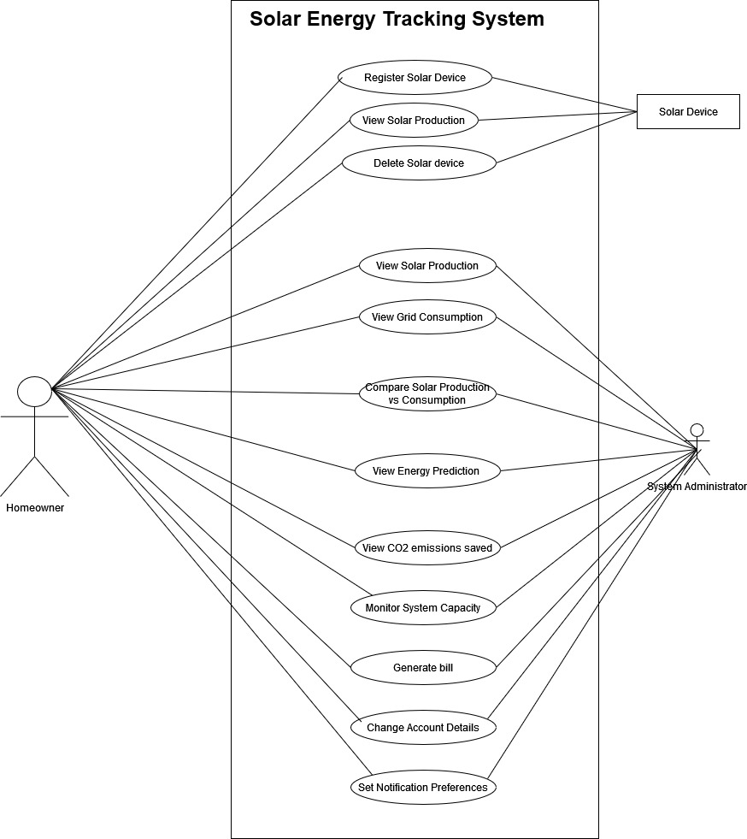

# Other Nonfunctional Requirements

## Performance Requirements

The system should provide real-time updates and calculations where feasible. Specifically:

Response Time: The dashboard should load in under 2 seconds for preloaded data.

Data Processing: Energy production vs. grid consumption comparison charts should be generated within 5 seconds for datasets of up to one year.

Weather Data Fetching: Sunlight hours data retrieval for cities should complete within 3 seconds.

Scalability: The system must handle up to 1,000 users concurrently without performance degradation.

Rationale: These performance requirements ensure a responsive and user-friendly experience while supporting a reasonable growth in user base.

## Safety Requirements

*The system must ensure accurate calculations for net metering bills to prevent financial disputes.*

*In case of data loss, safeguards like regular database backups should be implemented.*

*The system should prevent unauthorized access to prevent malicious manipulation of energy or billing data.*

*Actions like deleting essential data (e.g., solar production history) must be restricted and confirmed through multiple prompts.*

*Compliance: Adhere to relevant safety standards such as ISO 27001 for data integrity.*

## Security Requirements

User authentication must be enforced through secure login mechanisms (e.g., hashed passwords and email verification).

Sensitive user information, such as billing data, must be encrypted both in transit (using HTTPS) and at rest.

Restrict access based on user roles (e.g., admin vs. homeowner).

Comply with local data protection regulations like GDPR if applicable to target users.

A mechanism to log and monitor access attempts should be implemented for auditing and identifying security breaches.

## Software Quality Attributes

Reliability: The system should have an uptime of 99.9%.

Maintainability: Modular design with clear separation of concerns to facilitate future updates and debugging.

Usability: A simple and intuitive dashboard layout suitable for users with minimal technical knowledge.

Adaptability: The system should be easily adjustable to accommodate different net metering policies in various regions.

Testability: Automated unit and integration tests should cover at least 90% of the codebase.

Interoperability: Seamlessly integrate with weather APIs and any third-party energy monitoring systems.

## Business Rules

Only registered users with verified solar devices can view net metering reports.

Admins can manage user data but cannot alter user-specific production/consumption logs.

Users must have the ability to set notification preferences for system updates or production milestones.

Energy data must be recorded in kWh, ensuring consistency with utility company standards.

## Operating Environment

Hardware Platform: The system will operate on user devices such as desktops, laptops, and mobile devices.

Operating System: Cross-platform compatibility with Windows 10+, macOS, Linux (Ubuntu 20.04+), and Android/iOS browsers.

Software Components: The system requires Java 17, SQLite database, JavaFX for GUI, and an internet connection for fetching weather data.

## User Interfaces

*Dashboard Design: Includes small ImageView options for quick access to key features:*

*Set notification preferences.*

*Monitor solar capacity.*

*Change password.*

*Change username.*

*Standard Layout: Uniform placement of navigation buttons and consistent use of fonts and colors.*

*Error Messages: Display in a clear, concise format with actionable guidance (e.g., "Invalid login credentials. Please try again.").*

*Keyboard Shortcuts: Basic shortcuts like Ctrl+S for saving data should be supported.*

*Help Menu: Provide a dedicated help section accessible from all screens.*

# Domain Model

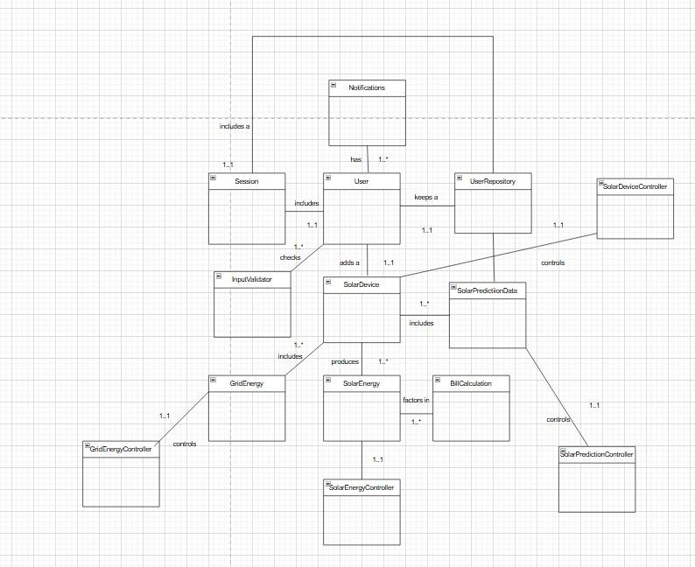

# System Sequence Diagram

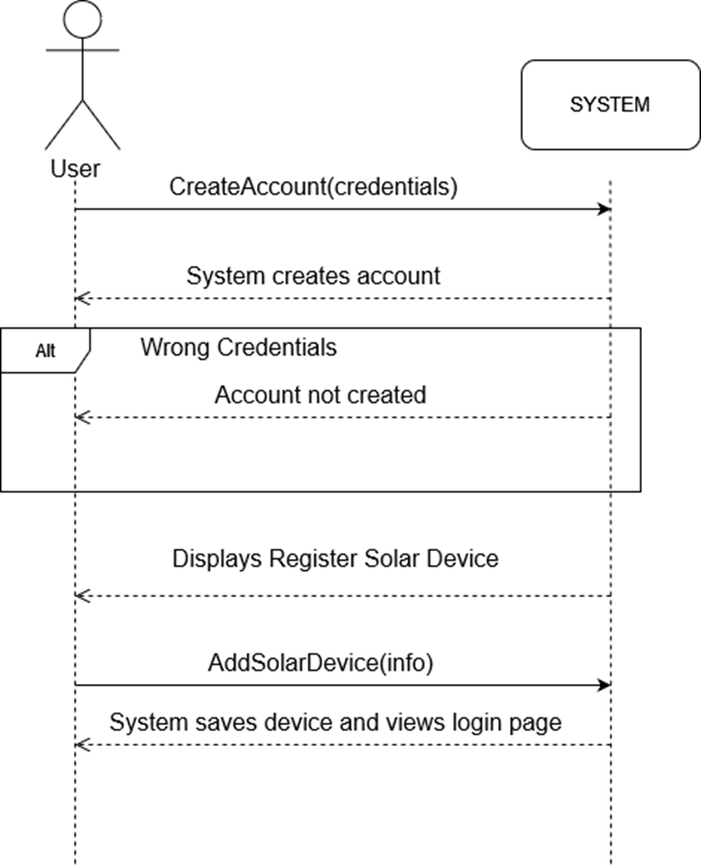

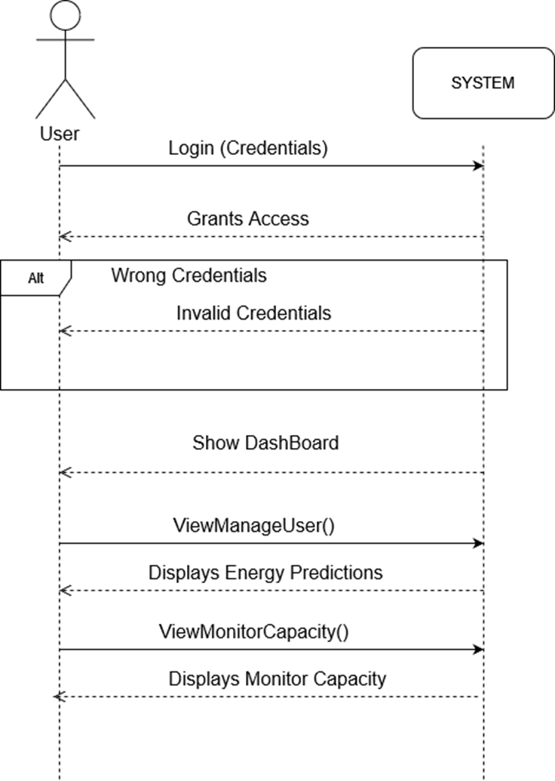

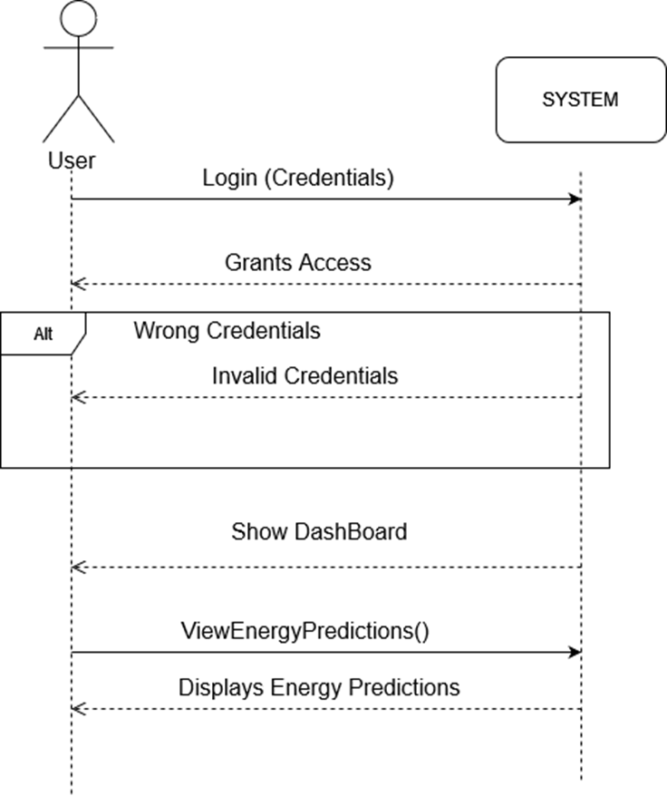





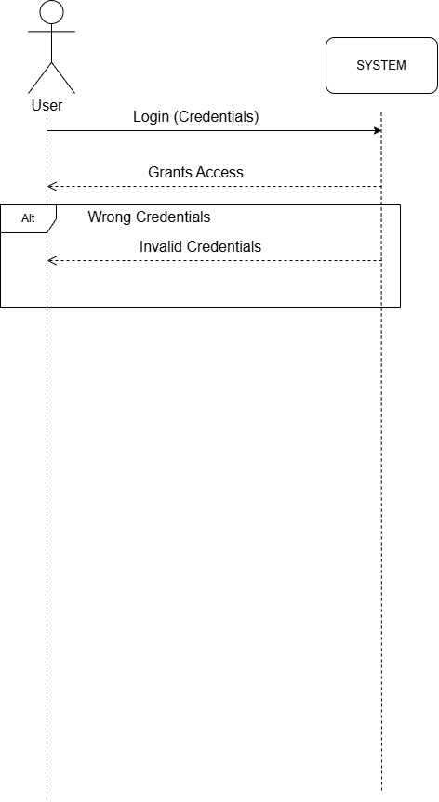

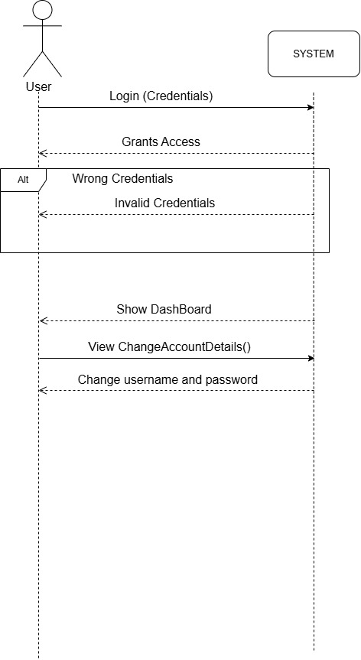

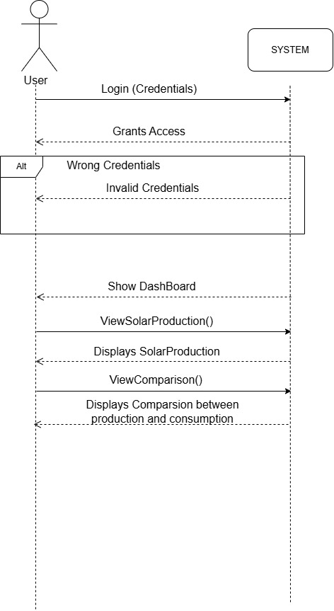

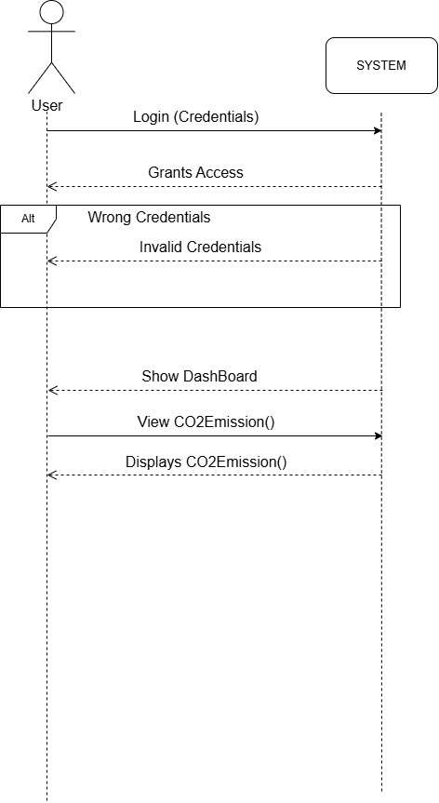

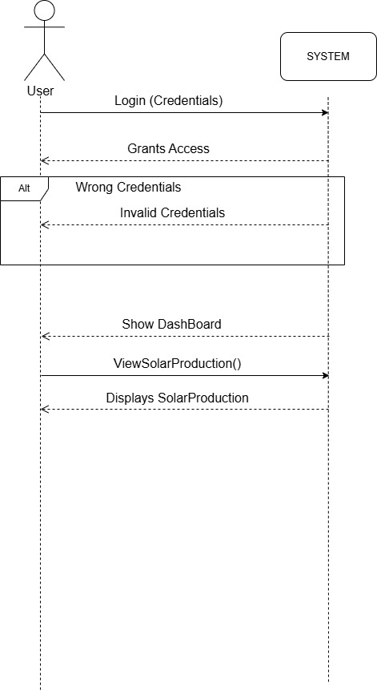

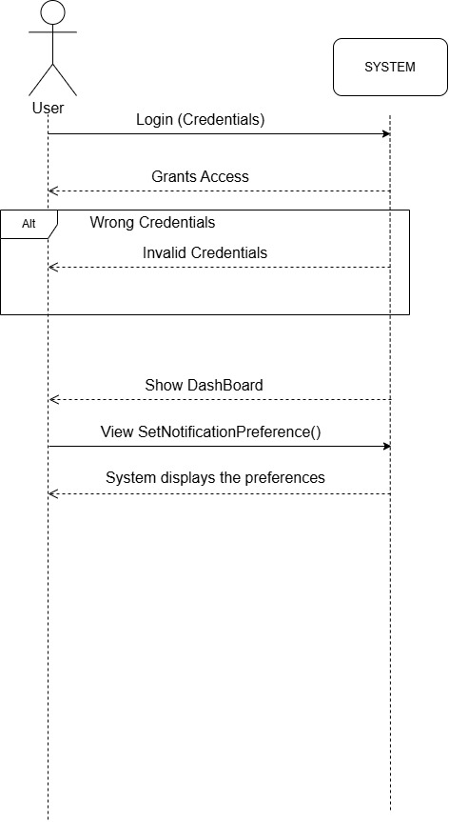

# Sequence Diagram

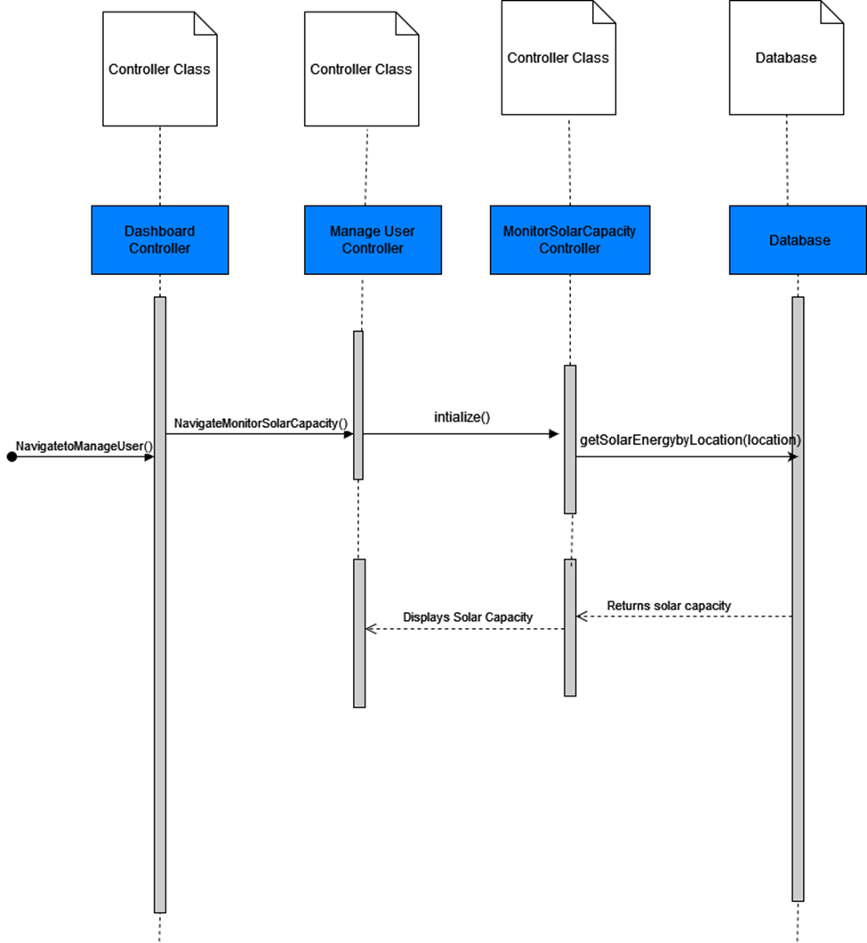



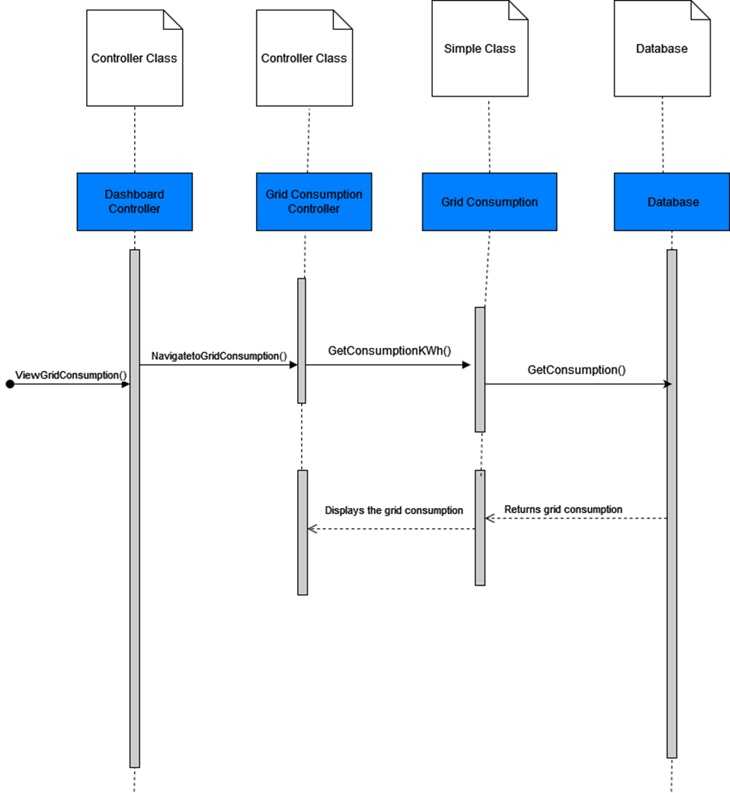

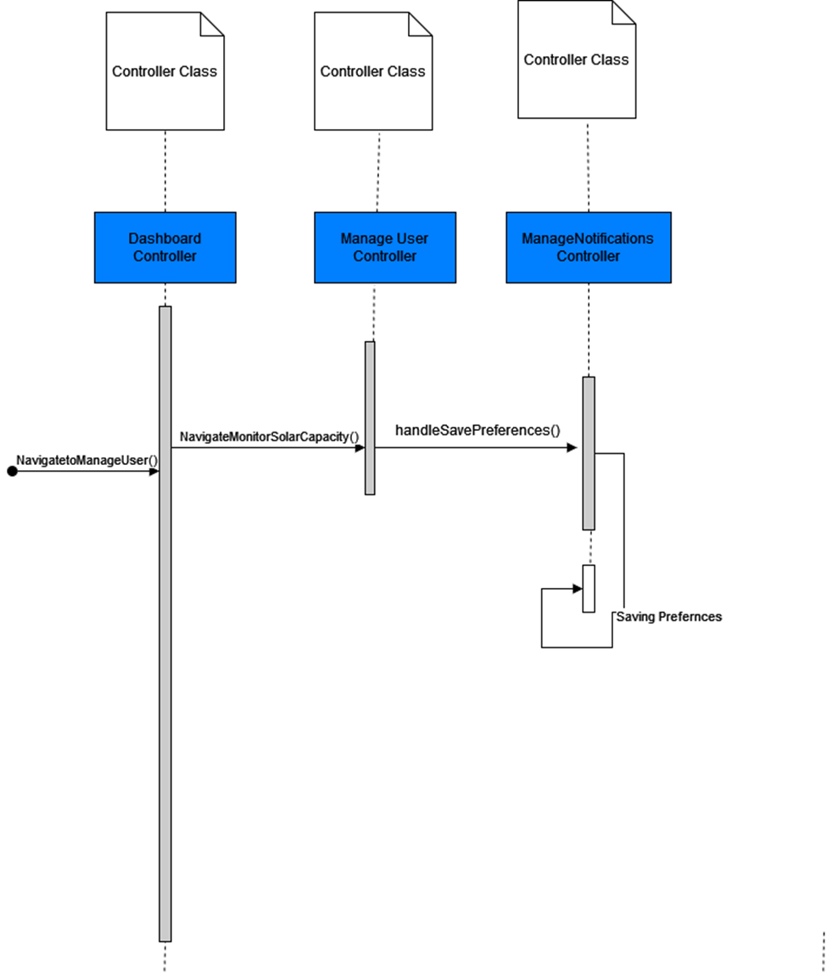



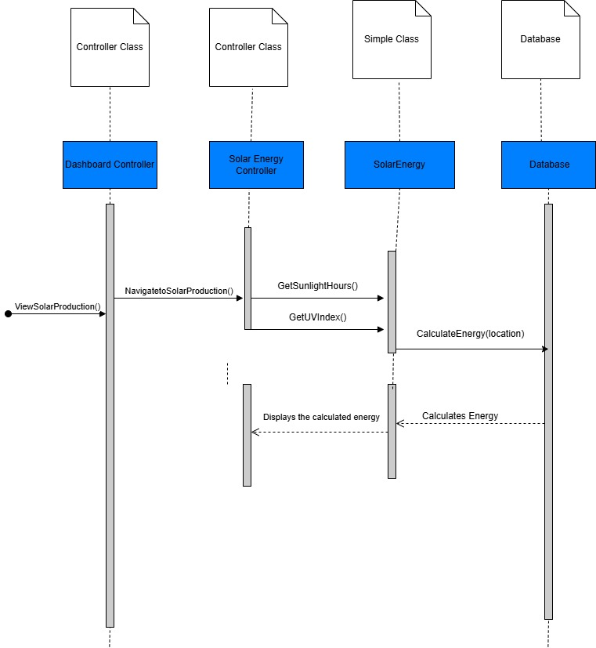

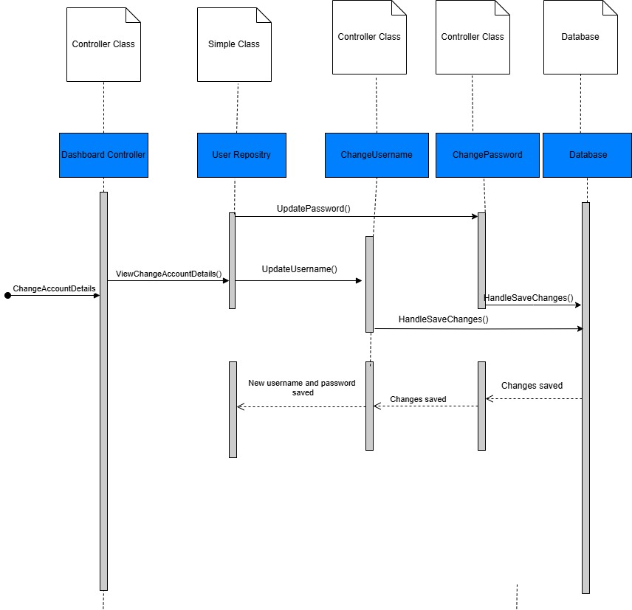

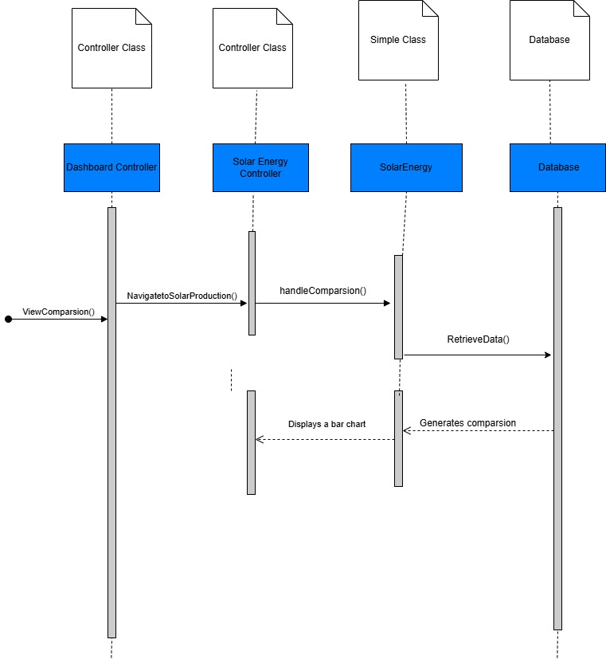

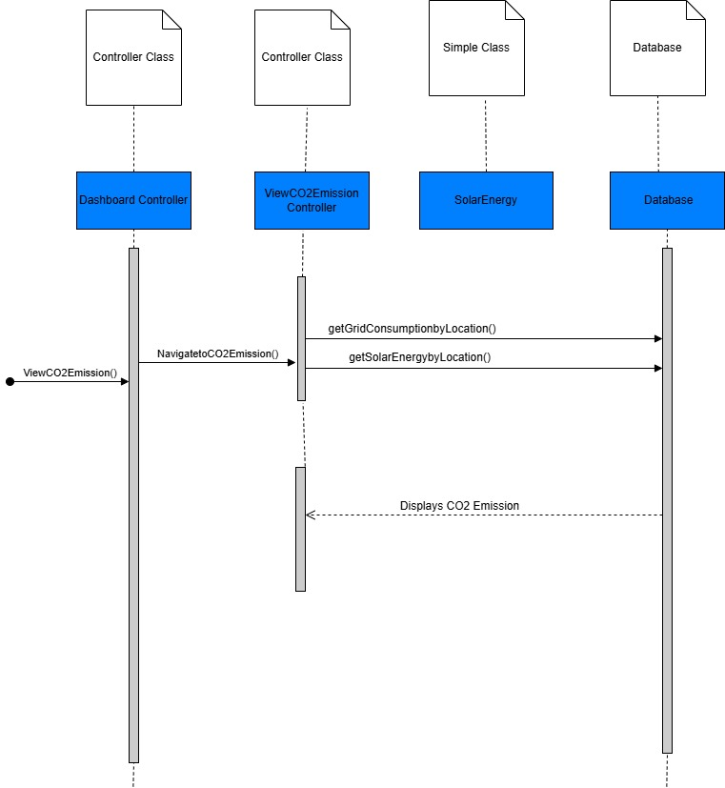

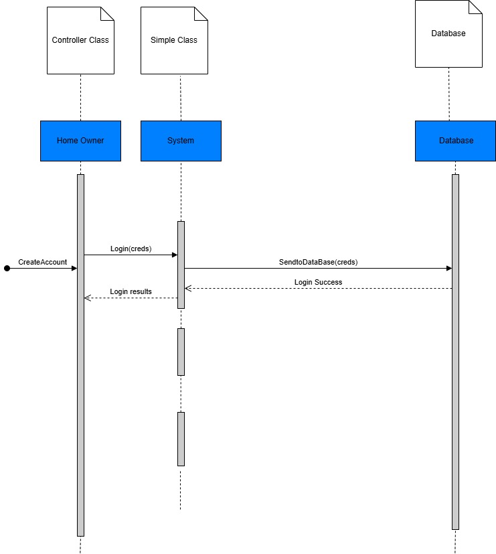

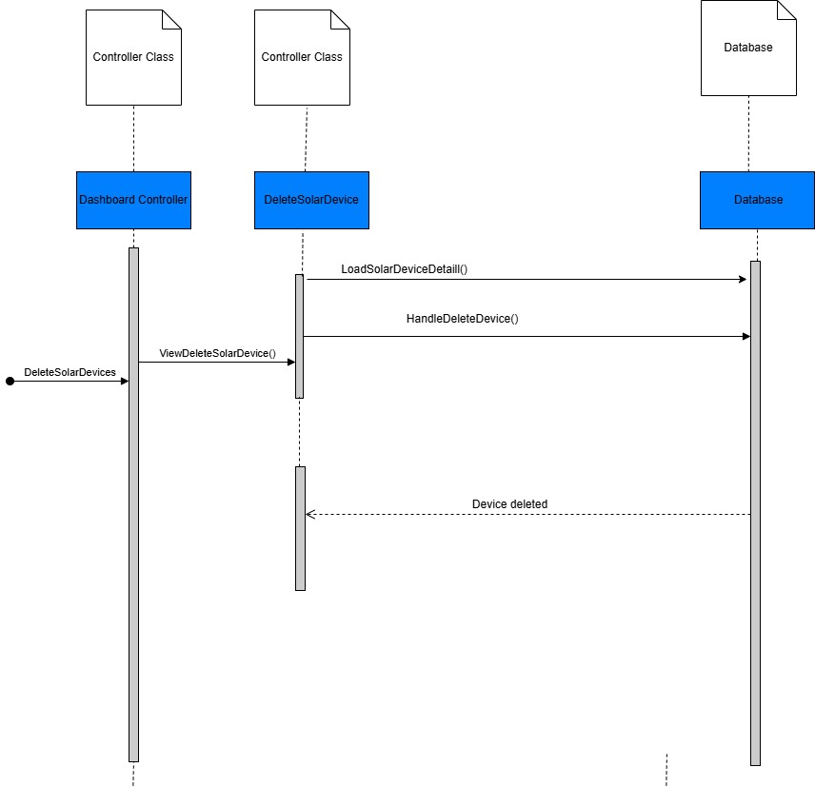

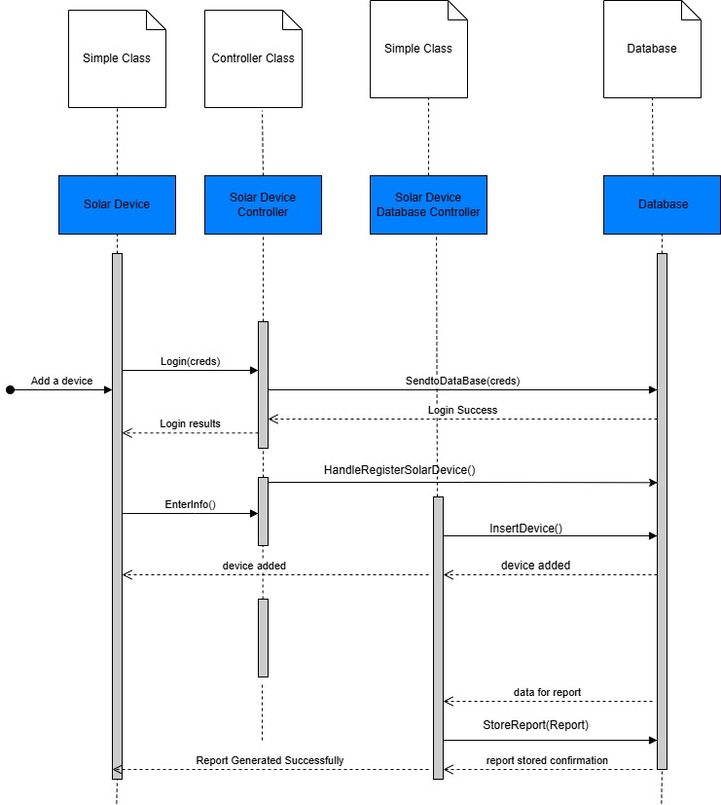

# Class Diagram

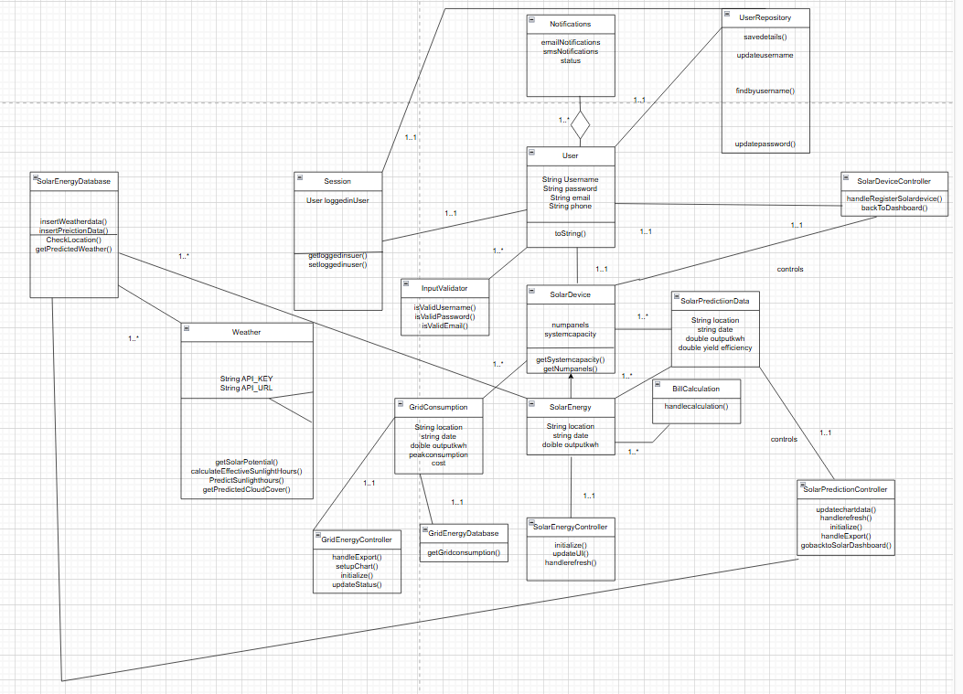

# Component Diagram

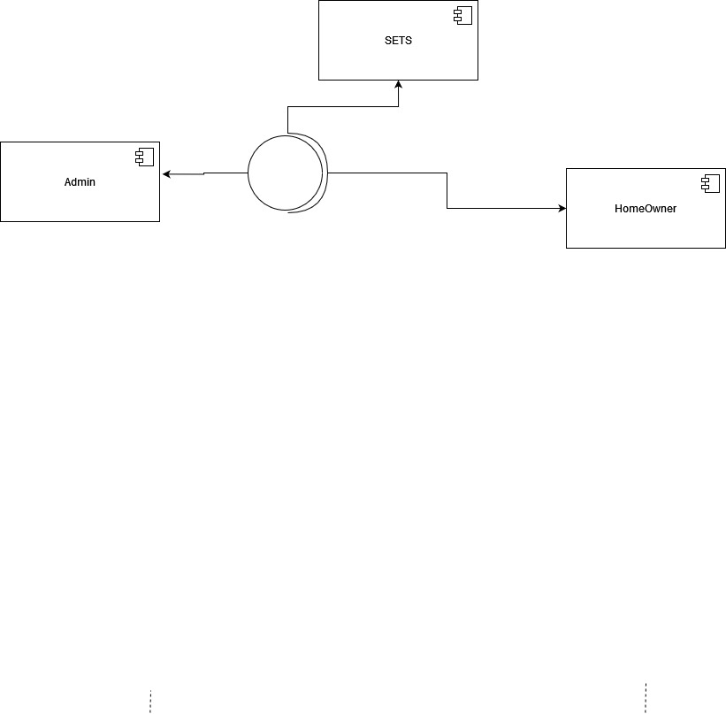

# Package Diagram

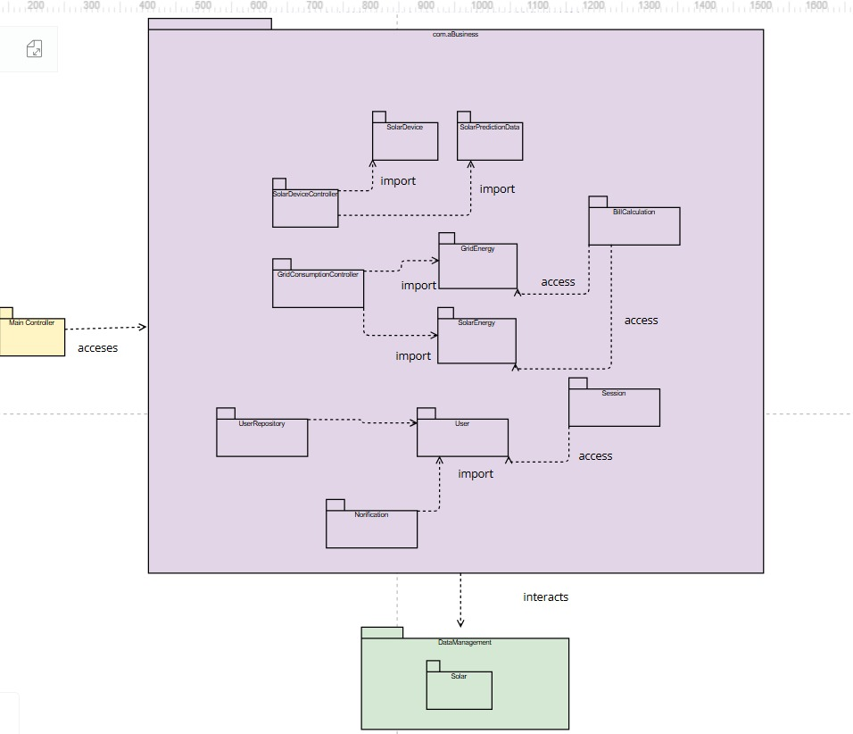

# Deployment Diagram

