BCI Motor Imagery Classification
Processing → EDA → CSP + SVM → Evaluation
Scope of this report: signal processing, exploratory data analysis, a CSP+SVM baseline classifier, and its evaluation. EEGNet / deep-learning comparison and deployment are intentionally out of scope.

1. Dataset
The provided data (eeg_hands_df.csv) differs from the originally planned "2000 Excel files" format: it is a single tidy CSV where every row is one time sample and each trial is identified by trial_id. After reshaping, the dataset contains:
Property | Value
Trials | 90
Subject(s) | 1 (single-subject recording)
Channels | 21 sensorimotor channels (Fc/C/Cp rows, incl. C3, Cz, C4)
Samples per trial | 641
Sampling rate | 160 Hz (derived from the 0.00625 s time step)
Trial duration | 4.0 s
Class balance | 46 Left Hand / 44 Right Hand
Missing values | 0

Because there is only one subject, evaluation below uses trial-level stratified cross-validation (not subject-independent splitting, which needs multiple subjects).

2. Processing Pipeline (applied)
The preprocessing plan from the project roadmap was adapted to what this dataset actually supports:
Step | Applied | Notes
Load & organize | Yes | 90 trials reshaped to (trials × channels × time)
Artifact rejection | Yes | Peak-to-peak amplitude rule; 0 trial(s) rejected
Band-pass filter | Yes | 0.5–40 Hz Butterworth (order 4, zero-phase)
Notch filter | Skipped | No evidence of 50/60 Hz line noise inside the 0.5–40 Hz band; skipped to avoid unnecessary distortion
Re-referencing | Yes | Common Average Reference (CAR)
Epoching | N/A | Data already arrives pre-epoched (one full 4 s trial per file)
Baseline correction | Yes | Per-trial, per-channel mean subtraction (no separate pre-stimulus window is present in the data)
Mu/Beta isolation | Yes | 8–30 Hz band-pass — the band CSP operates on

3. Exploratory Data Analysis (EDA)

3.1 Class balance
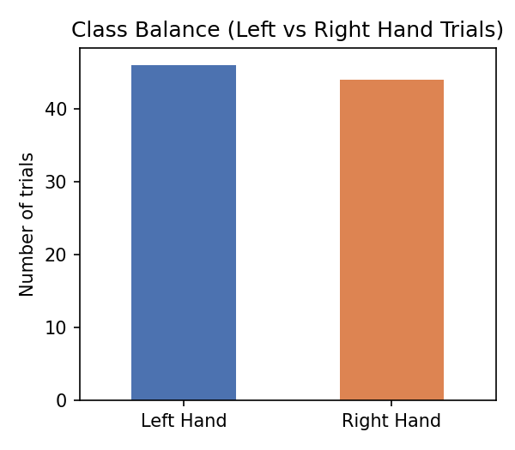
Figure 1 — Left vs Right Hand trial counts (46 vs 44): near-balanced, no resampling needed.

3.2 Time-domain inspection
Example single trials on C3 and C4, raw vs. 8–30 Hz filtered, for one Left and one Right trial:
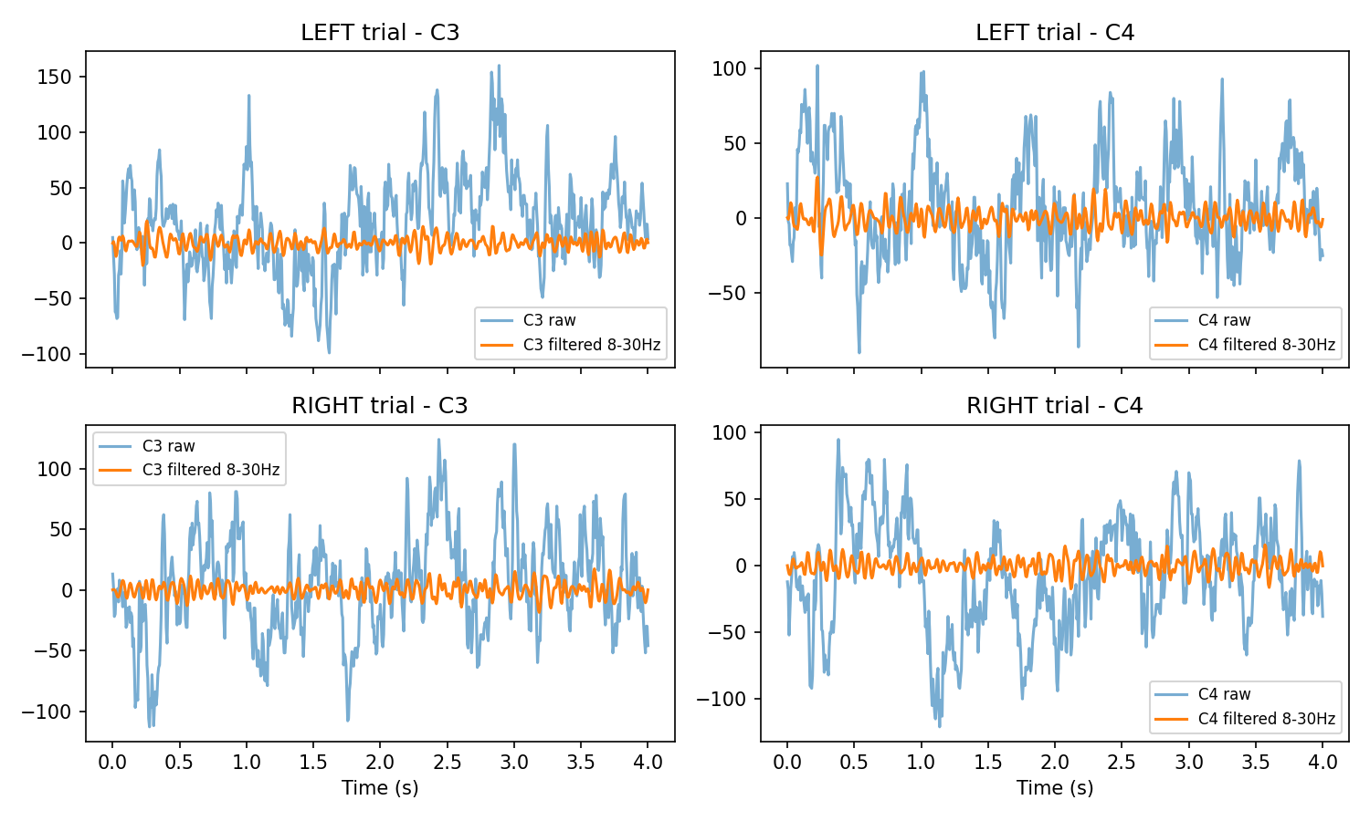
Figure 2 — Raw vs. filtered (mu/beta band) signal, C3 and C4, one Left and one Right trial.

3.3 Power Spectral Density — C3 / C4
Average PSD (Welch) per class, computed on the CAR-referenced broadband signal:
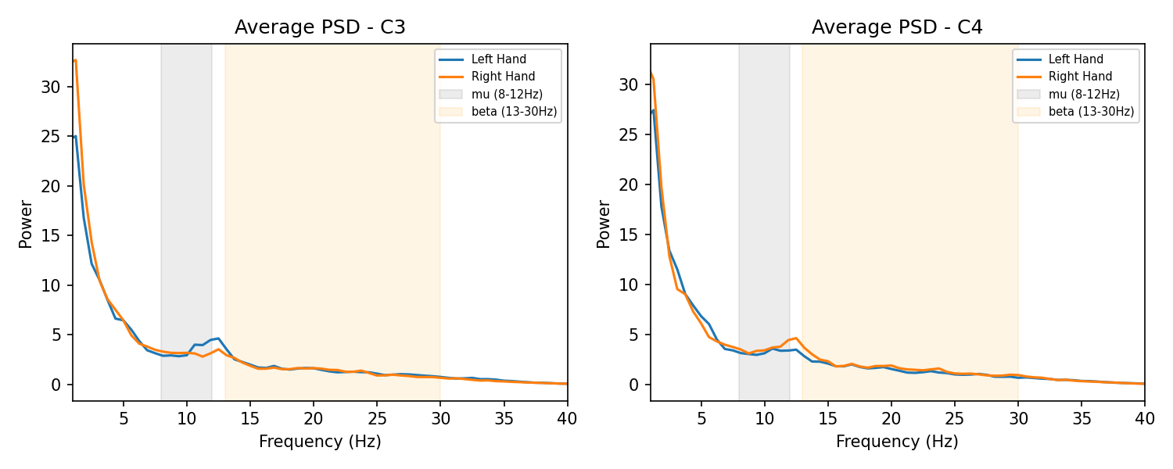
Figure 3 — Average PSD, Left vs Right, channels C3 and C4. Mu (8–12 Hz) and beta (13–30 Hz) bands shaded.
Numerically: C3 mu power is 12.73 (Left) vs 11.68 (Right); C4 mu power is 12.09 (Left) vs 13.32 (Right). The direction is consistent with expected contralateral ERD (Right-hand imagery showing relatively lower/altered mu power over the left-hemisphere channel C3, and vice versa for C4), though the single-subject sample makes this a suggestive rather than conclusive pattern.

3.4 Band power across all channels
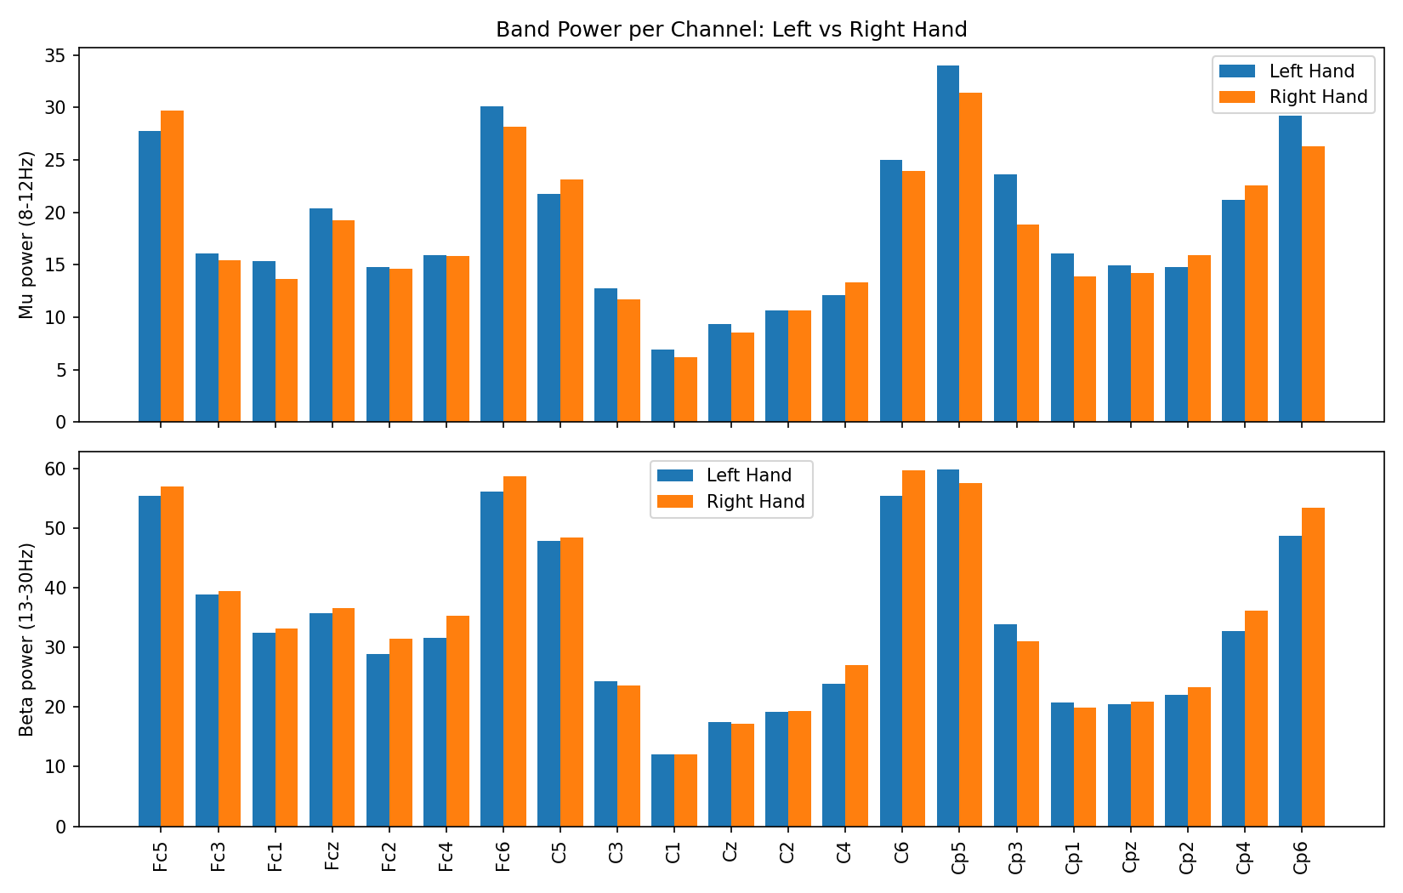
Figure 4 — Mu (top) and beta (bottom) band power per channel, Left vs Right.
Central channels (C3, C4, Cz and neighbours) show the clearest Left/Right separation, matching the physiological expectation that motor imagery signal concentrates over the sensorimotor strip — supporting CSP's use of exactly these channels.

4. Modeling: CSP + SVM
A classical two-class Common Spatial Patterns (CSP) pipeline was implemented (custom, scikit-learn-compatible) and paired with a Support Vector Machine classifier:
- Input to CSP: the 8–30 Hz (mu+beta) band-passed, CAR-referenced, baseline-corrected signal.
- CSP computes spatial filters that maximize the variance ratio between the two classes; log-variance of the top/bottom filtered components is used as the feature vector.
- Features are standardized (StandardScaler) and passed to an SVM (RBF/linear, grid-searched).
- Hyperparameters (CSP components, SVM C / kernel / gamma) were selected via nested cross-validation — inner 3-fold GridSearchCV inside each outer training fold — so the reported evaluation is not tuned on the test data.
Setting | Value
CSP band | 8–30 Hz
CSP components searched | 4, 6, 8
SVM kernels searched | linear, RBF
Outer CV | 5-fold stratified
Inner CV (hyperparameter search) | 3-fold stratified
Best params (full-data refit, for reference) | {"csp__n_components":6,"svm__C":1,"svm__gamma":"scale","svm__kernel":"linear"}

5. Evaluation
Metrics below are computed from nested cross-validated predictions on all 90 trials (i.e., every trial was predicted only by a model that never saw it during training or tuning):
Metric | Value
Accuracy | 80.0%
Balanced accuracy | 80.1%
F1-score | 0.804
AUC | 0.885
Mean outer-fold accuracy (± std) | 80.0% ± 8.3%

Per-fold accuracy across the 5 outer folds: 94.4%, 72.2%, 83.3%, 77.8%, 72.2%. The spread (±8.3%) is expected given only ~18 trials per fold.

5.1 Confusion matrix
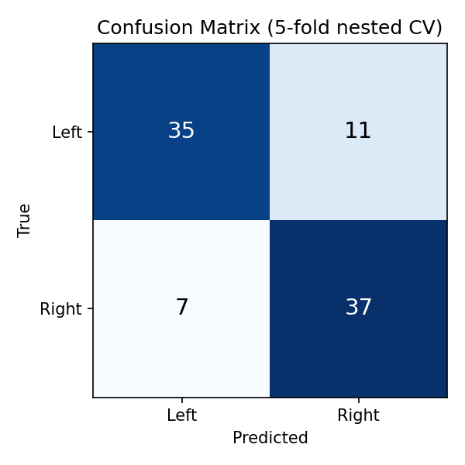
Figure 5 — Confusion matrix (nested CV). 35 true Left correctly classified, 37 true Right correctly classified.

5.2 ROC curve
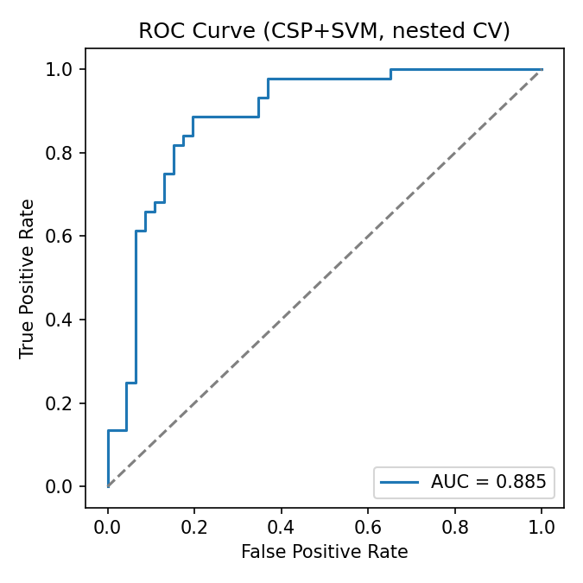
Figure 6 — ROC curve, AUC = 0.885.

6. Conclusion
The CSP+SVM baseline reaches 80% accuracy (balanced accuracy 80%, AUC 0.89) on this single-subject, 90-trial Left/Right hand motor-imagery dataset using nested cross-validation — well above the 50% chance level, and consistent with the mu/beta ERD pattern observed over C3/C4 in the EDA. This confirms the project roadmap's expectation: a clean CSP+SVM baseline is a solid, interpretable starting point.
As requested, this report stops at the CSP+SVM baseline and its evaluation. Deep-learning comparison (EEGNet/CNN) and deployment (Streamlit/Flask demo) were intentionally left out of scope for this stage.
Caveats: results come from a single subject and a modest number of trials (90), so cross-subject generalization is untested and fold-to-fold variance is non-trivial. Scaling to more subjects/trials would let the evaluation move to subject-independent (leave-subject-out) validation, which is the more realistic test for a deployable BCI.

