BCI Motor Imagery Classification
A CSP + SVM Pipeline for Left- vs. Right-Hand EEG Decoding
Technical Report | Notebook: Awad_SVM.ipynb | Dataset: eeg_hands_df.csv

1. Overview
This notebook implements a complete, DataFrame-based pipeline for classifying single-trial EEG signals into left-hand versus right-hand motor imagery. The scope covers five stages: signal processing, exploratory data analysis (EDA), Common Spatial Pattern (CSP) feature extraction, Support Vector Machine (SVM) modeling, and rigorous nested cross-validation evaluation. A distinguishing design choice is that the data is kept in pandas DataFrames end-to-end, rather than converting early to raw NumPy arrays: a long-format DataFrame holds every processing stage, and a trial-level DataFrame stores one per-trial (time × channel) DataFrame per row, so scikit-learn's cross-validation splitters can index trials directly.
The trained model (a scikit-learn Pipeline chaining CSP → StandardScaler → SVC) is fit on the full dataset using the hyperparameters selected by grid search, and is saved to disk as a pickle file so it can be reloaded and reused without repeating the training process.

2. Dataset
The input is eeg_hands_df.csv, a long-format table with one row per (trial, time-sample) pair. Each row records 21 EEG channel voltages plus trial_id, time, run, subject, and label (“Left Hand” / “Right Hand”).
Property | Value
EEG channels | 21 (fronto-central & centro-parietal montage, e.g. C3, C4, Cz, Fc*, Cp*)
Sampling rate | 160 Hz (derived from the 0.00625 s time step)
Samples per trial | 641
Trials after cleaning | 87 (44 Left Hand, 43 Right Hand)
Trials removed (std-dev outlier filter) | 3 of 90
Trials removed (peak-to-peak artifact filter) | 0 (none exceeded 3× the 99th-percentile threshold)

3. Signal Processing Pipeline
Each stage below operates on the full long-format DataFrame and hands off to the next stage, so every intermediate signal is inspectable as a normal pandas table:
- Load & sort — read the CSV, sort by trial_id then time.
- Outlier-trial filter — compute each trial's overall signal standard deviation, z-score it across trials, and drop trials with |z| ≥ 2.5 (removed 3 of 90 trials).
- Artifact rejection — compute peak-to-peak amplitude per trial/channel; reject any trial whose max peak-to-peak exceeds 3× the 99th-percentile threshold across trials (none were rejected here).
- Band-pass filter (0.5–40 Hz) — zero-phase (filtfilt) 4th-order Butterworth, applied per trial per channel, to remove drift and high-frequency noise.
- Common Average Reference (CAR) — subtract the across-channel mean at each time sample, reducing common noise shared by all electrodes.
- Baseline correction — center each trial/channel on its own temporal mean (no separate pre-stimulus window exists in this dataset, so whole-trial centering is used instead).
- Mu/Beta band isolation (8–30 Hz) — a second band-pass restricts the signal to the sensorimotor rhythm band that CSP will operate on; this is the feature-ready signal.
A notch filter for line noise was deliberately skipped: this PhysioNet-style dataset shows no dominant 50/60 Hz component inside the 0.5–40 Hz band of interest, so a generic notch would only risk distorting the band without evidence of contamination.
Finally, the long-format DataFrame is reshaped into a trial-level DataFrame: one row per trial, with a data column whose cells are themselves (time × channel) DataFrames. This trial-level table is built three times — for the raw signal, the broadband CAR-referenced signal (used for EDA/PSD), and the mu/beta-filtered signal (used for CSP features).

4. Exploratory Data Analysis
4.1 Class balance. The cleaned dataset is close to balanced: 44 Left Hand vs. 43 Right Hand trials, which avoids the need for class-weighting or resampling.
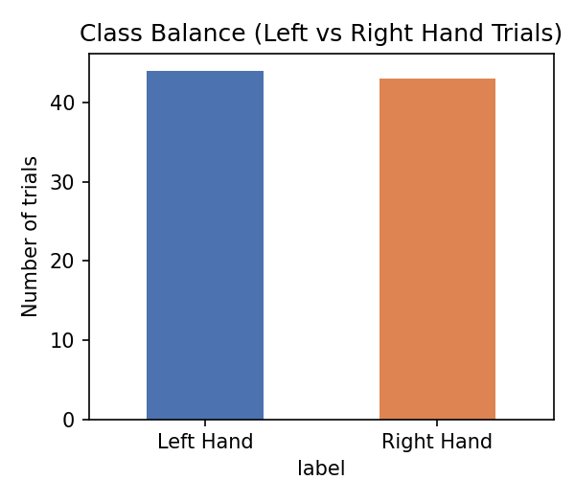
Figure 1. Trial counts by class after cleaning.
4.2 Time-domain traces. Example single trials show the expected effect of the 8–30 Hz mu/beta filter: the raw C3/C4 traces are dominated by low-frequency drift and broadband noise, while the filtered traces isolate the oscillatory sensorimotor rhythm that carries the class-discriminative information CSP will exploit.
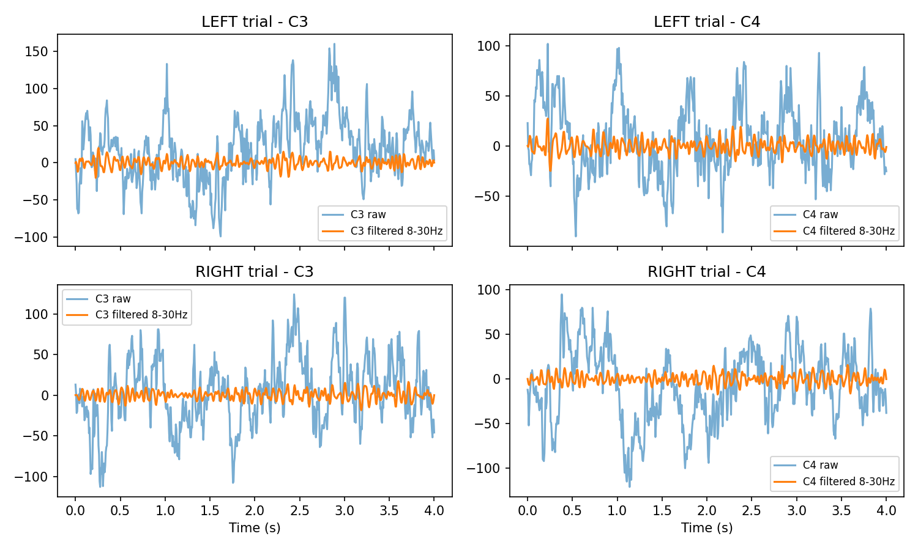
Figure 2. C3 and C4 raw vs. 8–30 Hz-filtered traces for one Left-Hand and one Right-Hand trial.
4.3 Power spectral density. Welch PSDs averaged across trials, for channels C3 and C4, show the mu (8–12 Hz) and beta (13–30 Hz) bands shaded. Motor imagery is expected to produce event-related desynchronization (a power decrease) over the contralateral sensorimotor cortex — i.e., right-hand imagery should reduce mu/beta power more over left-hemisphere channel C3, and vice-versa for C4.
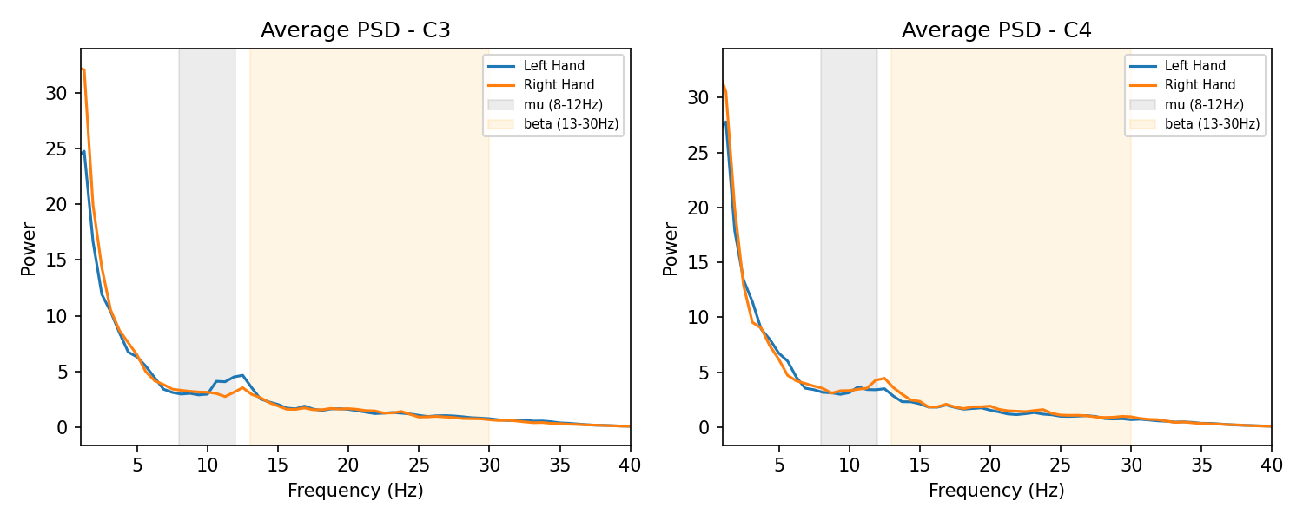
Figure 3. Average PSD for Left- vs. Right-Hand trials, channels C3 and C4.
4.4 Band power per channel. Mu and beta band power were integrated per trial/channel via Welch PSDs and averaged by class. The largest left- vs. right-hand differences appear over the central channels nearest C3/C4, consistent with the contralateral organization of the motor cortex, though the effect is modest at the single-channel level — which is exactly why a spatial-filtering method like CSP (which combines information across all 21 channels) outperforms any single electrode.
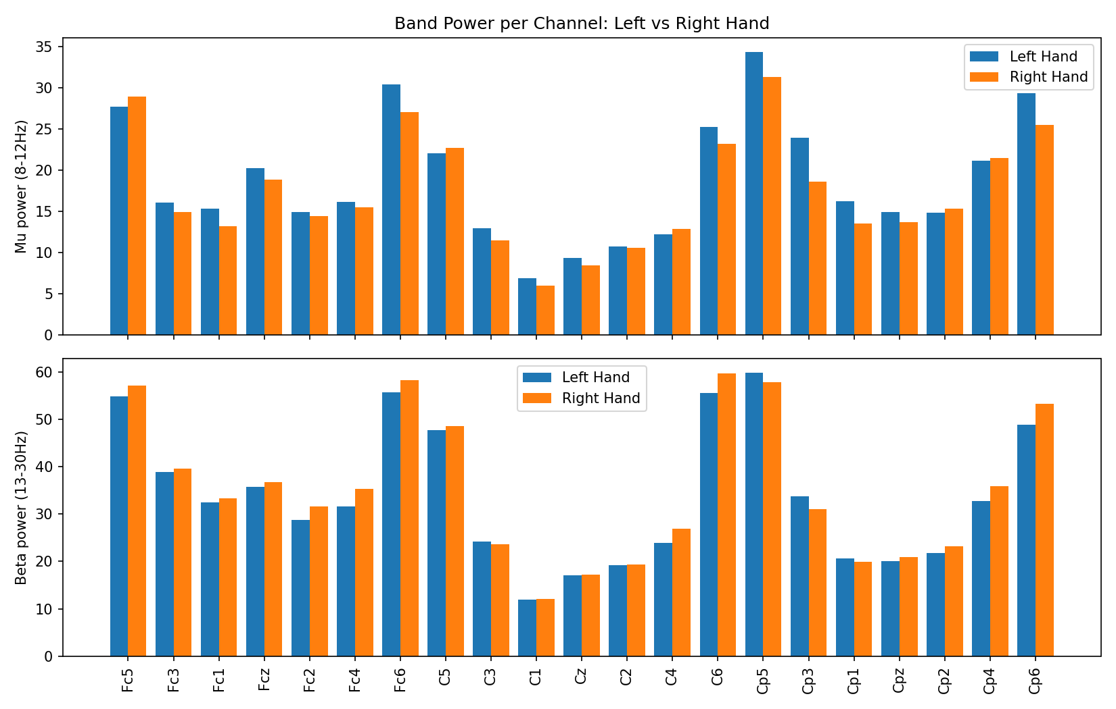
Figure 4. Mean mu- and beta-band power by channel and class.

5. Modeling: CSP + SVM

5.1 Common Spatial Patterns (CSP)
CSP is implemented as a custom scikit-learn-compatible transformer (BaseEstimator, TransformerMixin) so it can sit inside a Pipeline and be cross-validated like any other step. For each class, it averages the regularized, trace-normalized spatial covariance matrix across that class's trials, then solves a generalized eigenvalue problem between the two class-averaged covariances. The eigenvectors with the most extreme eigenvalues define spatial filters that maximize the variance ratio between the two classes when the multichannel signal is projected through them. The transform step projects each trial through these filters, takes the log-variance of each projected component, and returns a small feature vector (csp_1 … csp_n) per trial — collapsing a 641-sample × 21-channel trial into just a handful of highly discriminative numbers.

5.2 SVM Classifier & Pipeline
The CSP features feed into a StandardScaler and then a Support Vector Classifier (SVC) with probability estimates enabled, so the pipeline can output both class predictions and calibrated class probabilities (used for the ROC/AUC analysis below).

5.3 Hyperparameter Search & Nested Cross-Validation
Hyperparameters were tuned with GridSearchCV over the grid below, and performance was estimated with nested cross-validation — an outer 5-fold stratified split provides an unbiased performance estimate, while an inner 3-fold stratified split (run independently within each outer training fold) selects hyperparameters. This nesting prevents the optimistic bias that comes from tuning and evaluating on the same folds.
- csp__n_components: 4, 6, 8
- svm__C: 0.1, 1, 10, 100
- svm__gamma: scale, auto
- svm__kernel: rbf, linear
A final pipeline is also fit on the entire dataset (all 87 trials) purely to obtain a single best-parameter pipeline for inspection and for downstream use (e.g., the pickled model) — this full-data fit is not used to compute any of the reported evaluation metrics, which come exclusively from the nested cross-validation predictions.

6. Evaluation Results
Metrics below are computed from the nested cross-validation predictions on all 87 trials (i.e., every trial was predicted only by a model that never saw it during training or hyperparameter selection).
Metric | Value
Accuracy | 87.4%
Balanced accuracy | 87.3%
F1 score | 0.871
ROC AUC | 0.938
Best parameters (full-data fit) | n_components=4, C=0.1, gamma=scale, kernel=rbf
Outer-fold accuracy (mean ± std) | 87.3% ± 2.5%

Per-fold outer accuracies were 88.9%, 88.9%, 88.2%, 88.2%, and 82.4% — a tight spread (std ≈ 2.5 points) indicating the model's performance is stable across different train/test splits rather than driven by a single lucky fold.
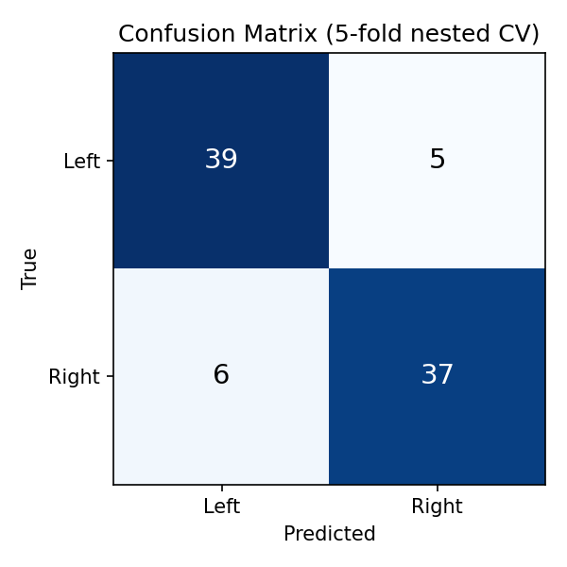
Figure 5. Confusion matrix (5-fold nested CV).
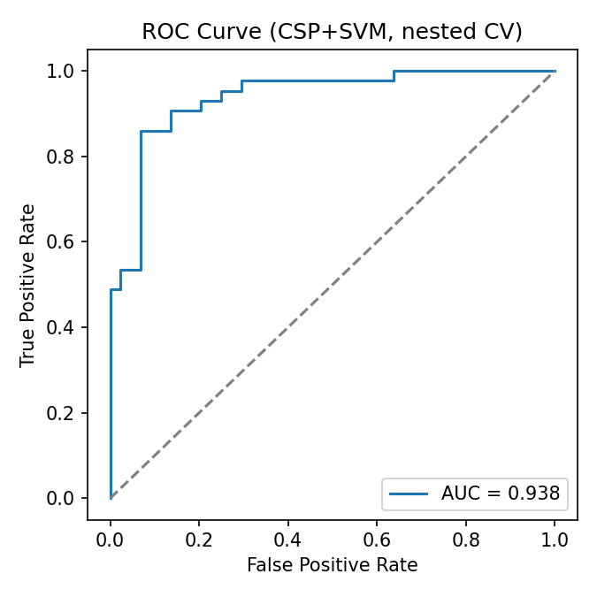
Figure 6. ROC curve, AUC = 0.938.
Precision and recall are balanced across both classes (Left Hand: precision 0.87 / recall 0.89; Right Hand: precision 0.88 / recall 0.86), meaning the model is not biased toward predicting one hand over the other — consistent with the near-even class distribution.

7. Model Persistence
The final cell of the notebook pickles the best full-data pipeline (grid.best_estimator_ — the fitted CSP transformer, StandardScaler, and SVC bundled together) to csp_svm_model.pkl. Because CSP, scaling, and classification are bundled into one scikit-learn Pipeline object, reloading the pickle and calling .predict() on new trial DataFrames reproduces the entire feature-extraction-plus-classification process with a single call — no need to separately reload CSP filters or scaler statistics.
A short sanity check after saving reloads the pickle and confirms it produces predictions on a few held-out trial DataFrames, verifying the artifact is valid and self-contained before the notebook finishes.

8. Limitations & Notes
- Sample size is modest (87 trials from what appears to be one subject/session), so the reported accuracy should be read as a solid proof-of-concept rather than a clinically validated result.
- The 5-fold nested CV gives an honest estimate of generalization to unseen trials from the same recording session, but does not test generalization across sessions or subjects.
- CSP with only two classes assumes the standard binary formulation; extending to more motor-imagery classes (e.g., feet, tongue) would require a one-vs-rest CSP+SVM ensemble or multiclass CSP variant.
- No notch filter was applied; this is appropriate for the observed spectrum but should be revisited if the pipeline is ever pointed at a new dataset with mains-frequency contamination.

