**The University of Jordan**

|  |
| --- |
| **School of Engineering**  **Department of Computer Engineering** |

|  |
| --- |
| **Finite State Machine Compiler** |

|  |  |  |  |
| --- | --- | --- | --- |
|  |  |  | *Supervisor:* |
|  |  |  | Dr. Fahed jubair |
| *Author(s):* |  |  |  |
| Ammar Abu Yaman | | 0186436 |  |
| Firas Al-Najjar | | 0186435 |  |

**May 25th, 2021**

|  |
| --- |
| Submitted in partial fulfillment of the requirements of B.Sc. Degree in Computer Engineering |

**This page is intentionally left blank**

# **ETHICAL STATEMENT**

We, the undersigned students, certify and confirm that the work submitted in this project report is entirely our own and has not been copied from any other source. Any material that has been used from other sources has been properly cited and acknowledged in the report.

We are fully aware that any copying or improper citation of references / sources used in this report will be considered plagiarism, which is a clear violation of the Code of Ethics of the University of Jordan.

We further certify and confirm that we had no external help without the approval of our supervisor and proper acknowledgment when it is due. We certify and affirm that we never at any point commissioned a 3rd. party to do the work or any part of it on our behalf regardless of the amount charged or lack thereof. We also acknowledge that if suspected and thereafter proven that we commissioned a 3rd. party to do any part of this project that we risk failing the entire project.

We certify and confirm that all results presented in this project are true with no manipulation of data or fraud, that any statistics done, or surveys collected are conducted with the highest degree of scientific fidelity and integrity, and that if proven otherwise, we risk failing the entire project. We acknowledge that for any data collected, we have taken all the steps necessary in applying for proper authorizations if deemed necessary, and that all user data collected is subject to the utmost degrees of privacy and anonymity.

|  |  |
| --- | --- |
| Ammar Abu Yaman: | Firas Al-Najjar: |
| Replace date here: | Replace date here |
| Signature: | Signature: |

**This page is intentionally left blank**

# **SUPERVISOR CERTIFICATION**

|  |  |
| --- | --- |
| I hereby certify that the students in this project have **successfully finished** their senior year project and by submitting this report they have fulfilled in partial the requirements of B.Sc. Degree in Computer Engineering. |  |
| I hereby certify that the students in this project have not completed their senior year graduation project and **I do not approve** that they proceed to the discussion. |  |
| I suspect that the students have **violated** one or more of the clauses in the **ethical statement** and I suggest that an investigation committee look into the matter. |  |

|  |
| --- |
| Prof. / Dr. / Eng. |
|  |
| Signature: |

**This page is intentionally left blank**

# **DEDICATION**

This is where you should thank people if you wish. Make it short – no more than two short paragraphs. You may also call this part Acknowledgements if you desire.

# **SYMBOLS, ABBREVIATIONS, AND ACRONYMS**

This is where you should put all the symbols used and abbreviations (**must be sorted in ascending order**). It is stored in a table format same as the table of contents. Use “inserts a row” to add more entries. Remove this paragraph once done!

|  |  |
| --- | --- |
| FSM | Finite State Machine |
|  |  |
|  |  |
|  |  |
|  |  |
|  |  |

# **ABSTRACT**

In Software Projects Finite State Machines are used to model and design Algorithms and Application behavior, Hardware digital systems protocols … etc., they have proven their usefulness in many aspects of software design and unfortunately they are usually are only used in the design phase.

In practice FSMs are only used as a reference for implementation and the implementation can look very different to It’s counterpart where the program logic is scattered around the codebase in many conditional branches and little objects encapsulating different parts of the state and it’s often quite disorganized and the conceptual simplicity of the design’s FSM is often lost. to counter these issues design patterns such as the State design pattern can be employed to help translate the design directly into code with entities such as state classes and transition functions that help better capture the design in code in an organized manner, however these patterns usually involve large amount of boiler plate code and are tedious to implement and have to be changed constantly every time a new state or transition is added to the FSM.

Our solution to this problem is to create a visual tool that can be used to design the software and model it using FSM and then the tool transforms the design directly into code using the State design pattern and automatically generate state classes, transitions and actions and automatically regenerate the code to accommodate changes in the design without needing manual rewrites and updates.

**Table of Contents**

**ETHICAL STATEMENT** III

**SUPERVISOR CERTIFICATION** V

**DEDICATION** VII

**SYMBOLS, ABBREVIATIONS, AND ACRONYMS** VIII

**ABSTRACT** IX

**LIST OF FIGURES** XI

**CHAPTER 1 INTRODUCTION** 1

**1.1.** **Problem Definition** 1

**1.2.** **Proposed Solution** 1

**1.3.** **Project Deliverables** 1

**1.4.** **Project Impact** 1

**1.5.** **Report guide** 1

**1.5.1.** **Text Style and Size** 1

**1.5.2.** **Tables** 2

**1.5.3.** **Figures** 2

**1.5.4.** **Numbers, Acronyms, and Latin Words** 4

**1.5.5. Equations** 5

**1.5.6 Algorithms or Pseudocodes** 5

**CHAPTER 2 RELATED WORK** 6

**CHAPTER 3 SOLUTION DESCRIPTION AND IMPLEMENTATION** 7

**CHAPTER 4 RESULTS AND DISCUSSION** 8

**4.1.** **Subsection** 8

**4.1.1. Some Text Here** 8

**CHAPTER 5 CONCLUSIONS AND FUTURE WORK** 9

**5.1** **Conclusions** 9

**5.2** **Future Work** 9

# **LIST OF FIGURES**

Figure 1 - Keil RTOS Scheduling 3

Figure 2 - Example of Having Subfigures 3

Figure 3 - Example Graph with Proper Graph Elements 4

**LIST OF TABLES**

Table 1 - Project Report Element Styles 14

**This page is intentionally left blank**

# **CHAPTER 1 INTRODUCTION**

The introduction states the problem and its significance, states the technical goals of the work, and usually contains background information that the reader needs to know in order to understand the report. Consider, as you begin your introduction, who your readers are and what background knowledge they have. For example, the information needed by someone educated in medicine could be very different from someone working in your own field of engineering.

The introduction is expected to have the following sections (you may combine or add more sections if needed). You may also change the titles of the sections. Note that for section heading you should use “Heading2”

## **Problem Definition**

State problems that gave rise to the investigation. Also, if needed, provide any background information that the reader needs to know to understand the problem.

## **Proposed Solution**

State a high-level description (a brief summary) of your solution/system. You may change the title of this section, if appropriate.

## **Project Deliverables**

State the final deliverables of the project. Each deliverable must be measurable or testable.

## **Project Impact**

State the impact of solving the project problem in a global, economic, environmental, and societal context.

## **Report Guide**

In this subsection, we will provide details on how to format your report properly per the requirements of the department of computer engineering.

### **Text Style and Size**

You must use the font “Times New Roman” throughout your report document. You must use size 12 for the paragraphs’ text in this report. You must use the proper heading style for the chapter, section, and subsection titles. Chapter titles must use the “Heading 1” style with size 20. The section headings must use the “Heading 2” style with size 14. For subsection heading you should use “Heading 3”. For the caption of the figures and tables you should use the “Caption” style. The caption of Figure 1 is formatted using the “Caption” style. Table 1 lists the style for the sections/subsections and captions. You have to follow these styles in your final documentation.

Table 1 - Project Report Element Styles

|  |  |
| --- | --- |
| **Element** | **Style** |
| Chapter Title | Heading 1 – Size 20, bold, centered |
| Section | Heading 2 – Size 14, bold, left justified |
| Subsection | Heading 3 – Size 13, bold, left justified |
| Caption | Caption – Size 10 or 11, but be consistent, centered |
| List with bullets | List paragraph |
| Normal text | Size 12, full justification |

Your final report must use 1.15 line spacing. This saves space, therefore paper and is better for the environment. You supervisor might ask you to increase it in the draft to give them space to write their comments, but do not forget to switch back to a line spacing of 1.15 before your final submission.

Do not leave lots of empty spaces between paragraphs. Try to justify your text to make it look beautiful and professional, and do not forget that your pages must be numbered. Always write in short sentences. Unlike Arabic, in English, we write short successive sentences that end with periods. If your sentence is more than two to two and half lines, break it!

### **Tables**

You must reference each table in your text. That is; you must not place a table without mentioning them, describing them, or providing some information about what they are supposed to present. This sentence for example references Table 1. You simply write the complete word “Table” followed by the table name. Table numbers must be sequential throughout your report. Every table must have a caption. The caption text must be smaller than the text size (*e.g.,* size 11). The caption must briefly inform the user what the table is about. The caption must always be **centered above** the table. The table itself must also be **centered**. Do not place a caption at the end of the page, and have the table placed at the start of another page.

### **Figures**

You must reference each figure in your text. That is; you must not place figures without mentioning them, describing them or providing some information about what they are supposed to illustrate. This sentence for example references Fig. 1. You simply write the shortened form of figure “Fig.” followed by a dot then the figure name. Figure numbers must be sequential throughout your report. Every figure must have a caption. The caption text must be smaller than the text size (*e.g.,* 11). The caption must briefly inform the user what the figure is about. The caption must always be **centered underneath** the figure. The figure itself must also be **centered**. Do not place a figure at the end of the page and have its caption at the start of another page.

Your figures must be clear (high resolution) and placed in the page in a beautiful manner. You must not have pages with one small figure and lots of empty space around. At the same time, do not cram lots of figures in one page. Depending on your case and project type, you can place 4 to at most 6 figures in one page. You might in some cases treat these figures as subfigures if they contain similar information, so you give them on figure caption, and have each subfigure named as (a), (b), *etc*. Fig. 2 illustrates an example combining similar figures in one main figure. If the figure does not add value to the text, refrain from using it altogether. If you want to reference a subfigure, use Fig. 2(a) format.

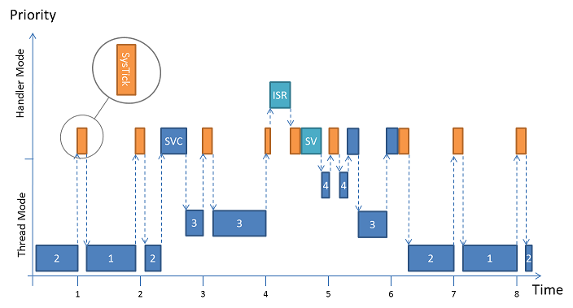

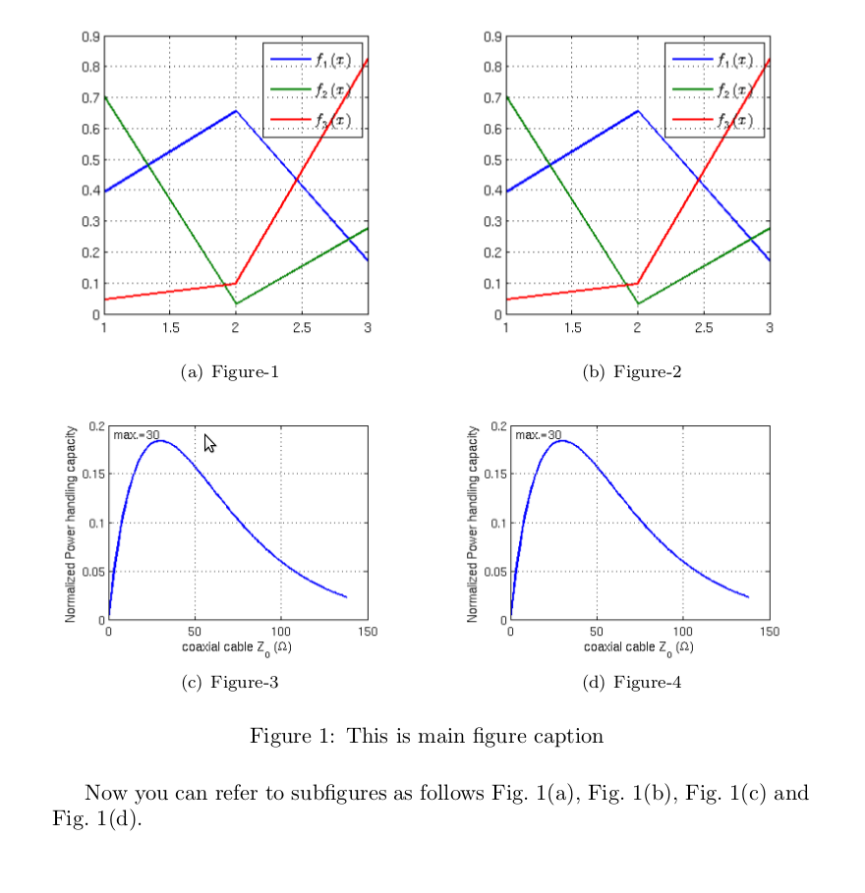Figure 1 - Keil RTOS Scheduling

Figure 2 - Example of Having Subfigures

You must be consistent in writing your captions. If you choose to capitalize only the first word, then all your captions must follow this style. If you choose to capitalize every single word, then be consistent throughout your report. The articles (a, an, the, and) or prepositions (on, in, at, over, *etc*. must not be capitalized).

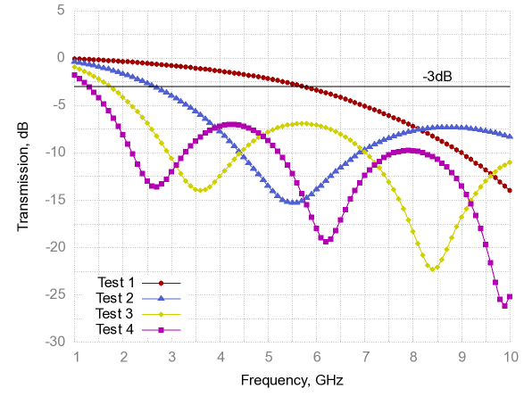If your figures represent experimental data, then you must have labels for the x-axis and y-axis clearly showing what you are representing and the units. You must use different colors to differentiate between the different lines/bars, *etc*. Use legends if necessary, to help the reader understand your graph, but this does not mean you do not fully explain them in text! You can generate beautiful plots in MATLAB, Python, or Excel. Fig. 3 shows a beautiful example on how to properly present scientific graphs.

Figure 3 - Example Graph with Proper Graph Elements

### **Numbers, Acronyms, and Latin Words**

All numbers below ten must always be written as words not numbers. For example, this sentence which contains 1 is wrong. The correct way to write it is to say this sentence has one example. You can write the numbers from 10 to 19 in number form or in words, but all other numbers must be formatted as numbers, say we have collected 1523 samples.

Latin acronyms, abbreviations, or words must be in italic (*e.g.*, *i.e., etc., et. al.*). There is a difference between “*e.g.*” and “*i.e.*”; *e.g.* stands for *exempli gratia* and means “for example.” while *i.e.* is the abbreviation for *id est* and means “in other words.” They are used mid-sentence and must be lower case. In general, you add a comma after *e.g.* and between each subsequent example if there is more than one item in your list. Look at these two examples:

* “I like citrus fruits, *i.e.*, the juicy, edible fruits with leathery, aromatic rinds.”
* “I like citrus fruits, *e.g.*, tangerines, lemons, and limes.”

In the first case, we are not giving examples for citrus fruits but rather describing them in other words. In the second example, we are listing examples of citrus fruits.

Many times, we encounter technical terms that have common acronyms, such as long-short term memory (LSTM) cells that are a type of recurrent neural networks (RNN) in the domain of artificial intelligence (AI). You must write the acronym the first time you encounter it in your report, add it to the abbreviations and acronyms list, then you can refer to these terms by their acronym only.

### **1.5.5. Equations**

Every equation must be referenced in your text as close as possible as to where it is written. All equations must be numbered. For example, Eq. 1 that describes the relativity equation of Einstein should be written as:

$E=mc^{2}$ (1)

Where *E* is the energy (in Joules), *m* is the mass (in Kg), and *c* is the speed of light (in m/s)

Notice that the equation itself is left-justified while the equation number in parenthesis is to the rightmost part of the line. Note also that we should not leave the equations ambiguous, if not explained before, you must explain or specify the equation variables and their units, and if they take any initial conditions.

Your equation numbers must be sequential throughout your report (1), (2), (3), *etc*. or can be written per chapter (3.1), (3.2), (3.3), *etc.* In any case, be consistent in your choice throughout your report.

### **1.5.6 Algorithms or Pseudocodes**

You must explain the algorithm in your text and not only list it in an Algorithm listing. Do not assume that the reader will understand your algorithm or pseudocode on their own. It is better to explain your algorithm sequentially while referring to the line numbers that implement the functionality you are explaining. You reference your algorithm by saying Algorithm 1 presents a sample algorithmic listing. You must number your algorithms or pseudocode listing sequentially throughout your report.

At the beginning of each algorithm, you must clearly list and explain the inputs and outputs of your code. If prior preprocessing is needed, also provide it in the “Pre” part. You must number the lines that correspond to functional statements.

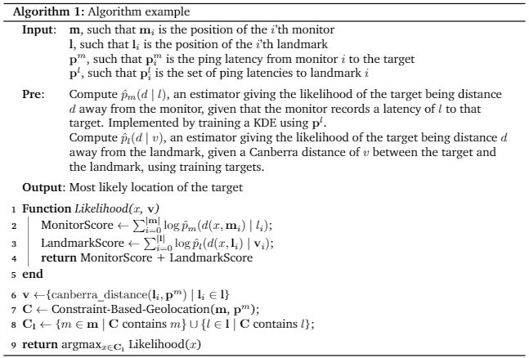

# **CHAPTER 2 RELATED WORK**

This chapter gives the theory or previous work on which the experimental work is based on. Here you give more details about previous products, projects, or similar research publications. Make sure to cite your sources of information and list the references at the end of your report. This is an example of a book citation [1], a web page citation [2], a conference paper citation [3], and a journal article [4]. Your references must not be after the period (this is wrong. [5]).

Your citations must follow the IEEE format. **Zotero** is a beautiful plugin used widely in academia to facilitate keeping track of references and easily adding them to your documents (*e.g.* Word, Latex, *etc*.).

# **CHAPTER 3 SOLUTION DESCRIPTION AND IMPLEMENTATION**

This chapter describes the technical details of the major pieces of your proposed solution (*e.g.*, hardware part, software part, *etc*.) and recaps the essential steps of what was done. You may expand this chapter into multiple chapters if appropriate. Also, change the title of each chapter, as appropriate.

General guidelines for this chapter:

* Provide sound and correct description of your solution;
* Include helpful block diagrams and charts;
* Include functional and non-functional requirements.

# **CHAPTER 4 RESULTS AND DISCUSSION**

This chapter presents the results or the final deliverables of the project and includes tables and/or graphs and an interpretation of what the results show. When discussing your results, be sure to explain what the results show, analyse uncertainties, note significant trends, compare results with theory and describe limitations and assumptions.

## **Subsection**

### **4.1.1. Some Text Here**

# **CHAPTER 5 CONCLUSIONS AND FUTURE WORK**

## **Conclusions**

This section summarizes the achieved project deliverables and the important results in your work. Be sure to spend some time thinking carefully about your conclusions. Be sure to also consider how your conclusions will be received by your readers.

## **Future Work**

This section includes the recommendations that you think must be taken in order to improve your solution. These directions may include expanding existing components of your system or completely adding new knowledge. Note that at this point in your report you are asking the reader to think or do something about the information you have presented. In order to achieve your purposes and have your reader do what you want, consider how they will react to your recommendations and phrase your words in a way to best achieve your purposes.

**REFERENCES**

|  |  |
| --- | --- |
| [1] | D. Patterson and J. Hennessy, Computer Architecture: A Quantitative Approach, 5th edition, Morgan Kaufman, 2011. |
| [2] | Wikipedia, "Fast Fourier Transform," [Online]. Available: https://en.wikipedia.org/wiki/Fast_Fourier_transform.. [Accessed September 2019]. |
| [3] | V. Agarwal, F. Petrini, D. Pasetto and D. A. Bader, "Scalable Graph Exploration on Multicore Processors," in *ACM/IEEE International Conference for High Performance Computing, Networking, Storage and Analysis*, New Orleans, LA, USA, 2010. |
| [4] | G. D, "Chip makers turn to multicore processors," *Computer,* vol. VI, no. 5, pp. 11-13, 2005. |

**APPENDICES**

Appendices may include the following sections:

* **Project Time Chart (*e.g.*, Microsoft Project Gannt Chart)**
* Raw Data (if applicable)
* Long Mathematical proofs (if applicable)
* Source Code (if applicable)
* Datasheets (if applicable)
* User Manual (if applicable)
* Presentation Slides (**mandatory**): must contain your presentation slide (two slides per page). However, this appendix is only required in the final documentation submitted to the department after students finish their project presentation.
* Project CD Soft Copy (**mandatory**):
  + CD submitted for examining committee members must contain a pdf version of your project documentation
  + CD submitted with the final documentation must contain pdf versions of your (i) project proposal; (ii) project 1 progress report; (iii) project documentation; and (iv) presentation slides.