
TuanTN
Home
05/12/2010

Easy
Tickets

Supervisor:Nguyen Xuan Doan
Curriculum: ACCP i7.1
Semester: 4 - HDSE
Batch Code: 0906E
Student : Tran Phan Quoc Hai
Nguyen Huu Sang
Pham Hong Tam
Nguyen Duc Viet





This is to certify that
Mr. Tran Phan Quoc Hai
has successfully designed and
developed
EasyTickets
Submitted by:

TRAN PHAN QUOC HAI
Date of Issue: 07/11/2011
Authorized Signature: ___________

This is to certify that
Mr. Nguyen Huu Sang
has successfully designed and
developed
EasyTickets
Submitted by:

NGUYEN HUU SANG
Date of Issue: 07/11/2011
Authorized Signature: ___________

This is to certify that
Mr. Pham Hong Tam
has successfully designed and
developed
EasyTickets
Submitted by:

PHAM HONG TAM
Date of Issue: 07/11/2011
Authorized Signature: ___________

This is to certify that
Mr. Nguyen Duc Viet
has successfully designed and
developed
EasyTickets
Submitted by:

NGUYEN DUC VIET
Date of Issue: 07/11/2011
Authorized Signature: ___________

TABLE OF CONTENT

Content Page
Introduction
1 . Problem Definition
2 . Customer Requirement Specification (CRS)
3 . Project Plan
4 . System Architecture
5 . Nonfunctional requirement specification
6 . Use Case
6.1. Customer
6.2. Administrator
7 . Flowchart
8 . Sequence Diagram
9 . E-R Diagram
10 . Data Flow Diagram (DFD)
11 . Class Diagram
12 . Table Design
13 . GUI Standard Document
14 . Site Map
15 . Interface Design Program
16 . Task Sheet
17 . Unit Testing Check List
18 . Final Check

INTRODUCTION
In today’s busy world, people find it hard to find the time for entertainment. It is really pretty time consuming to find out the various entertainment shows/movies and any other such shows in and around the city. And on the top of it is more irritating to go physically and book the ticket.
E-commerce can be thought as the best solution for this. Due to which the people can buy the tickets right from home. No more buying in black. Moreover one can find the information just with a click and get the booking done.
Showbiz is the company is principally into ticket sales, marketing and distribution of event tickets. The services include providing information on multiple event categories, providing ticketing facilities for several leading multiplexes, arenas and stadiums. They are thinking of the concept of developing a web portal, where a customer can book movie tickets in theatres that are made available in the site. They wish to launch the website by the name www.easytickets.com where they can provide convenient, secure, and fair access to the best possible tickets offered by the clients. Showbiz aims at making events happening across the city more accessible-just a click away. Booking tickets can now an effortless, fun and exciting experience for every showbiz customer.

1. PROJECT DEFINITION:
- Overview:
- Building a web portal, where a customer can book movie tickets in theatres that are made available in the site.
- The website by the name www.easytickets.com where it can provide convenient, secure, and fair access to the best possible tickets offered by the clients.
- In addition there are other kinds of tickets as Sport Event, Music, Drama.
- People shall use the system:
- Customer, who visits the site and book the ticket.
- Administrator, who manages the site.
- Book the ticket:
- Check the availability of tickets on mentioned date and time in specified city.
- View detail of ticket (venue, day/time, artist…).
- Book the tickets.
- The user selects a particular movie and show in a selected city, if there is availability of tickets for that show, then confirmation for ticket booking must be done. In case of non availability of tickets, the portal must display next available date & time.
- There is no cancellation of tickets once they are booked, at any cost. The provision for money transaction is provided in the same portal. This requires possession of a bank‘s credit or debit card with the customer.
- Online booking can be done only 15 days in advance.
- Difference:
- Customer can contact with Company about problems.
- Website can provide information of company(About us) and FAQ.

2. CUSTOMER REQUIREMENT SPECIFICATION/OVERVIEW
Name of the client: Showbiz Company
System Study:

  - List of inputs to the system
- Information of customer
- Contact information of customer
- The tickets are booked by customer

  - List of outputs expected from the system
- Ticket details
- Answer asks of customer
- FAQ Information.
- Email will send customer about contact

2.3. Overview of processes involved in the system
- Customer will register account, and login website
- After login, Customer book tickets, system will check its. If tickets are confirmed, system will store and notify customer.
- In case of non availability of tickets, must display next available date/time.
- Customer contact with company, website will send mail from administrator for customer
- Customer view FAQ, about us.

  - Data Constraints/Triggers/Validation tables.
- Account Information:
- Ebtablished date must to be greater than birthday of customer.
- Phone must to be integer number
- Person Card Number must to be integer number
- Ticket Information:
- Discount is less than price
- Ticket total must be greater than or equal to 0.
- Price is greater than 0
- Ebtablished data must to be less than or equal to view date.
- When I delete it, trigger will update Client’s Booking

- Booking
- Discount < Price Total
- If user books the ticket, program will update ticket number
- Delivery status is equal to Yes or No (Integer value is 1 or 0)
- Ticket total must be greater than 0
- Price total must be greater than 0
- Online booking can be done only 15 days in advance.

  - Hardware and software required for implementing the project
Hardware | Software
- A minimum computer system that will help you access all the tools in the courses is a Pentium 166 or better  - 128 Megabytes of RAM or better | - Java Virtual Machine/ J2EE server.  - Notepad/Java editor (Netbeen 6.8).  - j2sdk1.4.1_02 (or later).  - EJB Dev Kit .  - Java enabled web server.  - JSP / Servlets Dev. Kit .  - Subversion.

3. PROJECT PLAN
3.1. Project Details
- Customer: Showbiz Company
- Date of the Project Plan: 07-09-2011 (mm/dd/yyyy)
- The Project Purpose:
- The purpose of the project is to develop an intervention program using information technology as a means of providing information about ticket booking with a program offering home visits. The evaluation of the project will yield important for developing of Showbiz Company.
- The people can buy the tickets right from home. No more buying in black. Moreover one can find the information just with a click and get the booking done.
- The Project Scope:
- Define problem.
- Define deliverables.
- Define functionality and data.
- Define technical structure.
- Design and coding on module.
- Test and Review.
- Our Understanding Of The Client Organization:
Showbiz‘is the company is principally into ticket sales, marketing and distribution of event tickets.
- Team Member:
Name | Role | Responsibility
Pham Hong Tam | Team Leader | Manage group.
Nguyen Huu Sang | Developer | Coding and design document.
Tran Phan Quoc Hai | Developer | Coding
Nguyen Duc Viet | Tester | Test

3.2. Documents from Client
- Requirement (EasyTickets.doc file)
- Feadback form (eProject_Feeback_Form.exl file)
- Project status (eProject_Status_Report(V1).exl file)
- Project specification (ProjectSpecification.doc file)
3.3. Deliverables
- Installation Manual
- User Manual
- Document
- Application
3.4. Project Dependences
- Support from teacher.
- Good working environment.
- Members with good capacity.
3.5. Phase Of The Project
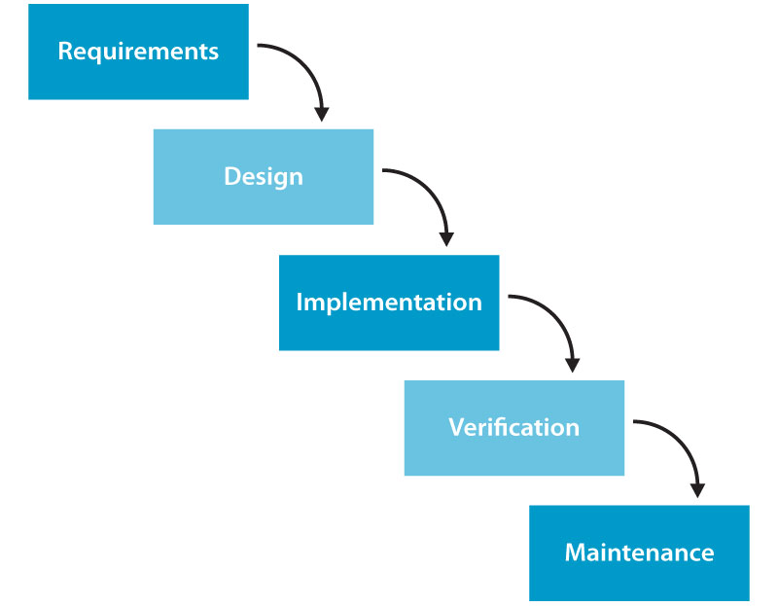

3.6. Quality Plan
- Review Activities (review meeting participants, and frequency).
- Testing Activities (Unit Test Plans, Integration Testing and Functionality Testing).
- Group will do something such as test links, test function every meeting.
- Backup and recovery strategies (in case of disk crash and network failures).
- After weekly, group will backup source code, database.

4. SYSTEM ARCHITECTURE:
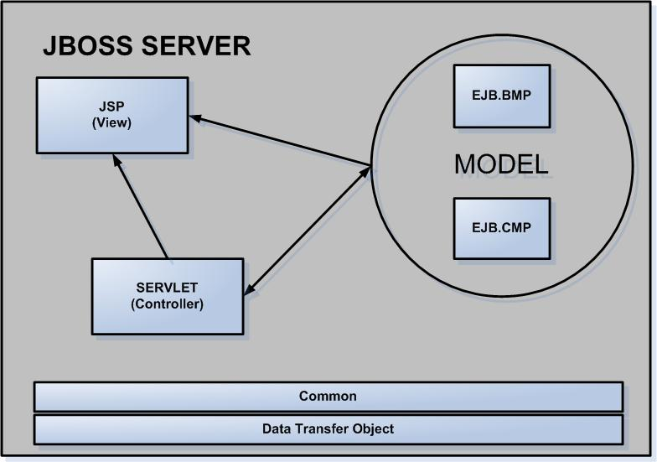

Benefits:
- Easier to build, maintain and extend
- Provide single point of control (Servlet) for security & logging
- Encasulate incoming data into a form usable by the backend
- Can reusable code

5. NON FUNCTIONAL REQUIREMENT SPECIFICATION:
- Evolution: Website uses some techniques such as JSP & Servlet, EJB... and it is always ready for upgrade, expanse the function and it also allow the administrator change the parameter and the configuration of the system easily.
- Friendliness: The website’ layout is clearly, friendly and easy to use with many kinds of user: user has the knowledge about information technology as well as user doesn’t have the knowledge about information technology.
- Safeness:
- The information in the system is only edited by authorized users.
- The personal information such as profile, advertisement and the property information is only edited by the member who is the owner of that information.
- Only the administrator or the authorized users have the suitable responsibility and authority can control, manage and update the information of system.

6.USECASE

6.1. Customer
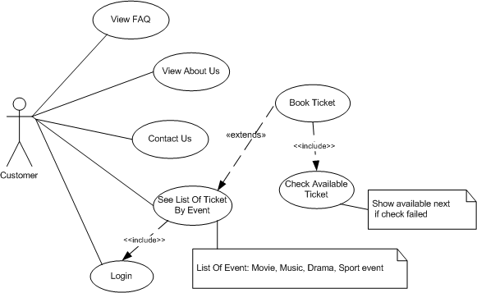

6.1.1.View FAQ
Use Case Name | View FAQ
Actors | Customer
Description | Customer want to see common question and answers.
Pre-conditions | N/A
Post-conditions
Basic Flow
Main Flow
Alternative Flow
Exception

6.1.2.View About Us
Use Case Name | View About Us
Actors | Customer
Description
Pre-conditions
Post-conditions
Basic Flow
Main Flow
Alternative Flow
Exception

6.1.3. Contact Us
Use Case Name | Contact Us
Actors | Customer
Description
Pre-conditions
Post-conditions
Basic Flow
Main Flow
Alternative Flow
Exception

6.1.4. Login
Use Case Name | Login
Actors | Customer
Description | Customer login to view ticket information and booking.
Pre-conditions | N/A
Post-conditions | Success: Customer logged in to website.  Fail: Login again.
Basic Flow | Actor Actions:  1. Actor goes to Home page of  website, then click login link.  3. Actor enters Username and  Password, then click the Login  button.  [Alternative 1] | System Responses:  2. System redirects to Login page  that has form with some control as:  - ‘Username’ text field.  - ‘Password’ text field.  - ‘Login’ button.  - ‘Cancel button.  4. System checks the information  [Exception 1]  5. System redirects to Actor’s  Home page.
Main Flow
Alternative Flow | Actor Actions:  1. Actor click ‘Back to Home’  button. | System Responses:  2. System returns to Home page.
Exception | Actor Actions:  1. Actor input invalid username and password. | System Responses:  - System redirects to Login page  again.  System shows a message: “Invalid  Username and password”.

6.1.5. See List Of Ticket By Event
Use Case Name | See List Of Ticket By Event.
Actors | Customer
Description | Customer want to see a list of tickets by event.
Pre-conditions
Post-conditions
Basic Flow
Main Flow
Alternative Flow
Exception

6.1.6. Book Ticket
Use Case Name | Book Ticket
Actors | Customer
Description | Customer want to book ticket.
Pre-conditions | Check available ticket and customer must login.
Post-conditions
Basic Flow
Main Flow
Alternative Flow
Exception

6.1.7. Check Available Ticket
Use Case Name | Check Available Ticket
Actors
Description
Pre-conditions
Post-conditions
Basic Flow
Main Flow
Alternative Flow
Exception

6.2. Admin
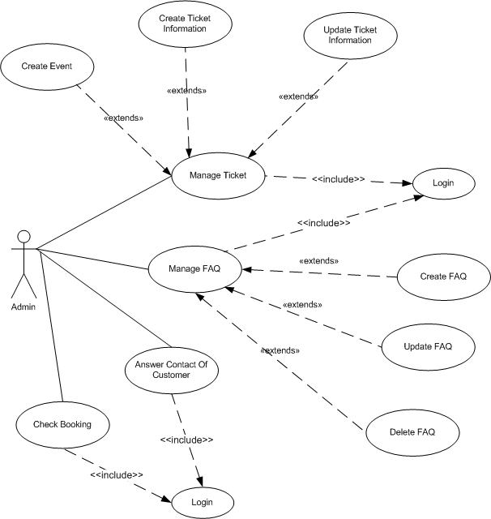

6.2.1. Check Booking
Use Case Name | Check Booking
Actors | Admin
Description | Admin update status of booking.
Pre-Conditions | Actor has logged in.
Post-conditions
Basic Flow
Main Flow
Alternative Flow
Exception

6.2.2. Manage Ticket
6.2.2.1. Create Ticket Information
Use Case Name | Create Ticket Information
Actors | Admin
Description | Admin wants to create a new ticket.
Pre-conditions | Actor has logged in.
Post-conditions | Success: Admin create a new ticket in this web site  Fail: Refill information.
Basic Flow
Main Flow
Alternative Flow
Exception

6.2.2.2. Update Ticket Information
Use Case Name | Update Ticket Information
Actors | Admin
Description | Admin to update the ticket.
Pre-conditions | Actor has logged in.
Post-conditions | Success: Admin update the ticket in the site  Fail: Refill information.
Basic Flow
Main Flow
Alternative Flow
Exception

6.2.2.3. Create Event
Use Case Name | Create Event
Actors | Admin
Description | Admin wants to create a event for ticket.
Pre-conditions | Actor has logged in.
Post-conditions
Basic Flow
Main Flow
Alternative Flow
Exception

6.2.3. Manage FAQ
6.2.3.1. Create FAQ
Use Case Name | Create FAQ
Actors | Admin
Description | Admin will answer or post questions available to.
Pre-conditions | Actor has logged in.
Post-conditions | Success: Admin create a new FAQ in this web site  Fail: Refill information.
Basic Flow
Main Flow
Alternative Flow
Exception

6.2.3.2. Update FAQ
Use Case Name | Update FAQ
Actors | Admin
Description | Admin will update the questions and answers.
Pre-conditions | Actor has logged in.
Post-conditions | Success: Admin update FAQ in this web site  Fail: Refill information.
Basic Flow
Main Flow
Alternative Flow
Exception

6.2.3.3. Delete FAQ
Use Case Name | Delete FAQ
Actors | Admin
Description | Admin will delete the questions and answers.
Pre-conditions | Actor has logged in.
Post-conditions | Success: Admin delete FAQ in this web site  Fail: Refill information.
Basic Flow
Main Flow
Alternative Flow
Exception

6.2.4. Answer Contact Of Customer
Use Case Name | Answer Contact Of Customer.
Actors | Admin
Description | Admin will answer questions from customers.
Pre-conditions | Actor has logged in.
Post-conditions | Admin will answer questions from customers.
Basic Flow
Main Flow
Alternative Flow
Exception

7. FLOWCHART DIAGRAM
7.1. Customer
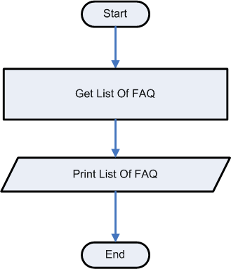
7.1.1. View FAQ

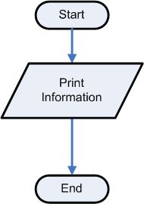
7.1.2. View About Us

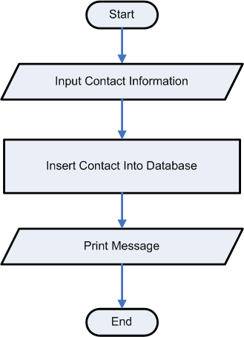
7.1.3. Contact Us

7.1.4. Login
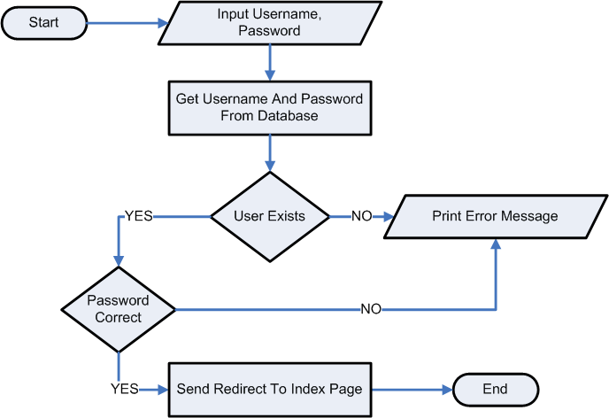

7.1.5. See List Of Ticket By Event

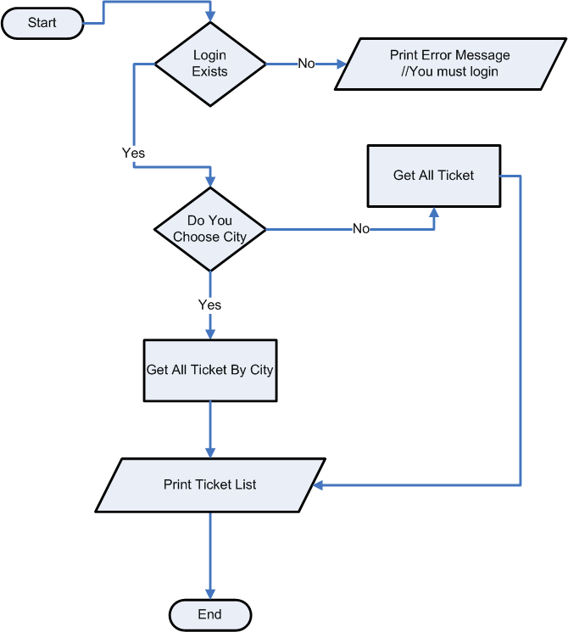

7.1.6. Book Ticket

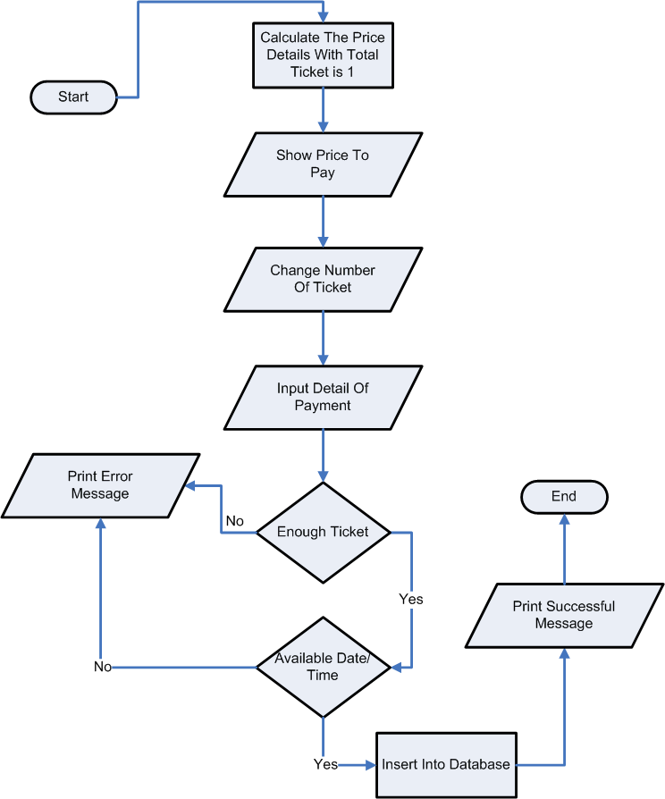

7.1.7. Check Available Ticket
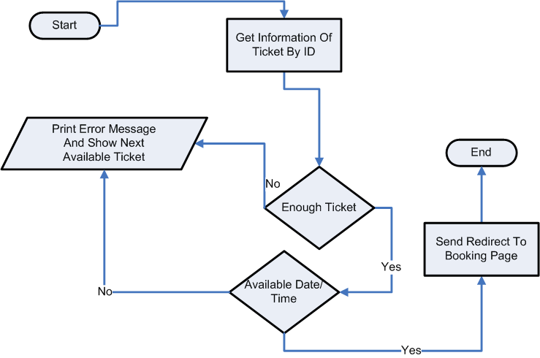

7.2. Admin
7.2.1. Check Booking
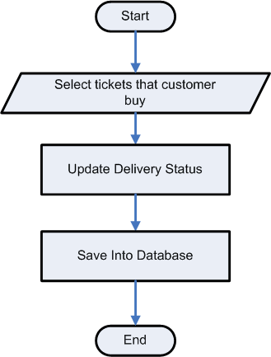

7.2.2. Manage Ticket
7.2.2.1. Create Ticket Information

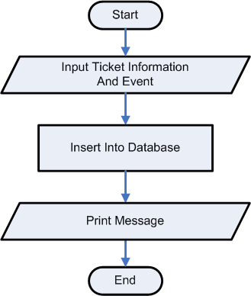

7.2.2.2. Update Ticket Information

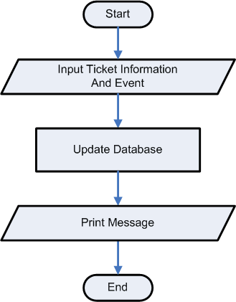

7.2.2.3. Create Event

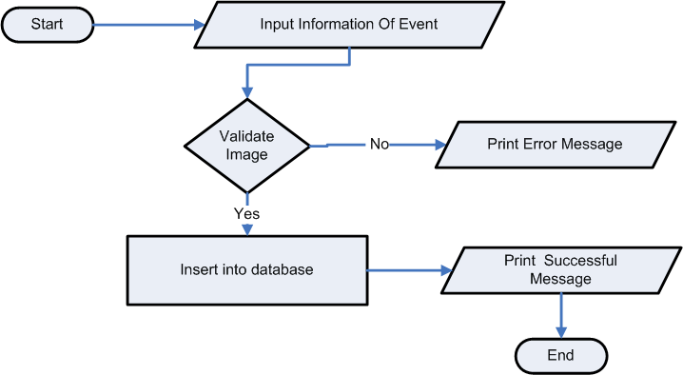

7.2.3. Manage FAQ
7.2.3.1. Create FAQ Information
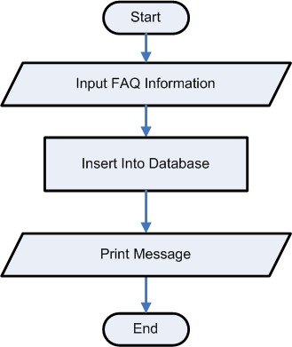

7.2.3.2. Update FAQ Information
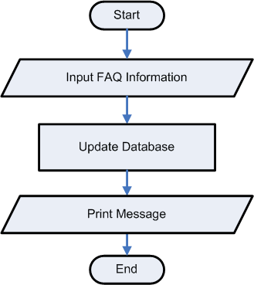

7.2.3.3. Delete FAQ Information
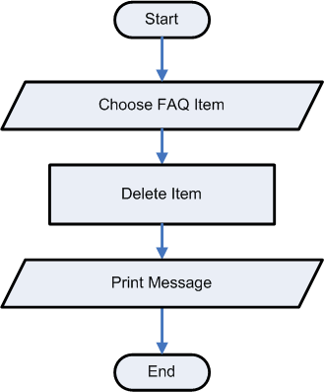

7.2.4. Answer Contact Of Customer

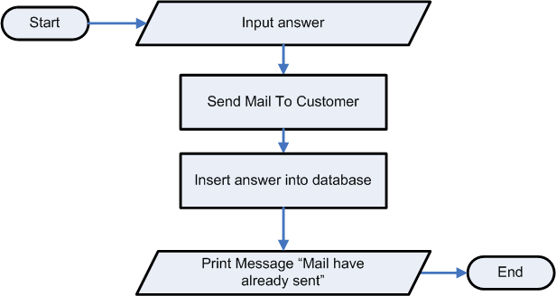

8. SEQUENCE DIAGRAM
8.1 Customer
8.1.1. View FAQ
8.1.2. View About Us
8.1.3. Contact Us

8.1.4. Login

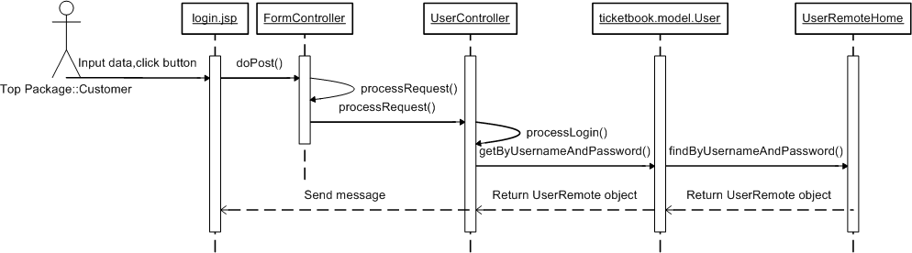

8.1.5. See List Of Ticket By Event

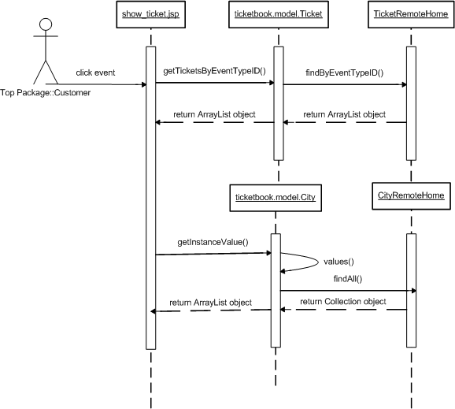

8.1.6. Book Ticket

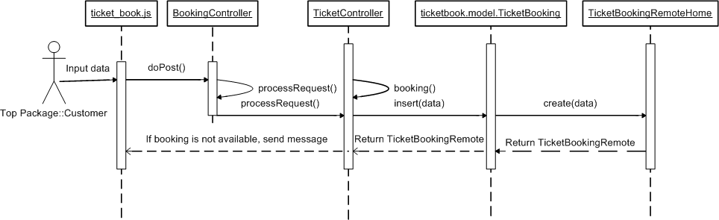

8.1.7. Check Available Ticket

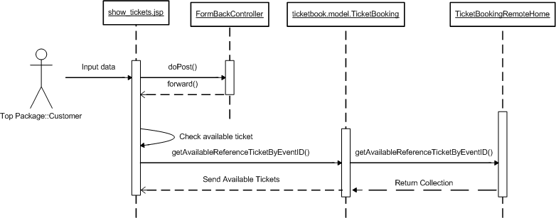

8.2. Admin
8.2.1. Check Booking
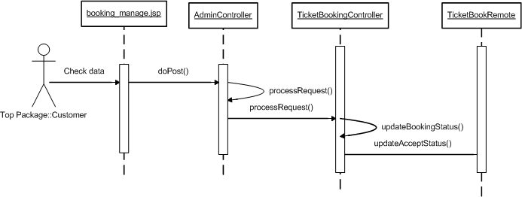
8.2.2. Manage Ticket
8.2.2.1. Create Ticket Information
8.2.2.2. Update Ticket Information
8.2.2.3. Create Event
8.2.3. Manage FAQ
8.2.3.1. Create FAQ Information
8.2.3.2. Update FAQ Information
8.2.3.3. Delete Ticket Information
8.2.4. Answer Contact Of Customer

9. E-R DIAGRAM
9.1. Entities

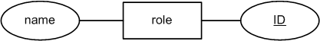

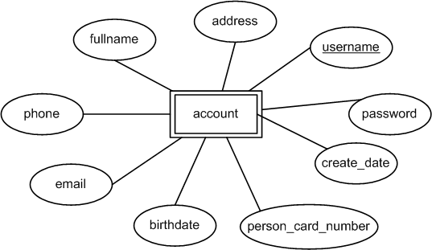

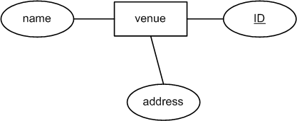

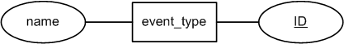

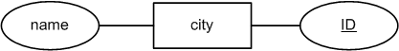

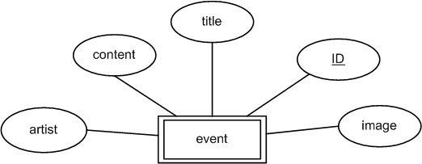

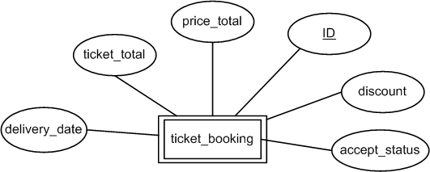

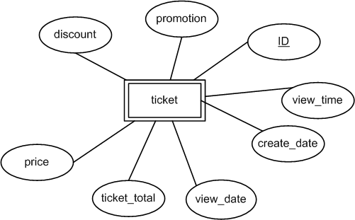

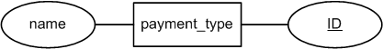

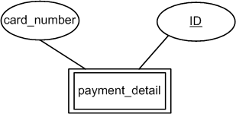

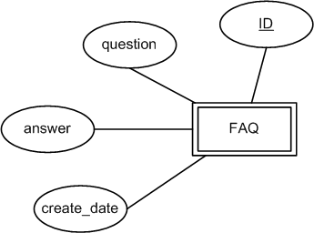

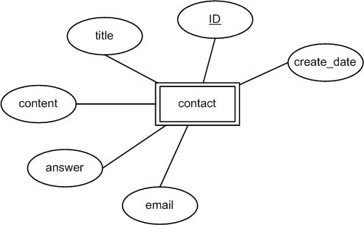

9.2. Relationship
9.2.1. Relationship Of Account
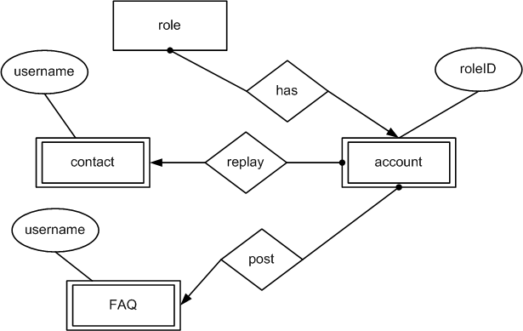

9.2.2. Relationship Of Ticket
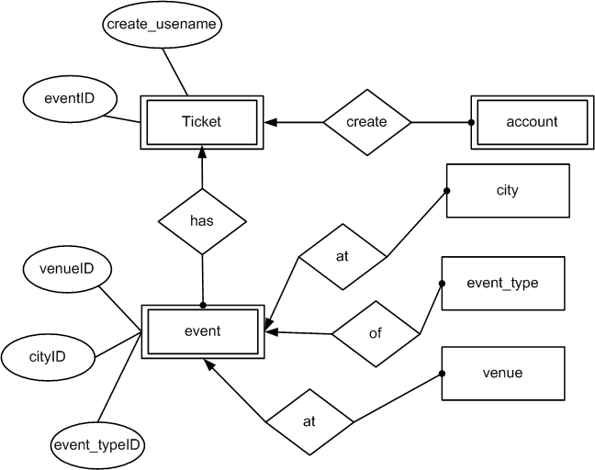

9.2.3. Relationship Of Booking
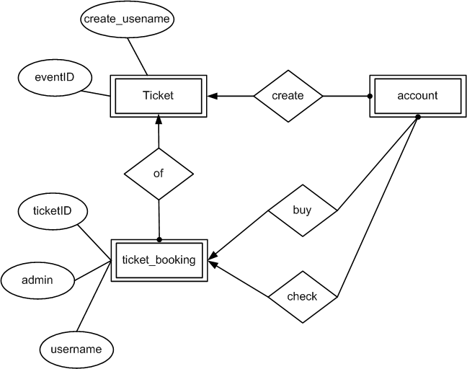

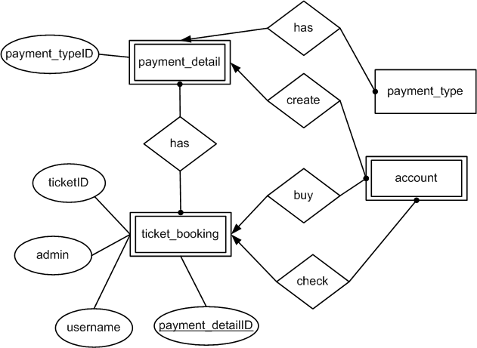
9.2.4. Relationship Of Payment

9.2.5. Overview

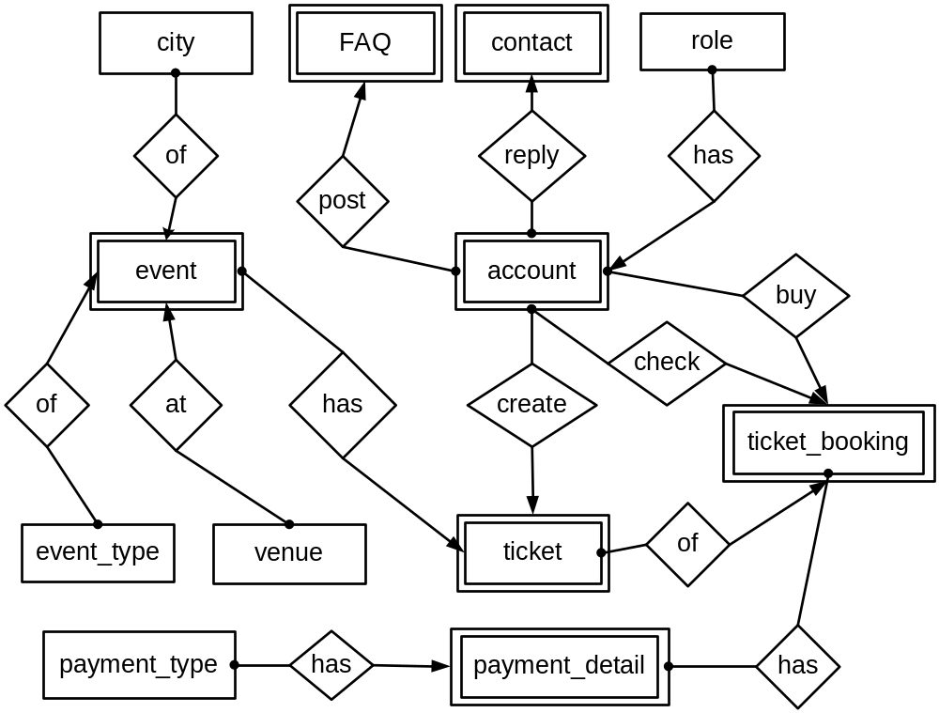

10. DATA FLOW DIAGRAM (DFD)

11. CLASS DIARAM

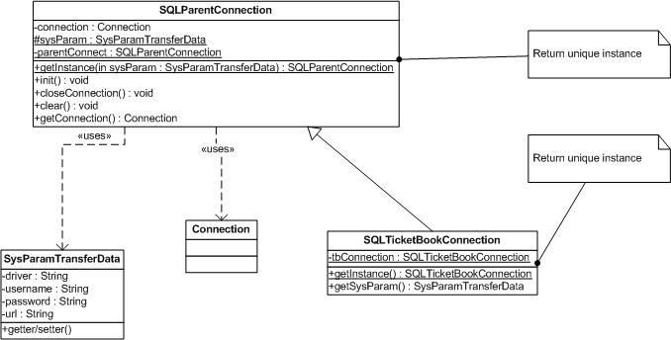

Figure1: Create object to connect with Database
Pattern: Singleton pattern
Explain: Connection is created with a instance, avoid for programer open persistent connection and redundant memory.
Usage:
SysParamTransferData dnew SysParamTransferData(“sql.com.driver…”,”servername:databasename”,”sa”,”123456”);
SQLParentConnection connSQL=SQLParentConnection.getInstance(driver);river=
Connection con=connSQL.getConnection()
OR: SQLTicketBookConnection().getInstance().getConnect() ;//use for “ticketbook” database

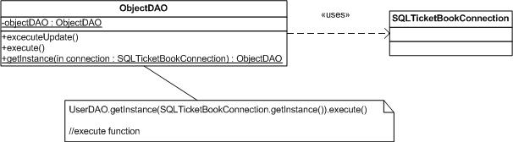

Figure 2: ObjectDAO execute database from Connection Input

Explain: If connection opens, ObjectDAO can execute function on database, help coder easy control the errors connection
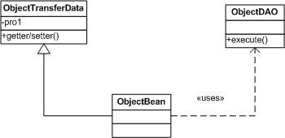

Figure 3: ObjectBean as Adapter for ObjectTransferData

Pattern: Adapter pattern
Explain:
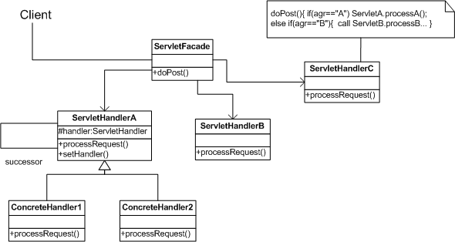

Figure 4: Client send request to ServletFacade, it will call sub servlet to process
Pattern: Facade + Chain Of Responsibility pattern
Explain: When user submit, I will create a Servlet Façade accept request and send request to a other servlet to process. If servlet doesn’t process, it will send to a other servlet… Until request is processed.

12. TABLE DESIGN

11.1. Table List
Name | Description | Total | Primary Key | Foreign Key
Account | User profile | 10 | Username | Role.roleID
City | City | 2 | ID | -
Contact | Contact list of Customer | 7 | ID | Account.username
FAQ | FAQ | 5 | ID | FAQ.username
Payment_detail | Credit card or debit card | 3 | ID | Payment_type.ID
Payment_type | Credit or debit type | 2 | ID | -
Role | Admin, Customer | 2 | ID | -
Ticket | TicketID | 10 | ID | 1. Account.username  2. Event.ID
Ticket_booking | - | 10 | ID | 1. Ticket.ID  2. Account.ID  3. Payment_detail.ID
Event | EventID | 8 | ID | 1. Event_type. ID  2. Venue.ID  3. City.ID
Event_type | Default value as “Movie”, ”Sport”, ”Music”, “Drama”… | 2 | ID | -
Venue | Venue | 3 | ID | -

12.2. Digram

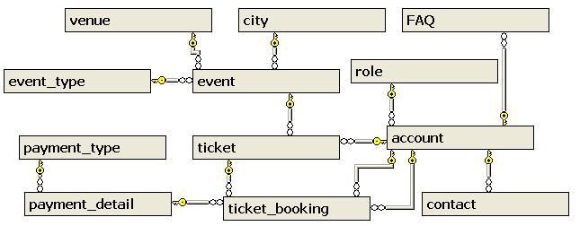
12.2.1. Overview

12.2.2. Digram shows the relationship of Account
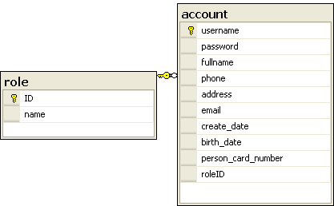

12.2.3. Digram shows the relationship of Contact
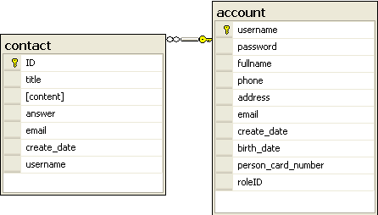

12.2.4. Digram shows the relationship of FAQ
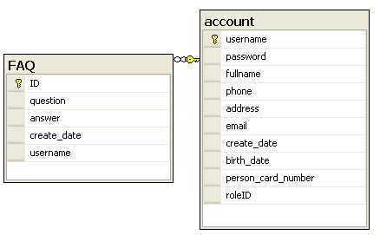

12.2.5. Digram shows the relationship of Ticket
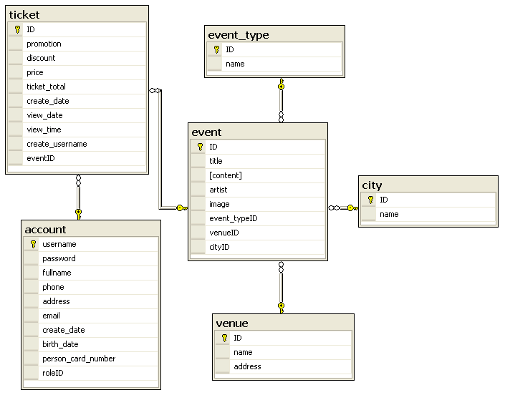

12.2.6. Digram shows the relationship of Booking
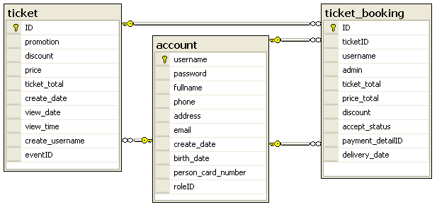

12.2.7. Digram shows the relationship of Payment
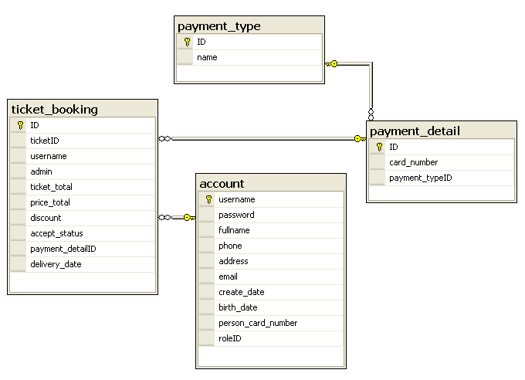

12.3. Table Specification

TABLE: Account

Column | Type | Null | ValueRange | Key
Username | Varchar(50) | No | - | Primary Key
Password | Varchar(50) | No | - | -
FullName | Nvarchar(50) | No | - | -
Phone | Varchar (15) | Yes | - | -
Address | Varchar(100) | No | - | -
Email | Varchar(100) | Yes | - | -
Create_date | DateTime | Yes | - | -
Brith_date | DameTime | Yes | - | -
Person_card_numer | Varchar(20) | No | - | -
RodeID | Int | Yes | - | ForeignKey

TABLE: City

Column | Type | Null | ValueRange | Key
ID | Int | No | - | Primary Key.
Name | Nvarchar(50) | No | - | -

TABLE: Contact

Column | Type | Null | ValueRange | Key
ID | Int | No | - | Primary Key.
Title | Nvarchar(200) | No | - | -
Content | Nvarchar(500) | No | - | -
Answer | Nvarchar(500) | Yes | - | -
Email | Varchar(100) | No | - | -
Create_Date | DateTime | Yes | - | -
UserName | Varchar(50) | Yes | - | Foreignkey

TABLE: Event

Column | Type | Null | ValueRange | Key
ID | Int | No | - | Primary Key
Title | Nvarchar(200) | No | - | -
Content | Nvarchar(100) | No | - | -
Artist | Nvarchar (200) | Yes | - | -
Image | Varchar(100) | Yes | - | -
Event_TypeID | Int | Yes | - | ForeignKey
Value_ID | Int | Yes | - | Foreignkey
City_ID | Int | Yes | - | Foreignkey

TABLE: Event_Type

Column | Type | Null | ValueRange | Key
ID | Int | No | - | Primary Key
Name | Nvarchar(100) | No | - | -

TABLE: FAQ

Column | Type | Null | ValueRange | Key
ID | Int | No | - | Primary Key
Question | Nvarchar(200) | No | - | -
Answer | Nvarchar(500) | No | - | -
Create_Date | DateTime | Yes | - | -
UserName | Varchar(50) | Yes | - | ForeignKey

TABLE: Payment_Detail

Column | Type | Null | ValueRange | Key
ID | Int | No | - | Primary Key
Card_Number | Varchar(20) | No | - | -
Payment_TypeID | Int | Yes | - | ForeignKey

TABLE: Payment_Type

Column | Type | Null | ValueRange | Key
ID | Int | No | - | Primary Key
Name | Nvarchar(100) | No | - | -

TABLE: Role

Column | Type | Null | ValueRange | Key
ID | Int | No. | - | Primary Key
Name | Nvarchar(50) | No. | - | -

TABLE: Ticket

Column | Type | Null | ValueRange | Key
ID | Int | No | - | Primary Key
Promotion | Varchar(300) | Yes | - | -
Discount | Money | Yes | - | -
Price | Money | No | - | -
Ticket_Total | Int | No | - | -
Create_Date | DateTime | No | - | -
View_Date | DateTime | No | - | -
View_Time | Varchar(5) | No | - | -
Create_UserName | Varchar(50) | Yes | - | ForeignKey
EventID | Int | Yes | - | ForeignKey

TABLE: Ticket _Booking

Column | Type | Null | ValueRange | Key
ID | Int | No | - | Primary Key
Ticket_ID | Int | Yes | - | ForeignKey
UserName | Varchar(50) | Yes | - | ForeignKey
Admin | Varchar(50) | Yes | - | ForeingKey
Ticket_Total | Int | No | - | -
Price_Total | Money | Yes | - | -
Discount | Money | Yes | - | -
Accept_Status | Char(1) | No | ‘1’ or ‘0’ | -
Payment_DetailID | Int | Yes | - | - ForeignKey  - Unique Key
Delivery_Date | Datetime | Yes | - | -

TABLE:Venue

Column | Type | Null | ValueRange | Key
ID | Int | No | - | Primary Key
Name | Nvarchar(100) | No | - | -
Address | Nvarchar(100) | No | - | -

13. GUI STANDARD DOCUMENT

Property | Value
Layout | Header, menu, banner, content, footer.
Background color for body. | #e8ecef
Background color for theme. | White+#176c9c
Form Theme and Color Scheme. | None
Header
Font | Tahoma;white;11 pixels;
Alignment | Right
Background Color | #282b34
Menu
Font | Tahoma;white;12 pixels;bold
Alignment | Left
Background Color | #282b34
Content
Title-Font-Size | 16 pixel
Title-Font-Color | #176c9c
Title-Font-Style | Tahoma
Content-Font-Size | 11 pixel
Content-Font-Color | #323232
Content-Font-Style | Tahoma
Title-Alignment | Left
Content-Alignment | Justify
Background Color | White
Footer
Font | Center; #808080;10px;
Background-color | #282b34
Form
Background color of controls on the form. | Default
Foreground color of controls on the form. | Default
Link
Link-Font-Color | Content layout: Silver  Menu layout: White
Link-Font-Style | Tahoma
Link-Font-Move | Menu layout: Gray
Link-Font-Visited | Menu layout: Gray
Text-decoration | None

14. SITEMAP

Login

Hello
Every
Body
…
Home

Hello
Every
Body
…
About Us

Hello
Every
Body
…
Contact Us

Hello
Every
Body
…
FAQ

Hello
Every
Body
…
Register

Hello
Every
Body
…
Admin

Hello
Every
Body
…
Show Events

Hello
Every
Body
…
Booking

Hello
Every
Body
…

15. INTERFACE DESIGN PROGRAM
15.1. Home Page
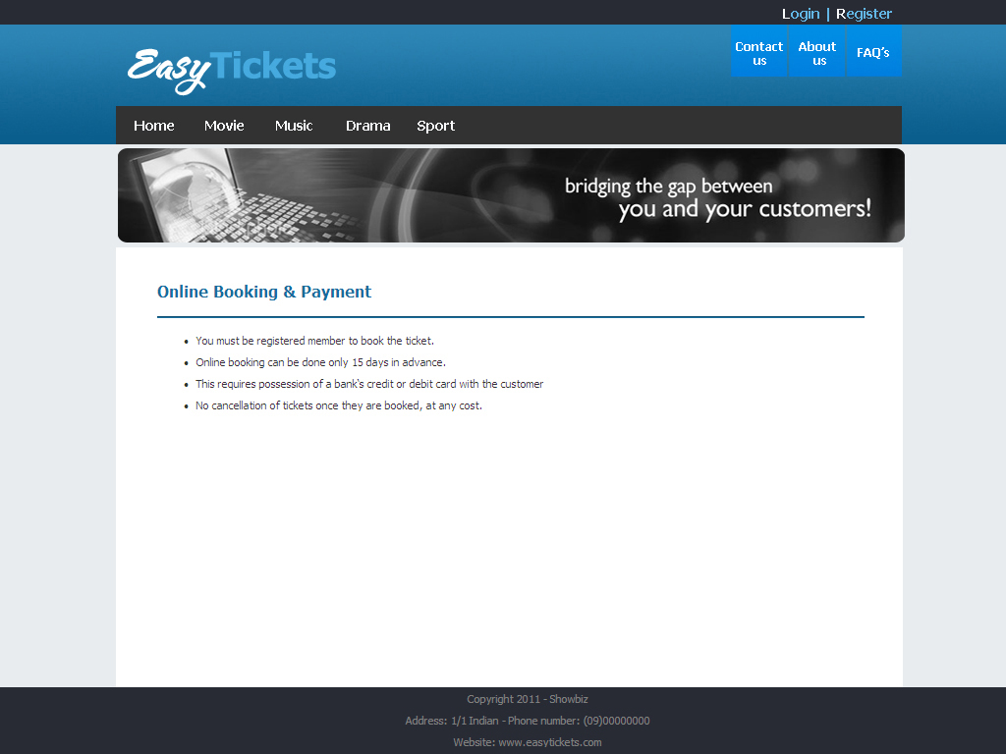

15.2. About Us Page
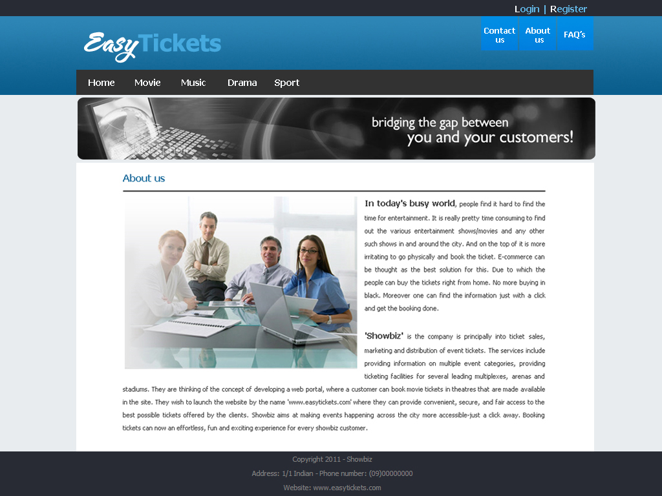
15.3. Login Form
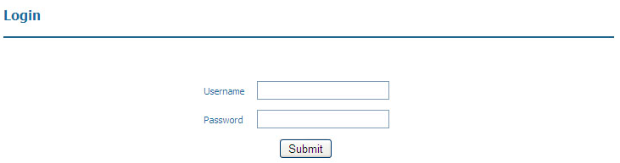

Screen description:

Function | Login
Description | User must login to view ticket and book ticket.
Control | Description | Type | Requirement | Event
Username (1) | Username | Textbox | - | -
Password (2) | Password | Textbox | - | -
Submit (3) | - | Button | - | Redirect to home page, you can view infortion about ticket and book ticket

15.4. Show Tickets Form
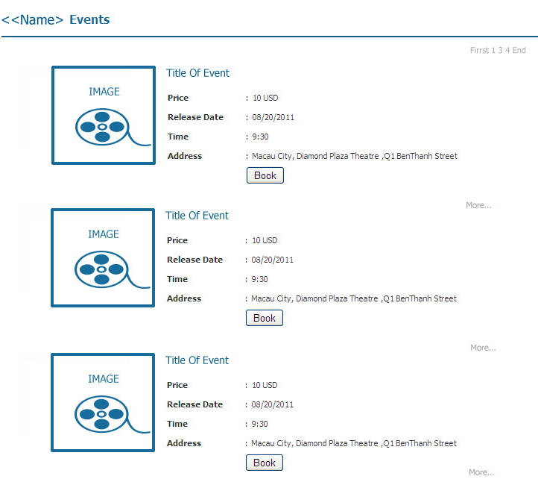

Screen description:

Function | Show Tickets
Description | Show all ticket by event to user can booking

15.5. View Detail Of Ticket
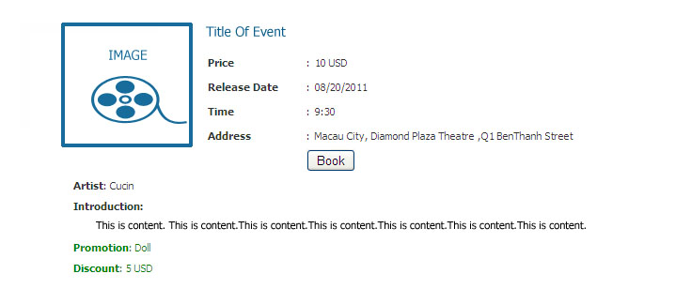

Screen description:

Function | View Detail Of Ticket
Description | Show all ticket by event to user can booking

15.6. Show Next Available Ticket
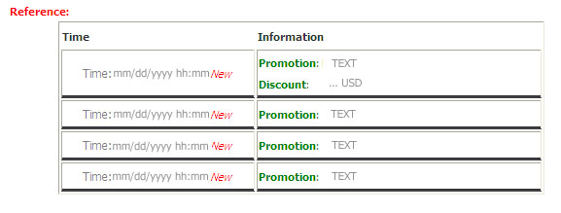

Screen description:

Function | Show Next Available Ticket
Description | If ticket is not available, this form wil show next available ticket

15.7. Book Ticket

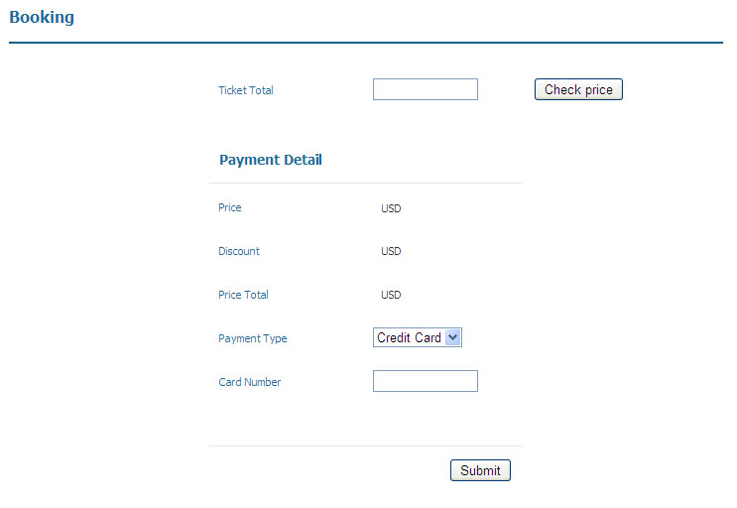

Screen description:

Function | Book Ticket
Description | Customer book the ticket
Control | Description | Type | Requirement | Event
Ticket Total(1) | Ticket Total | Textbox | - Required to enter.  - Only number. | -
Check price(2) | Update price by ticket total. | Button | - | Price, discount is shown.
Price(3) | Price that customer must pay for a ticket. | Label | - | -
Discount(4) | Discount | Label | - | -
Price Total(5) | Price total that customer must pay. | Label |  | -
Payment Type(6) | - | Combobox | - | -
Card Number(7) | - | Textbox | Required to enter | -
Submit(8) | - | Button | - | Redirect to show ticket page, you can view other ticket.

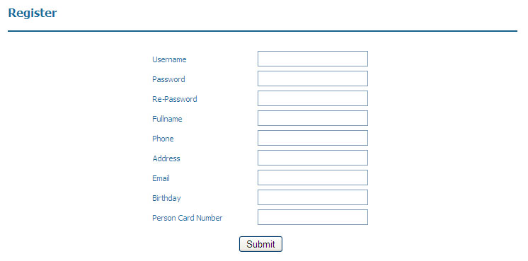
15.8. Additional
15.8.1 Register

Screen description:

Function | Register
Description | User want login must register.
Control | Description | Type | Requirement | Event
Username(1) | Username is account which user use to login. | Textbox | Required to enter. | -
Password(2) | Use to verify account. | Textbox | Required to enter. | -
Re-password(3) | Check correct. password with password have entered. | Textbox | Required to enter. | -
Fullname(4) | Name of customer | Textbox | Required to enter. | -
Phone(5) | Phone of customer | Textbox | Data must be integer. | -
Address(6) | - | Textbox | Required to enter. | -
Email(7) | - | Textbox | Required to enter. | -
Birthday(8) | - | Textbox | Required to enter. | -
Person Card Number(9) | - | Textbox | - Required to enter.  - Data must be integer. | -
Submit(10) | - | Button | - | Information of customer is stored
Reset(11) | - | Button | - | Input Data is reset

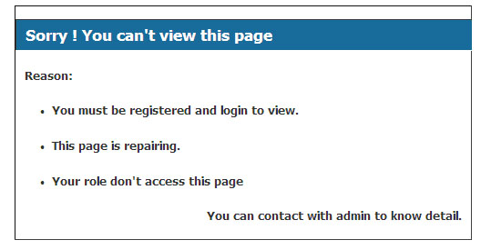
15.8.2. Alert Form

Screen description

Function | Alert Error
Description | User access page which don’t allow, application will redirect to this form

16. TASK SHEET

 |  | Project Title | Activity Plan Prepared By: | Date of Preparation of Activity Plan:
No. | Task | Project Title | Activity Plan Prepared By: | Actual Start Date  (mm/dd/yyyy) | Actual Days | Team Member Names | Status
01 | Analyze & Design Database | ET | Pham Hong Tam | 07/12/2011 | 6 | Pham Hong Tam  Nguyen Huu Sang  Tran Phan Quoc Hai  Nguyen Duc Viet | Finish
02 | Design Sitemap, Use Case | ET | Pham Hong Tam |  | 7 | Nguyen Huu Sang  Tran Phan Quoc Hai  Pham Hong Tam | Finish
03 | Design ER, Class Diagram | ET | Pham Hong Tam |  | 5 | Nguyen Huu Sang | Finish
04 | Design Flowchart, Sequence Diagram | ET | Pham Hong Tam |  | 10 | Nguyen Huu Sang | Finish
05 | Design Layout, Css | ET | Pham Hong Tam |  | 5 | Pham HongTam | Finish
06 | Collect Data For Database | ET | Pham Hong Tam |  |  | Nguyen Duc Viet
 | CODING
07 | About Us | ET | Pham Hong Tam |  |  | Nguyen Huu Sang | Finish
08 | Login | ET | Pham Hong Tam |  |  | Pham Hong Tam | Finish
09 | Register Member | ET | Pham Hong Tam |  |  | Nguyen Huu Sang | Finish
10 | Contact Us | ET | Pham Hong Tam |  |  | Tran Phan Quoc Hai | Finish
11 | View FAQ | ET | Pham Hong Tam |  |  | Tran Phan Quoc Hai
12 | Show Tickets | ET | Pham Hong Tam |  |  | Pham Hong Tam | Finish
13 | Book The Ticket | ET | Pham Hong Tam |  |  | Pham Hong Tam | Finish
14 | Check Booking Tickets | ET | Pham Hong Tam |  |  | Pham Hong Tam | Finish
15 | Manage Ticket | ET | Pham Hong Tam
 | Insert Ticket | ET | Pham Hong Tam |  |  | Pham Hong Tam
 | Update Ticket | ET | Pham Hong Tam |  |  | Pham Hong Tam
16 | Manage FAQ | ET | Pham Hong Tam
 | Insert FAQ | ET | Pham Hong Tam |  |  | Tran Phan Quoc Hai
 | Update FAQ | ET | Pham Hong Tam |  |  | Tran Phan Quoc Hai
 | Delete FAQ | ET | Pham Hong Tam |  |  | Tran Phan Quoc Hai
17 | Answer Contact | ET | Pham Hong Tam |  |  | Tran Phan Quoc Hai
18 | Testing | ET | Pham Hong Tam | 08-01-2011 | 7 | Nguyen Duc Viet
19 | Finish Document | ET | Pham Hong Tam | 08-01-2011 | 7 | Nguyen Huu Sang

17. UNIT TESTING CHECK LIST
18. FINAL CHECK

