
TuanTN
Home
05/12/2010

easy
tickets

Supervisor:Nguyen Xuan Doan
Curriculum: ACCP i7.1
Semester: 4 - HDSE
Batch Code: 0906E
Student : Tran Phan Quoc Hai
Nguyen Huu Sang
Pham Hong Tam
Nguyen Duc Viet





This is to certify that
Mr. Tran Phan Quoc Hai
has successfully designed and
developed
EasyTickets
Submitted by:

TRAN PHAN QUOC HAI
Date of Issue: 07/11/2011
Authorized Signature: ___________

This is to certify that
Mr. Nguyen Huu Sang
has successfully designed and
developed
EasyTickets
Submitted by:

NGUYEN HUU SANG
Date of Issue: 07/11/2011
Authorized Signature: ___________

This is to certify that
Mr. Pham Hong Tam
has successfully designed and
developed
EasyTickets
Submitted by:

PHAM HONG TAM
Date of Issue: 07/11/2011
Authorized Signature: ___________

This is to certify that
Mr. Nguyen Duc Viet
has successfully designed and
developed
EasyTickets
Submitted by:

NGUYEN DUC VIET
Date of Issue: 07/11/2011
Authorized Signature: ___________

Table of Content

Content Page
1 . Introduction
2 . Problem Definition
3 . Customer Requirement Specification (CRS)
4 . Project Plan
5 . System Architecture
6 . Use Case
6.1. Customer
6.2. Administrator
7 . Flowchart
8 . E-R Diagram
9 . DFD Diagram
10 . Class Diagram
11 . Table Design
12 . GUI Standard Document
13 . Site Map
14 . Interface Design Program
15 . Task Sheet
16 . Project Review Monitor Report
17 . Unit Testing Check List
18 . Final Check

INTRODUCTION
In today’s busy world, people find it hard to find the time for entertainment. It is really pretty time consuming to find out the various entertainment shows/movies and any other such shows in and around the city. And on the top of it is more irritating to go physically and book the ticket.
E-commerce can be thought as the best solution for this. Due to which the people can buy the tickets right from home. No more buying in black. Moreover one can find the information just with a click and get the booking done.
Showbiz is the company is principally into ticket sales, marketing and distribution of event tickets. The services include providing information on multiple event categories, providing ticketing facilities for several leading multiplexes, arenas and stadiums. They are thinking of the concept of developing a web portal, where a customer can book movie tickets in theatres that are made available in the site. They wish to launch the website by the name www.easytickets.com where they can provide convenient, secure, and fair access to the best possible tickets offered by the clients. Showbiz aims at making events happening across the city more accessible-just a click away. Booking tickets can now an effortless, fun and exciting experience for every showbiz customer.

1. PROJECT DEFINITION:
- Overview:
- Building a web portal, where a customer can book movie tickets in theatres that are made available in the site.
- The website by the name www.easytickets.com where it can provide convenient, secure, and fair access to the best possible tickets offered by the clients.
- In addition there are other kinds of tickets as Sport Event, Music, Drama.
- People shall use the system:
- Customer, who visits the site and book the ticket.
- Administrator, who manages the site.
- Book the ticket:
- Check the availability of tickets on mentioned date and time in specified city.
- View detail of ticket (venue, day/time, artist…).
- Book the tickets.
- The user selects a particular movie and show in a selected city, if there is availability of tickets for that show, then confirmation for ticket booking must be done. In case of non availability of tickets, the portal must display next available date & time.
- There is no cancellation of tickets once they are booked, at any cost. The provision for money transaction is provided in the same portal. This requires possession of a bank‘s credit or debit card with the customer.
- Online booking can be done only 15 days in advance.
- Difference:
- Customer can contact with Company about problems.
- Website can provide information of company(About us) and FAQ.

2. CUSTOMER REQUIREMENT SPECIFICATION/OVERVIEW
Name of the client: Showbiz Company
System Study:

  - List of inputs to the system
- Information of customer
- Contact information of customer
- The tickets are booked by customer

  - List of outputs expected from the system
- Ticket details
- Answer asks of customer
- FAQ Information.
- Email will send customer about contact

2.3. Overview of processes involved in the system
- Customer will register account, and login website
- After login, Customer book tickets, system will check its. If tickets are confirmed, system will store and notify customer.
- In case of non availability of tickets, must display next available date/time.
- Customer contact with company, website will send mail from administrator for customer
- Customer view FAQ, about us.

  - Data Constraints/Triggers/Validation tables.
- Account Information:
- Ebtablished date must to be greater than birthday of customer.
- Phone must to be integer number
- Person Card Number must to be integer number
- Ticket Information:
- Discount is less than price
- Ticket total imust to be greater than or equal to 0.
- Price is greater than 0
- Ebtablished data must to be less than or equal to view date.
- When I delete it, trigger will update Client’s Booking

- Booking
- Discount < Price Total
- Delivery status is equal to Yes or No (Integer value 1 or 0)
- Ticket total must to be greater than 0
- Price total must to be greater than 0
- Online booking can be done only 15 days in advance.

  - Hardware and software required for implementing the project
Hardware | Software
- A minimum computer system that will help you access all the tools in the courses is a Pentium 166 or better  - 128 Megabytes of RAM or better | - Java Virtual Machine/ J2EE server.  - Notepad/Java editor (Netbeen 6.8).  - j2sdk1.4.1_02 (or later).  - EJB Dev Kit .  - Java enabled web server.  - JSP / Servlets Dev. Kit .  - Subversion.

3. PROJECT PLAN
3.1. Project Details
- Customer: Showbiz Company
- Date of the Project Plan: 07-09-2011 (mm/dd/yyyy)
- The Project Purpose:
- The purpose of the project is to develop an intervention program using information technology as a means of providing information about ticket booking with a program offering home visits. The evaluation of the project will yield important for developing of Showbiz Company.
- The people can buy the tickets right from home. No more buying in black. Moreover one can find the information just with a click and get the booking done.

- The Project Scope:
- Define problem
- Define deliverables
- Define functionality and Data
- Define technical Structure
- Design and coding on module.
- Test and review
- Our Understanding Of The Client Organization
Showbiz‘is the company is principally into ticket sales, marketing and distribution of event tickets.

- Team Member:
Name | Role | Responsibility
Pham Hong Tam | Team Leader | Coding and manage group
Nguyen Huu Sang | Developer | Coding and design document
Tran Phan Quoc Hai | Developer | Coding and design GUI
Nguyen Duc Viet | Tester | Test

3.2 Documents from Client
- Requirement (EasyTickets.doc file)
- Feadback form(eProject_Feeback_Form.exl file)
- Project status (eProject_Status_Report(V1).exl file)
- Project specification (ProjectSpecification.doc file)

3.3 Deliverables
- CRS
- Installation Manual
- User Manual
- Maintain Manual
- Design Document
- Website (*.war file + source code)
- SQL Script + Source Code

3.4 Project Dependences
- Support from teacher.
- Good working environment
- Members with good capacity.

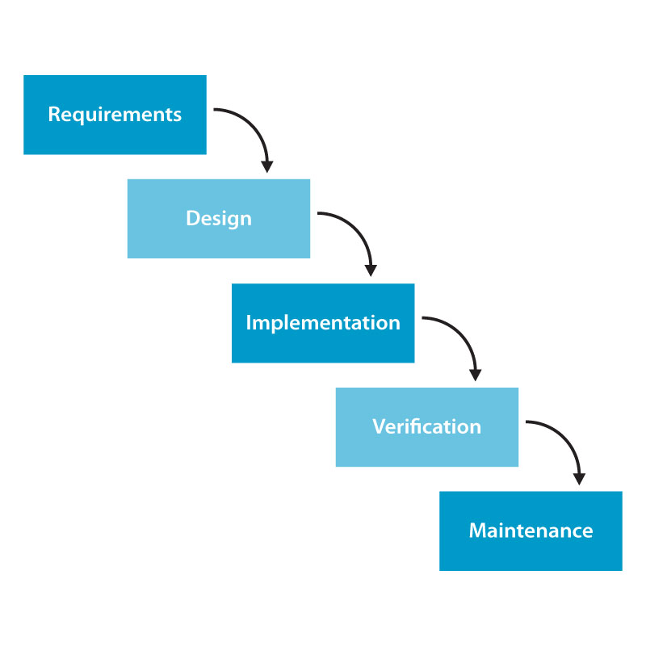
3.5 Phase Of The Project

  - Quality Plan
- Review Activities (review meeting participants, and frequency).
- Testing Activities (Unit Test Plans, Integration Testing and Functionality Testing).
- Group will do something such as test links, test function every meeting.
- Backup and recovery strategies (in case of disk crash and network failures).
- After weekly, group will backup source code, database.

4. SYSTEM ARCHITECTURE:
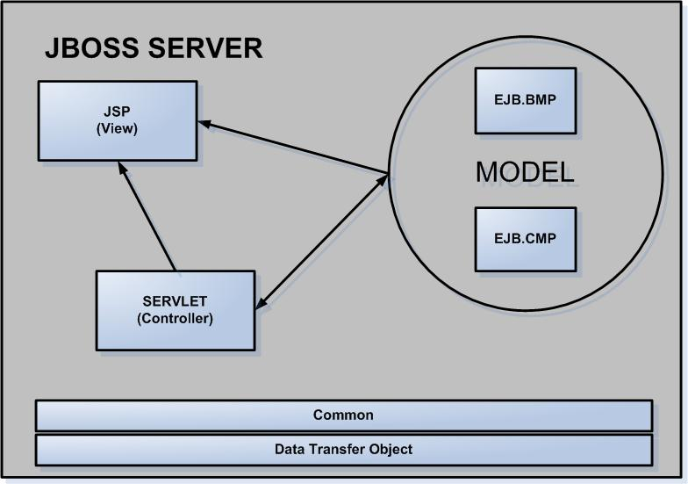

Benefits:
- Easier to build, maintain and extend
- Provide single point of control (Servlet) for security & logging
- Encasulate incoming data into a form usable by the backend
- Can reusable code

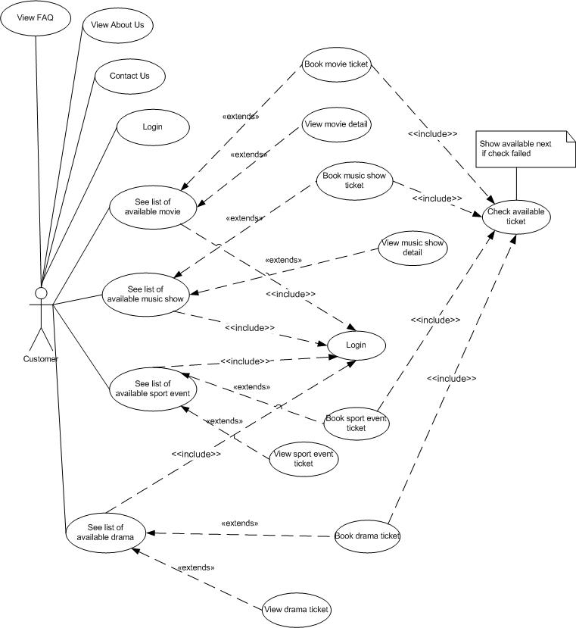
5.USECASE

5.1 Customer

5.2Admin

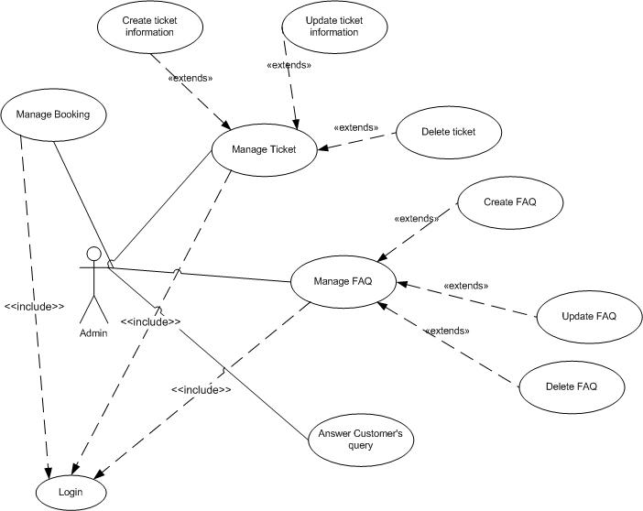
6. FLOWCHART DIAGRAM
7. E-R DIAGRAM

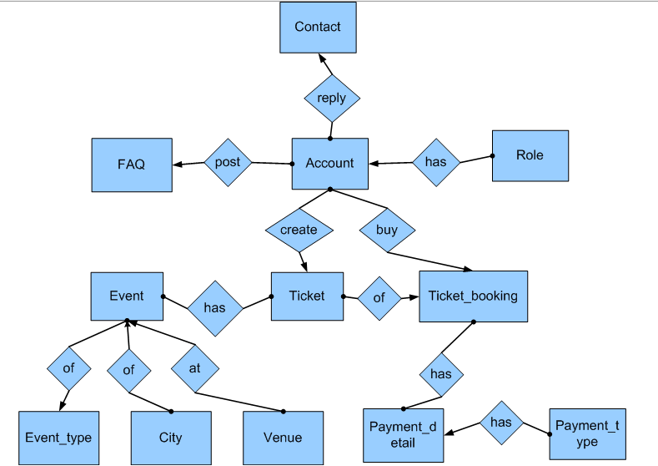

8. DFD DIAGRAM

9. CLASS DIARAM

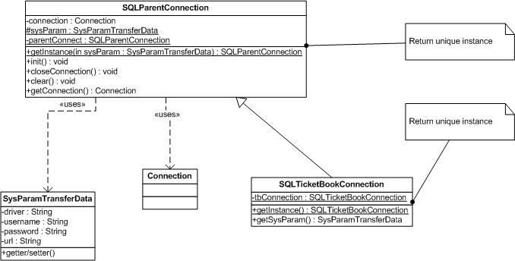

Figure1: Create object to connect with Database

Benefits: Avoid for programer open persistent connection and redundant memory.
Usage:
SysParamTransferData dnew SysParamTransferData(“sql.com.driver…”,”servername:databasename”,”sa”,”123456”);
SQLParentConnection connSQL=SQLParentConnection.getInstance(driver);river=
Connection con=connSQL.getConnection()
OR: SQLTicketBookConnection().getInstance().getConnect() ;//use for “ticketbook” database

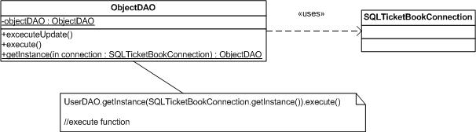

Figure 2: ObjectDAO execute database from Connection Input

Explain: If connection opens, ObjectDAO can execute function on database, help coder easy control the errors connection

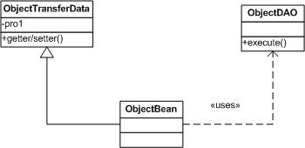

Figure 3: ObjectBean as Adapter for ObjectTransferData

Explain: I have a ObjectTransferData but I can’t insert code into it and I want a function of ObjectDAO, I will create ObjectBean to solution this problem (ObjectBean is a element of entity bean)

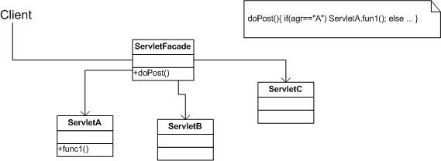

Figure 4: Client send request to ServletFacade, it will call sub servlet to process

10. TABLE DESIGN

10.1 Table List
Name | Description | Total | Primary Key | Relationship | Foreign Key
Account | User profile | 10 | Username | Role | 1. Role.roleID
City |  | 2 | ID
Contact |  | 7 | ID | Account | 1. Account.username
FAQ |  | 5 | ID | Account | 1. FAQ.username
Payment_detail | Payment detail: credit card or debit card | 3 | ID | Payment_type | 1. Payment_type.ID
Payment_type | Credit or debit type | 2 | ID
Role | Admin, Customer | 2 | ID
Ticket |  | 10 | ID | 1. Account  2. Event | 1. Account.username  2. Event.ID
Ticket_booking |  | 10 | ID | 1. Ticket  2. Account  3. Payment_detail | 1. Ticket.ID  2. Account.ID  3. Payment_detail.ID
Event |  | 8 | ID | 1. Event_type  2. Venue  3. City | 1. Event_type. ID  2. Venue.ID  3. City.ID
Event_type | Default value as “Movie”, ”Sport”, ”Music”, “Drama”… | 2 | ID
Venue |  | 3 | ID

10.2 Digram

10.2.1 Overview

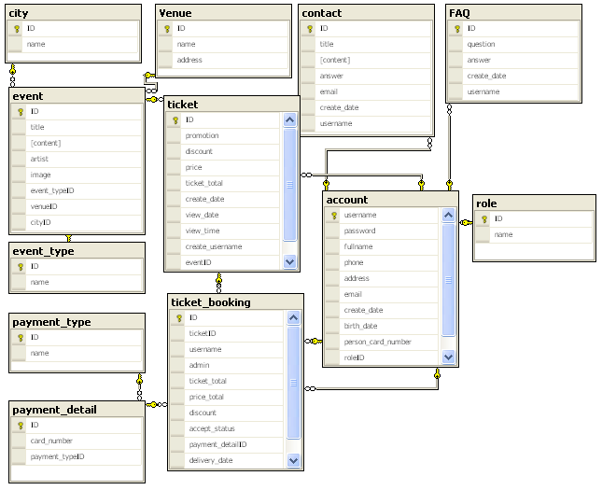

10.2.2 Digram shows the relationship of Account
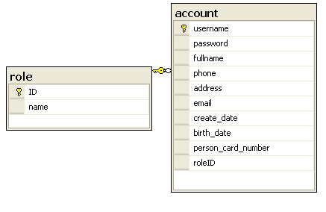

10.2.3 Digram shows the relationship of Contact

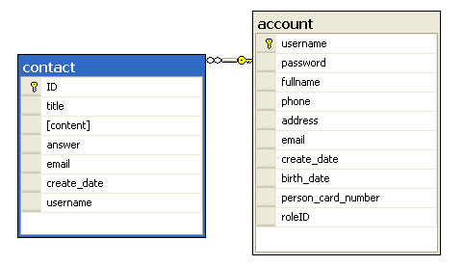

10.2.4 Digram shows the relationship of FAQ
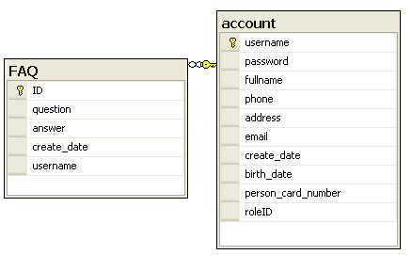

10.2.5 Digram shows the relationship of Ticket

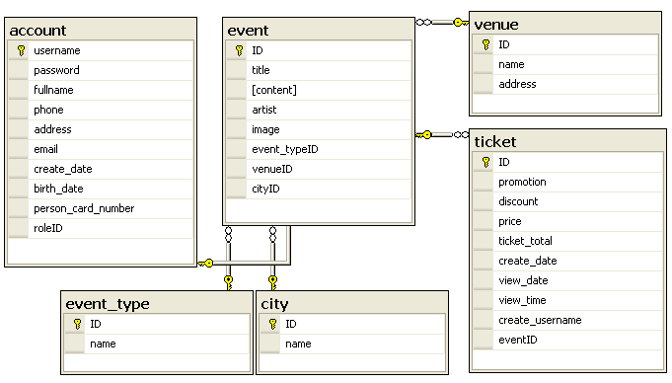

10.2.5 Digram shows the relationship of Booking

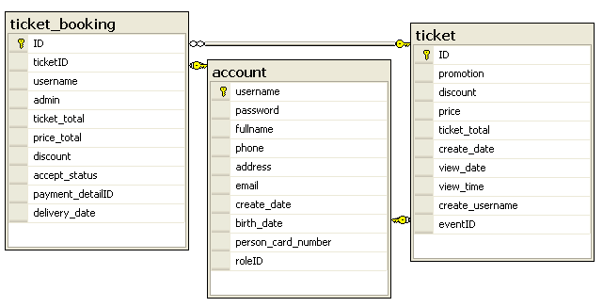

10.2.6 Digram shows the relationship of Payment
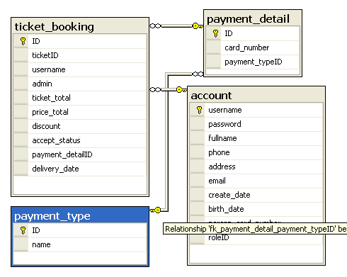

10.3 Table Specification

TABLE: Account

Column | Type | Null | ValueRange | Note
Username | Varchar(50). | No. | - | Primary Key.
Password | Varchar(50). | No. | -
FullName | Nvarchar(50) | No. | -
Phone | Varchar (15). | Yes. | -
Address | Varchar(100). | No. | -
Email | Varchar(100) | Yes. | -
Create_date | DateTime | Yes. | -
Brith_date | DameTime | Yes. | -
Person_card_numer | Varchar(20) | No. | -
RodeID | Int | Yes. | - | ForeignKey.

TABLE: City

Column | Type | Null | ValueRange | Note
ID | Int | No. | - | Primary Key.
Name | Nvarchar(50). | No. | -

TABLE: Contact

Column | Type | Null | ValueRange | Note
ID | Int | No. | - | Primary Key.
Title | Nvarchar(200) | No. | -
Content | Nvarchar(500) | No. | -
Answer | Nvarchar(500) | Yes. | -
Email | Varchar(100). | No. | -
Create_Date | DateTime | Yes. | -
UserName | Varchar(50) | Yes. | - | Foreignkey

TABLE: Event

Column | Type | Null | ValueRange | Note
ID | Int | No. | - | Primary Key.
Title | Nvarchar(200) | No. | -
Content | Nvarchar(100) | No. | -
Artist | Nvarchar (200). | Yes. | -
Image | Varchar(100). | Yes. | -
Event_TypeID | Int | Yes. | - | ForeignKey
Value_ID | Int | Yes. | - | Foreignkey
City_ID | Int | Yes. | - | Foreignkey

TABLE: Event_Type

Column | Type | Null | ValueRange | Note
ID | Int | No. | - | Primary Key.
Name | Nvarchar(100). | No. | -

TABLE: FAQ

Column | Type | Null | ValueRange | Note
ID | Int | No. | - | Primary Key.
Question | Nvarchar(200) | No. | -
Answer | Nvarchar(500) | No. | -
Create_Date | DateTime | Yes. | -
UserName | Varchar(50). | Yes. | - | ForeignKey

TABLE: Payment_Detail

Column | Type | Null | ValueRange | Note
ID | Int | No. | - | Primary Key.
Card_Number | Varchar(20) | No. | -
PayMent_TypeID | Int | Yes | - | ForeignKey

TABLE: Payment_Type

Column | Type | Null | ValueRange | Note
ID | Int | No. | - | Primary Key.
Name | Nvarchar(100). | No. | -

TABLE: Role

Column | Type | Null | ValueRange | Note
ID | Int | No. | - | Primary Key.
Name | Nvarchar(50). | No. | -

TABLE: Ticket

Column | Type | Null | ValueRange | Note
ID | Int | No. | - | Primary Key.
Promotion | Varchar(300). | Yes. | -
Discount | Money | Yes. | -
Price | Money | No. | -
Ticket_Total | Int | No. | -
Create_Date | DateTime | No. | -
View_Date | DateTime | No. | -
View_Time | TimeStamp | No. | -
Create_UserName | Varchar(50) | Yes. | - | ForeignKey
Event_ID | Int | Yes | - | ForeignKey

TABLE: Ticket _Booking

Column | Type | Null | ValueRange | Note
ID | Int | No. | - | Primary Key.
Ticket_ID | Int | Yes. | - | ForeignKey
UserName | Varchar(50) | Yes. | - | ForeignKey
Admin | Varchar(50) | Yes. | - | ForeingKey
Ticket_Total | Int | No. | -
Price_Total | Money | Yes. | -
Discount | Money | Yes. | -
Accept_Status | Char(1) | No. | ‘1’ or ‘0’
Payment_DetailID | Int | Yes. | - | ForeignKey
Delivery_Date | Datetime | Yes | -

TABLE:Venue

Column | Type | Null | ValueRange | Note
ID | Int | No. | - | Primary Key.
Name | Nvarchar(100) | No. | -
Address | Nvarchar(100) | No. | -

11. GUI STANDARD DOCUMENT

Property | Value
Layout | Header, menu, banner, content, footer.
Background Color for Body | #e8ecef
Background Color for Theme | White+#176c9c
Form Theme and Color Scheme | None
Header
Font | Tahoma;white;11 pixels;
Alignment | Right
Background Color | #282b34
Menu
Font | Tahoma;white;12 pixels;bold
Alignment | Left
Background Color | #282b34
Content
Title-Font-Size | 16 pixel
Title-Font-Color | #176c9c
Title-Font-Style | Tahoma
Content-Font-Size | 11 pixel
Content-Font-Color | #323232
Content-Font-Style | Tahoma
Title-Alignment | Left
Content-Alignment | Justify
Background Color | White
Footer
Font | Center; #808080;10px;
Background-color | #282b34
Form
Background Color of Controls on the Form | Default
Foreground Color of Controls on the Form | Default
Link
Link-Font-Color | Content layout: Silver  Menu layout: White
Link-Font-Style | Tahoma
Link-Font-Move | Menu layout: Gray
Link-Font-Visited | Menu layout: Gray
Text-decoration | None

12. SITEMAP

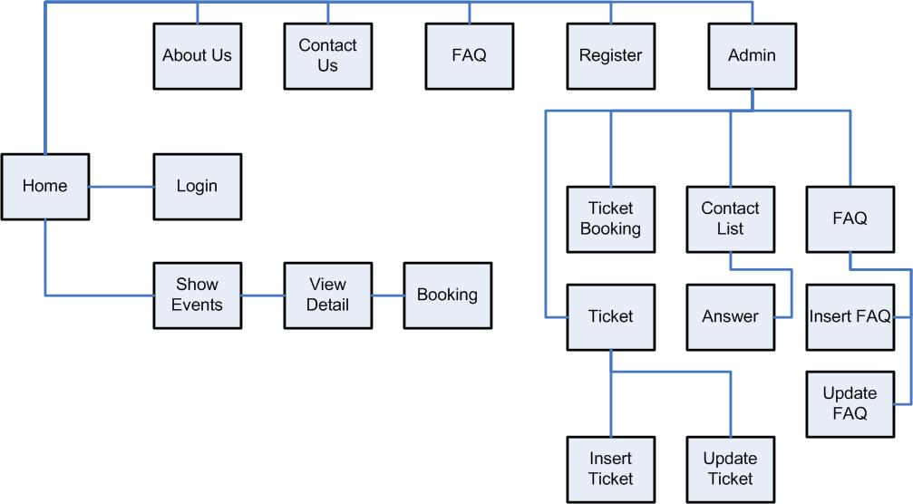
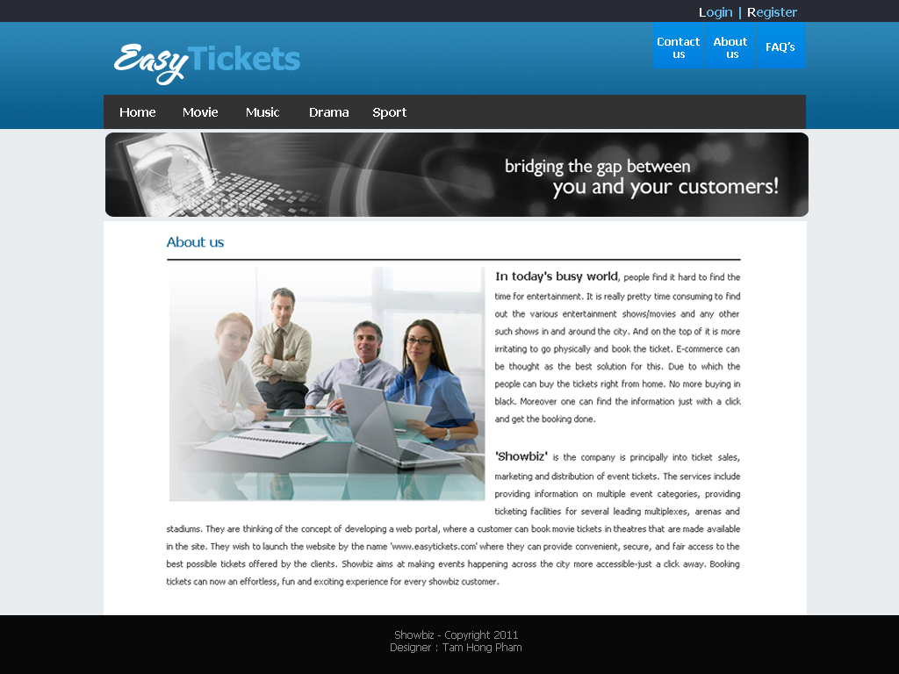
13. INTERFACE DESIGN PROGRAM
14. Task Sheet
15. Project Review Monitor Report
16. Unit Testing Check List
17. Final Check

