**King Fahd University for Petroleum & Minerals**

**Project Report:**

**Matching Game**

Date:12/12/2020

**Prepared by:**

ID:201855360, Ammar Alfaifi,

ID:201855360, Ammar Alfaifi,

ID:201855360, Ammar Alfaifi,

**For:**

**ICS201 - 201**

**1.Objectives:**

In this project we aim to design a matching game of 4X4 cards based on javaFX. The game should show the passed time as well as info about scores, i.e., current score and highest score. Also, it has interactive sounds.

**2.Framework:**

We divide the project into 3 subproblems so everyone can work separately and then we merged those subprojects into the main one. The subprojects as following:

1. Build a tile class that describes an object for each tile it has methods for opening, closing and checking (whether the selected tile matched the previous one) tiles. Build a general pain for testing the previous class.
2. Find the good sound and build the methods for sounds. Design the handler methods. Prepare the images and sounds file and create their objects.
3. Build two java file one of them is abstract class. Those are to represents two sense, the game scene and the home scene. Get the previous subprojects and merge them into the game.java file. Design the home scene. Styling the nodes and adding backgrounds.

The Game class contains the Tiles class, opening images and sounds media, handling the actions and scores with the timer.

The Home class shows up once opening the game. It has general information about the program with a single button that move to the game. When this button is pressed the timer starts counting and shows the current score and the last highest score.

**

Figure 1: This is the Home page. it shows the KFUPM logo with description about the game. Also, it shows the "Start the Game Now!" button. This button changes the scene it the game scene and start the game

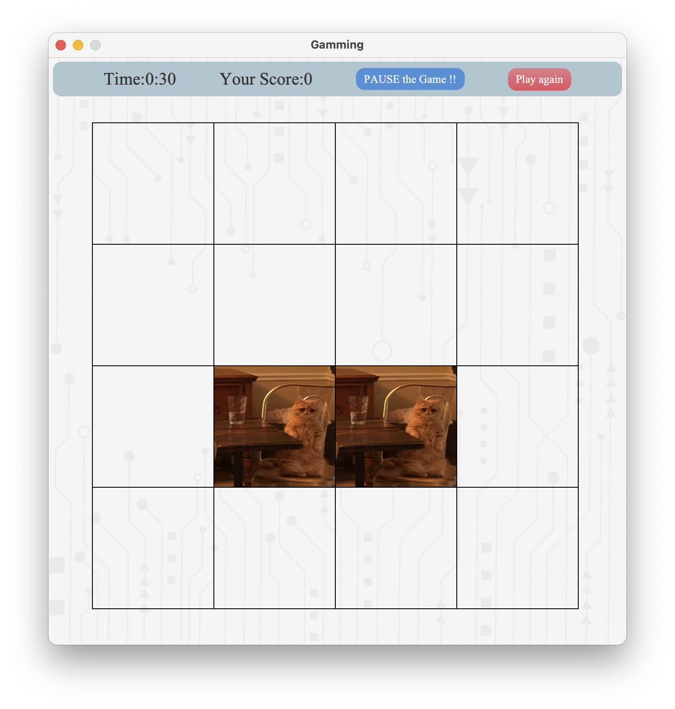

Figure 2: This shows the Game scene with an example of correct choice. On the header, it displays the timer, current score and the last highest score. There are two buttons, the blue one is to move to the home scene and pausing the current state (timer and tiles). The player can go back to the same state that was before when pressing the" Start the Game Now!" button. The red button is used to shuffle the tiles then hide them starting new timing.