**King Fahd University for Petroleum & Minerals**

**Mini Project Report:**

**Descent Timer**

Date:4/12/2020

**Prepared by:**

ID:201855360, Ammar Alfaifi, Sec:54

ID:201840840, Sami Alfaifi, Sec:53

**For:**

**COE203 - 201**

**1.Objectives:**

In this project we aim to design a descent timer based on Verilog and programmed on an FPGA board. Also, we will simulate the project based on computer-generated clock signals

**2.Proceduer:**

Task1: Designing mod10:

This module is used to count from 9-0 for the first digit of the seconds.

1. Create new projects of HDL type.
2. Create a counter that counts from 9 to 0 and reset itself automatically when it becomes 0 than name it “mod10”.
3. Make the inputs: clk, reset, CE, LED.
4. Make the outputs: reg [3:0] counter, CEO
5. Assign (counter == 0) && CE to CEO
6. Start always block with posedge of the clk
7. Start condition statement with if LED is True then assign 0 to counter.
8. If not so check whether reset or CEO is True then assign 9 to counter.
9. If not so check if CE is True then decrement counter by 1.
10. End the module

Task2: Designing mod06:

This module is used to count from 5-0 for the second digit of the seconds.

1. Create new Verilog file named mod06.
2. Create another counter that counts from 5 to 0 and reset itself automatically when it becomes 5.
3. Make the inputs: clk, reset, CE, LED.
4. Make the outputs: reg [3:0] counter, CEO
5. Assign (counter == 0) && CE to CEO
6. Start always block with posedge of the clk
7. Start condition statement with if LED is True then assign 0 to counter.
8. If not so check whether reset or CEO is True then assign 5 to counter.
9. If not so, check if CE is True then decrement counter by 1.
10. End the module

Task3: Designing DownCounter:

This module is used to count from 9-0 for the two minute digits as well as loading the starting time inputs. If the inputs larger than 99 an LED error will turn on and set all digits zeros.

1. Create new Verilog file named BCD_3D.
2. Make the inputs: clk, reset, load, CE, [3:0] data, LED.
3. Make the outputs: CEO, reg error, reg [3:0]count.
4. Assign (counter == 0) && CE to CEO.
5. Start always block with posedge of the clk
6. Start condition statement with if LED is True then assign 0 into count and error.
7. If not so, check if the input data exceeding 9 is True assign 1 to error and zero into count.
8. If not so, check whether reset or CEO is True then assign 9 to counter.
9. If not so, check if CE is True then decrement counter by 1.
10. End the module

Task4: Designing the Main Module Timer:

This module is used to gather the previous modules and instantiate them.

1. Create new Verilog file named timer.
2. Make the inputs: clk, reset, load, CE, [3:0] I1, I0.
3. Make the outputs: LED, ErrorLED, [7:0]seg, [3:0]an.
4. Assign S2 = (&(~I0))? ( |I1? 4'b1001 : 0) : (I0-1)
5. Assign S3 = (&(~I0))? (I1-1) : I1.
6. Assign ErrorLED = Error1 | Error2.
7. Assign STOP = LED | ErrorLED.
8. Instantiate the mod10 as s0 and pass in "clk, reset, CE, STOP, D0, CEO1".
9. Instantiate the mod06 as s1 and pass in " clk, reset, CE, STOP, D0, CEO2".
10. Instantiate the DownCounter as m0 and pass in "clk, reset, load, CEO2, S2, STOP, CEO2, Error1, D2"
11. Instantiate the DownCounter as m1 and pass in "clk, reset, load, CEO3, S3, STOP, CEO3, Error2, D3"
12. Instantiate DISP7SEG as ssd and pass in "clk, D0, D1, D2, D3, text_mode, slow, med, fast, error, wrong, seg, an".
13. For uploading to a FPGA board, instantiate onehz as mHz and pass in "clk, reset, CE, counter, clk_1hz"
14. End module.

Task5: Simulation:

1. Select timer module and open up the simulation window.
2. Force clock "clk" to 1ns.
3. Force constant "reset" to 1ns.
4. Force constant "load" to 2ns.
5. Force constant "CE" always.
6. Change the radix to unsigned decimal for each of I1and I2.
7. To test timer of 10:00, force constant I1 to 1 and I0 to 0.
8. Run the simulation for the specified time.

Task6: For FPGA Boards:

Here we want to integrate the previous modules to be working and uploaded into FPGA board

1. Create .ucf file or open I/O Pin Planning.
2. Assign clk to V10.
3. Assign the inputs I1 and I0 to 8 switches.
4. Assign load to D9.
5. Assign reset to C4.
6. Assign LED to U16.
7. Assign ErrorLED to V16.
8. Assign CE to T12.

Figure 1: Verilog code for the mod10; that counts from 9-0 repeatedly

Figure 2: Verilog module for the mod06; it counts from 5-0 repeatedly

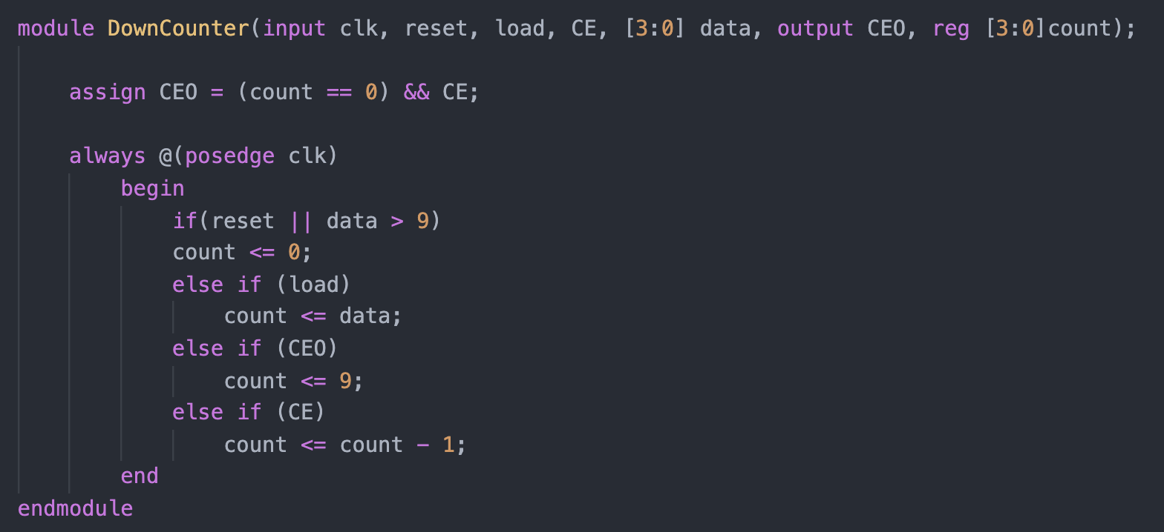

Figure 3 Verilog DownCounter code, this is used for counting from 9 to 0 and can start from specified input

Figure 4 Verilog timer code; this is the main module that does the simulation

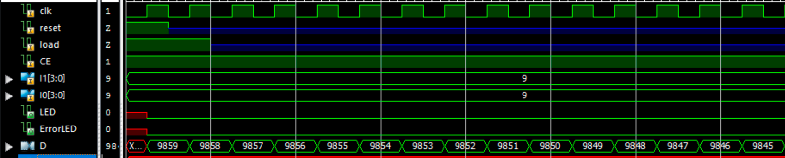

Figure 6: sample simulation for starting from 99:00

Figure 7 continued, at the 00:00 point the LED is turned on

Figure 8: An error sample for an input that exceeded 9; here it is given 13 for the first. The display will be 00:00 and the ErrorLED will turn on

**3.Problem Faced:**

No problem faced

**4.Work Distribution:**

|  |  |  |
| --- | --- | --- |
|  | Sami | Ammar |
| Task1 | 80% | 20% |
| Task2 | 20% | 80% |
| Task3 | 45% | 55% |
| Task4 | 100% | 0% |
| Task5 | 45% | 55% |
| Task6 | 20% | 80% |
| Report | 45% | 55% |

**5.Conclusion:**

In short, we designed a decreasing timer that its starting minutes can be specified by switches. The maximum number is 99. If the inputs is larger an error LED will turn on and the display will be all zeros until it is reset again. We used three module and one main module as well as the FPGA module.