LAB Logbook
Lab 9
code your Use EarlyStopping() and ModelCheckpoint() functions
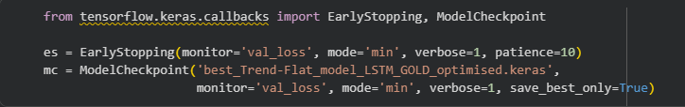
code and training result using model.fit()
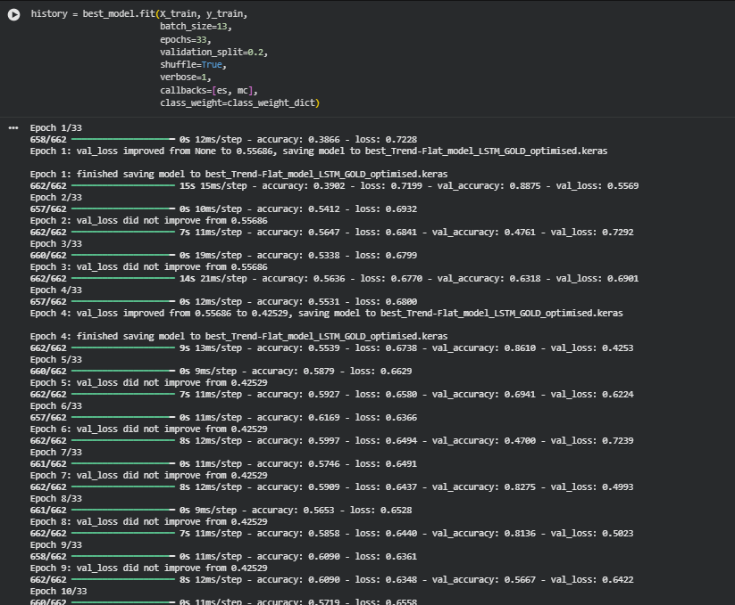
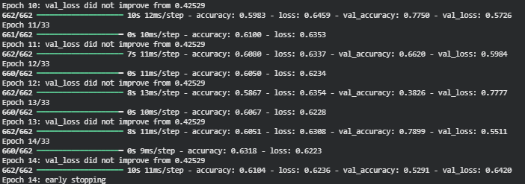
the resulting test Accuracy and other error metrics for the classification task using classification_report().
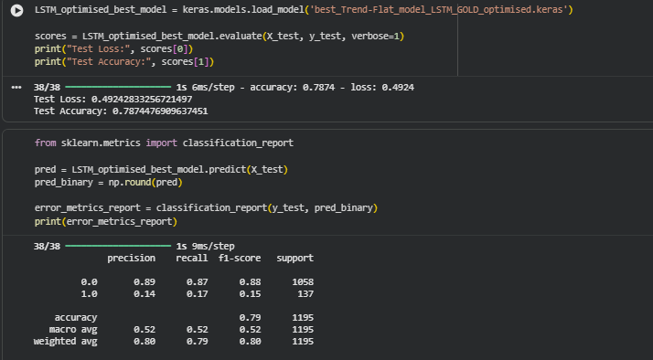

Accuracy detailed graph
