**COMP 3133 – Full Stack Development – LabTest01 : POSTMAN and MONGO DB**

**POSTMAN Sign Up**

**POSTMAN Check If User Exists**

**POSTMAN Sign In**

**POSTMAN Check Auth**

**POSTMAN Logout**

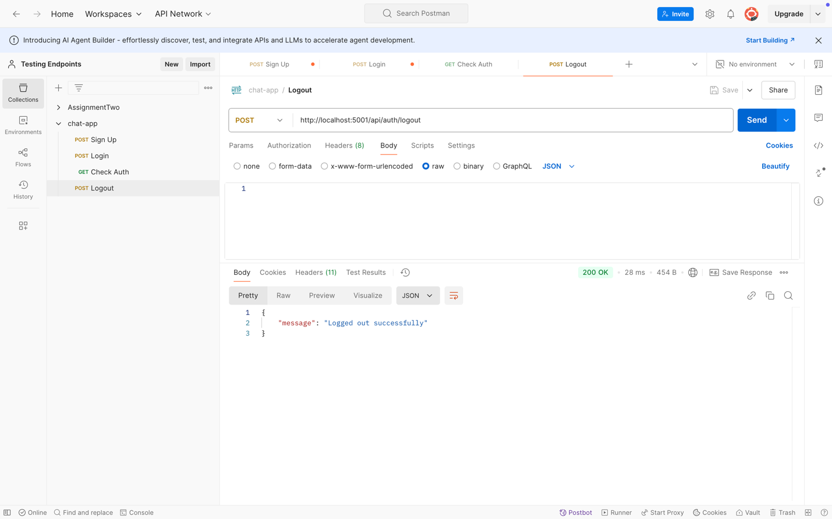

**MONGO DB Users**

**MONGO DB Messages**

