**COMP 3123 – Full Stack Development – Lab 2**

**Exercise 1:**

**Exercise 2:**

**Exercise 3:**

**Exercise 4:**

**Exercise 5:**

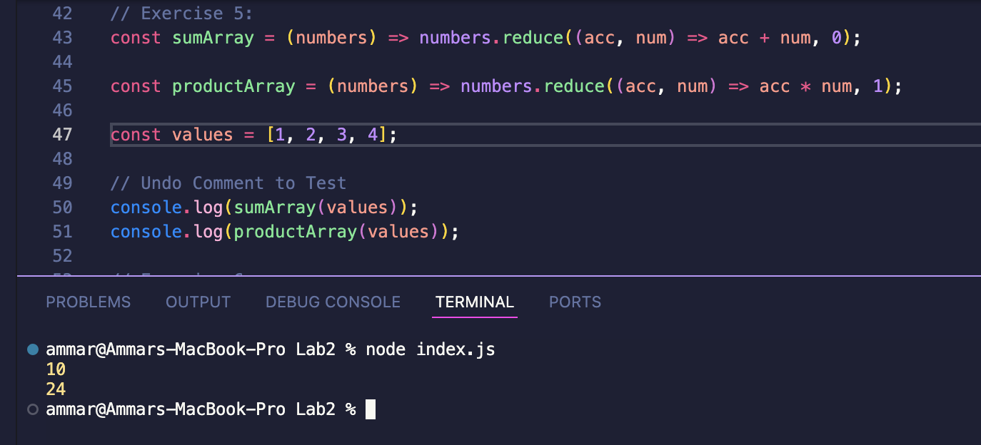

**Exercise 6:**

