**COMP 3123 – Full Stack Development – Lab 3**

**http://localhost:8081/**

**http://localhost:8081/employee**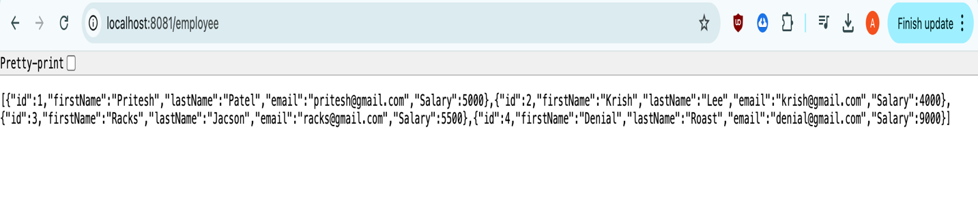

**http://localhost:8081/employee/names**

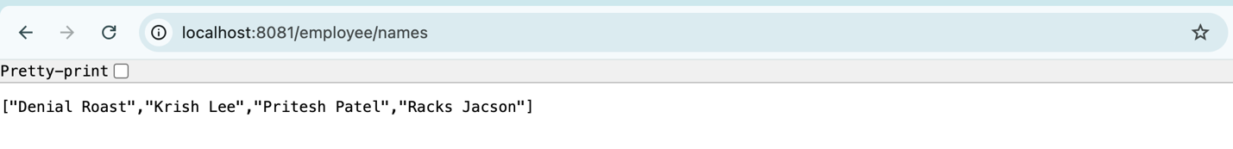

**http://localhost:8081/employee/totalsalary**

