**COMP 3123 – Full Stack Development – Lab 4**

**http://localhost:3000/hello**

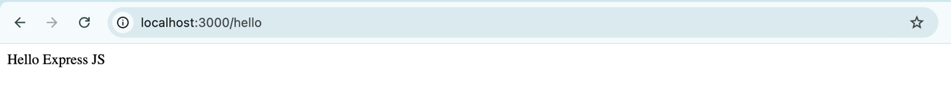

**http://localhost:3000/user?**

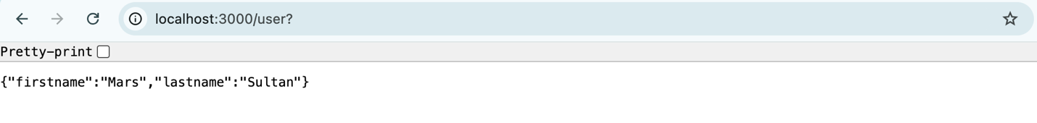

**Using Postman**

