ISIC Archive PMS Integration
User Journeys
Document ID: PRD-PMS-ISICARCHIVE-001
Version: 1.0
Date: February 21, 2026
Author: Ammar (CEO, MPS Inc.)
Status: Draft

Journey 1: DermaCheck — Skin Lesion Capture, Classification, and Review
Persona: Physician
Platform: Android, backend and AI
PRD Reference: Phase 1–2 (core classification pipeline), Section 6.1–6.6 (all CDS components)
The primary end-to-end workflow on Android, from the physician's perspective:
- Camera Capture — The camera on Android opens (configured with a dermoscopy CameraProfile). The physician photographs the skin lesion.
- Notes / Dictation — Before or after capture, the physician can type or dictate clinical notes — anatomical site, patient concern, visual observations — that are sent alongside the image.
- Upload & AI Processing — The image and notes upload to the PMS Backend (POST /api/lesions), which forwards them to the DermCDS Service (:8090) for classification, enrichment, similarity search, and risk scoring.
The DermCDS pipeline includes:
- EfficientNet-B4 classification across the 9 ISIC diagnostic categories (melanoma, melanocytic nevi, BCC, SCC, actinic keratosis, benign keratosis, dermatofibroma, vascular lesions, other)
- Gemma 3 enrichment via the AI Gateway (:8001) — clinical reasoning about the classification in the patient's context
- pgvector similarity search — cosine distance against pre-computed embeddings to retrieve visually similar ISIC reference images
- Risk score calculation — low / medium / high with referral urgency
- Results Display — The Android app presents: top-3 classification with confidence percentages, Gemma 3 clinical narrative, risk level indicator, and similar ISIC reference images gallery.
- Clinician Action — The physician can Save (persist to encounter), Discard (delete), or Add Another Photo (return to camera).
Note: On-device results are labeled as "preliminary triage" only (per SUB-PR-0013-AND). Full classification results require server-side processing through the DermCDS Service and are not finalized until the backend pipeline completes.

Sequence Diagram
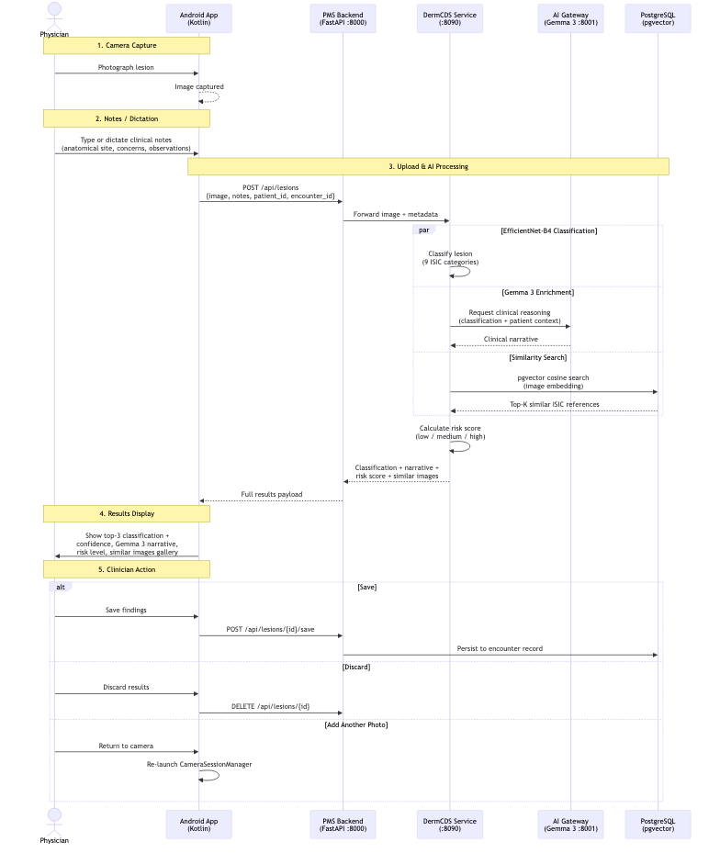
DermaCheck User Journey — Skin Lesion Capture, Classification, and Review

