David San Kim – 30038419

Ammar Elzeftawy – 30113872

Yaseen ElSherif – 30116102

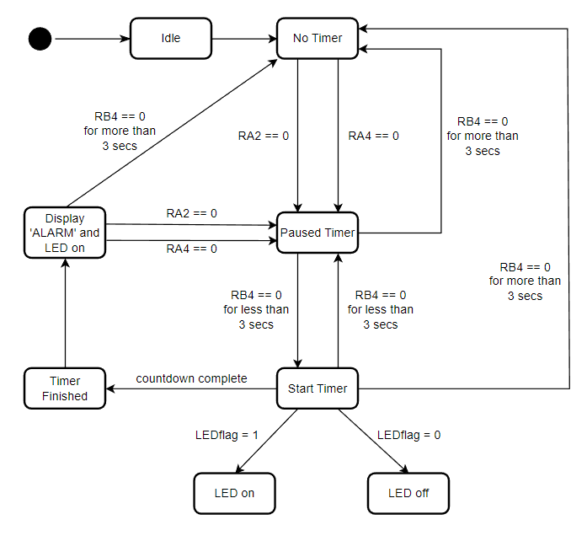

David: Responsible for video demo, testing and documents.

Ammar: Responsible for coding.

Yaseen: Responsible for coding.