**GIKI RIDE APPLICATION**

**SEMESTER PROJECT**

**CS 225**

Date: 1st June 2022

**Supervisor:**

Sir Ahsan Shah

**Group Members:**

SYED AMMAR BIN FARRUKH 2020468

SAMEER ARIF KHAN 2020430

SHAHEER NASHAD 2020442

MUAZ SHAFIQ 2020250

**Revision History:**

|  |  |  |
| --- | --- | --- |
| ***Revision History*** | ***Date*** | ***Comments*** |
| 1.00 | 1st June 2022 | No comments |

List of Contents

1 INTRODUCTION 5

1.1. PURPOSE 5

1.2. PRODUCT SCOPE 5

2 OVERVIEW 5

2.1 THE OVERALL DESCRIPTION 5

2.2 PRODUCT PERSPECTIVE 5

2.2. PRODUCT FUNCTIONS 6

2.3. USER CHARACTERISTICS 6

2.4. CONSTRAINTS 6

2.5. ASSUMPTIONS AND DEPENDENCIES 6

3 STATE OF THE ART 7

4 USER/SYSTEM REQUIREMENTS 7

4.1 External Interface Requirements 8

4.1.1 User Interfaces 8

4.1.2 Hardware Interfaces 8

4.1.3 Software Interfaces 8

5 Functional Requirements 9

5.1 Functional Requirements with Traceability information 9

6 Nonfunctional Requirements & Software System Attributes 11

7 Project Design/Architecture 12

**List of Tables**

Figure 1 Use Case (System)

Figure 2 User Interface Diagrams

Figure 3 Class Diagram

Figure 4 ER Diagram

# INTRODUCTION

## PURPOSE

We are developing a Car Rental Application for the students and faculty of the GIK Institute. Since there exist some private drivers that do this service but since most of the people don’t know about them therefore there is a lot of problem at the end of semesters and during mid semester breaks. Therefore, this a single platform for all the drivers to exist here and their details are on the application and now the user which are the students and the faculty staff a can book their rides on a click of a button hassle free.

## PRODUCT SCOPE

The demand for a platform like “GIKI RIDE” has now become a necessity because the major affected from this booking problem are students and every time at the end most f the students are not able to book their rides and are late and have to face a lot of difficulty in order to reach major cities like Islamabad, Rawalpindi and Peshawar. After carefully studying the needs of the students after survey we were able to find out that this application will be successful because no other application like this exist which is solely for the people of GIK Institute.

# OVERVIEW

The application that we have created is one of a kind since there are platforms available like this like Uber, Careem and Bykea but these platforms are for general purpose users and these all are large scale applications but this application of ours is based on the footsteps of these booking applications but the purpose of this application is for the benefit of Gikians only and the environment of this application is closed and is restricted for the people residing behind the boundaries of the Institute only.

## THE OVERALL DESCRIPTION

This application of ours is basically based upon two basic user which are users and administrator, which means that it only for Gikians and staff and faculty that reside inside the institute. This application is also very helpful for the new students that come every year because students from every nook and corner of the country come to GIK therefore they also face problems related to car rentals but after the implementation of this application it would be really helpful for fresh students as well. The duty of the administrative staff is to manage the application by adding the data of new drivers if the current drivers extend their businesses. The application is based on Flutter and its database is made in SQFlite using SQLite.

## PRODUCT PERSPECTIVE

The main consumer of this application are the students as there are about 2000-2500 students residing inside the campus at any time. And this application also helps the students to arrange their transport hassle free and, in less time, due to which their studies are also not disrupted. The consumer market of this application is vast and by using this application the client will be free from getting numbers of different drivers from other people and wasting their and his/her own time as well.

## PRODUCT FUNCTIONS

The main functions provided by this application are:

**1.Rental Car booking:** The client will be able to book a car for his/herself to go to different cities from the university premises and vice-versa.

**2. Bus seat booking:** The user can also book a seat in a bus as well to go to different cities form university premises. The user can also book the seat of his/her desire.

## USER CHARACTERISTICS

There are two main types of users who would be accessing this application. Those are:

1. Students/Faculty/Staff

2. Administrator/ Developers

## CONSTRAINTS

Following are the constraints of this application:

1. An internet connection would be needed for this application to work because users can also book their rides form their cities as well.

2. The application is based on android therefore the user should have an android device to install this application.

3. This application is currently limited to GIK Institute.

## ASSUMPTIONS AND DEPENDENCIES

The dependencies and assumptions of this application are following:

1. The user should have an android phone in order to access this application
2. The user should also have an active internet to access the sign in portal to create an account and proceed to booking.

# STATE OF THE ART

* **LITERATURE REVIEW**

We all know that booking a car for rental purpose is a hectic job in GIK because you must ask several people to get numbers of local drivers then you have to contact those drivers and get along with the schedule and then travel. Although there are systems that provide you this facility but none of them was solely made for the people of GIK Institute so by making this application we have tried our best to provide comfort and easiness to our fellow people.

The few technologies that are currently in Pakistan providing the same solutions but on a larger scale are:

1. **UBER:** ItisUS based transport company that has been operating around in many countries around the globe. They were the first one to introduce this concept of online ride booking and ride sharing applications.
2. **CAREEM:** It is UAE based transport company working on the same principle as Uber and recently they were acquired by Uber in deal worth millions of dollars.
3. **BYKEA:** It is a Pakistan based startup; they are also working on the same concept, but they use motorcycles instead of cars.

So, now the question arises why us? so basically our application is also based upon the same concept, but we are different from the rest of us because our sole purpose is to help our fellows which live with us on the Campus.

Moreover, our system is only for Gikians and people residing in the university campus, therefore we have named this application “GIKI RIDE”.

And with the help of Almighty we will try to make this application successful and then take to much higher level by making it for different universities and educational institutions.

* **EXISTING SYSTEMS**

The existing software and applications are the same which I have discussed earlier in the Literature Review which are UBER, CAREEM, BYKEA, SWVL, AIRLIFT, etc.

# USER/SYSTEM REQUIREMENTS

The user should have:

1. Mobile and its knowledge.
2. Access to internet
3. The device must be an android device.

## External Interface Requirements

### User Interfaces

The first screen will be the home screen that will ask the user to create a account, it will also ask the user the option to sign in if his/her account already exist, then it will take the user to a login screen from where the user would sign in the application, now there will be a home screen on which there will be two options related to booking instructions. In the bottom there will be options related to car and bus booking which will take the user to two different screens from where the user can book either car or a seat in the bus with his choice.

### Hardware Interfaces

The basic hardware needed is a mobile that supports internet, and it is based upon android because the application is based on android development environment.

### Software Interfaces

The frontend of the application is based on Flutter while the backend consists of combination of Dart and SQLite. The database is based upon SQLite using SQFlite package which is integrated with the frontend.

# Functional Requirements

List all the functional requirements here

## Functional Requirements with Traceability information

Each requirement will have a separate table

Requirement no 1: **LOGIN FUNCTIONAL REQUIREMENT**

|  |  |  |  |  |  |  |  |  |  |  |  |  |  |  |  |  |  |  |  |
| --- | --- | --- | --- | --- | --- | --- | --- | --- | --- | --- | --- | --- | --- | --- | --- | --- | --- | --- | --- |
| **Requirement ID** | 1 | | | | **Requirement Type** | | | | Functional Requirement | | | | | **Use Case #** | | | | | 1 |
| **Status** | ***New*** | Yes | ***Agreed-to*** | | | | - | ***Baselined*** | | | | - | ***Rejected*** | | | | | - |  |
| **Parent Requirement #** | 2 | | | | | | | | | | | | | | | | | | |
| **Description** | The app takes your username and password for login which checks whether the user has an account or not. | | | | | | | | | | | | | | | | | | |
| **Rationale** | User logs in to segregate private sets of files for the multiple users. | | | | | | | | | | | | | | | | | | |
| **Source** | -- | | | | | | | | **Source Document** | | | | | | - | | | | |
| **Acceptance/Fit Criteria** | If the entered username and password matches with any of the existing records then, the user is logged in to the app. | | | | | | | | | | | | | | | | | | |
| **Dependencies** | The user must sign up first in order to login as first new user has to make a new account. | | | | | | | | | | | | | | | | | | |
| **Priority** | ***Essential*** | | | - | | ***Conditional*** | | | | yes | ***Optional*** | | | | | ***-*** |  | | |
| **Change History** | -- | | | | | | | | | | | | | | | | | | |

Requirement no 2: **SIGNUP FUNCTIONAL REQUIREMENT**

|  |  |  |  |  |  |  |  |  |  |  |  |  |  |  |  |  |  |  |  |
| --- | --- | --- | --- | --- | --- | --- | --- | --- | --- | --- | --- | --- | --- | --- | --- | --- | --- | --- | --- |
| **Requirement ID** | 2 | | | | **Requirement Type** | | | | Functional Requirement | | | | | **Use Case #** | | | | | 2 |
| **Status** | ***New*** | Yes | ***Agreed-to*** | | | | - | ***Baselined*** | | | | - | ***Rejected*** | | | | | - |  |
| **Parent Requirement #** | - | | | | | | | | | | | | | | | | | | |
| **Description** | When the new user visits app for the first time, he/she must enter email, user id, username and password in order to make an account on the app. | | | | | | | | | | | | | | | | | | |
| **Rationale** | When a user visits an app for the first time it should register itself and this signing is required to segregate private sets of files for the multiple users. | | | | | | | | | | | | | | | | | | |
| **Source** | -- | | | | | | | | **Source Document** | | | | | | - | | | | |
| **Acceptance/Fit Criteria** | The user must enter password greater than or equal to 8 characters. The user must enter valid email which includes ‘@’ symbol in it. | | | | | | | | | | | | | | | | | | |
| **Dependencies** | - | | | | | | | | | | | | | | | | | | |
| **Priority** | ***Essential*** | | | yes | | ***Conditional*** | | | | - | ***Optional*** | | | | | - |  | | |
| **Change History** | -- | | | | | | | | | | | | | | | | | | |

Requirement no 3: **BOOKING FUNCTIONAL REQUIREMENT**

|  |  |  |  |  |  |  |  |  |  |  |  |  |  |  |  |  |  |  |  |
| --- | --- | --- | --- | --- | --- | --- | --- | --- | --- | --- | --- | --- | --- | --- | --- | --- | --- | --- | --- |
| **Requirement ID** | 3 | | | | **Requirement Type** | | | | Functional Requirement | | | | | **Use Case #** | | | | | 3 |
| **Status** | ***New*** | Yes | ***Agreed-to*** | | | | - | ***Baselined*** | | | | - | ***Rejected*** | | | | | - |  |
| **Parent Requirement #** | 1/2 | | | | | | | | | | | | | | | | | | |
| **Description** | The user must select date and location for booking a car and for bus, the user must select the city only and check the return ticket box whether it wants the return ticket of bus to GIKI or not. | | | | | | | | | | | | | | | | | | |
| **Rationale** |  | | | | | | | | | | | | | | | | | | |
| **Source** | -- | | | | | | | | **Source Document** | | | | | | - | | | | |
| **Acceptance/Fit Criteria** | The user must select dates from 1 to 30/31. | | | | | | | | | | | | | | | | | | |
| **Dependencies** | The user must login or sign up first in order to book a car or a seat in a bus. | | | | | | | | | | | | | | | | | | |
| **Priority** | ***Essential*** | | | - | | ***Conditional*** | | | | yes | ***Optional*** | | | | | yes |  | | |
| **Change History** | -- | | | | | | | | | | | | | | | | | | |

# Nonfunctional Requirements & Software System Attributes

* **Usability:**

The interface of our application is user friendly as it has been carefully designed to cater the needs of the user without any difficulty.

* **Reliability:**

Constant testing has shown that the system is reliable and always give right answers without failing.

* **Security:**

For security purposes we as a developer have added different features, we have given unique id to each user accessing the database while login in order to ensure that no two same accounts occur causing a security failure.

1. **Project Design/Architecture**

* **4+1 ARCHITECTURE VIEW MODEL** 
  + **Use Case View**

**USE CASE 1: (System):**

* + **Logical View:**

Class Diagram:

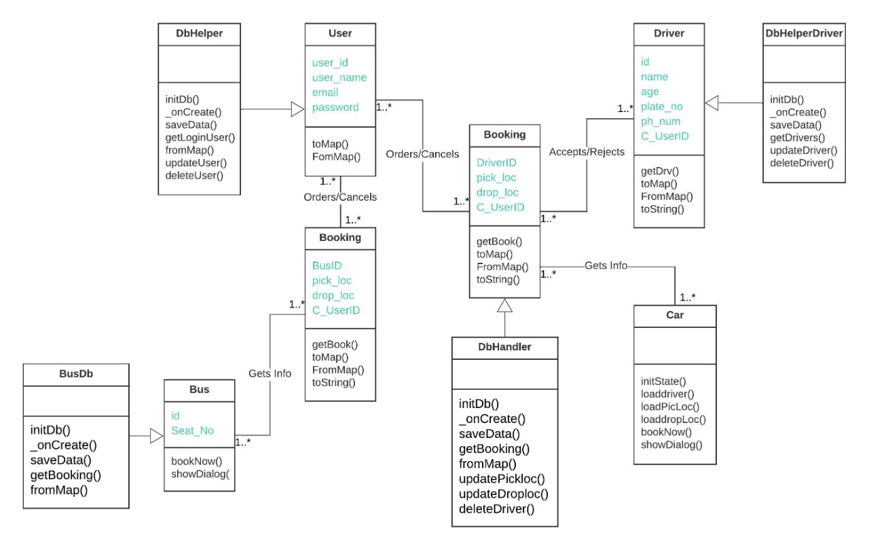

* + **Graphical user interface, text

    Description automatically generated with medium confidenceUser Interface Design**

* + **ER Diagram**

