These are my results after I ran the WORDCOUNT EXAMPLE in HADOOP. I ran it in both single-node and pseudo cluster mode. For further review I have attached some screenshots of my results below and provided configuration and source files. Please email at mafaroo1@uno.edu regarding any questions about the information below.

This is output on the terminal
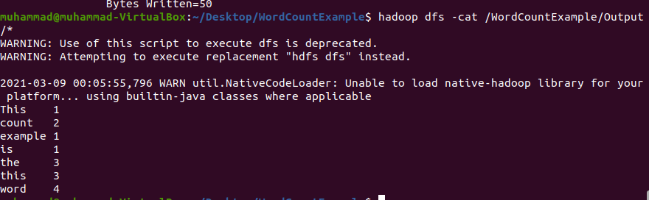

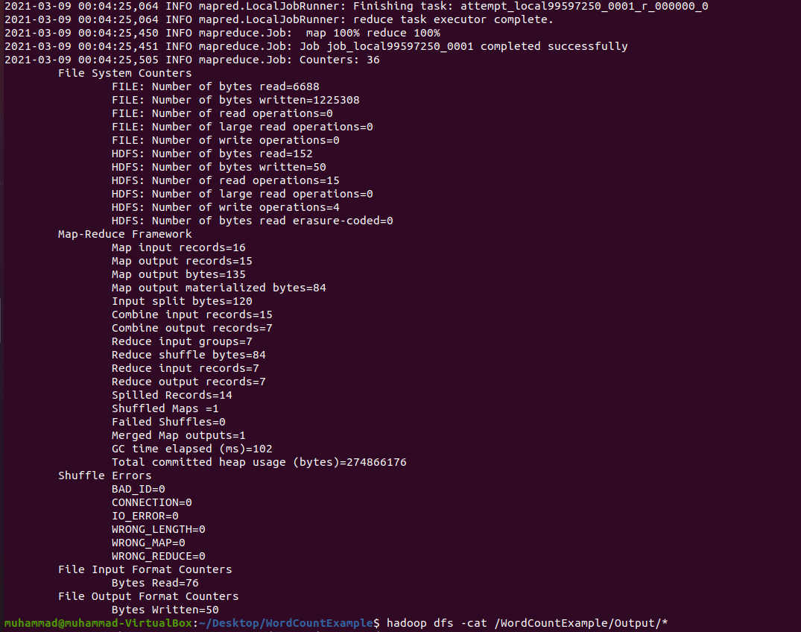
This shows that program ran successfully and mapreduce job was completed.

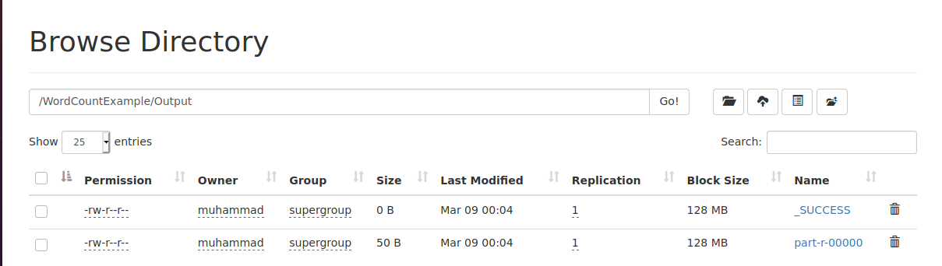
This is a screenshot from local host stating the output was a success.

