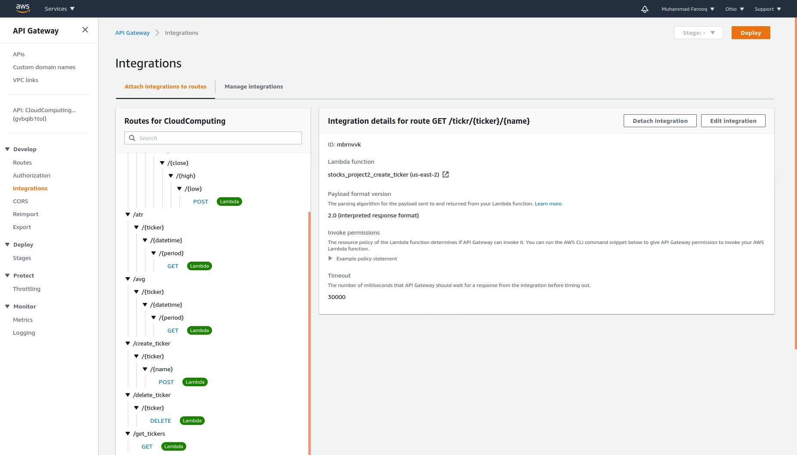
Run script runnable.sh to integrate the functions into API

Here is a screenshot of my console with the functions integrated.

