Software Requirements Specification
Requirements Specification for App in Medical Application Platforms
Version 1.0
<<Annotated Version>>

June 20, 2020
Eng nahla saad aldeen

Ammar alabrash
Hamza zakraia
Osama Audi

<<Any comments inside double brackets such as these are not part of this SRS but are comments upon this SRS example to help the reader understand the point being made.
Refer to the SRS Template for details on the purpose and rules for each section of this document.
The two students presented this work as a project for the fourth year of the software department
The project works on the Android platform, providing medical services to people and helping doctors and medical centers display their information and sites >>

المحتويات
0.2 List of Figures 3
1.0 Introduction 4
1.1. Purpose 4
1.2 . Scope of Project 4
1.3. Glossary 4
1.4. Reference Documents 5
1.5. Overview of Document 5
2.0 Overall Description 6
2.2 Functional Requirements Specification 7
2.2.1 User Use Case 7
2.2.2 Doctor Use Case 8
Describes the entry of the user (doctor, pharmacy, hospital or medical center) so that he is previously registered in app database 9
Describes the entry of the user (doctor, pharmacist or medical center) And send his personal data (name, phone and location…) to be stored at the Database after verification by the Admin 9
Describes the entry of the user (doctor, pharmacist or medical center) so that he is previously registered in Database And modify his data when it has any change 10
2.2.3 Admin Use Case 10
2.3 User Characteristics 13
2.4 Non-Functional Requirements 13

0.2 List of Figures
Figure 1 - System Environment 6.

Introduction

Purpose

The purpose of this document is to present a detailed description of the Android Application System. It will explain the purpose and features of the system, the interfaces of the system, what the system will do, the constraints under which it must operate and how the system will react to external stimuli. This document is intended for both the stakeholders and the developers of the system and will be proposed to the collage As a project for the fourth year software department.

1.2 . Scope of Project
The goal of this project is to build a customer / server application running on the Android platform to allow the user to facilitate the finding of medical places within the government of Homs
The user will browse and search for medical facilities in this city.
The search can be by region or service required
The registrants can update their data and the admin can control the accounts (remove, update).

1.3. Glossary
Acronyms / Definitions / Terms | Description
Database | Collection of all the information monitored by this system.
Admin | Application Developer
Doctor | the services provided by the application for example pharmacy, doctors, hospitals and medical centers
View | Review the types of services provided and their locations
Search | Looking for the required service so that it is closest to its location
App | Shortcut is intended to application your doctor here
Sign in | The doctor, hospital, or medical center is registered with the application
Sign up | The doctor, hospital, pharmacy or medical center send the request for registration by application...
Information | Personal data of the doctor, hospital, pharmacy or medical center ( name, telephone number, location and specialty)
Account | A special account for each application registrant that includes personal data and gives it the possibility of modification
ID | A number given by the administrator for easy deletion, filtering or modification...
Stakeholders | Any person with an interest in the project who is not a developer.

1.4. Reference Documents
IEEE. IEEE Std 830-1998 IEEE Recommended Practice for Software Requirements Specifications. Internet

1.5. Overview of Document
The following section, the General Description section, of this document provides an overview of the functionality of the application. Describes informal requirements and is used to create a context for specification of technical requirements in the next chapter.
Chapter III, section requirements specifications, of this document is written primarily for developers and technically describes the details of the application function.
Both sections of the document describe the entire program product itself, but are intended for different audiences, and therefore use a different language

Overall Description
2.1 System Environment
Contains a detailed description of the medical system that explains the purpose of the system and its features and the constraints under which it must operate
The system provides a user interface that can be used to search for its target. It also allows doctors and medical centers to publish their detailed information by registering with the application. This is done after the manager approves their request after verifying their information.
<<The system divides into two parts a user looking for a medical service and a Doctor that provides his information and location on the application to make it easier for the user to choose and determine his request. is an example of using domain classes to make an explanation clearer. >>

Application

App Manager

DB
Admin
Doctor
User

Figure 1 - System Environment

2.2 Functional Requirements Specification
This section outlines the use cases for each of the active Actors .
The user has two use case view and search .

2.2.1 User Use Case
The User has the following sets of use cases:
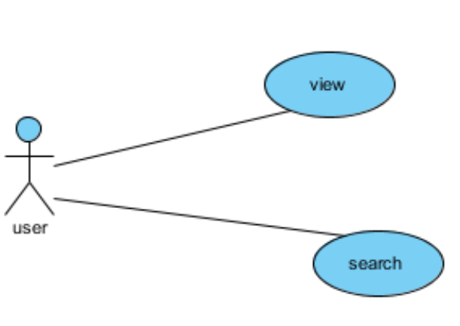
2.2.1.1 View use cases
Use case : View
Diagram
User
View
Brief Description
The user browses the application interface the doctors and reads their profile information and sites
Initial Step-By-Step Description
Before this use case can be initiated The user loads the application on their mobile device
- He logs on with his own email
- A user browser his request according to the nearest to his region.

Xref: Section 3.2.1, View
2.2.1.2 Use case name: Search
Diagram
User
Search
Brief Description
The user search through the application interface doctors and reads their profile information and sites
Initial Step-By-Step Description
Before this use case can be initiated The user loads the application on their mobile device
- He logs on with his own email
- Looking for a doctor or a specific medical center
- Look for a doctor or medical center are closet to him
Xref: Section 3.2.2, Search

Doctor Use Case
In this use case for multiple users, is described the users pharmacy, doctors, hospitals and medical centers where he is registered enters his own information and location and he can updates his information
. 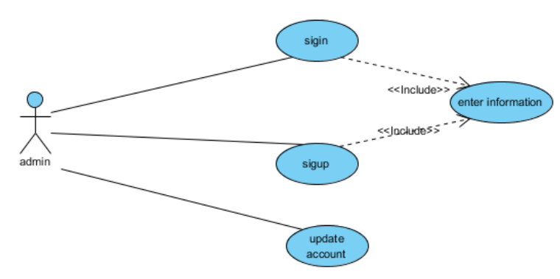
Doctor

2.2.2.1 Use case: Doctor sign in
Diagram:
Doctor
Sign in
Brief Description

Describes the entry of the user (doctor, pharmacy, hospital or medical center) so that he is previously registered in app database
Initial Step-By-Step Description
Before you start using the state of use, the user has uploaded the application to their device
- log in
- sign out
Xref: Section 3.2.3,
Diagram :

2.2.2.2 Use case: Doctor sign up
Sign up

Doctor

Brief Description

Describes the entry of the user (doctor, pharmacist or medical center) And send his personal data (name, phone and location…) to be stored at the Database after verification by the Admin

Initial Step-By-Step Description
Before you start using the state of use, the user has uploaded the application to their device
- Send his personal information (name and telephone number)
- Determines its specialization
- Determines his location
Xref: Section 3.2.4, sign up

2.2.2.3 Use case: Doctor update
Diagram:

Update Reviewer

Doctor

Brief Description

Describes the entry of the user (doctor, pharmacist or medical center) so that he is previously registered in Database And modify his data when it has any change
Initial Step-By-Step Description
Before you start using the state of use, the user has uploaded the application to their device
- log in
- modify his data
- send his new data
- sign out
Xref: Section 3.2.5,

Admin Use Case
this use case for Admin the application Describes the work of the application Admin who can accept register by the (doctor or medical center) after checking the validity of his information and deleting accounts
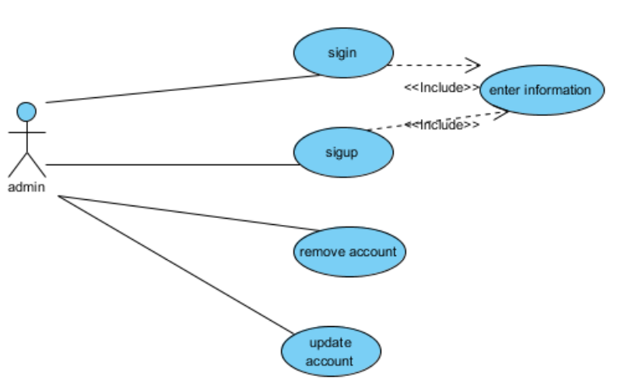

2.2.3.1 Use case: Admin sign in
Diagram:
Admin
Sign in

Brief Description
Describes the sign-in process by the Admin
Initial Step-By-Step Description
Before this situation begins, the administrator has finished application development and is ready to use
- Log in using his username and password
- Create new accounts
- Grant a special ID to users (doctor and clinic) to activate the account after confirming their identity
Xref: Section 3.2.3,

2.2.3.2 Use case: Admin sign up
Diagram:
Admin
Sign up

Brief Description
Describes the sign-up process by the Admin
Initial Step-By-Step Description
Before this situation begins, the administrator has finished application development and is ready to use
- Create username and password for him
Xref: Section 3.2.4

2.2.3.3 Use case: Admin update
Diagram:
Admin
update account

Brief Description
Describes the update account process by the Admin
Initial Step-By-Step Description
Before this situation begins, the administrator has finished application development and is ready to use and create his account
- Updating previously registered information in the database after sending the user new information
Xref: Section 3.2.5,

2.2.3.4 Use case: Admin remove
Diagram:
Admin
remove account

Brief Description
Describes the remove account process by the Admin
Initial Step-By-Step Description
Before this situation begins, the administrator has finished application development and is ready to use and create his account
- Remove previously registered information in the database
Xref: Section 3.2.6

User Characteristics
The User is expected to be Internet literate and be able to use a search engine to download the application. The interface of application will be easy to user and doctor
The detailed look of these pages is discussed in section 3.2 below.

Non-Functional Requirements
- Access to the system allows (Normal user) just access the system and review the content
- It should work on more than one version of Android
- The application interface should be easy and clear to users

