Data Mining Project
Master in Data Science and Advanced Analytics

NOVA Information Management School
Universidade Nova de Lisboa

Title of Report

Group 99

Student1 Name, 20001111
Carolina Luz, 20250409
Student3 Name, 20003333
Student4 Name, 20004444

Fall/Spring Semester 2025-2026

TABLE OF CONTENTS

1. Introduction 1
2. Section Heading Level 1 1
2.1. Level 2 Title 1
2.1.1. Level 3 title 2
2.1.1.1. Level 4 title 2
3. Another Section Heading 2
Bibliographical References (Optional, Not included in page limit) 3
Appendix A (Optional, Not included in page limit) 4
Annexes (Optional, Not included in page limit) 5

Introduction
Amazing International Airlines Inc. (AIAI) is an Airline company that was been in the market for a couple of years now and as any successful and competitive industry understand the important to keep improving in all aspects of the business. Using data analytics to uncover customer segment insights is key to improving satisfaction, building loyalty, and boosting revenue potential. Currently Amazing International Airlines is trying to address the need to design individualized services and marketing plans suited to a broad and diverse range of customers.
Through the strategic use of data analytics, AIAI can conduct customer segmentation to identify distinct groups within both its loyalty program and broader customer base. For example, some travelers may place greater value on premium services and convenience, whereas others may prioritize affordability and essential travel options. Moreover, certain segments might reveal seasonal travel tendencies or show preferences for specific destinations or routes. By uncovering these behavioral and preference-based patterns, AIAI can refine its service portfolio, loyalty incentives, and marketing strategies to effectively address the unique expectations of each customer segment.
The purpose of this report is to provide an overview of potential strategies and solutions that could help AIAI enhance these capabilities and further improve customer satisfaction, loyalty, and overall business performance.

Data Exploration
We began by performing exploratory data analysis on both datasets — Customers and Flights — to develop a comprehensive understanding of the data. Initially, we examined the Customers dataset, which consisted of 16,921 rows and 20 columns. Subsequently, we analyzed each table within the dataset separately to gain a detailed understanding of the data and its underlying structure.

Within the 20 columns of the dataset, we examined potential data inconsistencies, missing values, and duplicate entries. Additionally, we verified the data types of each column to ensure consistency and logical coherence. During this process, the Loyalty variable was converted from an integer to a string format, while EnrollmentDateOpening and CancellationDate were converted from object to date formats. We also verified that the combination of the First Name and Last Name variables corresponded exactly to the Customer Name variable. Since this duplication did not contribute any additional information, we decided to remove the First Name and Last Name variables and retain only the Customer Name variable.

Data inconsistencies were identified in cases where different customers shared the same loyalty number. This anomaly is presumed to result from data entry errors and may compromise the relationship between customers and flight records. Consequently, we plan to remove these records in subsequent cleaning stages, considering that they represent only 0.97% of the total data. We identify other inconsistencies in the cancellation date which occurs before the enrollment date, there are 121 records representing (0.715%), they are invalid so we should exclude them in the future.
In this dataset, we identified five geographical variables: Country, Province or State, City, Postal Code, and Latitude and Longitude. Upon examination, we found that the Country variable contained only a single unique value (Canada), indicating that it is not a meaningful attribute for analysis and can therefore be removed from the dataset. To ensure data accuracy, we also verified compliance with Canadian postal code formatting rules and observed that 15.79% of the records contained invalid postal codes (i.e., values not adhering to the official Canadian postal code structure). This represents a considerable portion of the dataset, suggesting that these geographical features may not reliably represent customer location information.
We then examined the Flights dataset, which consisted of 608,436 rows and nine columns, and conducted a separate analysis of each table within the dataset to gain a detailed understanding of the data and its underlying structure.
Within these nine columns, we also assessed potential data inconsistencies, missing values, and duplicate entries. Similar to the Customers dataset, we verified the data types of all variables and identified the need to perform several conversions: the Loyalty variable was converted from an integer to a string format; YearMonthDate was converted from an object to a datetime format; and both NumFlights and NumFlightsWithCompanions were converted from float to integer formats.
For duplicate entries, we identified a total of 5,778 records, representing 0.95% of the dataset. As these records do not provide any additional information, they will be removed during the data cleaning process.
We then combined the two datasets to look for extra information and analysis. Looked for data inconsistence and 20 customers records were not found in the flight database, and then Remove duplicate Customers from both databases and filled the missing values of newly created columns with 0 and converting data type of some columns ('NumFlights', 'NumFlightsWithCompanions', 'DistanceKM', 'PointsAccumulated', 'PointsRedeemed', 'DollarCostPointsRedeemed')

Feature Engineering
From the customers dataset we performed a Boolean feature in the IsCancelled variable indicating whether a customer left the program or not. Looking at another perspective, it provides information about active customers. We then create a new derived feature (Tenure_months) calculate each customer’s tenure (in months) — that is, how long they’ve been with the company.
You’re creating new engineered features that flag zero (IncomeZero_flag) or missing income (IncomeNA_flag) and calculate each customer’s lifetime value relative to their income (CLV_per_income).
We decided not to search for missing values or data inconsistencies in newly created features, because if existent, they are likely due to the original features from which they were derived. So, in the following phase, when correcting missing values for those features, new features will be corrected as a consequence.

Univariate aNALYSIS
For the metric features in the customer's dataset, the Income variable suggested two separate groups: one with zero income and another distributed mostly between 15,000 and 100,000, most likely indicating persons who either did not report their income or had no earnings, such as children. The Customer Lifetime Value (CLV) has a strong right-skew, with the majority of customers ranging from 2,000 to 10,000 and a tiny high-value sector being in the tens of thousands. The latitude and longitude values were inline with Canadian geographic boundaries, with concentrations around significant population centers in Ontario, Quebec, and British Columbia. Tenure (months) varied mostly between 50 and 125 months, with a notable peak at 55-60 months, indicating a big 2018-2019 enrollment cohort.
The CLV-to-Income ratio was similarly heavily skewed to the right, showing that a tiny minority of consumers created far more value than their income (see Figure 1, Appendix).

Non-metric features were highly concentrated in Ontario (32%), British Columbia (26%), and Quebec (20%), with big metropolitan regions like Toronto, Vancouver, and Montreal dominating the city distribution. Gender distribution was balanced, and the majority of education levels were bachelor's (62.6%) and college (25.3%). The locations were evenly spread throughout suburban, rural, and urban categories, and the majority of clients (58%) were married. Loyalty categories were distributed among Star (46%), Nova (34%), and Aurora (20%), while enrollment type was primarily Standard (93%), with just a minor number coming from the 2021 Promotion (7%). Finally, most clients (94.6%) stayed active, with only 5.4% canceling their membership (see Figure 2, Appendix).

As for the flights dataset a new variable, average distance per flight, was created to capture client travel behavior. It reflects the average distance traveled each flight, giving insight into whether consumers prefer shorter regional trips or longer-distance flights. Companion_share was also designed to track the percentage of flights done with companions. This measure adds insight into consumer travel behavior, distinguishing those who travel alone from those who regularly fly with others.
This analysis revealed that most customer months had no flight activity, with distinct right-skewed trends across NumFlights, NumFlightsWithCompanions, and DistanceKM. A very small percentage of customers accounted for the majority of long-distance and high-engagement trips. PointsAccumulated, DistanceKM, PointsRedeemed, and DollarCostPointsRedeemed all exhibit similar distributions, indicating redundant data. The avg_distance_per_flight variable suggested primarily short to moderate journeys; however, companion_share revealed two patterns: solo travelers and those who typically fly with companions (see Figure 3, Appendix).

To comprehend consumer travel behavior, we discovered that 8.9% of customers had no documented flights, most likely due to new loyalty program members. The majority of clients were active but did not fly on a monthly basis, showing irregular yet recurring travel activity. No customers flew every month, indicating that flight activity is sporadic centered among a limited number of people. These data aid in identifying different degrees of client interaction and facilitating segmentation based on trip frequency and behavior (see Figure 4, Appendix).

For the combined dataset, the analysis of the newly created metric features reveals distinct variations in how customers travel and use rewards. The histograms indicate that some parameters, such as the number of flights and total distance, divide consumers into two groups: those who travel occasionally and those who travel frequently. In contrast, features such as the number of flights with companions, points redeemed, and dollar value of redeemed points are typically low, indicating that most customers rarely travel with others or use their reward points, whereas a smaller group does so frequently. There are no missing values, indicating that the data is clean; nonetheless, certain changes, such as utilizing simpler scales or transformations, might facilitate comparisons. Overall, the findings show clear and persistent trends in consumer travel behavior and reward usage (Figure 5, Appendix).

Outliers
CUSTOMERS
Boxplots were generated for all numerical features to identify extreme values and guide subsequent data treatment
For Income, the distribution is right-skewed, with a median around 33–35k and values extending up to 100k. Two main outlier groups were identified: a mass at zero, likely representing non-disclosed or missing income values, and high earners within the top percentiles. Customer Lifetime Value (CLV) also showed a strong right skew, with typical values around 5–6k and several extreme observations exceeding 80k, which likely represent genuine high-value customers rather than errors.
Latitude and Longitude values were consistent with Canadian geographic ranges. A few northern and coastal points were detected as outliers but considered valid due to their geographic plausibility. Tenure (months) displayed a wide distribution centered around 80–85 months, with some negative values identified as invalid entries to be removed. Finally, the CLV-to-Income ratio showed a narrow IQR with a long right tail, where unusually high ratios resulted primarily from very low or zero income values.

FLIGHTS
The boxplot analysis of the Flights dataset showed strong right-skew and high zero inflation across most variables. NumFlights, NumFlightsWithCompanions, and DistanceKM all revealed low medians with long right tails, indicating that while most customers have no monthly flights, a few exhibit heavy-travel behavior. PointsAccumulated closely mirrored DistanceKM, and PointsRedeemed aligned with DollarCostPointsRedeemed, suggesting redundancy among these pairs. avg_distance_per_flight displayed extreme values caused by small flight counts, while companion_share revealed two clear behaviors—customers who mostly travel alone and those who consistently fly with companions.

CORRELATION

We then did a correlation matrix using the Pearson but didn’t find any relevant correlation (figure x) so decided to use the spearman since it handles skewness and outliers better (figure x).

The Spearman rank correlation analysis (see Figure 5, Appendix) was performed to identify general patterns and rank-based relationships between key business metrics. Results were consistent with the Pearson analysis, showing a strong positive association between Customer Lifetime Value (CLV), Income, and CLV per Income, confirming that these metrics move together and capture similar aspects of customer value. Latitude and Longitude showed a moderate negative relationship (−0.54), reflecting Canada’s geographic layout from southwest to northeast. All other relationships were weak, indicating that factors such as income, tenure, or geographic location have limited influence on customer value. These findings suggest that while income and CLV are naturally related, location and customer longevity play a smaller role in driving overall customer profitability.

Geographical Visualization
For the geographical interpretation of the combined dataset, several visual analyses were conducted. A bar chart shows the top 10 cities by total flights compared with the overall flight count (Figure X, Appendix), and another illustrates the top 10 cities by flights with companions (Figure Y, Appendix). A pie chart presents the percentage share of total flights by customer education level (Figure Z, Appendix). A geospatial scatter plot displays the Distance Flown by Location, showing where customers are located (via latitude and longitude) and how much each has flown (via color intensity) (Figure W, Appendix). Lastly, a regional bar chart displays the average number of flights per customer across Canadian regions (Figure V, Appendix).

Several regional trends may be seen in the distinct customers dataset. Customer activity rates are equally high across Canada (0.83-0.89), with a slight difference of about six percentage points. A distinct regional tendency emerges: the far West (Yukon and British Columbia) and Atlantic provinces (Prince Edward Island and Nova Scotia) have highest activity rates, while the Prairies, notably Manitoba and Saskatchewan, lag behind. Ontario and Quebec remain constant in the middle range (Figure T, Appendix).

Customer counts are concentrated in a few provinces, with Ontario having the largest customer base, following by British Columbia and Alberta. Quebec has a significant but smaller base than Ontario, whereas Manitoba and Saskatchewan have lower populations. The Atlantic provinces (Nova Scotia, New Brunswick, Newfoundland, and Prince Edward Island) have the smallest proportions, while Yukon has very little representation. This uneven geographical footprint shows that disparities in number of consumers may impact provincial key performance indicators (KPIs) such as active rate, customer lifetime value (CLV), and revenue, making results for smaller provinces like Prince Edward Island and Yukon more unpredictable (Figure O, Appendix).

For the flights dataset, a line chart was generated to display the active customer rate over time, displaying the percentage of consumers that took at least one flight (NumFlights > 0) throughout each period. This time series illustrates the proportion of consumers who fly each month. The active customer rate climbed from roughly 44% in early 2019 to around 51% by late 2019, followed by a dramatic fall in early 2020, possibly due to the COVID-19 outbreak and related travel restrictions. Following this drop, the rate steadily rebounded during 2020 and increased significantly in 2021, indicating a comeback in consumer activity and engagement. Overall, seasonality looks to be mild, with the major trend being a brief fall in early 2020, followed by steady increase (Figure Q, Appendix).

Appendix A
Figure 1.

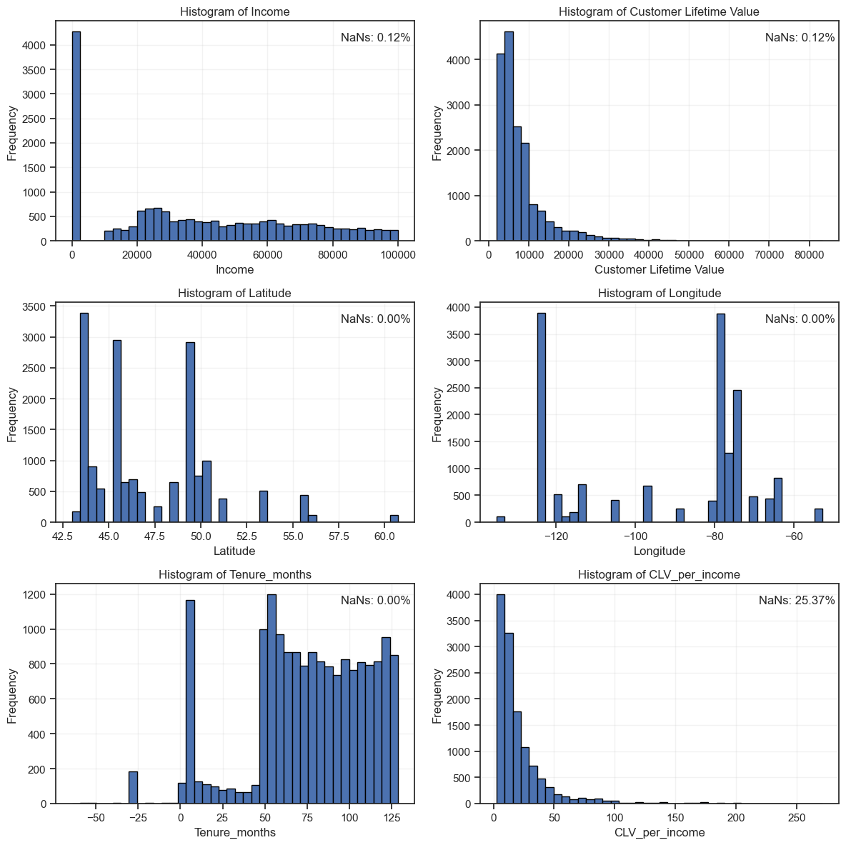

Figure 2.
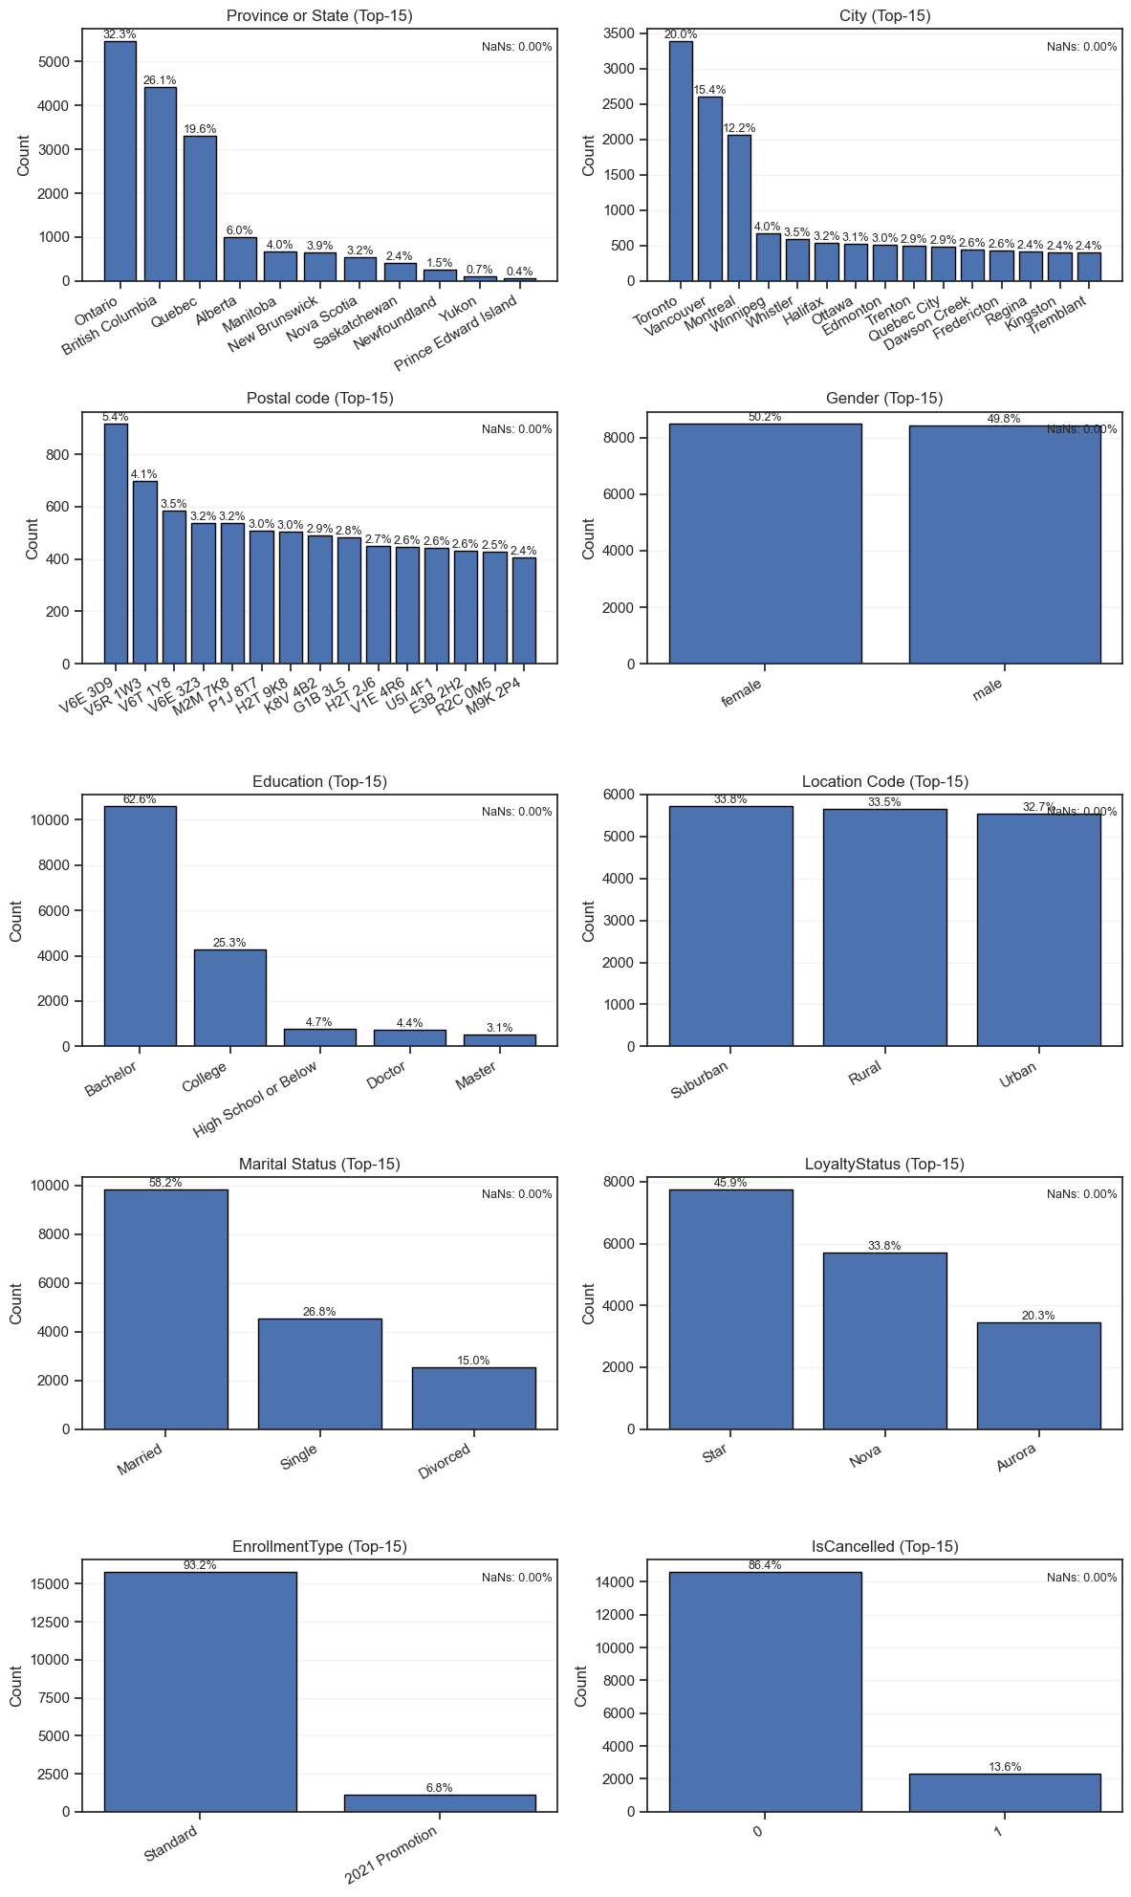
Figure 3.

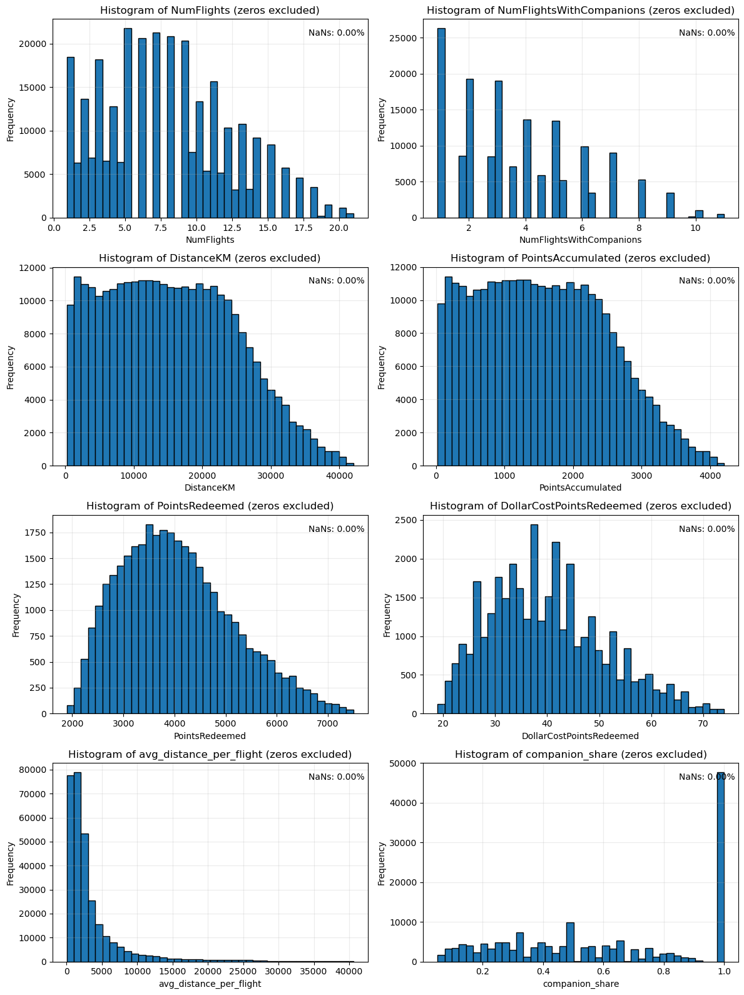

Figure 4.

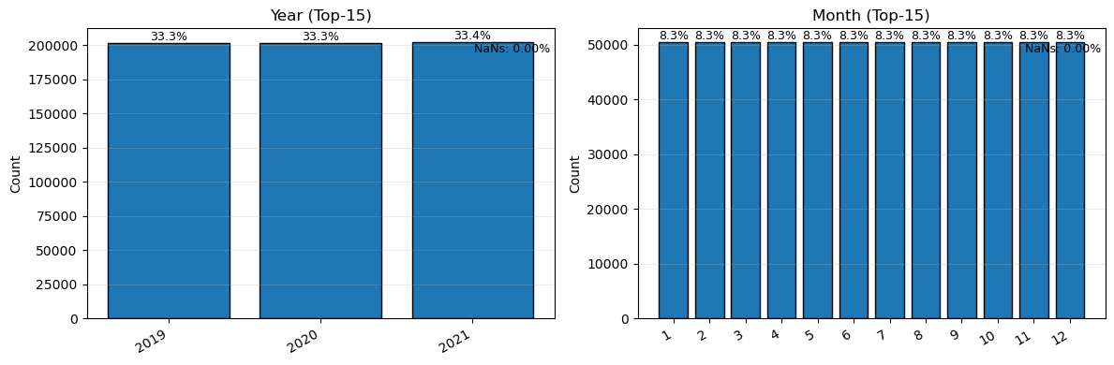

Figure 5.

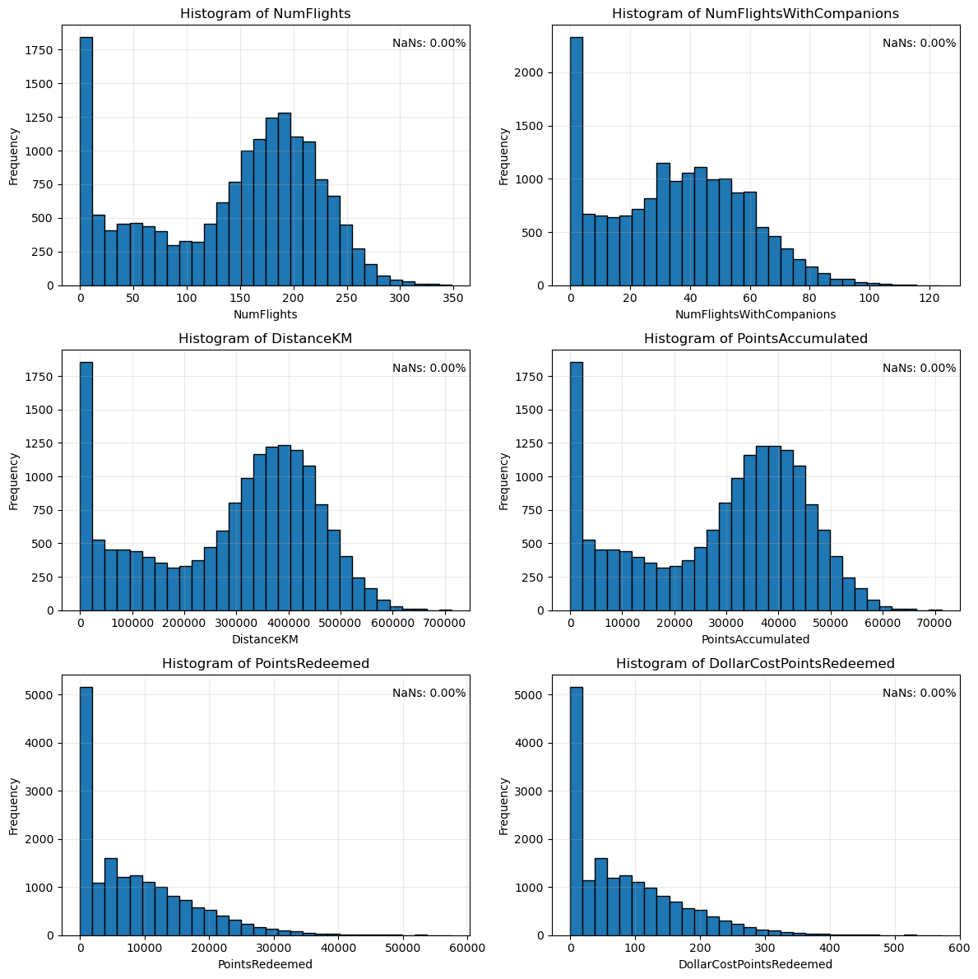

(….)

Figure x. 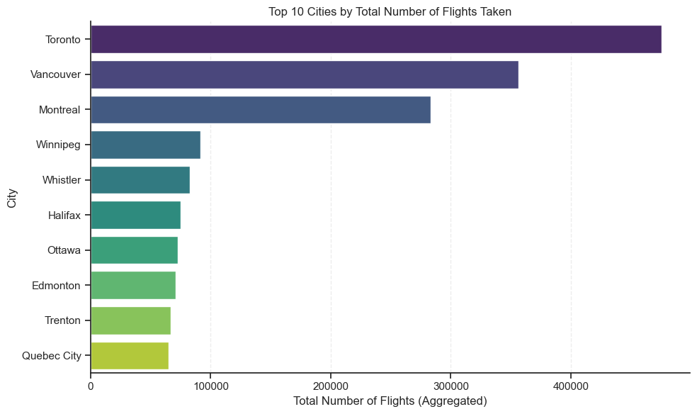

Figure y.

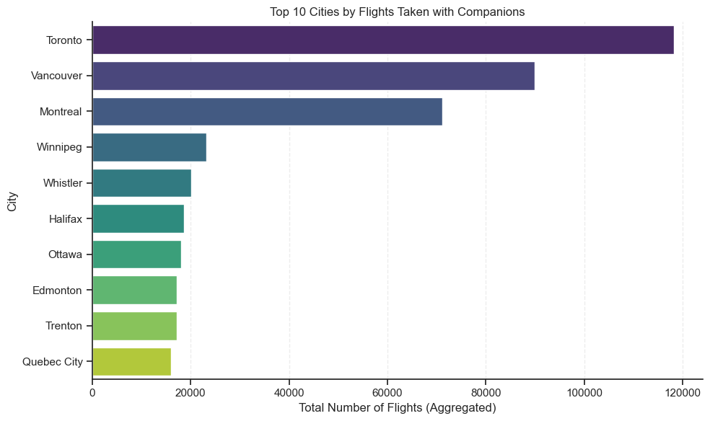

Figure z.
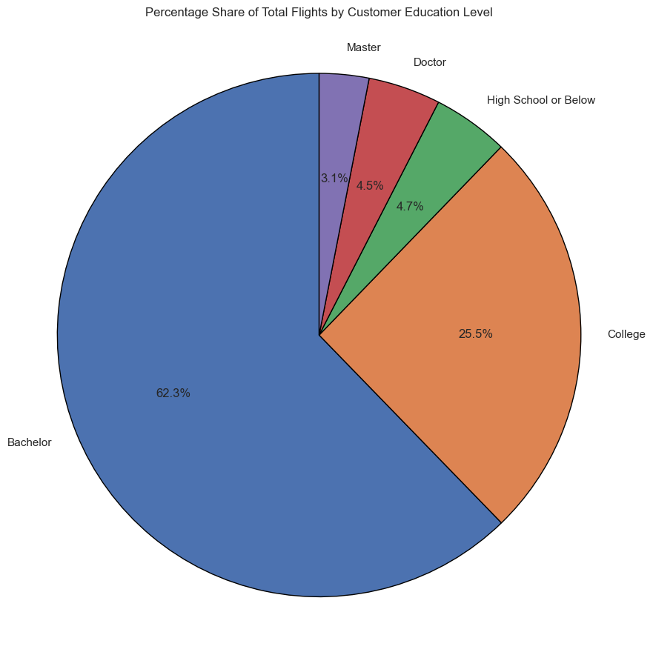
Figure w. 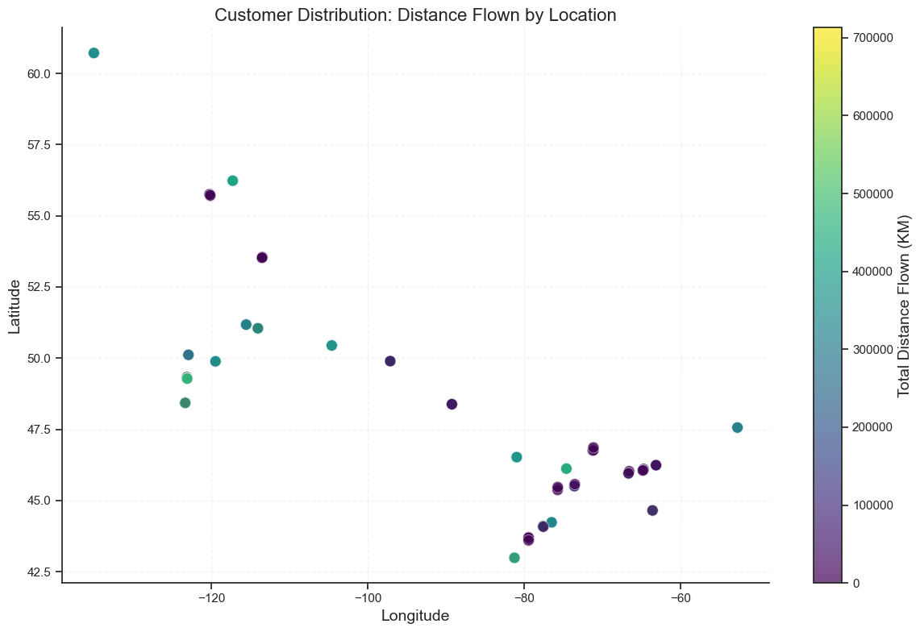

Figure v.
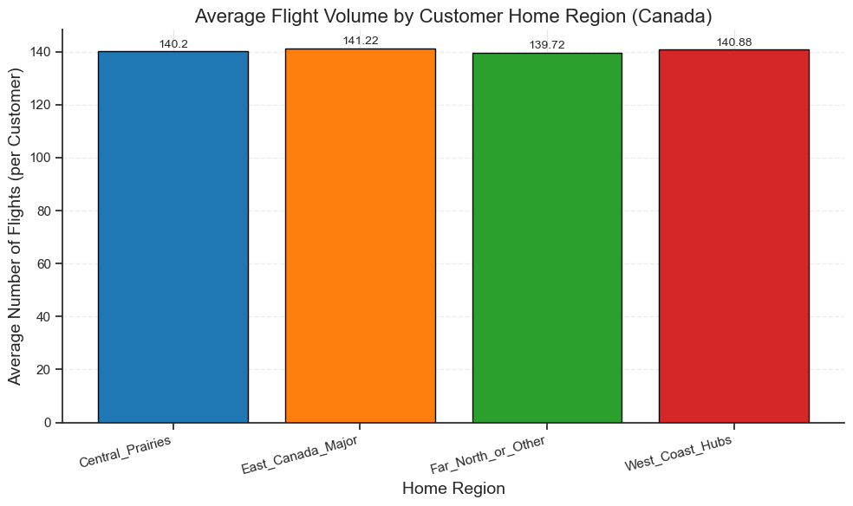

Figure T.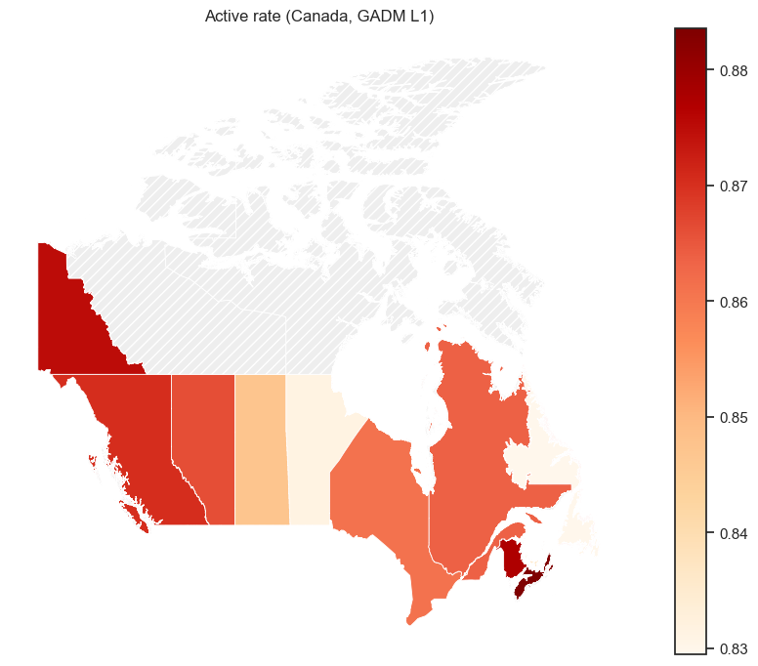

Figure O.
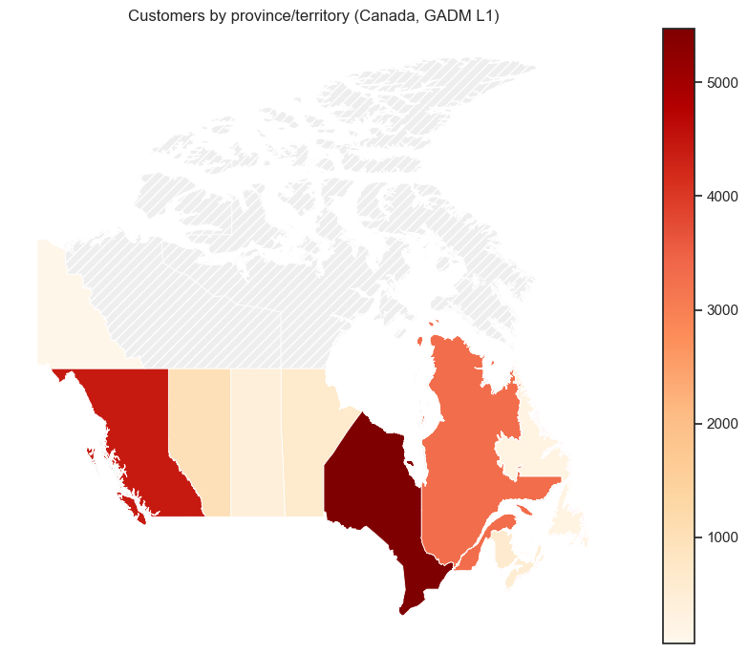

Figure Q.

