Data Mining Project
Master in Data Science and Advanced Analytics

NOVA Information Management School
Universidade Nova de Lisboa

Amazing International Airlines Inc.

Group 25

Carolina Luz, 20250409
Marta Boavida, 20240519
Muhammad Ammar, 20250440
Muhammad Khuzaima Bashir, 20250441

Fall/Spring Semester 2024-2025

TABLE OF CONTENTS

1. 1
Data analysis: 1
1.1. 1
1.2. 1
1.3. 2
2. 2
2.1. 2
2.2. 2
2.2.1. 2
2.2.2. 2
2.3. 3
2.3.1. 3
2.3.2. 3
2.4. 3
2.4.1. 3
2.4.1.1. 3
2.4.1.2. 4
2.4.2. 4
2.4.3. 4
2.4.4. 5
3. 5
Appendix A: 6
ANNEX: 25

Introduction
Amazing International Airlines Inc. (AIAI) operates in a highly competitive airline industry where continuous improvement and customer understanding are essential for success. To strengthen loyalty and profitability, AIAI aims to leverage data analytics to perform customer segmentation, identifying distinct groups within both its loyalty program and broader customer base. By uncovering behavioral and preference-based patterns, such as service priorities, spending habits, or travel frequency, the airline can design personalized services, loyalty incentives, and marketing strategies tailored to each segment. This initiative aligns with the CRISP-DM framework, focusing on using data-driven insights to enhance customer satisfaction, retention, and overall business performance.

Data analysis:

Customers:
We began by performing exploratory data analysis to develop a comprehensive understanding of the data. The Customers dataset consisted of 16,921 rows and 20 columns. No full duplicate records were identified in the dataset. Regarding missing data, the CancellationDate variable showed a high proportion of missing values (86.36%), which is expected since most customers remain active and therefore have no cancellation record. Additionally, Customer Lifetime Value (CLV) and Income had small proportions of missing data (0.12% each), and these missing values were found to occur for the same customers. Regarding datatypes, the Loyalty variable was converted from integer to string, while EnrollmentDateOpening and CancellationDate were converted from object to date formats. First Name and Last Name were merged into a single Customer Name variable to remove redundancy.
Data inconsistencies were observed in customers sharing the same loyalty number (0.97% of data), which likely stems from entry errors and will be removed since they compromise the relationship between customers and flights records. Similarly, 121 records (1.194%) had cancellation dates preceding enrollment dates, and these will also be excluded. Additionally, we identified five geographical variables: Country, Province or State, City, Postal Code, and Latitude and Longitude. Upon examination, we found that the Country variable contained only a single unique value (Canada), indicating that it is not a meaningful attribute for analysis and can be removed from the dataset. To ensure data accuracy, we also verified compliance with Canadian postal code formatting rules and observed that 15.79% of the records contained invalid postal codes (i.e., values not adhering to the official Canadian postal code structure). This represents a considerable portion of the dataset, suggesting that these geographical features may not reliably represent customer location information.

Flights:
The Flights dataset contained 608,436 rows and 9 columns. We searched for data inconsistencies, missing values and duplicates. Adjustments included converting Loyalty# to string, YearMonthDate to datetime. We also found that NumFlights and NumFlightsWithCompanions are floats and they should be rounded to unit values in subsequent preprocessing stage. For duplicate entries, we identified a total of 5,778 records, representing 0.95% of the dataset. As these records do not provide any additional information, they will be removed during the data cleaning process. There are no missing values in this dataset. Approximately 9.97% of rows showed impossible values (NumFlights = 0 with positive distance and points) and will also be excluded. There were no missing values in this dataset.

Results:

Feature Engineering:
For the Customers dataset, we created a Boolean feature IsCancelled indicating whether a customer left the program or not. Looking at another perspective, it provides information about active customers. We then create a new derived feature, Tenure_months, which represents customer longevity in the company. We also calculated CLV_per_income to measure value relative to income.
For the flights dataset a new variable, average distance per flight, was created to capture client travel behavior. It reflects the average distance traveled each flight, giving insight into whether consumers prefer shorter regional trips or longer-distance flights. Companion_share was also designed to track the percentage of flights done with companions. This measure adds insight into consumer travel behavior, distinguishing those who travel alone from those who regularly fly with others.

Univariate Analysis:

Customers:
For the metric features in the customer's dataset, the Income variable suggested two separate groups: one with zero income and another distributed mostly between 15,000 and 100,000, most likely indicating persons who either did not report their income or had no earnings. The CLV has a strong right-skew, with the majority of customers ranging from 2,000 to 10,000 and a tiny high-value sector being in the tens of thousands, indicating a small elite segment driving outsized value. Tenure varied mostly between 50 and 125 months, with a notable peak at 55-60 months, indicating a big 2018-2019 enrollment cohort. The CLV-to-Income ratio was similarly heavily skewed to the right, showing that a tiny minority of consumers created far more value than their income (Fig 1, Appendix).
For non-metric features, customers were highly concentrated in Ontario (32%), British Columbia (26%), and Quebec (20%), with big metropolitan regions like Toronto, Vancouver, and Montreal dominating the city distribution. Gender distribution was balanced, and most education levels were bachelor's (62.6%) and college (25.3%). The locations were evenly spread throughout suburban, rural, and urban regions, and the majority of clients (58%) were married. Loyalty categories were distributed among Star (46%), Nova (34%), and Aurora (20%), while enrollment type was primarily Standard (93%), with just a minor number coming from the 2021 Promotion (7%). The label for 2021 promotion implies those customers likely joined 2021. If we just compare standard vs promotion, we might attribute those differences to the channel, when they are might be due to when people enrolled. Finally, most clients (94.6%) stayed active, with only 5.4% canceling their membership (Fig 2, Appendix).

Flights:
For flights database, this analysis revealed that across all flight activity features, there is pronounced zero inflation, reflecting that most customer-months show no travel activity. When activity occurs, it tends to be episodic and highly right-skewed, with long tails indicating a few heavy travelers. DistanceKM and PointsAccumulated follow nearly identical shapes, suggesting redundancy between them. PointsRedeemed and DollarCostPointsRedeemed mirror this pattern, exhibiting extreme zero inflation and thin tails, again implying close correlation and redundancy. Average distance per flight remains right-skewed with most trips under 2,500 km, while companion_share highlights two clear behavioral modes: solo versus fully accompanied months, with few mixed cases. Overall, the data depicts a highly inactive customer base with occasional high-activity months, offering potential for segmentation based on engagement and travel style (Fig 3, Fig 4, Appendix). Moreover, both year and month features are evenly distributed (Fig 5, Appendix).
To comprehend consumer travel behavior, we found that 8.9% of customers had no documented flights, most likely representing new members. No customers flew every month, and the majority of clients were active but did not fly on a monthly basis, showing irregular yet recurring travel activity.

Outliers:

Customers:
For Income, the distribution is right-skewed and two main outlier groups were identified: a mass at zero, likely no income customers like student, and high earners within the top percentiles. Customer Lifetime Value (CLV) also showed a strong right skew and extreme observations exceeding 80k, which likely represent genuine high-value customers rather than errors. Latitude and Longitude values were consistent with Canadian geographic ranges. A few northern and coastal points were detected as outliers but considered valid due to their geographic plausibility. Tenure displayed a wide distribution with some negative values identified as invalid entries to be removed. Finally, the CLV-to-Income ratio showed a narrow IQR with a long right tail, where unusually high ratios resulted primarily from very low or zero income values (Fig 6, Appendix).

Flights:
NumFlights and NumFlightsWithCompanions both have medians near zero, compact interquartile ranges, and long upper whiskers extending to legitimate high-activity outliers, reflecting occasional heavy or group travel months. DistanceKM and PointsAccumulated show wide spreads and long right tails with valid extreme values, typical of aviation behavior. PointsRedeemed and DollarCostPointsRedeemed share the same pattern, mostly zeros with a thin high-value tail corresponding to redemption events making them redundant as well. Average distance per flight has a long right tail and extreme values driven by small denominators, while companion_share reveals two consistent patterns: mostly solo travel with some fully accompanied months. Year (2010–2021) and Month (1–12) show even distributions and no outliers. (Fig 7, Appendix).

Multivariate analysis:

Numerical features:

Customers:
In a first approach we built a correlation matrix using Pearson, however since most of our data is heavily skewed we decided to perform a second correlation analysis using Spearman due to its ability to handle skewness and outliers more effectively.
The relationships between CLV, income, and tenure reveal weak and non-linear patterns, supported by both the scatter plot analysis and the correlation results. CLV shows only a mild positive association with income, with high CLV values appearing across all income levels, confirming that income alone is not a strong predictor of customer value. The Spearman correlation matrix reinforces this finding, showing a strong positive relationship between CLV, Income, and CLV_per_Income, indicating that these metrics move together and capture overlapping aspects of customer value. CLV also rises quickly during early tenure periods before plateauing, while maintaining considerable variation within each tenure range, likely reflecting cohort effects. Income exhibits no clear link to tenure, with customers distributed widely between 50 and 125 months and a distinct cluster at zero income. The CLV-to-Income ratio generally remains low across tenure, with occasional spikes caused by very low-income values. (Fig 8, Fig 9, Appendix).

Flights:
The analysis of flight activity features reveals strong redundancy among several metrics and clear behavioral patterns in how customers earn and redeem points. DistanceKM and PointsAccumulated are almost perfectly linear and share identical distributions, confirming that they represent the same underlying behavior and that one of them can be removed without information loss. Similarly, PointsRedeemed and DollarCostPointsRedeemed are perfectly aligned, indicating full duplication. DistanceKM also shows a very strong correlation with avg_distance_per_flight, reinforcing their shared dependence on flight distance. A consistent pattern of zero inflation is observed across all activity variables, reflecting that most customer-months involve no flights or redemptions. Among active months, total distance traveled, not the number of flights, drives point accumulation, as shown by the wide DistanceKM variation within each NumFlights level (Fig 10 Appendix).
Correlation values confirm these relationships: NumFlights correlates strongly (≈0.85) with both DistanceKM and PointsAccumulated, while moderate correlations (0.5–0.7) appear between flight activity and companion-related measures (NumFlightsWithCompanions, companion_share), suggesting that customers who fly more are also more likely to travel with companions, particularly on longer trips. Companion-related features also show modest positive associations (≈0.4) with PointsRedeemed, implying that redemptions occasionally coincide with group or leisure travel. Weaker correlations (≈0.2) between redemption and earning metrics confirm that point accumulation and redemption occur at different times, as members tend to earn points consistently and redeem them sporadically. Finally, Year and Month show near-zero correlation with all activity variables, indicating stable behavioral patterns over time and minimal seasonal effects. (Fig 11 Appendix).
The time-series analysis of active customer rates highlights a clear behavioral shift across the study period. Engagement strengthened steadily through 2019 before a sharp decline in early 2020, aligning with the onset of the pandemic and its immediate impact on travel activity. However, the subsequent recovery and acceleration throughout 2020 and 2021 indicate a resilient customer base, with participation surpassing pre-pandemic levels. This pattern suggests growing customer reactivation and increasing loyalty engagement as travel conditions normalized. (Fig 12 Appendix).

Categorical features – customers:
For customer dataset, loyalty status and enrollment type show no meaningful variation across geographic segments, indicating that both attributes are evenly distributed among regions. Similarly, cancellation rates remain consistent across segments and geographies, suggesting uniform customer behavior. The only notable demographic relationship is between education and marital status where single customers tend to have a higher share of college-level education, while married individuals are more likely to hold bachelor’s degrees, and divorced customers fall between these groups. Beyond this, education levels show little variation across segments or locations (Fig 13-Fig 16 Appendix).

Categorical and numerical features – customers:
Across categories, CLV distributions are consistently right-skewed with long high-value tails, and the category curves largely overlap, indicating weak marginal differences. Geographic effects on CLV are also minimal. The only slight deviation is observed in EnrollmentType, where the 2021 Promotion group shows marginally lower CLV, likely due to shorter tenure. Tenure patterns reinforce the program’s maturity, with most customers active for 4–10 years and highly similar distributions across all categories. Geography again shows little influence, with provincial and city curves nearly identical and only the 2021 Promotion cohort standing out as a smaller, newer group. Income shows a bimodal shape with a large spike at zero and a right-skewed tail up to about 100k, reflecting a mix of non-earning college students and higher-income participants. Income is broadly consistent across all categories with only modest differences by education and marital status. (Fig 17-Fig 19 Appendix).

Geographical analysis – customers:
Customer activity rates are equally high across Canada (0.83-0.89). The far West (Yukon and British Columbia) and Atlantic provinces (Prince Edward Island and Nova Scotia) have highest activity rates, while the Prairies, notably Manitoba and Saskatchewan, lag behind. Ontario and Quebec remain constant in the middle range (Fig 20 Appendix).
Customer counts are concentrated in a few provinces, with Ontario having the largest customer base, following by British Columbia and Alberta. Quebec has a significant but smaller base than Ontario, whereas Manitoba and Saskatchewan have lower populations. The Atlantic provinces (Nova Scotia, New Brunswick, Newfoundland, and Prince Edward Island) have the smallest proportions, while Yukon has very little representation. This uneven geographical footprint shows that disparities in number of consumers may impact provincial KPIs such as active rate, CLV, and revenue, making results for smaller provinces like Prince Edward Island and Yukon more unpredictable (Fig 24 Appendix).
Median tenure varies modestly across Canada (~77-85 months), with a clear peak in Yukon (85 months) (Fig 23 Appendix). Median income also varies moderately across Canada (~$29k-$45k), with a peak in Prince Edward Island and Nova Scotia (Fig 22 Appendix). Finally, median CLV is fairly uniform across Canada with a modest ~$1.1K spread (Fig 21 Appendix).

conclusion:
This analysis establishes the analytical foundation for Data Preparation and Clustering. The findings show that redundancy among distance, points, and redemption metrics should be addressed through feature selection. High zero inflation and skewed distributions will require transformations (e.g., log-scaling or normalization). Segmentation hypotheses include clusters based on travel frequency (occasional vs frequent), companionship behavior (solo vs group), and value generation (high vs low CLV relative to income). The proposed clustering approach will employ standardized and scaled numerical features, removing redundant and low-variance attributes. Categorical attributes such as LoyaltyStatus and EnrollmentType may serve as post-cluster descriptors rather than direct inputs. The expected outcome is a set of distinct, interpretable customer segments that inform personalized engagement strategies, optimized loyalty design, and targeted marketing initiatives.
To study the interaction between datasets, a preliminary analysis was conducted by merging both datasets, however due to lack of preprocessing this will be reviewed in latter stages in which we plan to address inconsistencies specifically in loyalty# so that we can get a more realistic overview of our customers’ activity.

Appendix A:
Figure 1.
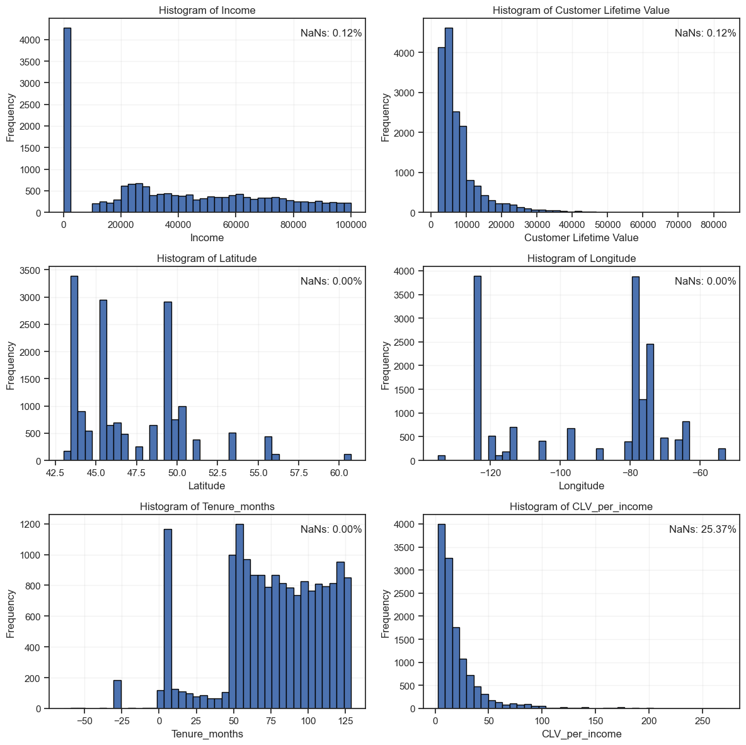

Figure 2.
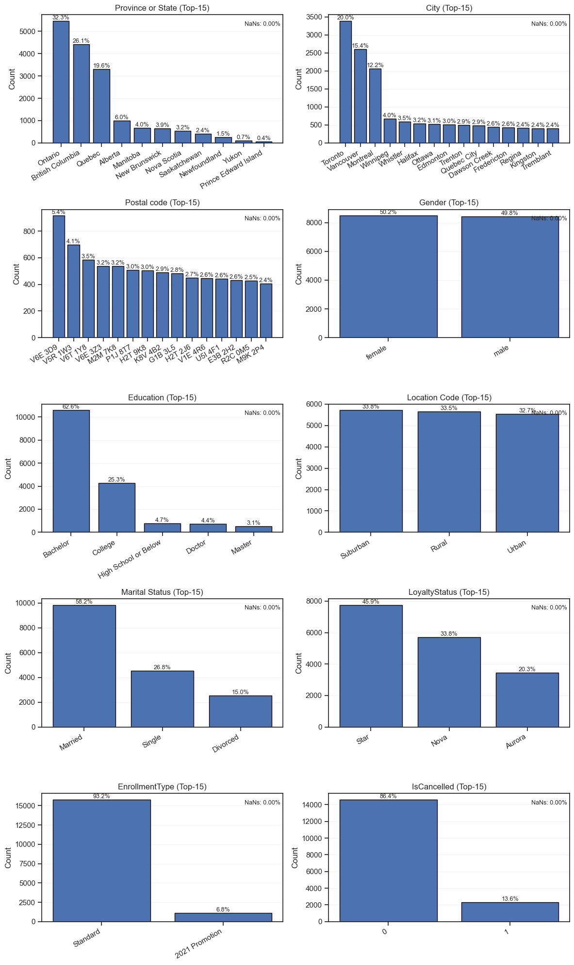
Figure 3.
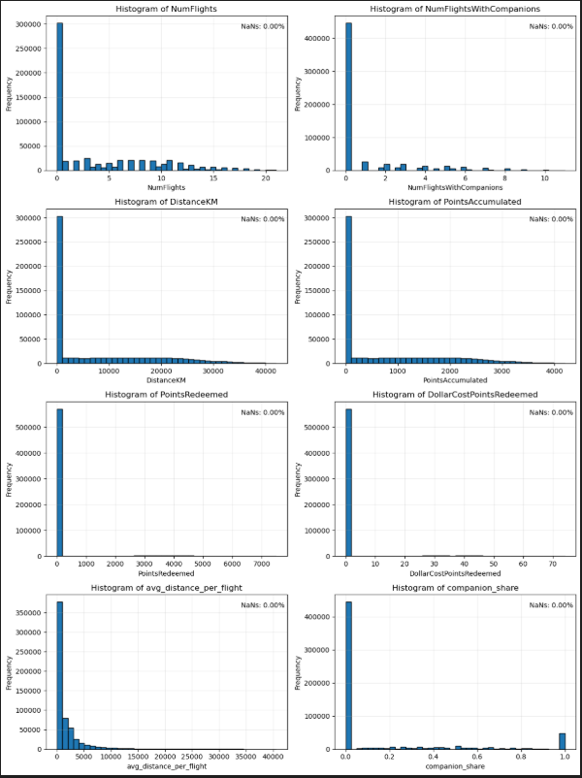

Figure 4.
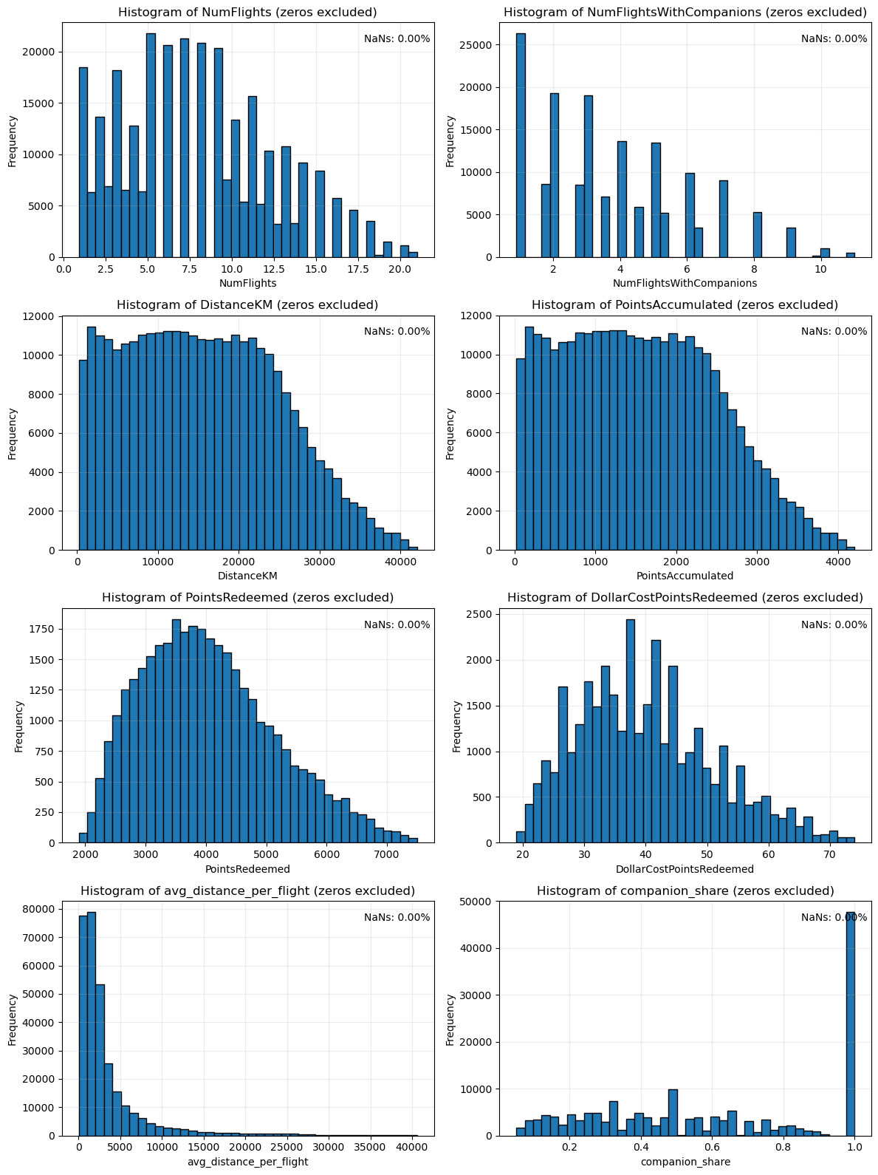

Figure 5.
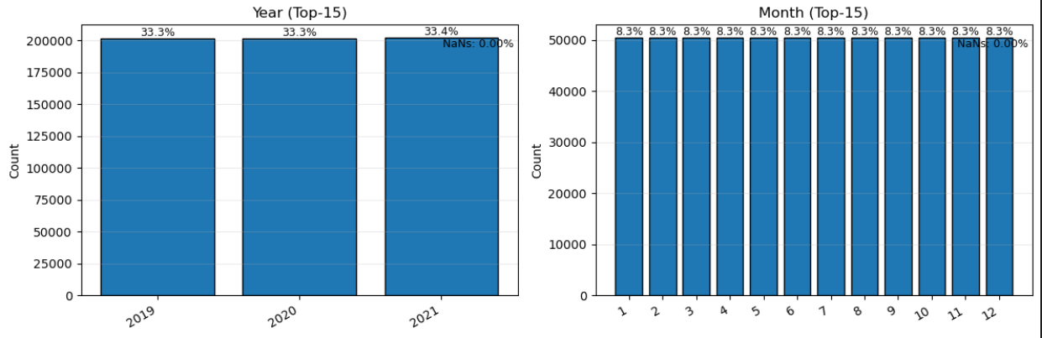

Figure 6.

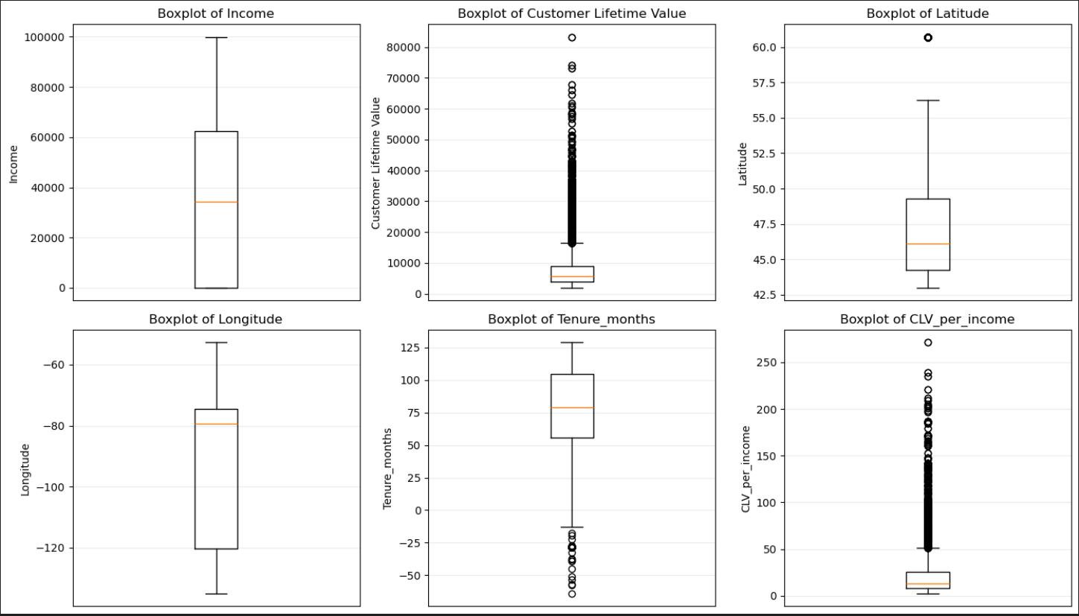

Figure 7.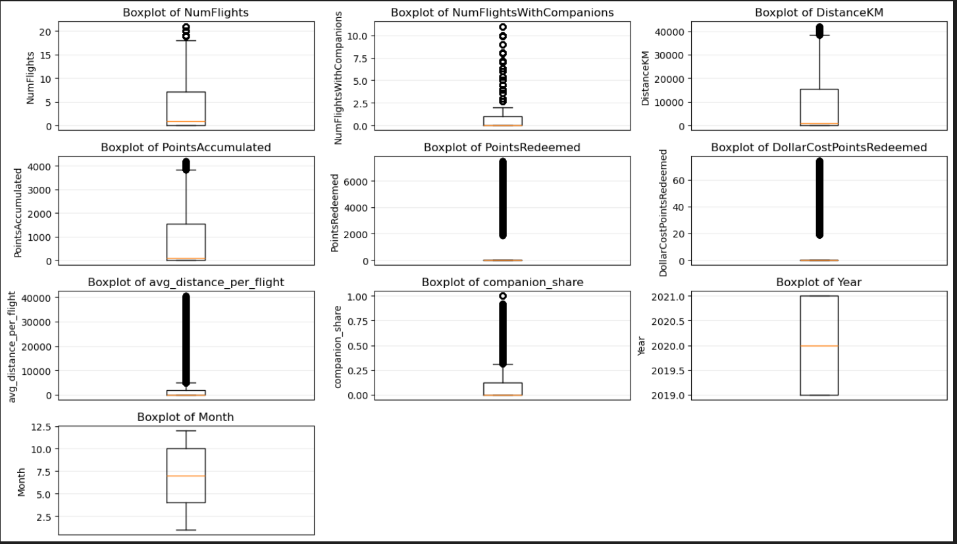

Figure 8.

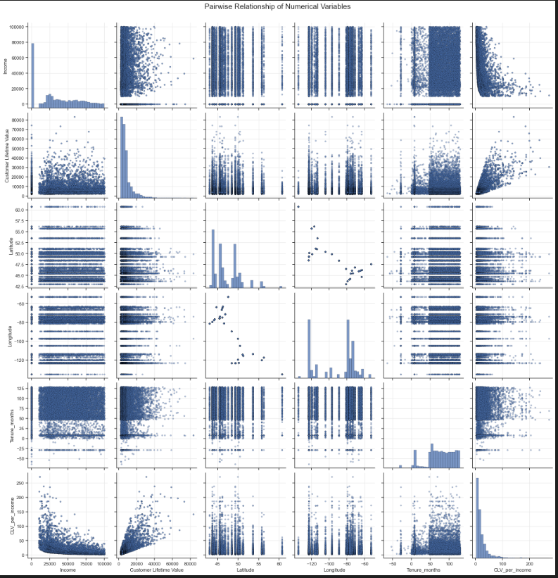

Figure 9.

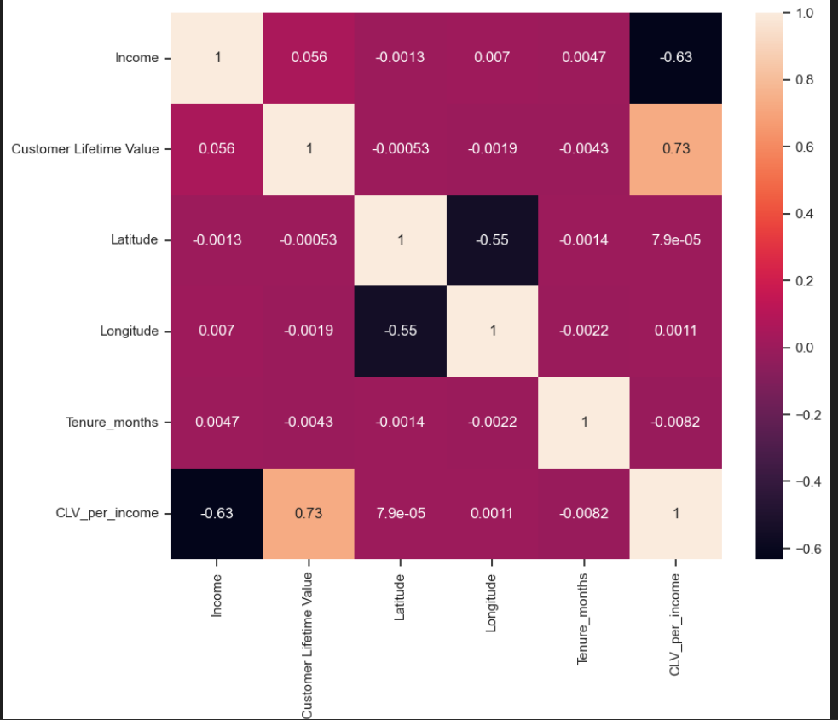

Figure 10.
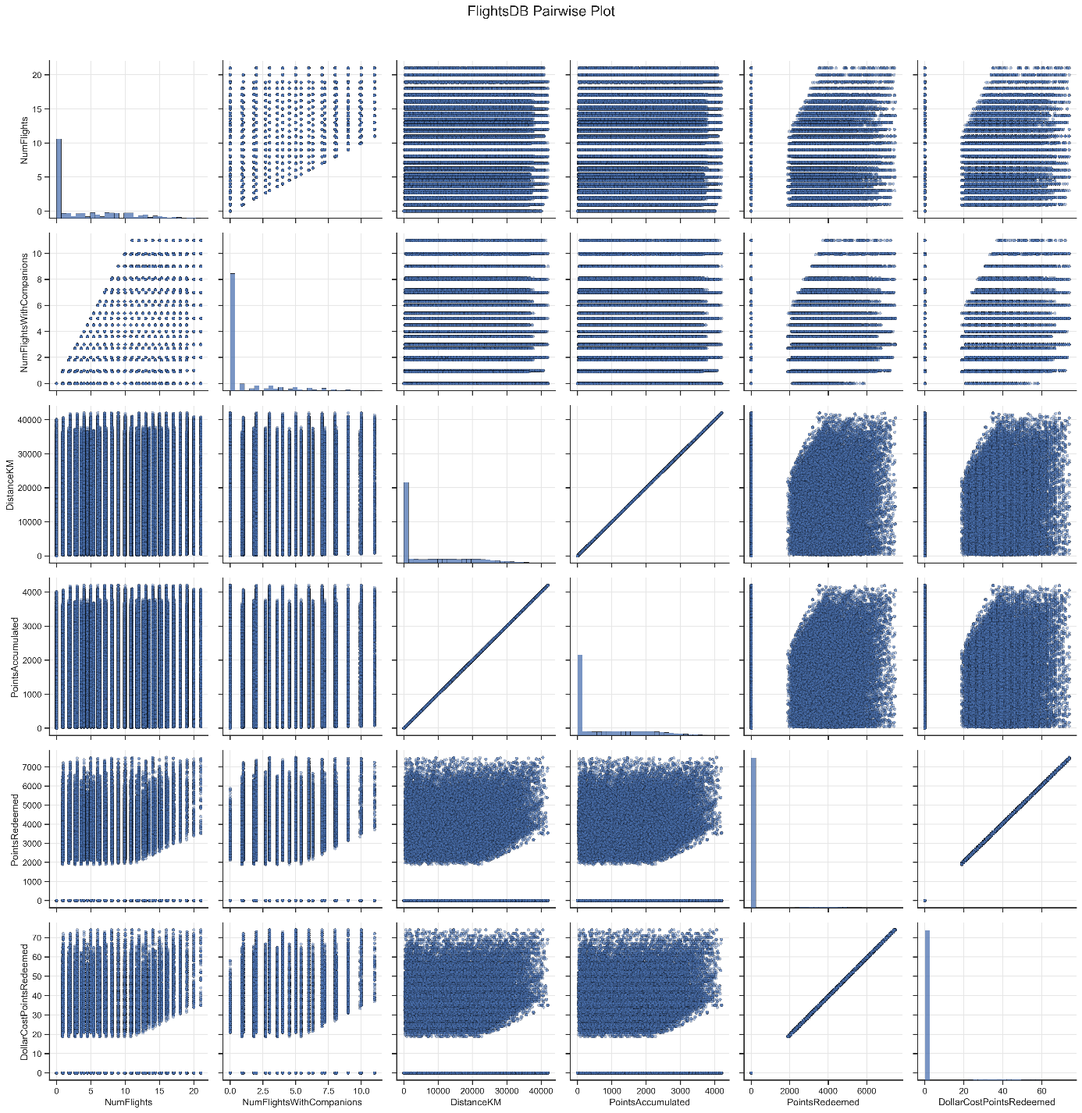

Figure 11.

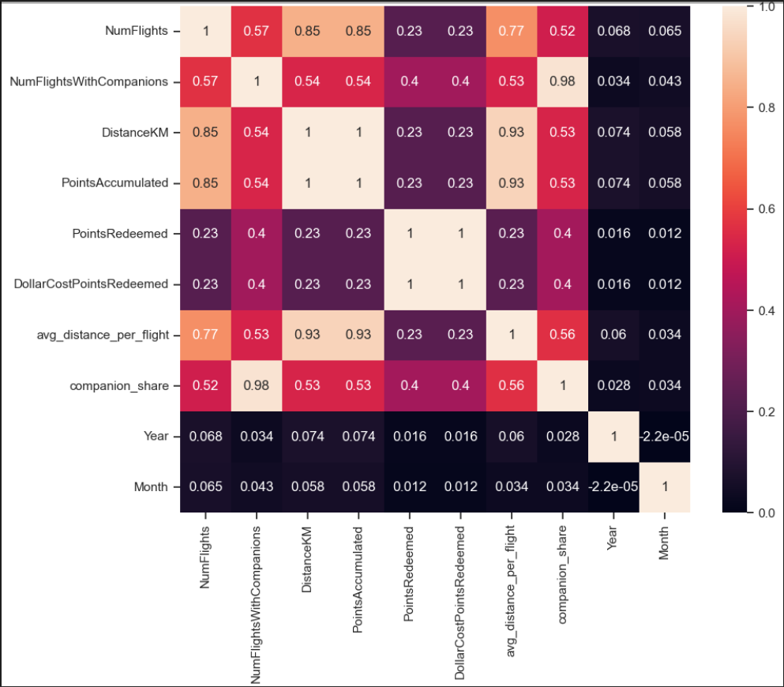

Figure 12.

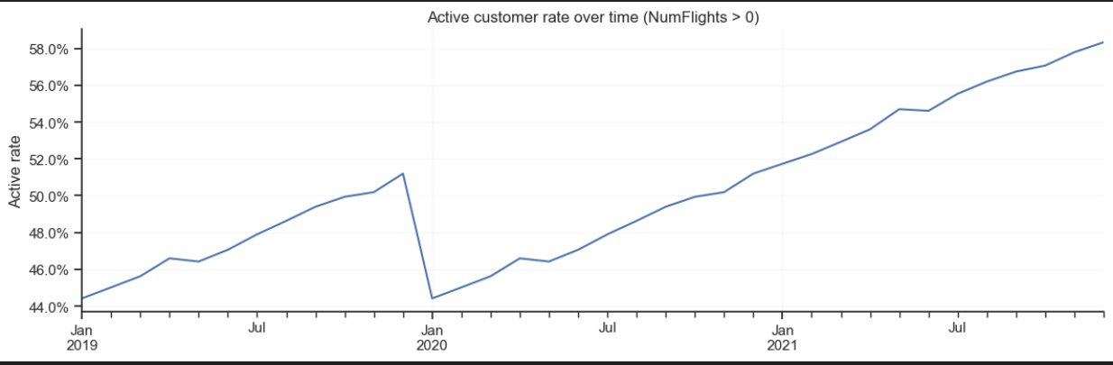

Figure 13.
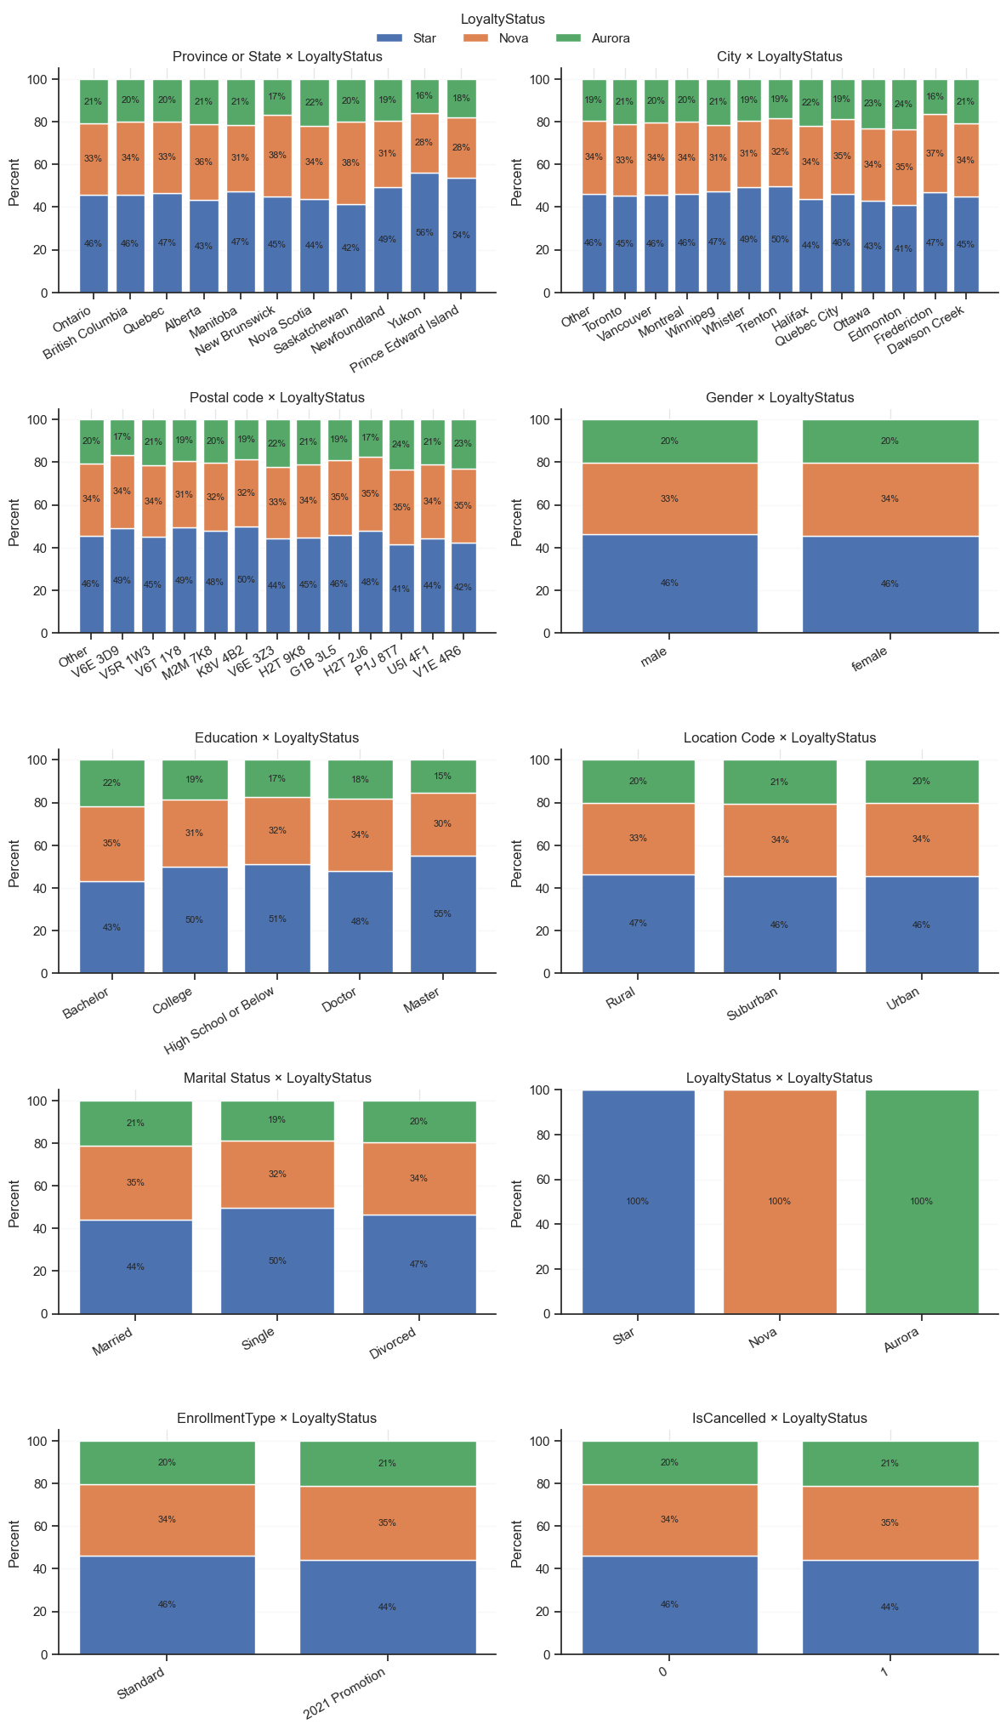

Figure 14.

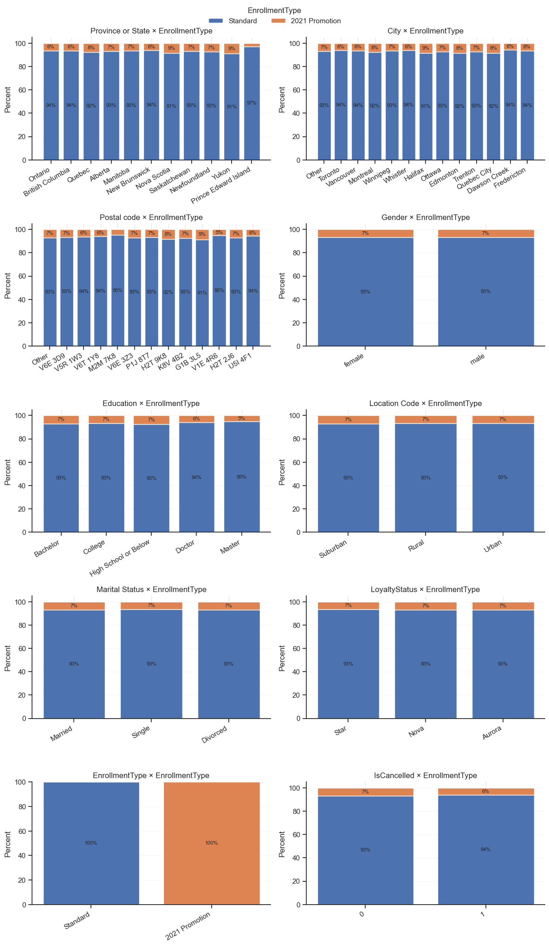
Figure 15.
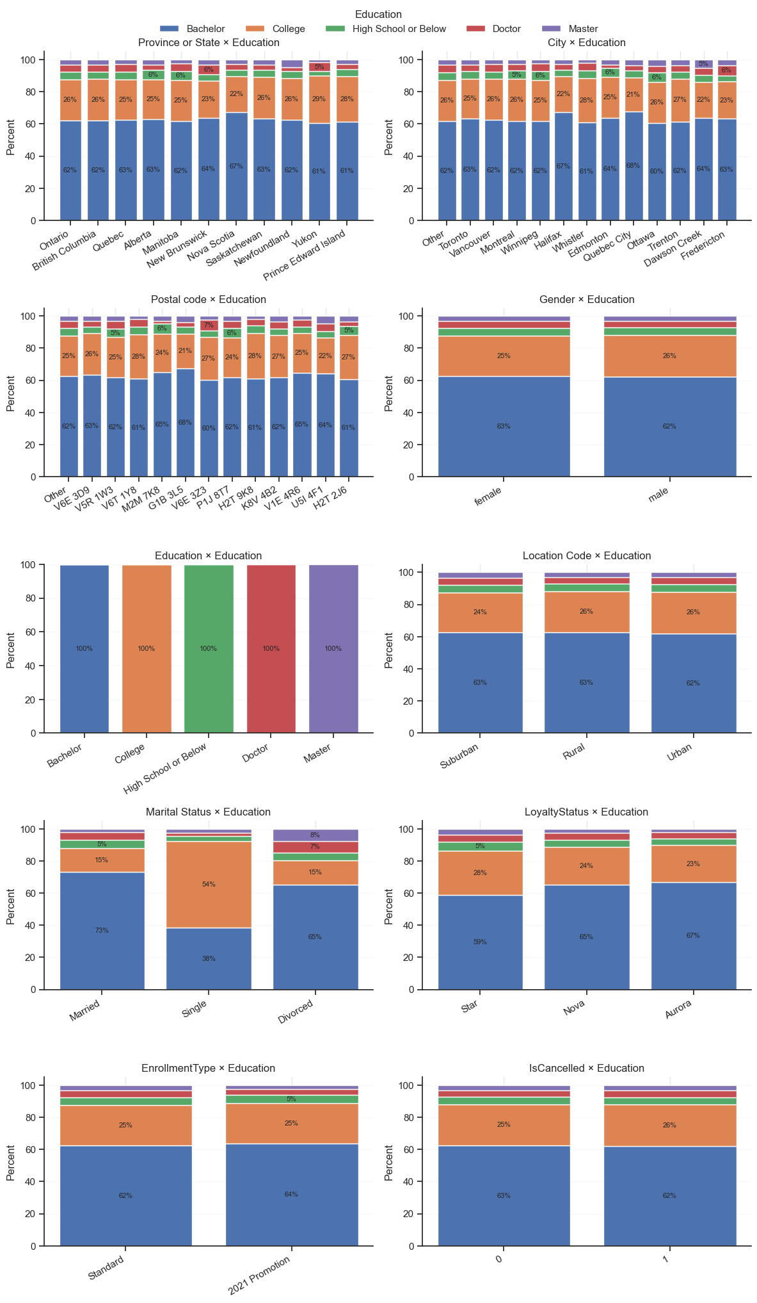
Figure 16.
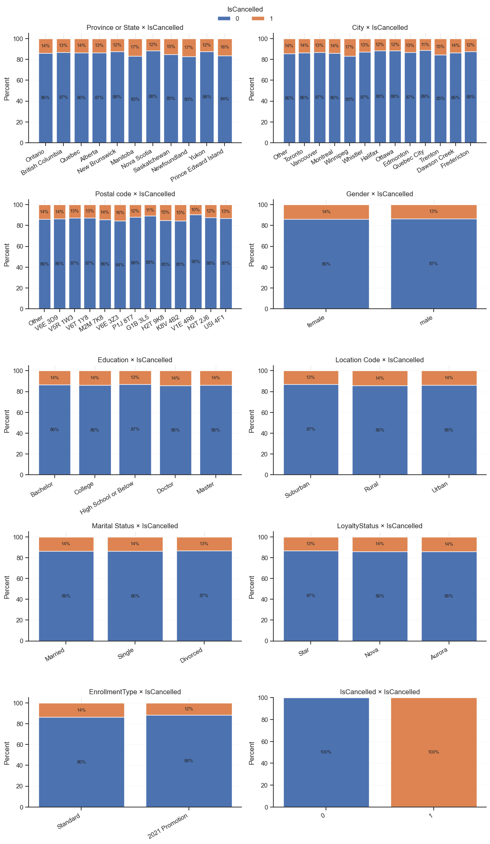

Figure 17.

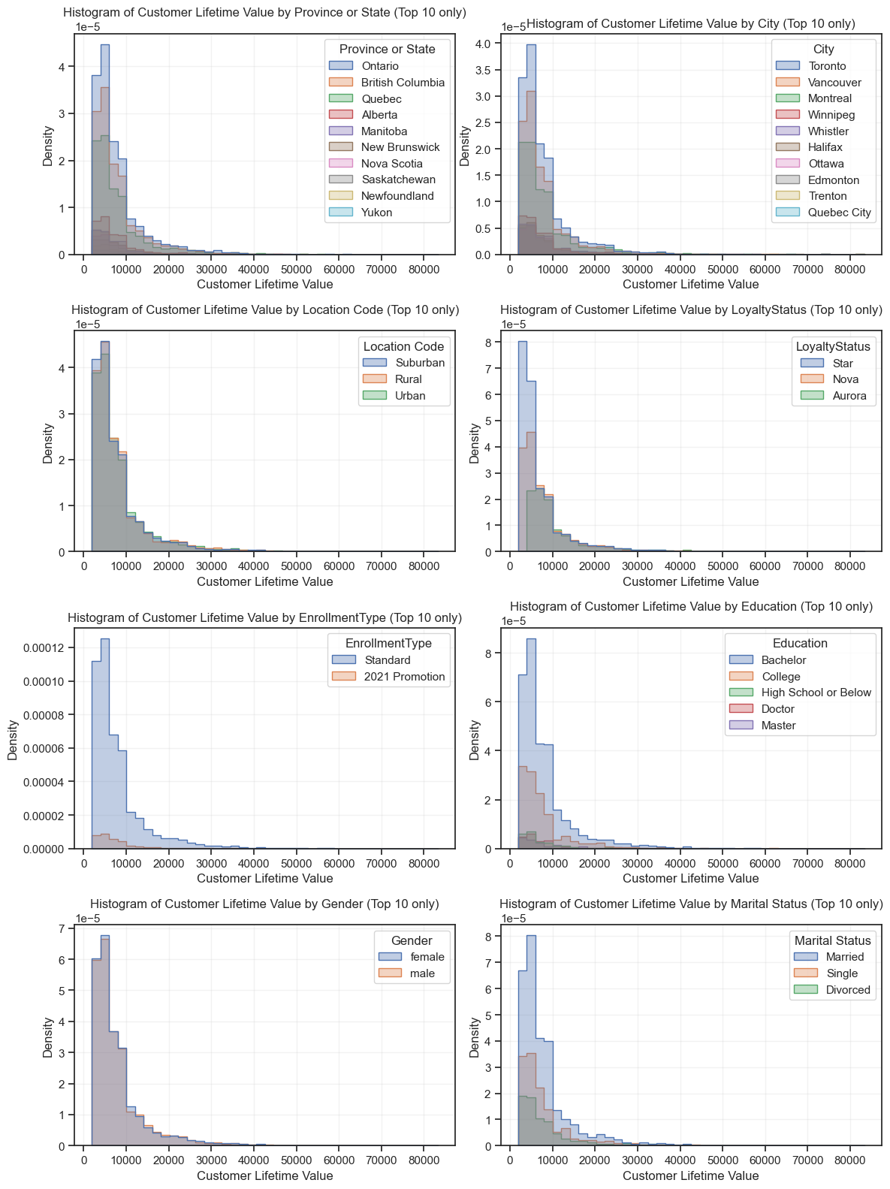

Figure 18.
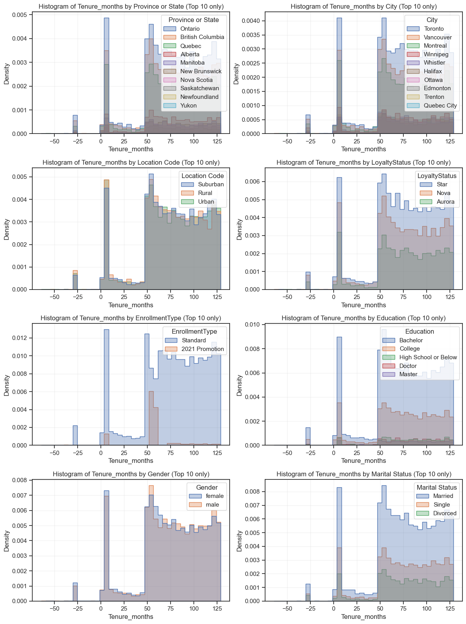

Figure 19.
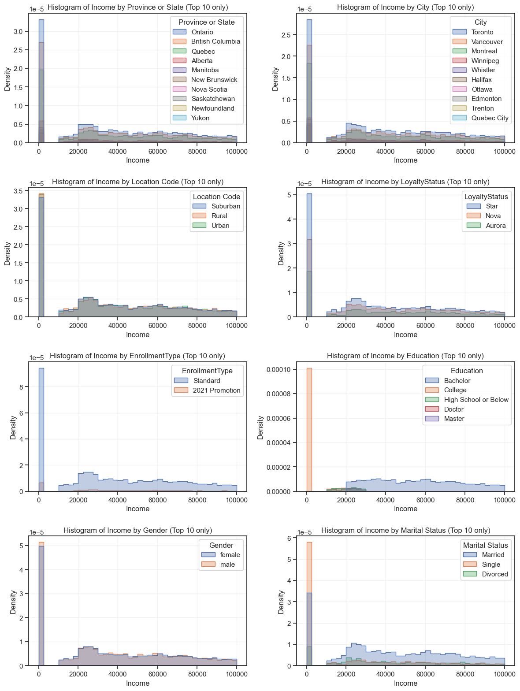

Figure 20.
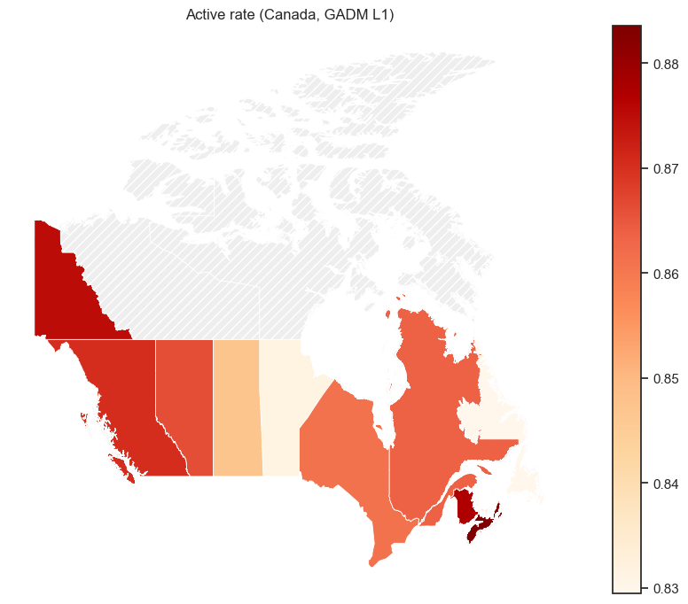
Figure 21.

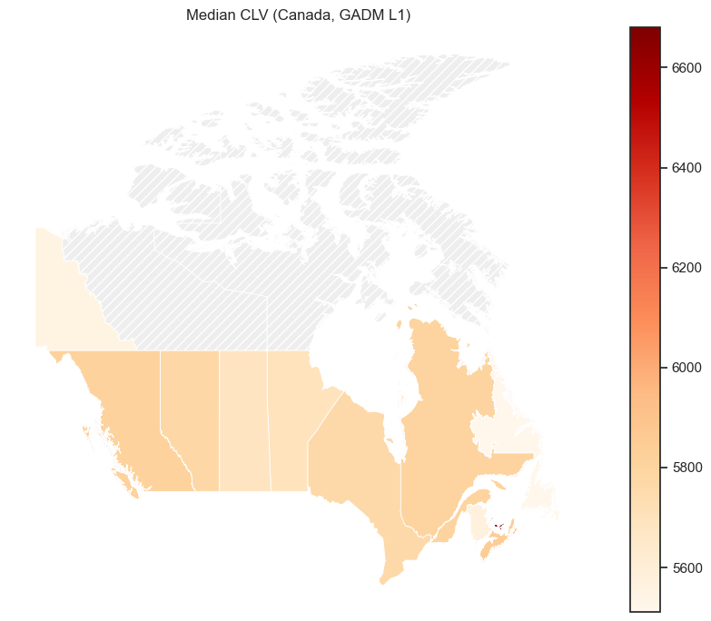
Figure 22.
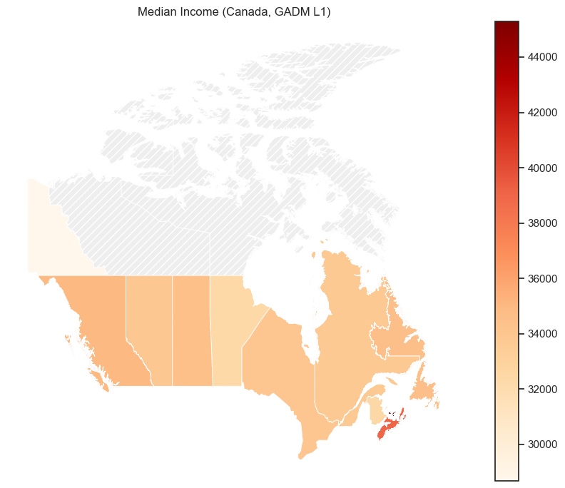
Figure 23.

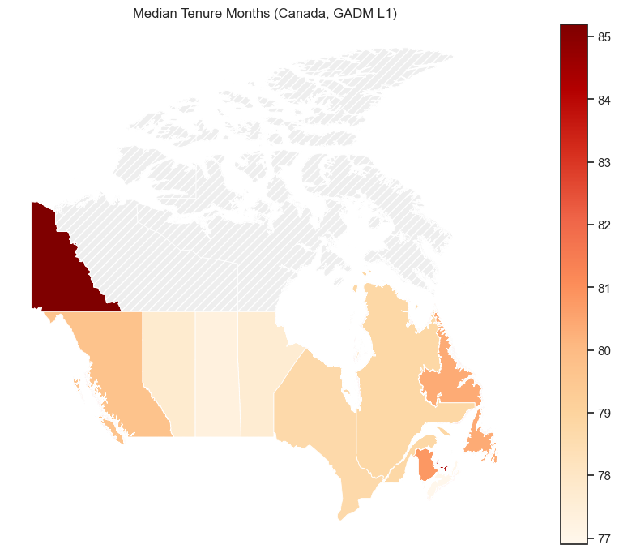
Figure 24.
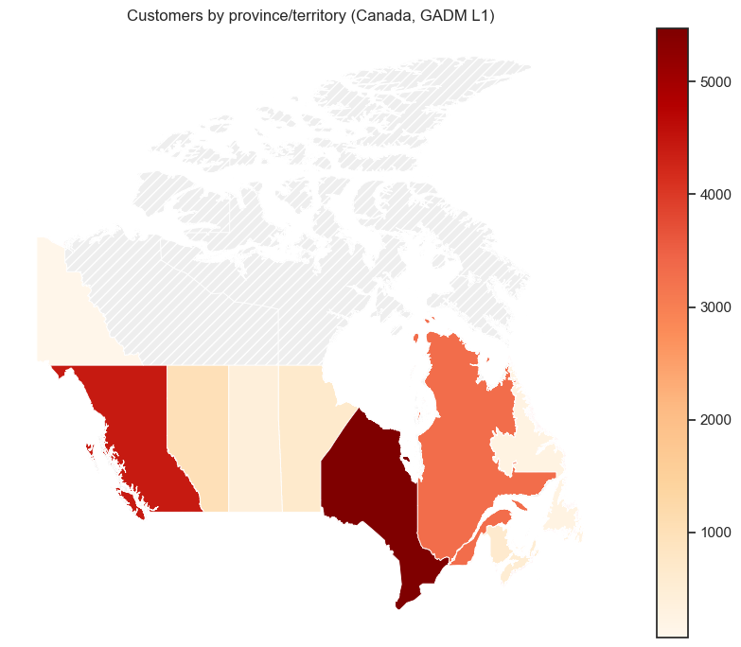

ANNEX:
AIUsageStatement:
AI tools were used for coding syntax assistance and report proofreading (ChatGPT).

Contribution Statement:
Muhammad Ammar (StudentID: 20250440) - Aggregating Customers and Flights dataset. Analysis on combined dataset.

Marta Boavida (StudentID:20240519) – Main analysis and conclusions for separate customer and flight datasets. Organization of individual notebooks and report writing.

Muhammad Khuzaima Bashir (StudentID: 20250441) - Customer and Flights initial separate and combined analysis. Poster.

Carolina Luz (Student ID: 20250409) – Report writing and Bonus Point (Business-Oriented Storytelling).

All members contributed to collaborative discussions and ideation.

