

Faculty Of Engineering And Technology (FEST)

Department Of Computer Science, IUAC, Karachi

PROJECT:
Smart Enterprise Network
SUBJECT:
Computer Network Lab
PROGRAM:
BS (Computer Science)
SEMESTER:
Third Semester

"The network is the computer."
— John Gage (Sun Microsystems)

SUBMITTED BY:
Ammarah Umer — IU05-0125-0142
SUBMITTED TO:
Sir Hammad Ahmed
SUBMISSION DATE:
26-June-2025
REMARKS:
_______________________________
FACULTY SIGNATURE:
_______________________________

Design Preview File

1. NETWORK TOPOLOGY DIAGRAM
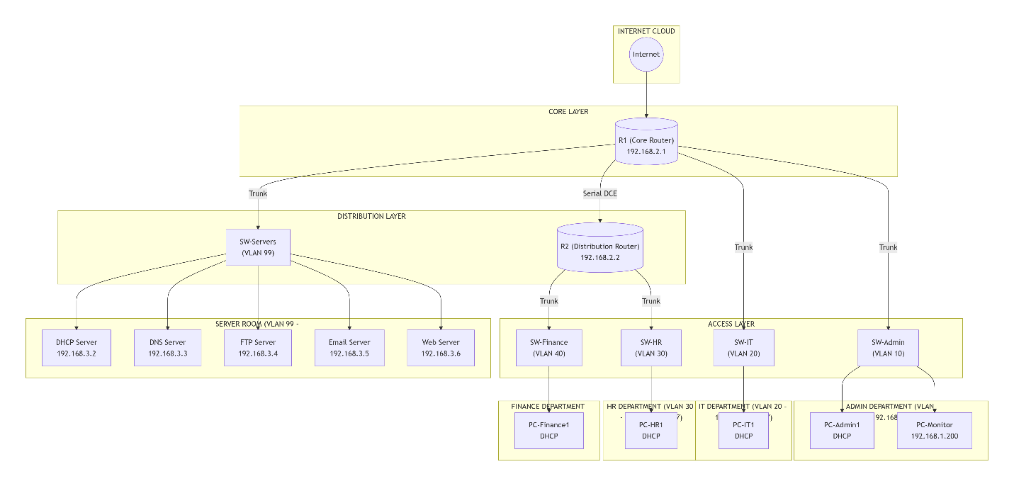

2. HIERARCHICAL NETWORK ARCHITECTURE
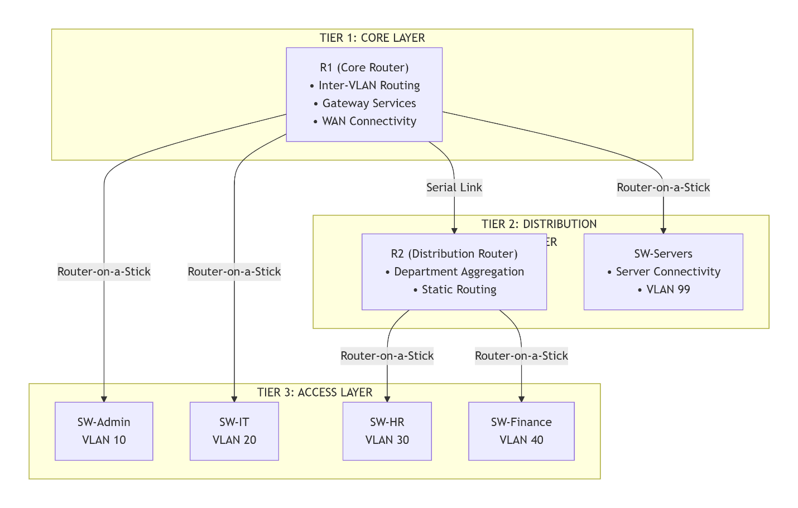

3. VLAN SEGMENTATION DIAGRAM
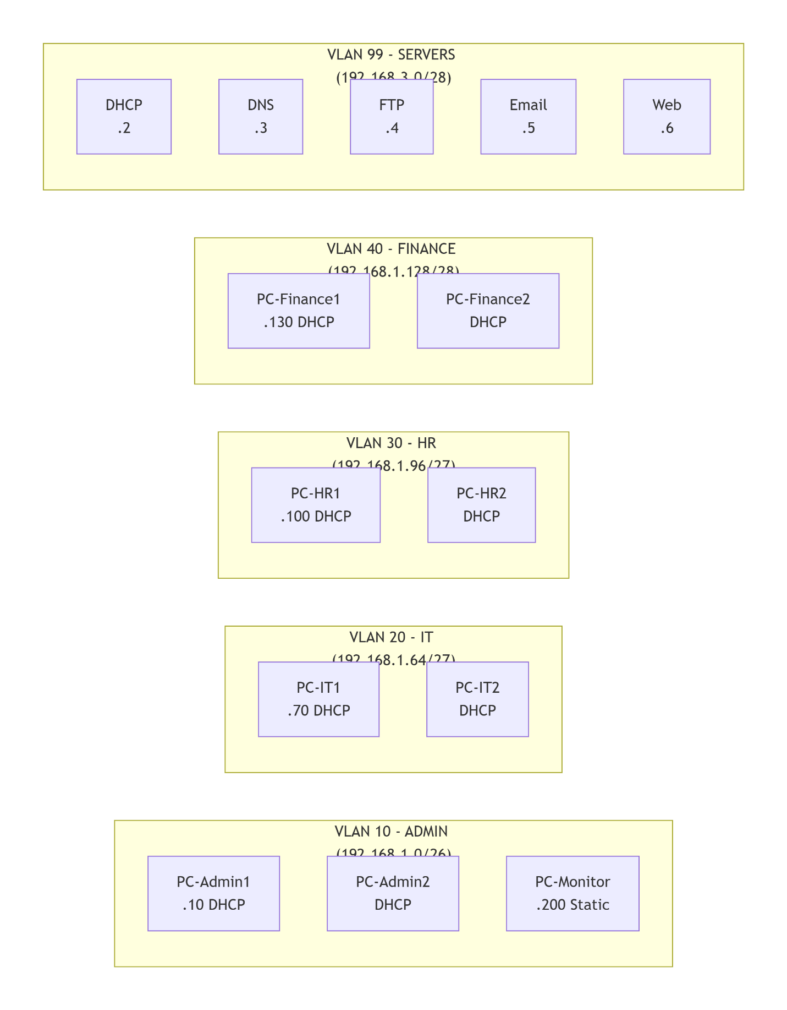

4. IP ADDRESSING SCHEME (VLSM)
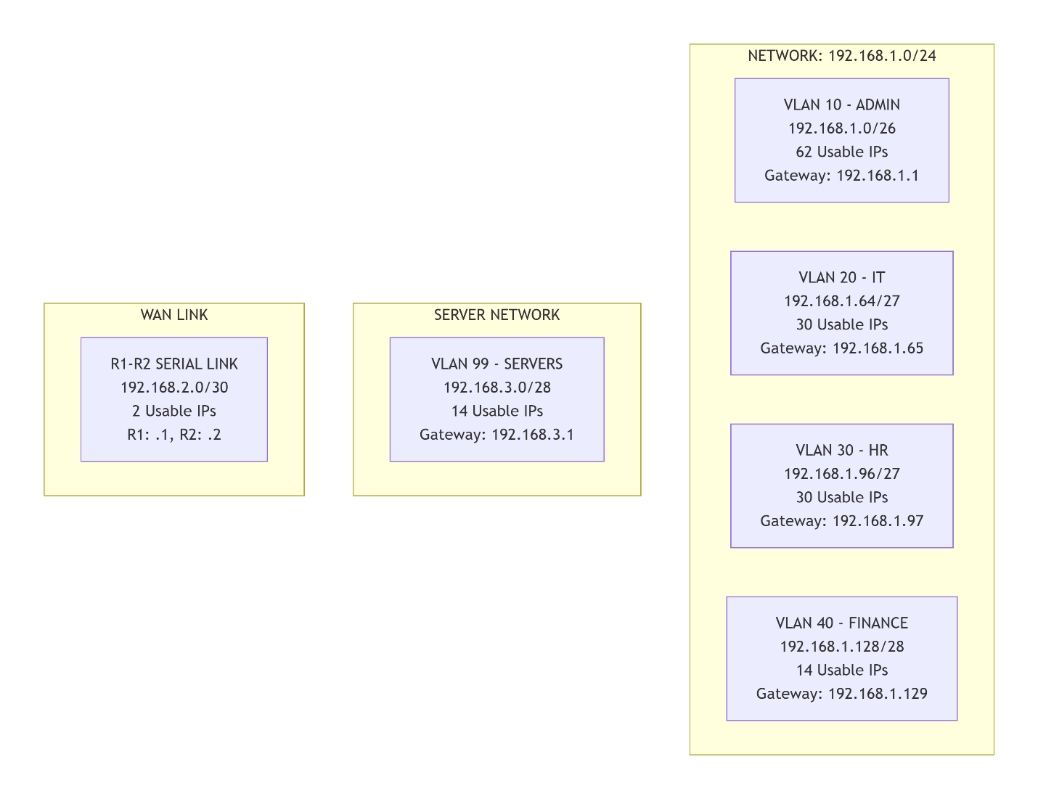

5. ROUTING & INTER-VLAN COMMUNICATION FLOW
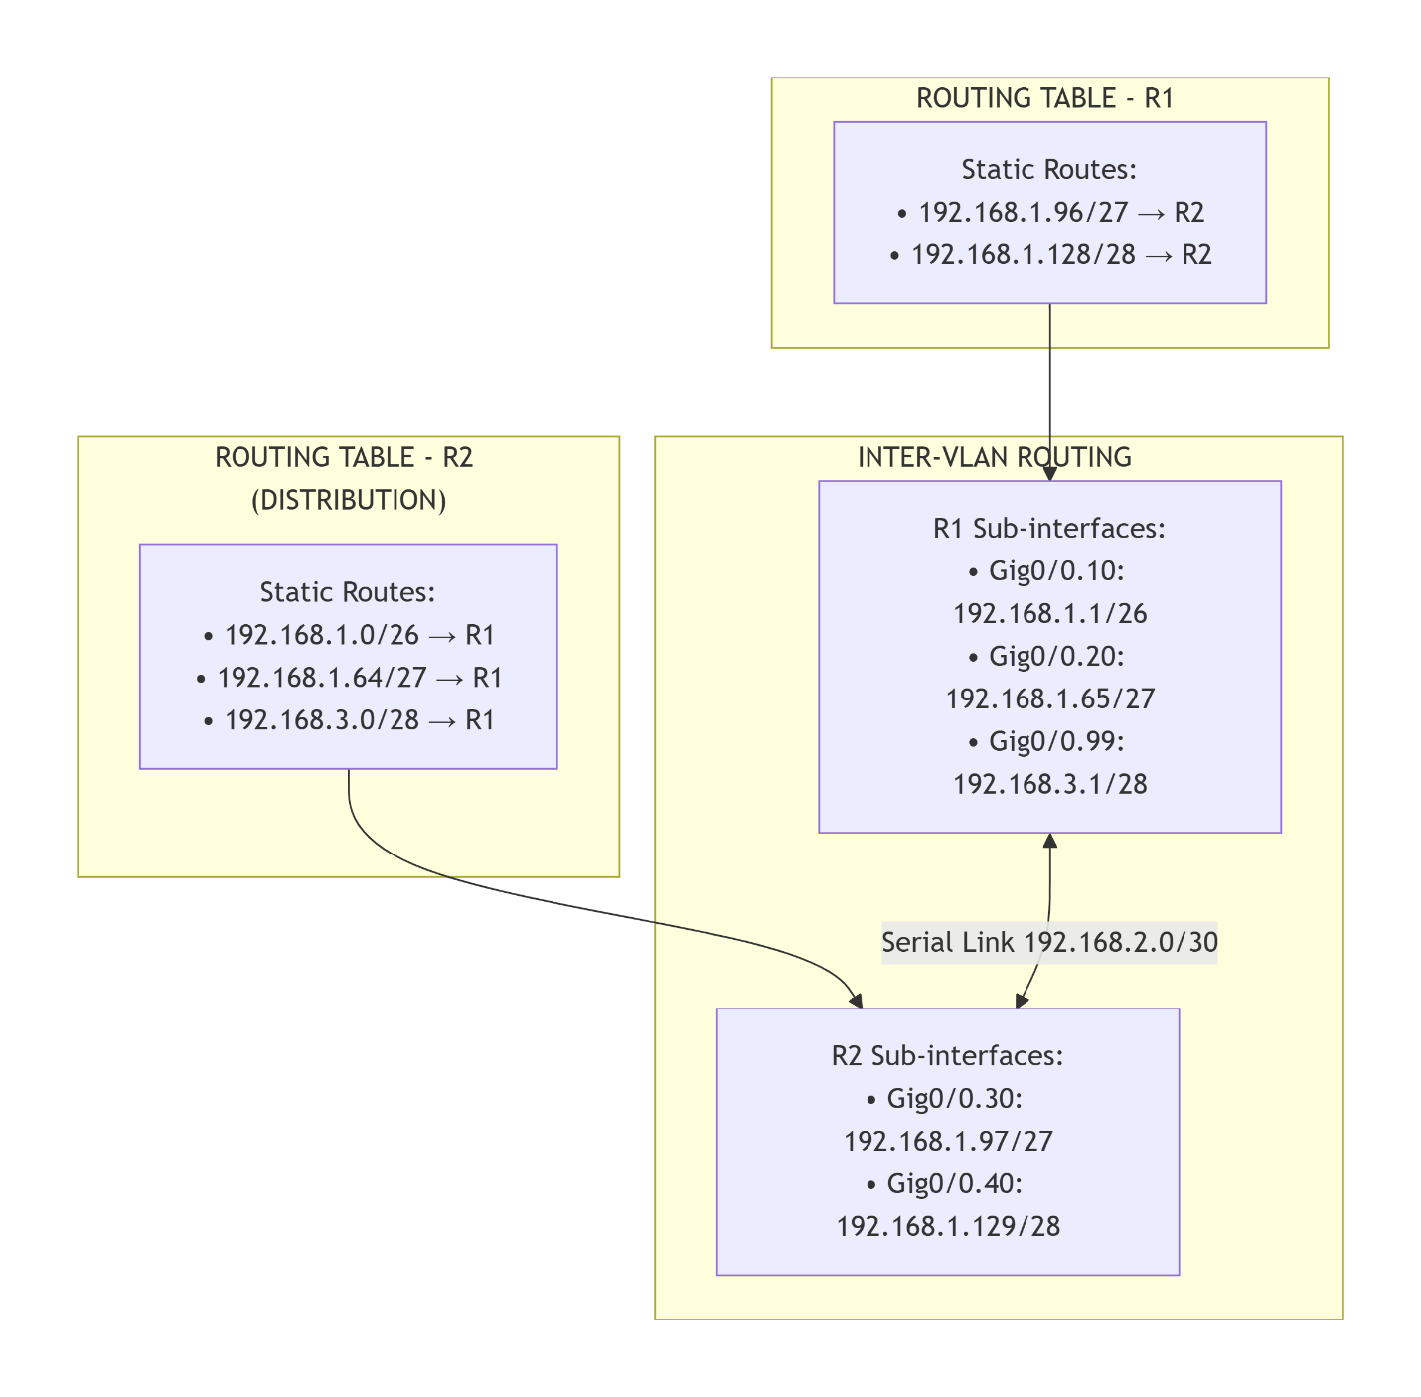

6. SERVICES ARCHITECTURE
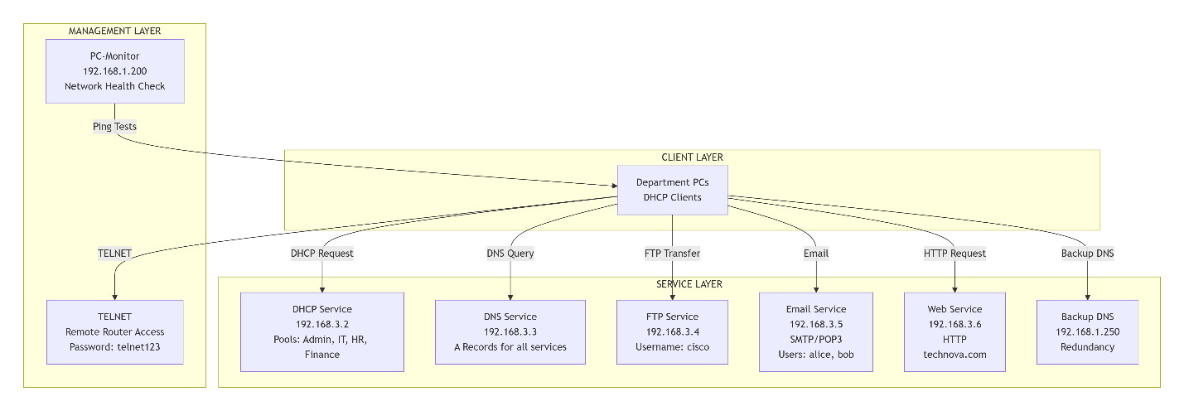

7. DHCP POOL CONFIGURATION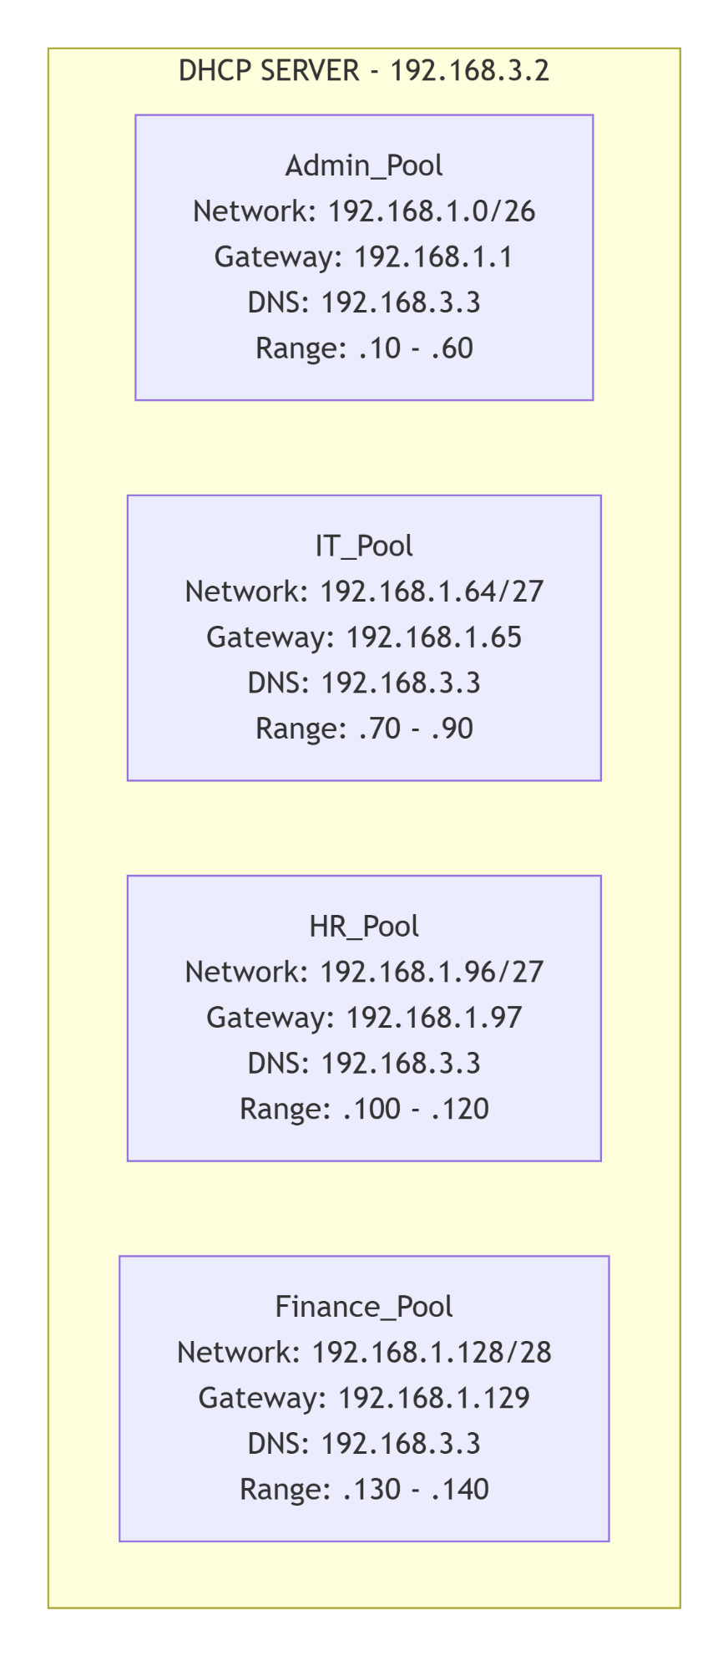

8. DNS RECORDS STRUCTURE
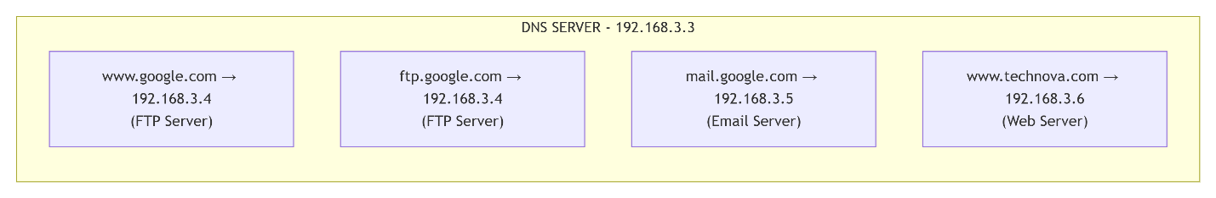

9. NETWORK MONITORING & TROUBLESHOOTING FLOW
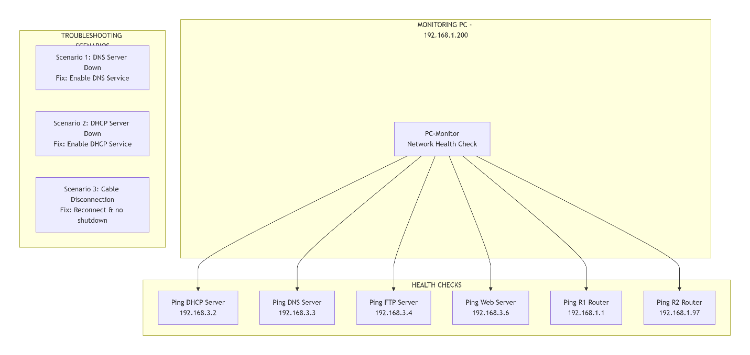

10. NETWORK DEVICE CONNECTION DIAGRAM
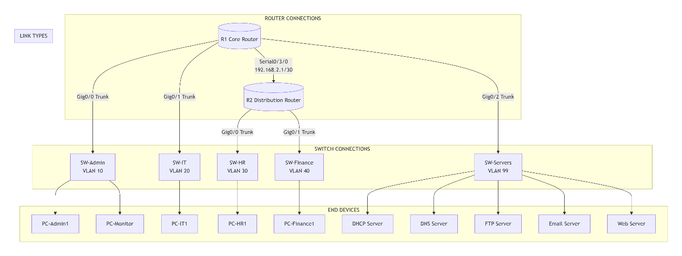

11. SECURITY & VLAN ISOLATION
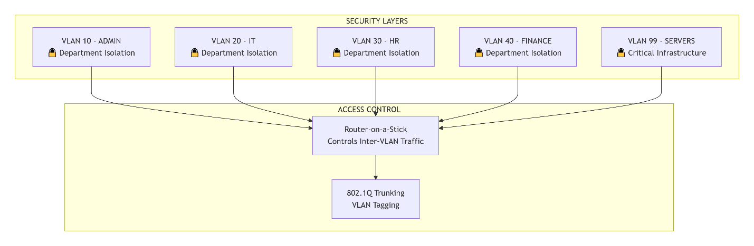

12. PROJECT WORKFLOW DIAGRAM 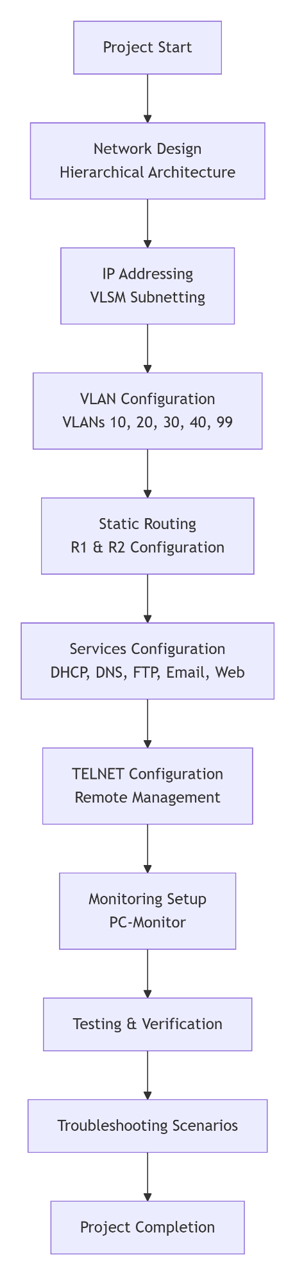

13. TECHNOLOGY STACK
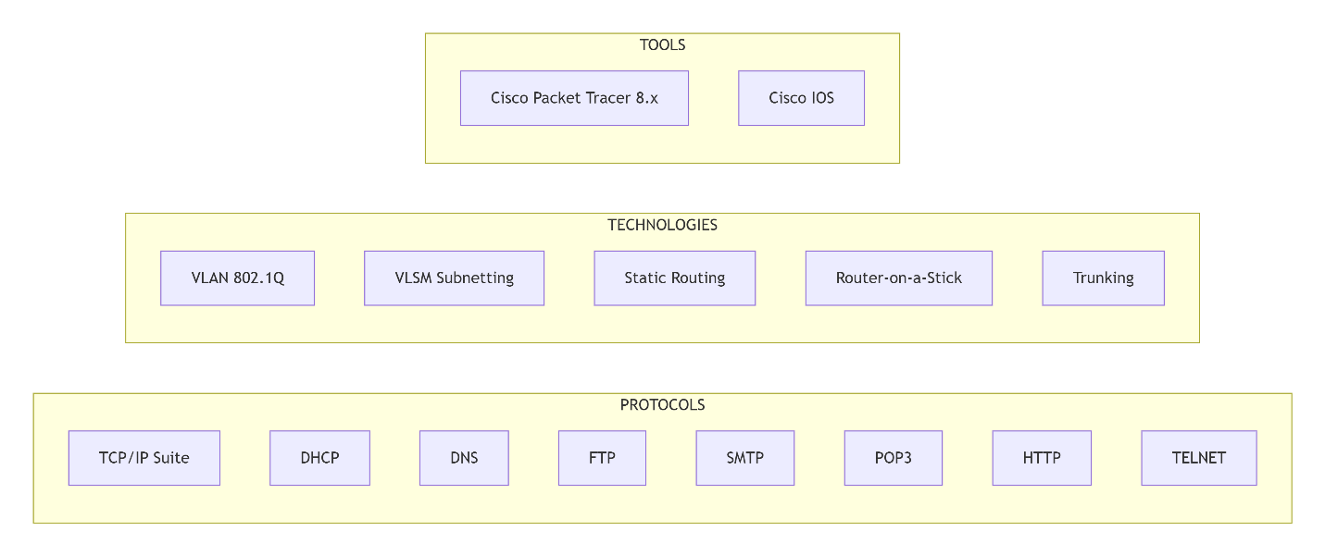

14. SYSTEM COMPONENT INTERACTION
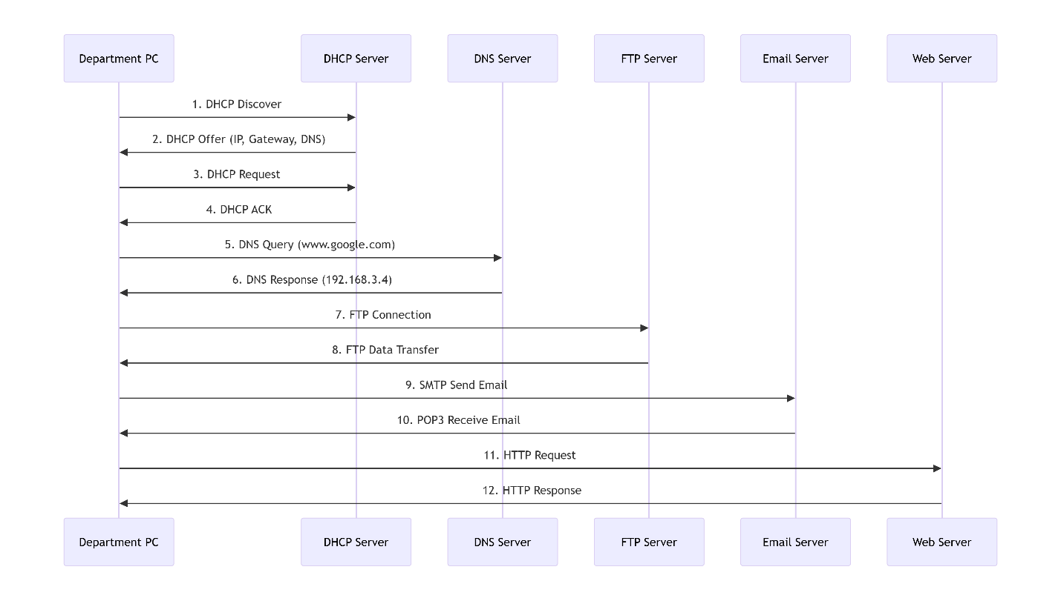

15. NETWORK PARAMETERS SUMMARY