

Faculty Of Engineering And Technology (FEST)

Department Of Computer Science, IUAC, Karachi

PROJECT:
Smart Enterprise Network
SUBJECT:
Computer Network Lab
PROGRAM:
BS (Computer Science)
SEMESTER:
Third Semester

"The network is the computer."
— John Gage (Sun Microsystems)

SUBMITTED BY:
Ammarah Umer — IU05-0125-0142
SUBMITTED TO:
Sir Hammad Ahmed
SUBMISSION DATE:
21-June-2025
REMARKS:
_______________________________
FACULTY SIGNATURE:
_______________________________

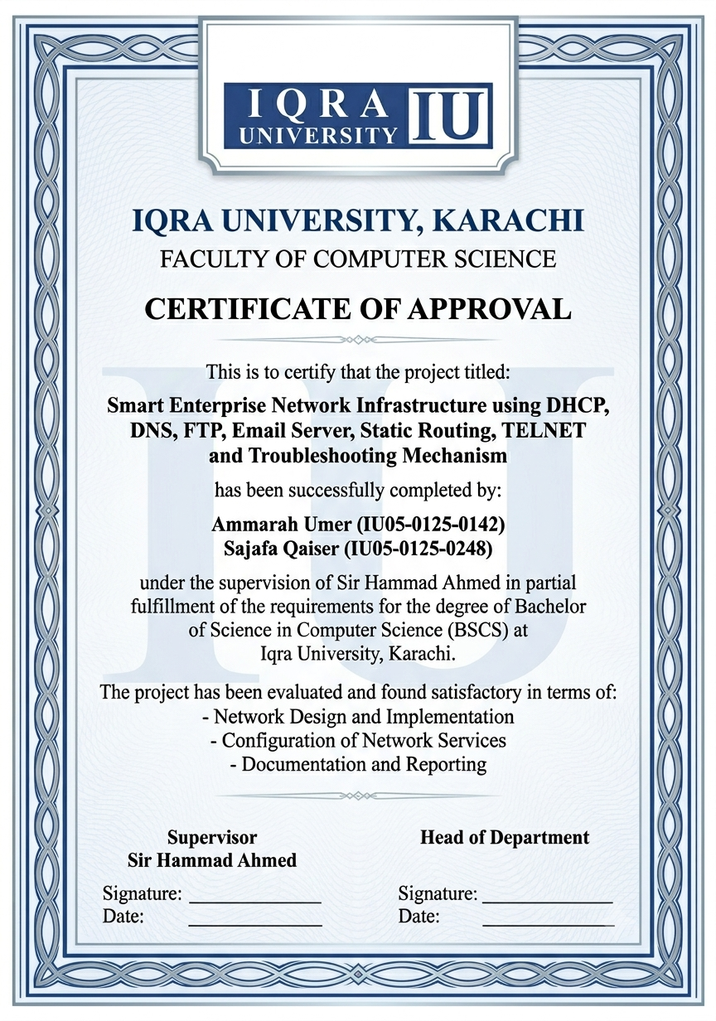
ACKNOWLEDGEMENT

First and foremost, we are grateful to Almighty Allah for giving us the strength, knowledge, and perseverance to complete this project successfully.
We would like to express our sincere gratitude to our supervisor, Sir Hammad Ahmed, for his invaluable guidance, continuous support, and constructive feedback throughout this project. His expertise and encouragement helped us understand complex networking concepts and implement them effectively.
We also extend our thanks to the Department of Computer Science, Iqra University, for providing us with the necessary resources and environment to work on this project.
Special thanks to our families and friends for their unwavering support and motivation during the course of this project.
Lastly, we appreciate the efforts of all those who directly or indirectly contributed to the successful completion of this project.

ABSTRACT
This report presents the design and implementation of a complete enterprise-level network for Tech-Nova Solutions, a software house based in Karachi, Pakistan. The network is simulated using Cisco Packet Tracer and demonstrates a real organizational environment where multiple departments communicate through routers, switches, and servers.
The network provides essential services including automatic IP assignment (DHCP), domain name resolution (DNS), file transfer (FTP), email communication (SMTP/POP3), web hosting (HTTP), and remote device management (TELNET). The project incorporates advanced networking features such as VLAN Segmentation, Inter-VLAN Routing, Backup DNS Server, Network Monitoring PC, and Hierarchical Network Design to create a scalable, secure, and enterprise-grade infrastructure.
The network follows a three-tier hierarchical architecture with core, distribution, and access layers. A centralized server room hosts all critical services on a dedicated server network (192.168.3.0/28). Departmental traffic is isolated using VLANs (10, 20, 30, 40, 99) while inter-VLAN routing enables cross-department communication through router-on-a-stick configuration. Static routing ensures connectivity between different network segments.
All services have been successfully tested and verified. DHCP automatically assigns IP addresses to all PCs, DNS resolves domain names to server IPs, FTP enables file sharing, email communication works between users, the web server hosts the company website, and TELNET allows remote router access. The implementation of VLANs, redundancy, and monitoring demonstrates a professional enterprise networking solution suitable for real-world deployment.
Keywords: Enterprise Network, VLAN, DHCP, DNS, FTP, Email Server, Static Routing, TELNET, Cisco Packet Tracer, Inter-VLAN Routing, Network Monitoring.

Chapter 1: Introduction
1.1 Background
In today's digital era, computer networks form the backbone of modern organizations. An enterprise network connects various departments, enables resource sharing, facilitates communication, and supports business operations. Without a properly designed network infrastructure, organizations face challenges such as inefficient communication, security vulnerabilities, and difficulty in managing multiple departments.
This project focuses on designing and implementing a complete enterprise-level network for Tech-Nova Solutions, a software house based in Karachi, Pakistan. The network is simulated using Cisco Packet Tracer, a powerful network simulation tool widely used in academia for teaching networking concepts.
The project incorporates essential networking services including:
- DHCP (Dynamic Host Configuration Protocol): Automatically assigns IP addresses to devices
- DNS (Domain Name System): Resolves domain names to IP addresses
- FTP (File Transfer Protocol): Enables file sharing across the network
- Email Server: Provides email communication using SMTP and POP3
- Web Server: Hosts the company website
- TELNET: Enables remote management of network devices
Additionally, the project implements advanced features such as VLAN segmentation, Inter-VLAN routing, Backup DNS, and Network Monitoring to demonstrate a professional enterprise networking solution.
1.2 Problem Statement
In real-world organizations, manual network configuration leads to several issues:
- IP Conflicts: When multiple devices are assigned the same IP address
- Inefficient Communication: Lack of proper routing between departments
- Difficulty in Management: Managing multiple departments without segmentation
- Lack of Centralized Services: No centralized servers for DHCP, DNS, or file sharing
- Security Vulnerabilities: No isolation between departments
- No Redundancy: Single points of failure for critical services
This project solves these issues by implementing a centralized, automated, and scalable enterprise network with:
- VLAN segmentation for security and broadcast isolation
- Centralized server room for all network services
- Backup DNS for redundancy
- Network monitoring for fault detection
- Static routing for inter-network communication
1.3 Objectives
The primary objectives of this project are:
- To design a multi-department enterprise network for Tech-Nova Solutions in Cisco Packet Tracer
- To implement DHCP for automatic IP assignment across all departments
- To configure DNS for domain-based access to network resources
- To enable FTP service for secure file sharing
- To implement Email server communication using SMTP/POP3 protocols
- To configure Web server for hosting the company website
- To implement VLAN segmentation for improved security and performance
- To configure Inter-VLAN routing for cross-department communication
- To implement Static Routing between different network segments
- To enable TELNET for remote router access
- To deploy Network Monitoring PC for fault detection
- To create troubleshooting scenarios for network fault analysis
1.4 Scope of the Project
The project covers the following aspects of enterprise network design and implementation:
Network Design
- Hierarchical network architecture (Core, Distribution, Access layers)
- Multi-department LAN design (Admin, IT, HR, Finance)
- Centralized server room with dedicated network
Configuration
- Router and switch configuration
- VLAN implementation (10, 20, 30, 40, 99)
- IP addressing using VLSM
- Static routing between networks
- Inter-VLAN routing using router-on-a-stick
Services
- DHCP server configuration
- DNS server configuration (Primary and Backup)
- FTP server configuration
- Email server configuration (SMTP/POP3)
- Web server configuration
Management
- TELNET remote access
- Network monitoring PC
- Troubleshooting scenarios
Deliverables
- Packet Tracer (.pkt) file
- Network topology diagram
- Configuration documentation
- Final project report
All implementations are based on standard networking concepts and Cisco Packet Tracer simulation.

Chapter 2: Literature Review
2.1 Networking Concepts
A computer network is a collection of interconnected devices that communicate with each other to share resources and information. Networks are classified based on their size and geographical coverage:
- LAN (Local Area Network): Covers a small geographical area like an office or building
- WAN (Wide Area Network): Covers a large geographical area like cities or countries
Network communication follows the TCP/IP (Transmission Control Protocol/Internet Protocol) model, which consists of four layers:
- Application Layer: Provides services like HTTP, FTP, SMTP
- Transport Layer: Provides reliable communication (TCP) or connectionless communication (UDP)
- Internet Layer: Handles addressing and routing (IP)
- Network Access Layer: Physical transmission of data
2.2 Routers
A router is a networking device that forwards data packets between different networks. Routers operate at Layer 3 (Network Layer) of the OSI model and use IP addresses to make forwarding decisions.
Key Functions of Routers:
- Interconnect different networks
- Determine the best path for data transmission
- Forward packets based on routing tables
- Implement routing protocols (static or dynamic)
In this project, two routers are used:
- R1 (Core Router): Connects all networks and performs inter-VLAN routing
- R2 (Branch Router): Connects HR and Finance departments to the core network
2.3 Switches
A switch is a networking device that connects devices within the same network. Switches operate at Layer 2 (Data Link Layer) of the OSI model and use MAC addresses to forward frames.
Key Functions of Switches:
- Connect multiple devices in a LAN
- Forward frames based on MAC addresses
- Support VLANs for network segmentation
- Improve network performance by reducing collisions
In this project, five switches are used:
- SW-Admin: Admin department (VLAN 10)
- SW-IT: IT department (VLAN 20)
- SW-HR: HR department (VLAN 30)
- SW-Finance: Finance department (VLAN 40)
- SW-Servers: Server room (VLAN 99)
2.4 IP Addressing
IP addressing is a system for identifying devices on a network. IPv4 addresses are 32-bit numbers represented in dotted decimal notation (e.g., 192.168.1.1).
Key Concepts:
- Network Address: Identifies the network
- Host Address: Identifies the device
- Subnet Mask: Determines the network and host portions
VLSM (Variable Length Subnet Masking):
VLSM allows subnetting a network with different subnet masks to optimize IP address utilization. In this project, VLSM is used to assign appropriate subnet sizes to each department based on their requirements.
2.5 VLAN (Virtual Local Area Network)
VLAN is a technology that allows a single physical switch to be divided into multiple logical networks. VLANs operate at Layer 2 and provide several benefits:
- Security: Departments are isolated from each other
- Performance: Broadcast traffic is limited to the VLAN
- Management: Easy to add or move users
- Scalability: Supports large networks

VLAN IDs Used in the Project:
VLAN ID | Name | Purpose
10 | Admin | Management Department
20 | IT | IT Department
30 | HR | Human Resources
40 | Finance | Accounts Department
99 | Servers | Centralized Server Room

2.6 Routing
Routing is the process of selecting the best path for data packets to travel from source to destination. There are two types of routing:
Static Routing
- Routes are manually configured by the network administrator
- Simple, secure, and predictable
- Suitable for small to medium networks
- Used in this project for all routing configurations
Dynamic Routing
- Routes are automatically learned and updated by routing protocols
- Suitable for large, complex networks
2.7 Network Services
DHCP (Dynamic Host Configuration Protocol)
DHCP automatically assigns IP addresses and other network parameters to devices. Benefits include:
- Simplified network administration
- Reduced IP conflicts
- Efficient IP address utilization
DNS (Domain Name System)
DNS resolves human-readable domain names to IP addresses. Benefits include:
- Users can access services by name (e.g., www.google.com)
- Simplified resource access
- Scalable and distributed architecture
FTP (File Transfer Protocol)
FTP enables file transfer between devices. Benefits include:
- Easy sharing of files
- Secure authentication
- Support for upload and download
Email Protocols (SMTP and POP3)
- SMTP (Simple Mail Transfer Protocol): Sends emails
- POP3 (Post Office Protocol v3): Receives emails
TELNET
TELNET enables remote access to network devices. Benefits include:
- Remote management and configuration
- Troubleshooting from any location
Inter-VLAN Routing
Inter-VLAN routing allows communication between different VLANs. This is achieved using:
- Router-on-a-stick: A router with sub-interfaces connects to a trunk port
- Layer 3 Switch: A switch with routing capabilities

Chapter 3: System Analysis and Design
3.1 Project Overview
The project is designed for Tech-Nova Solutions, a software house with four departments:
- Admin Department: Management and administration (50 employees)
- IT Department: Software development and IT support (30 employees)
- HR Department: Human resources management (20 employees)
- Finance Department: Accounts and finance (15 employees)
Each department has its own switch and VLAN to ensure network segmentation and security. All departments connect through routers for inter-network communication. A centralized server room hosts all critical services including DHCP, DNS, FTP, Email, and Web servers.
3.2 Network Requirements
Functional Requirements
Requirement | Description
DHCP | Automatic IP assignment to all PCs
DNS | Domain name resolution for network services
FTP | File sharing across departments
Email | Email communication between users
Web Server | Hosting company website
TELNET | Remote management of routers
VLANs | Departmental segmentation
Inter-VLAN Routing | Communication between departments
Static Routing | Inter-network connectivity
Backup DNS | Redundancy for name resolution
Monitoring | Network health checking

Non-Functional Requirements
Requirement | Description
Scalability | Support for future expansion
Security | Department isolation via VLANs
Reliability | Backup DNS for redundancy
Performance | Efficient routing and switching
Manageability | Remote access via TELNET

3.3 Topology Design
The network topology follows a hierarchical design with three layers:
Core Layer
- R1 (Core Router): Interconnects all networks, performs inter-VLAN routing, and provides gateway services
Distribution Layer
- R2 (Distribution Router): Connects HR and Finance departments to the core
- SW-Servers: Connects all servers to the network
Access Layer
- SW-Admin: Admin department (VLAN 10)
- SW-IT: IT department (VLAN 20)
- SW-HR: HR department (VLAN 30)
- SW-Finance: Finance department (VLAN 40)
3.4 Network Architecture
The network architecture follows a hierarchical model with three distinct layers.
Core Layer (R1)
- Provides high-speed routing between networks
- Performs inter-VLAN routing
- Serves as the gateway for all VLANs
- Connects to the distribution router (R2)
Distribution Layer (R2 and SW-Servers)
- R2: Connects HR and Finance access switches
- SW-Servers: Provides connectivity for all servers
- Aggregates traffic from access layer
Access Layer (All Switches)
- Provides connectivity for end devices
- Assigns VLANs to departmental ports
- Acts as the entry point for the network
3.5 Device Selection
Device | Model | Quantity | Purpose
Router | Cisco 2911 | 2 | Core and Distribution routing
Switch | Cisco 2960-24TT | 5 | Department and server connectivity
Server | Server-PT | 6 | DHCP, DNS, FTP, Email, Web, Backup DNS
PC | PC-PT | 5 | Department PCs and Monitoring PC

Chapter 4: Implementation
4.1 Network Topology
The complete network topology consists of:
Routers
- R1 (Core Router): Connects to SW-Admin, SW-IT, SW-Servers, and R2
- R2 (Distribution Router): Connects to SW-HR, SW-Finance, and R1
Switches
- SW-Admin: Admin department (VLAN 10)
- SW-IT: IT department (VLAN 20)
- SW-HR: HR department (VLAN 30)
- SW-Finance: Finance department (VLAN 40)
- SW-Servers: Server room (VLAN 99)
Servers
- DHCP-Server: 192.168.3.2
- DNS-Server: 192.168.3.3 (Primary)
- FTP-Server: 192.168.3.4
- Email-Server: 192.168.3.5
- Web-Server: 192.168.3.6
- DNS-Backup: 192.168.1.250 (Backup, configured in VLAN 10 due to Packet Tracer limitations)
PCs
- PC-Admin1: DHCP IP in VLAN 10
- PC-IT1: DHCP IP in VLAN 20
- PC-HR1: DHCP IP in VLAN 30
- PC-Finance1: DHCP IP in VLAN 40
- PC-Monitor: Static IP 192.168.1.200 (VLAN 10)
Cable Connections
Source | Source Port | Destination | Destination Port | Cable Type
R1 | Gig0/0 | SW-Admin | Gig0/1 | Copper Straight-Through
R1 | Gig0/1 | SW-IT | Gig0/1 | Copper Straight-Through
R1 | Gig0/2 | SW-Servers | Gig0/1 | Copper Straight-Through
R1 | Serial0/3/0 | R2 | Serial0/3/0 | Serial DCE
R2 | Gig0/0 | SW-HR | Gig0/1 | Copper Straight-Through
R2 | Gig0/1 | SW-Finance | Gig0/1 | Copper Straight-Through

4.2 IP Addressing Scheme
The network uses VLSM (Variable Length Subnet Masking) for efficient IP address allocation.
Department | VLAN | Network | Subnet Mask | CIDR | Usable IPs | Gateway
Admin | 10 | 192.168.1.0 | 255.255.255.192 | /26 | 62 | 192.168.1.1
IT | 20 | 192.168.1.64 | 255.255.255.224 | /27 | 30 | 192.168.1.65
HR | 30 | 192.168.1.96 | 255.255.255.224 | /27 | 30 | 192.168.1.97
Finance | 40 | 192.168.1.128 | 255.255.255.240 | /28 | 14 | 192.168.1.129
Servers | 99 | 192.168.3.0 | 255.255.255.240 | /28 | 14 | 192.168.3.1
R1-R2 Link | - | 192.168.2.0 | 255.255.255.252 | /30 | 2 | -

Device IP Assignments
Device | Interface/Sub-interface | VLAN | IP Address | Subnet Mask
R1 | Gig0/0.10 | 10 | 192.168.1.1 | 255.255.255.192
R1 | Gig0/0.20 | 20 | 192.168.1.65 | 255.255.255.224
R1 | Gig0/0.99 | 99 | 192.168.3.1 | 255.255.255.240
R1 | Serial0/3/0 | - | 192.168.2.1 | 255.255.255.252
R2 | Gig0/0.30 | 30 | 192.168.1.97 | 255.255.255.224
R2 | Gig0/0.40 | 40 | 192.168.1.129 | 255.255.255.240
R2 | Serial0/3/0 | - | 192.168.2.2 | 255.255.255.252

Server IP Assignments
Server | IP Address | Subnet Mask | Gateway
DHCP-Server | 192.168.3.2 | 255.255.255.240 | 192.168.3.1
DNS-Server | 192.168.3.3 | 255.255.255.240 | 192.168.3.1
FTP-Server | 192.168.3.4 | 255.255.255.240 | 192.168.3.1
Email-Server | 192.168.3.5 | 255.255.255.240 | 192.168.3.1
Web-Server | 192.168.3.6 | 255.255.255.240 | 192.168.3.1
DNS-Backup | 192.168.1.250 | 255.255.255.192 | 192.168.1.1

4.3 VLAN Configuration
VLANs are implemented to isolate departmental traffic and improve security.
VLAN IDs and Names
VLAN ID | Name | Associated Switch
10 | Admin | SW-Admin
20 | IT | SW-IT
30 | HR | SW-HR
40 | Finance | SW-Finance
99 | Servers | SW-Servers

SW-Admin Configuration
cisco
vlan 10
name Admin
interface fastethernet0/1
switchport mode access
switchport access vlan 10
interface gigabitethernet0/1
switchport mode trunk
switchport trunk allowed vlan 10,20,30,40,99
SW-IT Configuration
cisco
vlan 20
name IT
interface fastethernet0/1
switchport mode access
switchport access vlan 20
interface gigabitethernet0/1
switchport mode trunk
switchport trunk allowed vlan 10,20,30,40,99
SW-HR Configuration
cisco
vlan 30
name HR
interface fastethernet0/1
switchport mode access
switchport access vlan 30
interface gigabitethernet0/1
switchport mode trunk
switchport trunk allowed vlan 10,20,30,40,99
SW-Finance Configuration
cisco
vlan 40
name Finance
interface fastethernet0/1
switchport mode access
switchport access vlan 40
interface gigabitethernet0/1
switchport mode trunk
switchport trunk allowed vlan 10,20,30,40,99
SW-Servers Configuration
cisco
vlan 99
name Servers
interface fastethernet0/2-7
switchport mode access
switchport access vlan 99
interface gigabitethernet0/1
switchport mode trunk
switchport trunk allowed vlan 10,20,30,40,99
4.4 Router Configuration
R1 (Core Router) Configuration
cisco
hostname R1
enable secret cisco123
no ip domain-lookup

! Interface configurations
interface gigabitethernet0/0.10
encapsulation dot1Q 10
ip address 192.168.1.1 255.255.255.192
ip helper-address 192.168.3.2

interface gigabitethernet0/0.20
encapsulation dot1Q 20
ip address 192.168.1.65 255.255.255.224
ip helper-address 192.168.3.2

interface gigabitethernet0/0.99
encapsulation dot1Q 99
ip address 192.168.3.1 255.255.255.240

interface serial0/3/0
ip address 192.168.2.1 255.255.255.252
clock rate 64000
no shutdown

! Static routes
ip route 192.168.1.96 255.255.255.224 192.168.2.2
ip route 192.168.1.128 255.255.255.240 192.168.2.2

! TELNET configuration
line vty 0 4
password telnet123
login
exec-timeout 5 0

line con 0
password cisco
login
R2 (Distribution Router) Configuration
cisco
hostname R2
enable secret cisco123
no ip domain-lookup

! Interface configurations
interface gigabitethernet0/0.30
encapsulation dot1Q 30
ip address 192.168.1.97 255.255.255.224
ip helper-address 192.168.3.2

interface gigabitethernet0/0.40
encapsulation dot1Q 40
ip address 192.168.1.129 255.255.255.240
ip helper-address 192.168.3.2

interface serial0/3/0
ip address 192.168.2.2 255.255.255.252
no shutdown

! Static routes
ip route 192.168.1.0 255.255.255.192 192.168.2.1
ip route 192.168.1.64 255.255.255.224 192.168.2.1
ip route 192.168.3.0 255.255.255.240 192.168.2.1

! TELNET configuration
line vty 0 4
password telnet123
login
exec-timeout 5 0

line con 0
password cisco
login
4.5 Switch Configuration
All switches are configured with VLANs and trunk ports.
SW-Admin
cisco
hostname SW-Admin
vlan 10
name Admin
interface fastethernet0/1
switchport mode access
switchport access vlan 10
interface fastethernet0/6
switchport mode access
switchport access vlan 10
interface gigabitethernet0/1
switchport mode trunk
switchport trunk allowed vlan 10,20,30,40,99
SW-IT
cisco
hostname SW-IT
vlan 20
name IT
interface fastethernet0/1
switchport mode access
switchport access vlan 20
interface gigabitethernet0/1
switchport mode trunk
switchport trunk allowed vlan 10,20,30,40,99
SW-HR
cisco
hostname SW-HR
vlan 30
name HR
interface fastethernet0/1
switchport mode access
switchport access vlan 30
interface gigabitethernet0/1
switchport mode trunk
switchport trunk allowed vlan 10,20,30,40,99
SW-Finance
cisco
hostname SW-Finance
vlan 40
name Finance
interface fastethernet0/1
switchport mode access
switchport access vlan 40
interface gigabitethernet0/1
switchport mode trunk
switchport trunk allowed vlan 10,20,30,40,99
SW-Servers
cisco
hostname SW-Servers
vlan 99
name Servers
interface fastethernet0/2-7
switchport mode access
switchport access vlan 99
interface gigabitethernet0/1
switchport mode trunk
switchport trunk allowed vlan 10,20,30,40,99
4.6 Server Configuration
DHCP Server (192.168.3.2)
Pool Name | Default Gateway | DNS Server | Start IP | Subnet Mask | Max Users
Admin_Pool | 192.168.1.1 | 192.168.3.3 | 192.168.1.10 | 255.255.255.192 | 54
IT_Pool | 192.168.1.65 | 192.168.3.3 | 192.168.1.70 | 255.255.255.224 | 30
HR_Pool | 192.168.1.97 | 192.168.3.3 | 192.168.1.100 | 255.255.255.224 | 30
Finance_Pool | 192.168.1.129 | 192.168.3.3 | 192.168.1.130 | 255.255.255.240 | 14

DNS Server (192.168.3.3)
Name | Type | Address
www.google.com | A Record | 192.168.3.4
ftp.google.com | A Record | 192.168.3.4
mail.google.com | A Record | 192.168.3.5
www.technova.com | A Record | 192.168.3.6

FTP Server (192.168.3.4)
- Service: ON
- Username: cisco
- Password: cisco
Email Server (192.168.3.5)
- Domain: company.com
- Users: alice/alice123, bob/bob123
Web Server (192.168.3.6)
- Service: HTTP ON
- Hosts: Tech-Nova Solutions website
4.7 PC Configuration
All department PCs are configured for DHCP.
PC | VLAN | IP Assignment | Expected IP Range | Gateway
PC-Admin1 | 10 | DHCP | 192.168.1.10-60 | 192.168.1.1
PC-IT1 | 20 | DHCP | 192.168.1.70-90 | 192.168.1.65
PC-HR1 | 30 | DHCP | 192.168.1.100-120 | 192.168.1.97
PC-Finance1 | 40 | DHCP | 192.168.1.130-140 | 192.168.1.129
PC-Monitor | 10 | Static | 192.168.1.200 | 192.168.1.1

4.8 Routing Configuration
Static Routes on R1
cisco
! Route to HR network (VLAN 30)
ip route 192.168.1.96 255.255.255.224 192.168.2.2

! Route to Finance network (VLAN 40)
ip route 192.168.1.128 255.255.255.240 192.168.2.2
Static Routes on R2
cisco
! Route to Admin network (VLAN 10)
ip route 192.168.1.0 255.255.255.192 192.168.2.1

! Route to IT network (VLAN 20)
ip route 192.168.1.64 255.255.255.224 192.168.2.1

! Route to Server network (VLAN 99)
ip route 192.168.3.0 255.255.255.240 192.168.2.1
Inter-VLAN Routing
Inter-VLAN routing is implemented using router-on-a-stick configuration on R1 and R2.
R1 Sub-interfaces:
- Gig0/0.10 → VLAN 10 (Admin) → 192.168.1.1/26
- Gig0/0.20 → VLAN 20 (IT) → 192.168.1.65/27
- Gig0/0.99 → VLAN 99 (Servers) → 192.168.3.1/28
R2 Sub-interfaces:
- Gig0/0.30 → VLAN 30 (HR) → 192.168.1.97/27
- Gig0/0.40 → VLAN 40 (Finance) → 192.168.1.129/28
4.9 TELNET Configuration
R1 TELNET Configuration
cisco
line vty 0 4
password telnet123
login
exec-timeout 5 0
R2 TELNET Configuration
cisco
line vty 0 4
password telnet123
login
exec-timeout 5 0
TELNET Access
- From any PC: telnet 192.168.1.1 (R1)
- From Admin PC: telnet 192.168.1.97 (R2)
- Password: telnet123

Chapter 5: Screenshots and Explanation
5.1 Topology View
The complete network topology in Cisco Packet Tracer is shown in Figure 5.1. The topology displays all devices including routers (R1, R2), switches (SW-Admin, SW-IT, SW-HR, SW-Finance, SW-Servers), servers, and PCs.
Figure 5.1: Packet Tracer Topology View
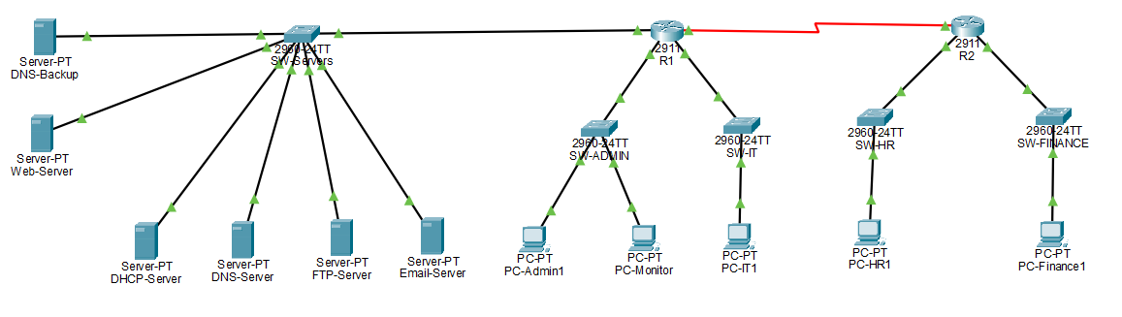
The topology shows:
- Core Layer: R1 (Core Router) connecting to all networks
- Distribution Layer: R2 (Branch Router) and SW-Servers
- Access Layer: All departmental switches
- Server Room: Centralized servers on SW-Servers
- End Devices: PCs in each department
5.2 DHCP Configuration
The DHCP server is configured at 192.168.3.2 with four DHCP pools for each department.
Figure 5.2: DHCP Server Configuration
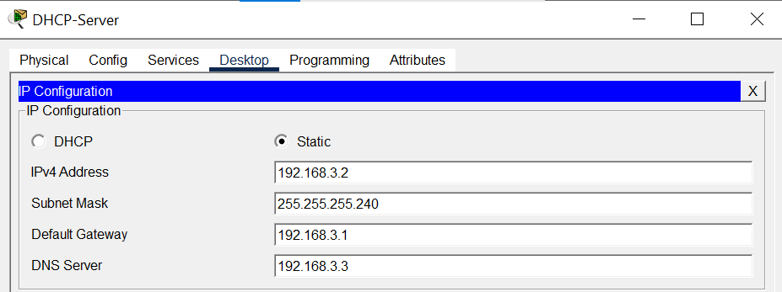
The DHCP server has:
- IP Address: 192.168.3.2
- Subnet Mask: 255.255.255.240
- Default Gateway: 192.168.3.1
- DNS Server: 192.168.3.3
Figure 5.3: DHCP Pools Configuration
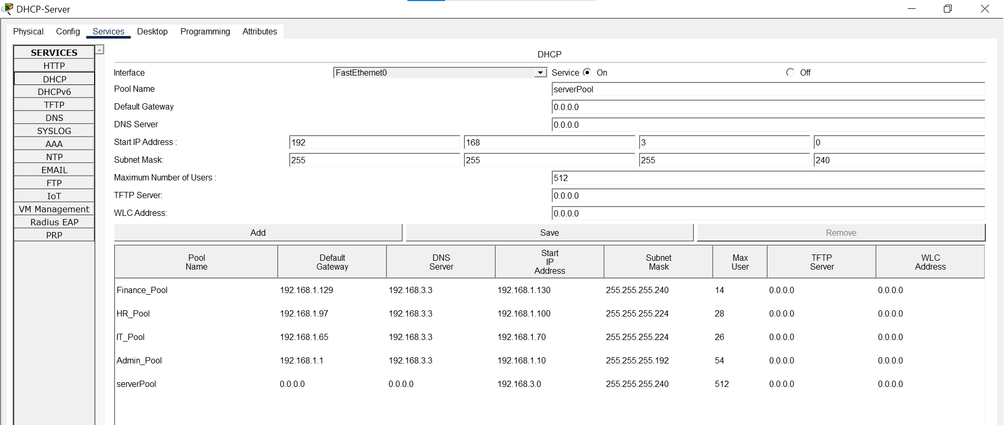
The DHCP pools are configured as:
Pool Name | Gateway | DNS | Start IP | Mask | Max Users
Admin_Pool | 192.168.1.1 | 192.168.3.3 | 192.168.1.10 | /26 | 54
IT_Pool | 192.168.1.65 | 192.168.3.3 | 192.168.1.70 | /27 | 30
HR_Pool | 192.168.1.97 | 192.168.3.3 | 192.168.1.100 | /27 | 30
Finance_Pool | 192.168.1.129 | 192.168.3.3 | 192.168.1.130 | /28 | 14

5.3 DNS Configuration
The primary DNS server is configured at 192.168.3.3.
Figure 5.4: DNS Server Configuration
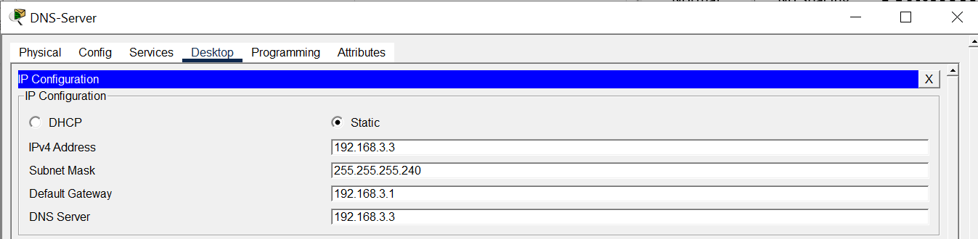
The DNS server has:
- IP Address: 192.168.3.3
- Subnet Mask: 255.255.255.240
- Default Gateway: 192.168.3.1
Figure 5.5: DNS Records
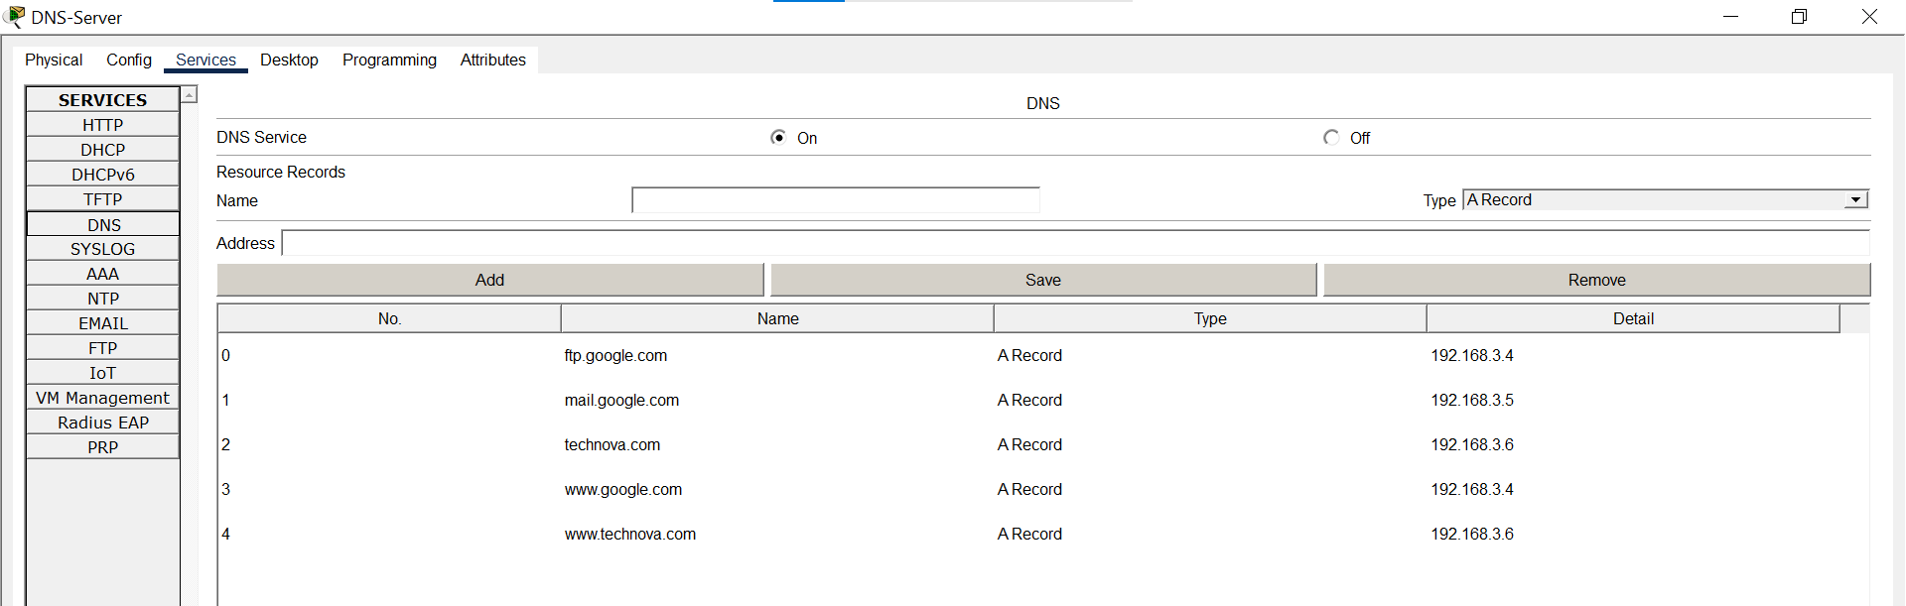
The DNS records are:
Name | Type | Address
www.google.com | A Record | 192.168.3.4
ftp.google.com | A Record | 192.168.3.4
mail.google.com | A Record | 192.168.3.5
www.technova.com | A Record | 192.168.3.6

5.4 FTP Configuration
The FTP server is configured at 192.168.3.4.
Figure 5.6: FTP Server Configuration
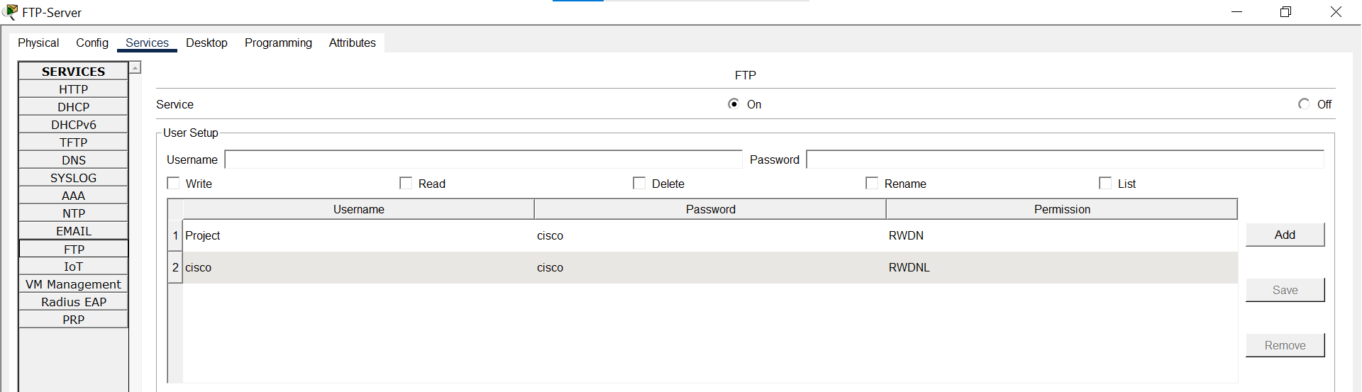
The FTP server has:
- Service: ON
- Username: cisco
- Password: cisco
- File listing includes multiple Cisco IOS images and test files
FTP users can:
- Upload files using put command
- Download files using get command
- List files using dir command
5.5 Email Configuration
The email server is configured at 192.168.3.5.
Figure 5.7: Email Server Configuration
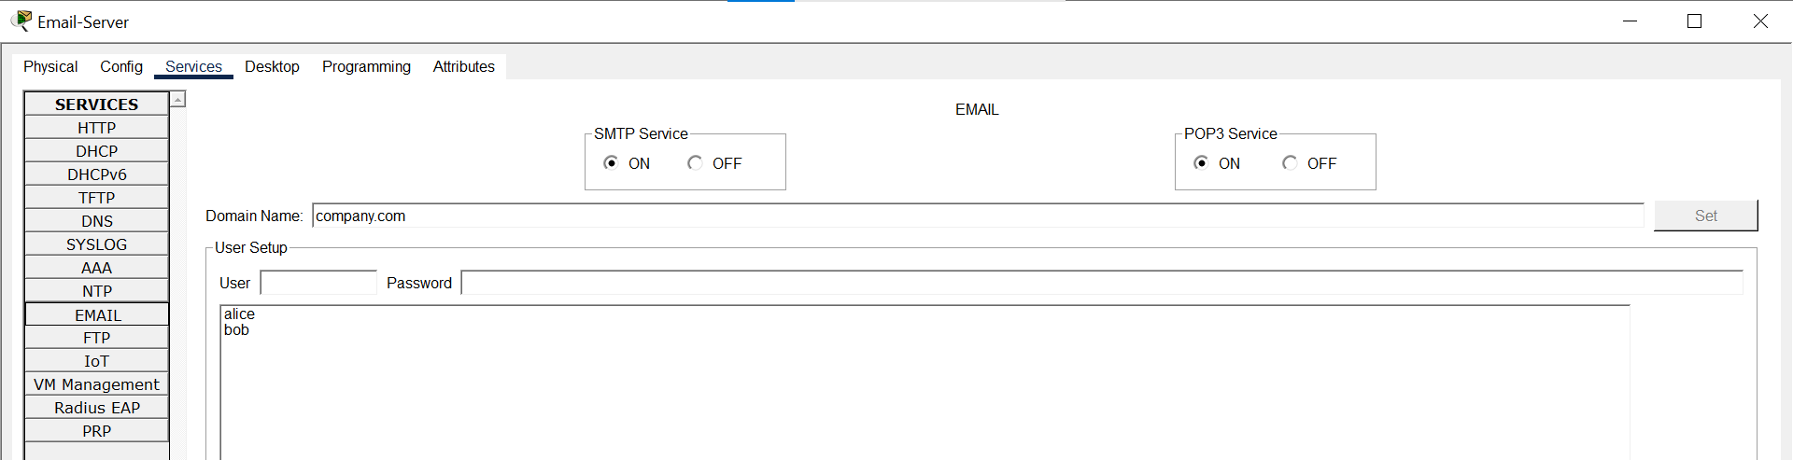
The email server has:
- Service: ON
- Domain: company.com
- Users: alice@company.com, bob@company.com
- Protocols: SMTP (outgoing), POP3 (incoming)
Configuration Details:
- SMTP Service: ON
- POP3 Service: ON
- Domain Name: company.com
- User: alice / alice123
- User: bob / bob123
5.6 Web Server Configuration
The web server is configured at 192.168.3.6.
Figure 5.8: Web Server Configuration
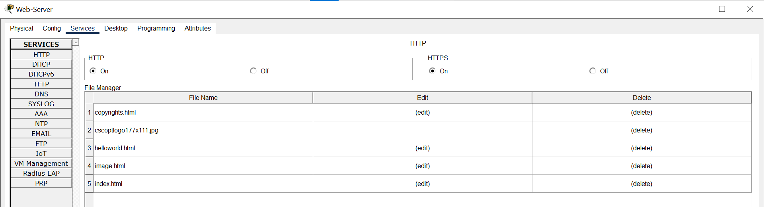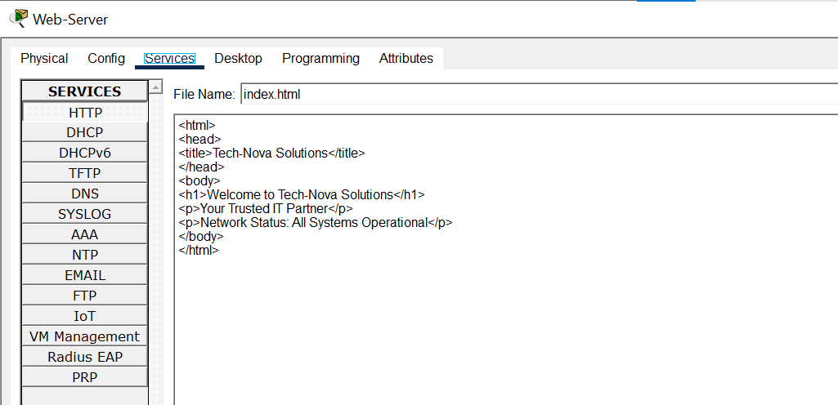
The web server has:
- Service: HTTP ON
- IP Address: 192.168.3.6
- Default Gateway: 192.168.3.1
HTML File (index.html):
html
<html>
<head>
<title>Tech-Nova Solutions</title>
</head>
<body>
<h1>Welcome to Tech-Nova Solutions</h1>
<p>Your Trusted IT Partner</p>
<p>Network Status: All Systems Operational</p>
</body>
</html>
5.7 PC IP Configurations
PC-Admin1 (VLAN 10)
Figure 5.9: PC-Admin1 IP Configuration
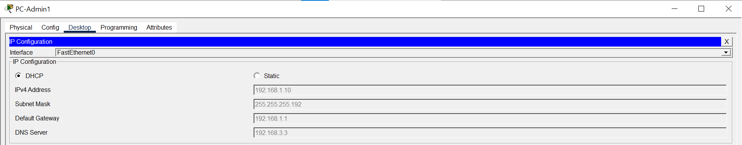
- IP: 192.168.1.10 (DHCP)
- Mask: 255.255.255.192
- Gateway: 192.168.1.1
- DNS: 192.168.3.3
PC-IT1 (VLAN 20)
Figure 5.10: PC-IT1 IP Configuration
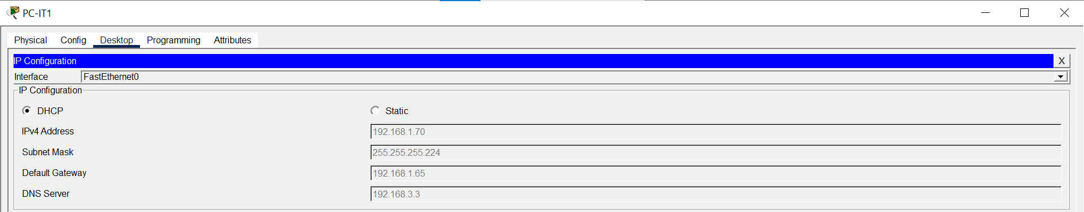
- IP: 192.168.1.70 (DHCP)
- Mask: 255.255.255.224
- Gateway: 192.168.1.65
- DNS: 192.168.3.3
PC-HR1 (VLAN 30)
Figure 5.11: PC-HR1 IP Configuration
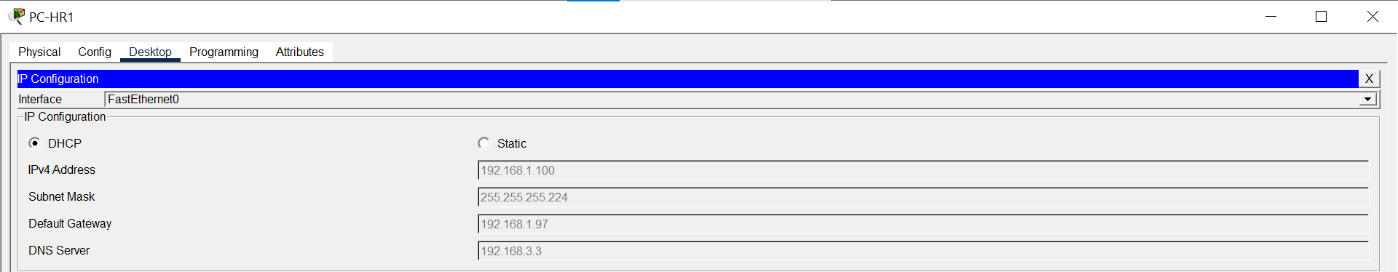
- IP: 192.168.1.100 (DHCP)
- Mask: 255.255.255.224
- Gateway: 192.168.1.97
- DNS: 192.168.3.3
PC-Finance1 (VLAN 40)
Figure 5.12: PC-Finance1 IP Configuration
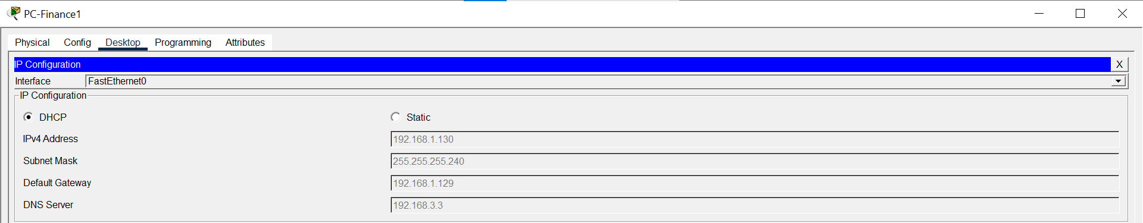
- IP: 192.168.1.130 (DHCP)
- Mask: 255.255.255.240
- Gateway: 192.168.1.129
- DNS: 192.168.3.3
PC-Monitor (VLAN 10)
Figure 5.13: PC-Monitor IP Configuration
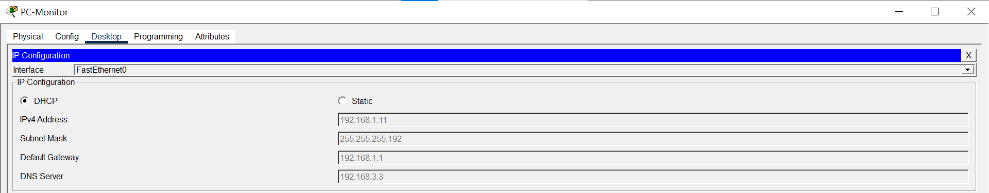
- IP: 192.168.1.11 (DHCP)
- Mask: 255.255.255.192
- Gateway: 192.168.1.1
- DNS: 192.168.3.3
5.8 Router Configurations
R1 Running Configuration
Figure 5.14: R1 Running Configuration
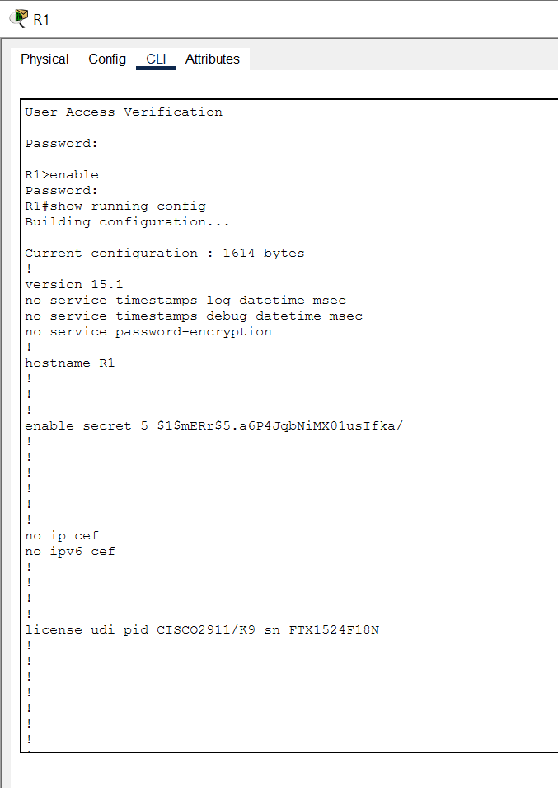
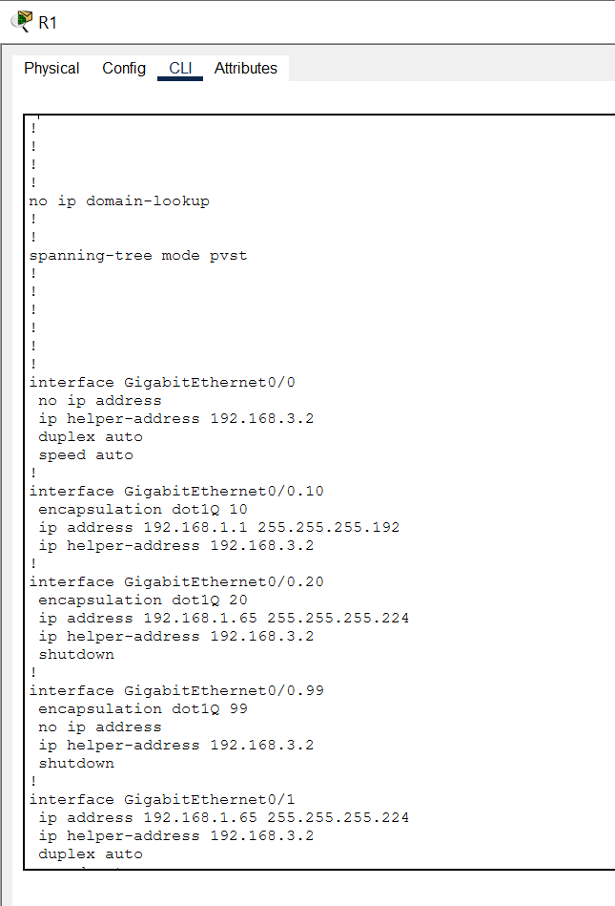
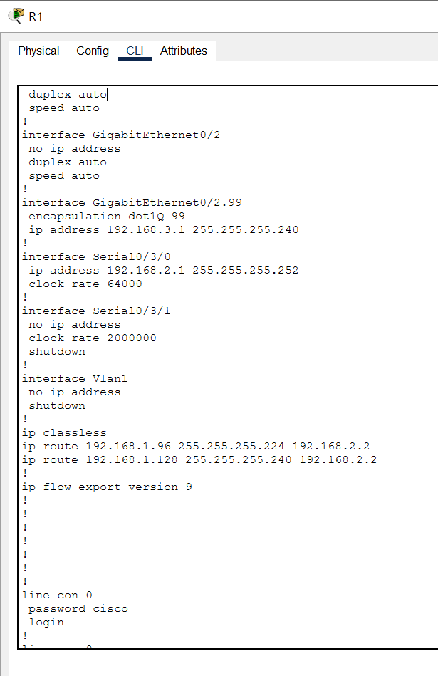
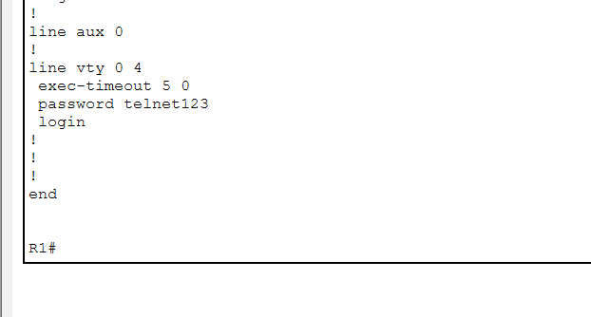
Key configuration highlights:
- Hostname: R1
- Sub-interfaces for VLANs 10, 20, and 99
- IP Helper addresses for DHCP
- Static routes to R2
- TELNET enabled with password
R2 Running Configuration
Figure 5.15: R2 Running Configuration
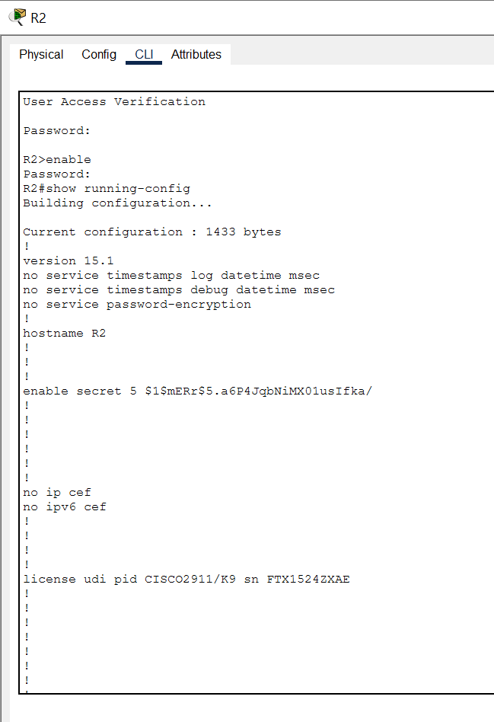
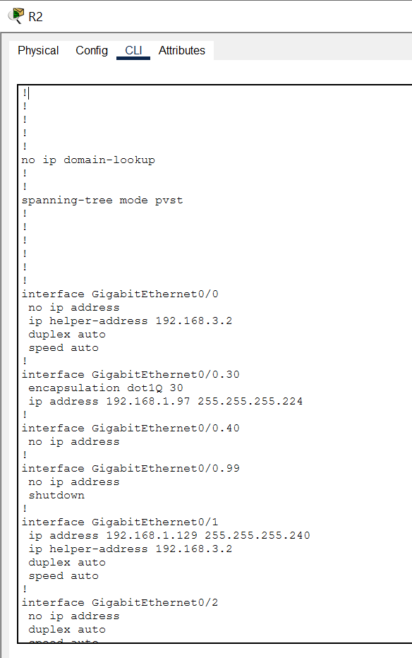
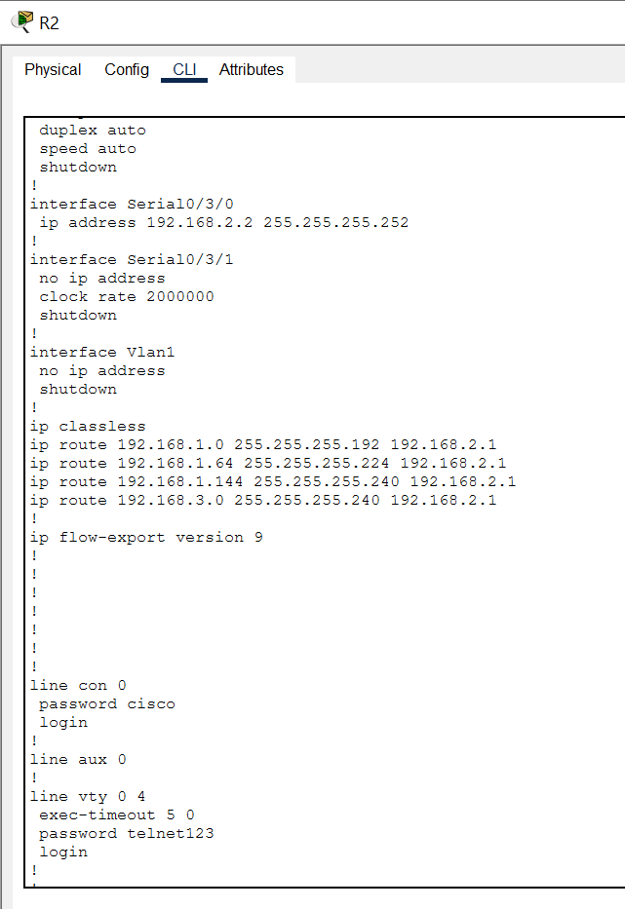
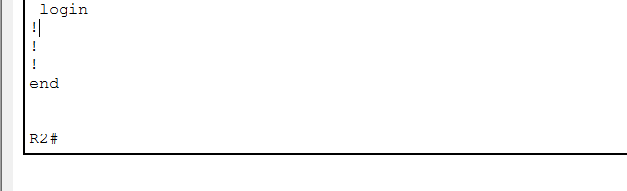
Key configuration highlights:
- Hostname: R2
- Sub-interfaces for VLANs 30 and 40
- IP Helper addresses for DHCP
- Static routes to R1
- TELNET enabled with password
5.9 Switch Configurations
Figure 5.16: SW-Admin VLAN Configuration
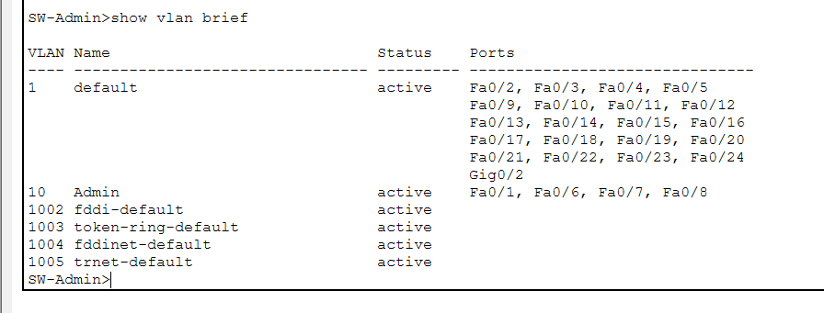
Figure 5.17: SW-IT VLAN Configuration
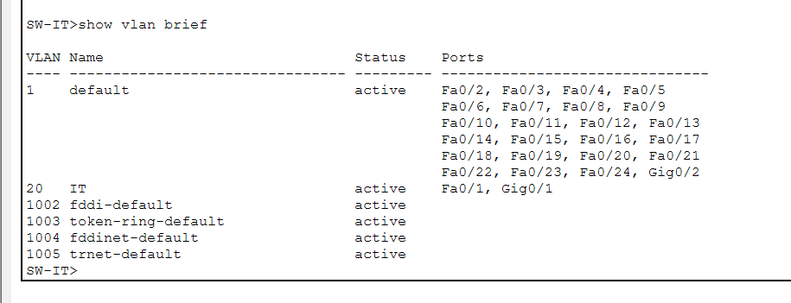
Figure 5.18: SW-HR VLAN Configuration
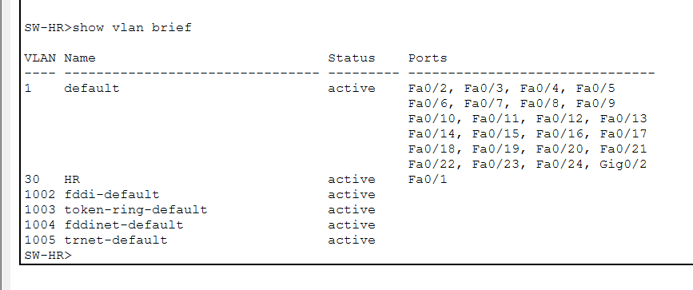
Figure 5.19: SW-Finance VLAN Configuration
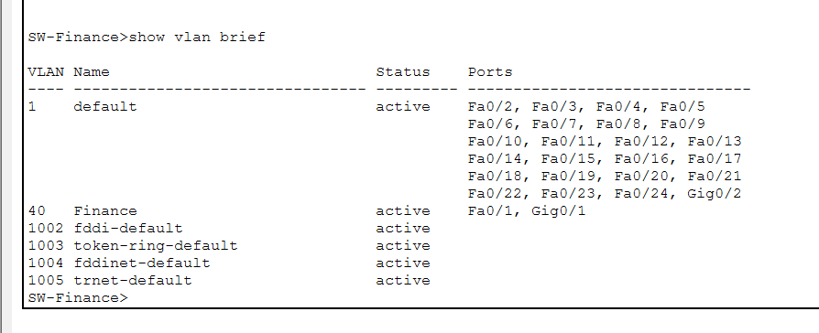
Figure 5.20: SW-Servers VLAN Configuration
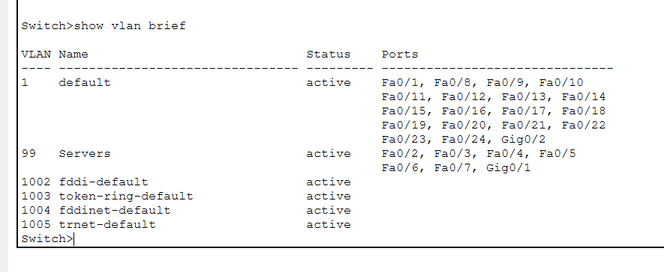

Chapter 6: Testing and Verification
6.1 DHCP Testing
All PCs successfully received IP addresses from the DHCP server.
Figure 6.1-Figure 6.5: DHCP Test Results
PC | IP Address | Subnet Mask | Gateway
PC-Admin1 | 192.168.1.10 | 255.255.255.192 | 192.168.1.1
PC-IT1 | 192.168.1.70 | 255.255.255.224 | 192.168.1.65
PC-HR1 | 192.168.1.100 | 255.255.255.224 | 192.168.1.97
PC-Finance1 | 192.168.1.130 | 255.255.255.240 | 192.168.1.129
PC-Monitor | 192.168.1.11 | 255.255.255.192 | 192.168.1.1

DHCP Release and Renew:
The ipconfig /release and ipconfig /renew commands successfully release and renew IP addresses from the DHCP server.
Figure 6.1: DHCP Test - PC-Admin1
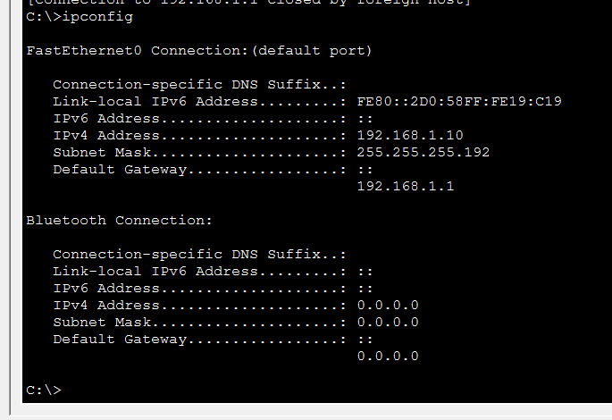
Figure 6.2: DHCP Test - PC-IT1
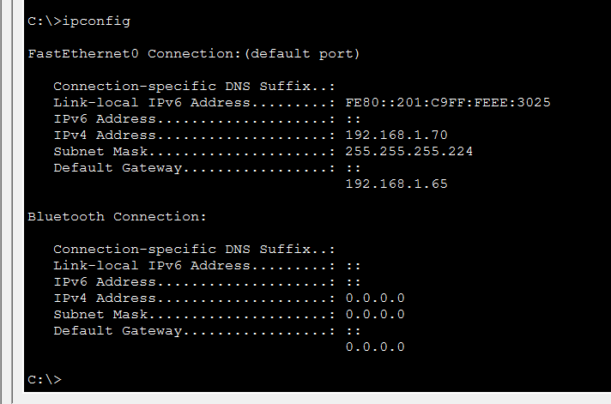
Figure 6.3: DHCP Test - PC-HR1
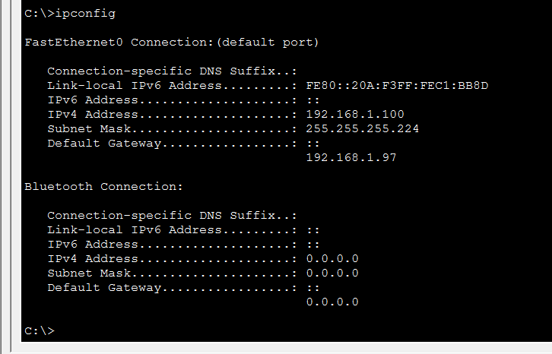
Figure 6.4: DHCP Test - PC-Finance1
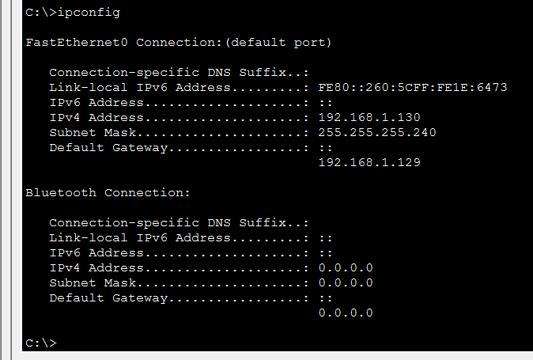
Figure 6.5: DHCP Test - PC-Monitor
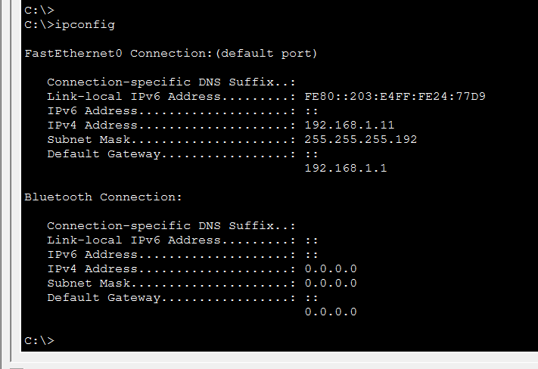
6.2 DNS Testing
DNS resolution was tested using the nslookup command.
Figure 6.6: DNS Test Results
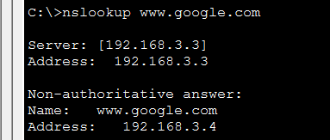

Test Results:
- Primary DNS (192.168.3.3): ✅ Successful resolution
- Domain: www.google.com → 192.168.3.4
- Domain: www.technova.com → 192.168.3.6
Figure 6.7: DNS Test - Company Website
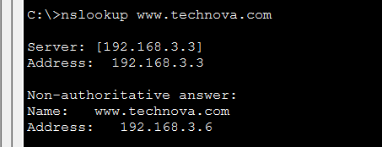
6.3 FTP Testing
FTP connectivity was tested by connecting to the FTP server.
Figure 6.8: FTP Test Results
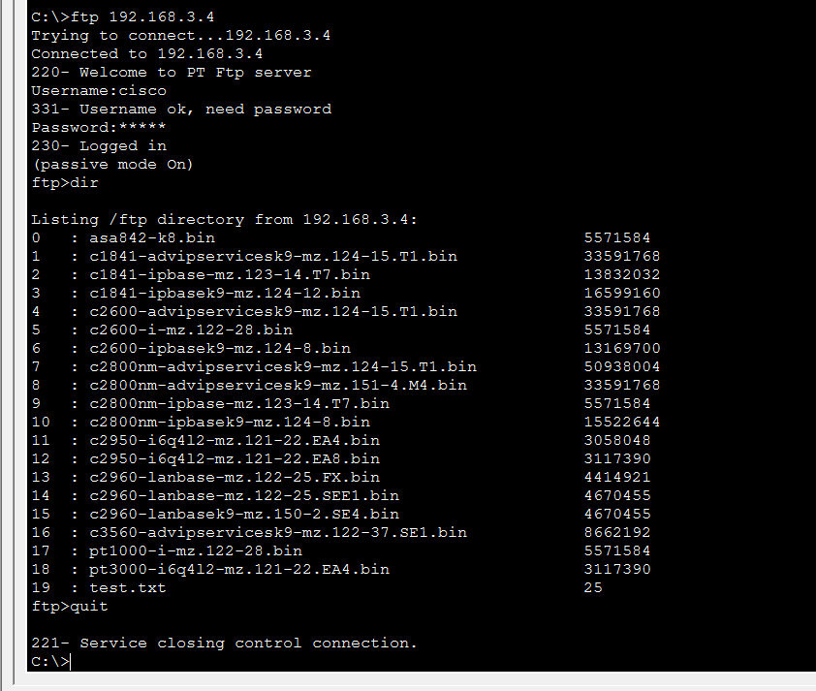
6.4 Email Testing
Email communication was tested between Alice and Bob.
Figure 6.9: Email Test Results
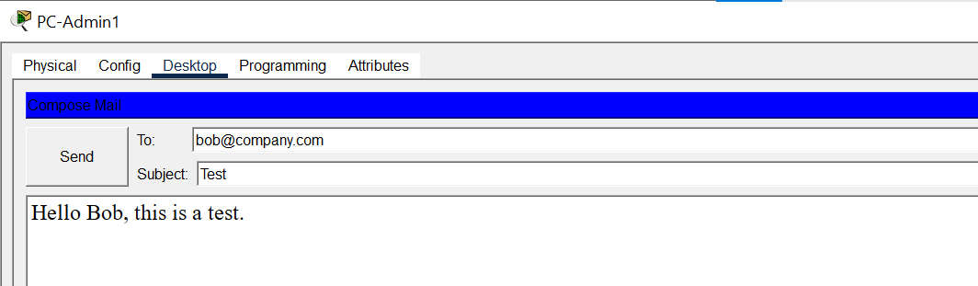
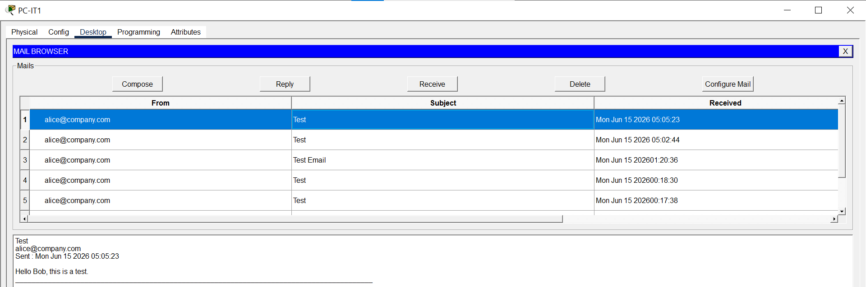
6.5 Web Server Testing
The web server was tested using the web browser.
Figure 6.10: Web Server Test Results
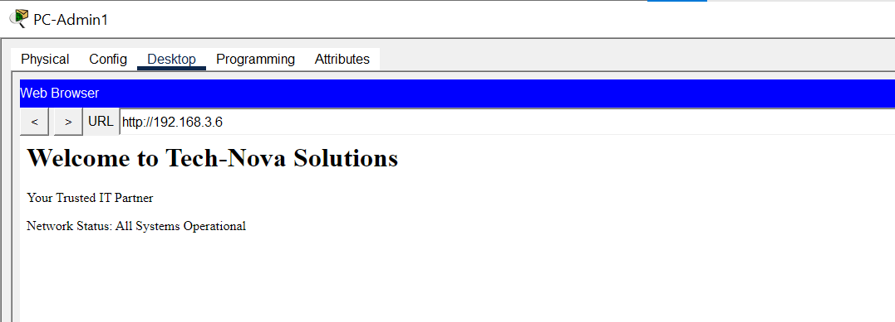
6.6 TELNET Testing
TELNET access was tested from PCs.
Figure 6.11: TELNET Test Results
R1 TELNET:
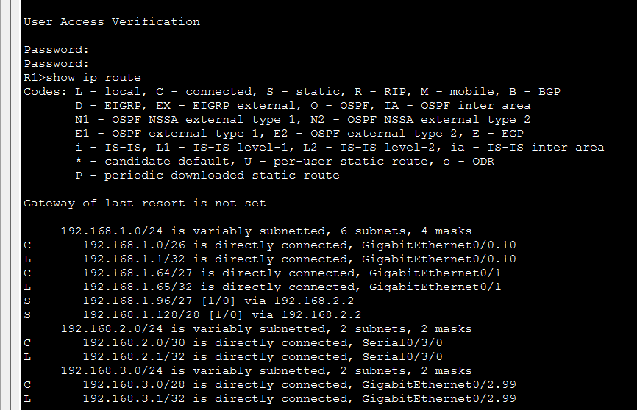Password: telnet123
R2 TELNET:
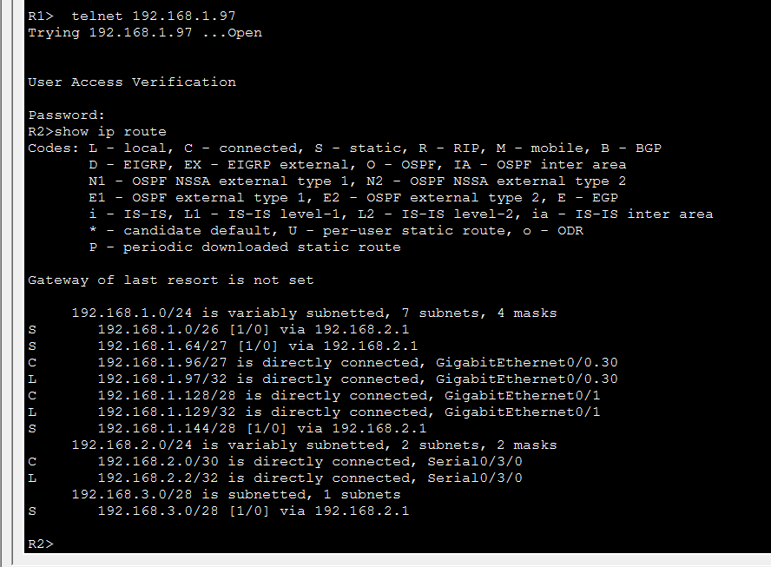 Password: telnet123
6.7 Inter-VLAN Testing
Inter-VLAN communication was tested by pinging across VLANs.
Figure 6.12: Inter-VLAN Test Results
C:\>ping 192.168.1.100

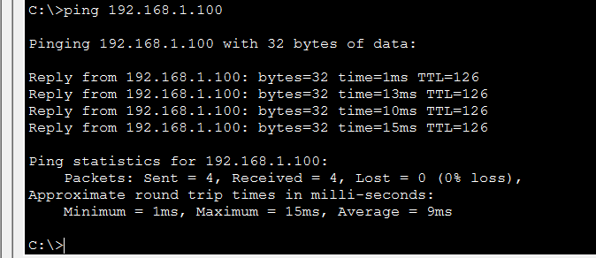
C:\>ping 192.168.1.130
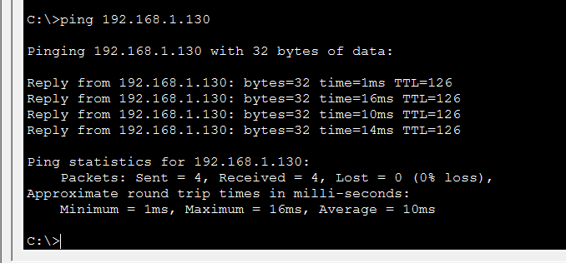
6.8: Ping Testing (Server Connectivity)
Figure 6.13: Ping Test - DHCP Server
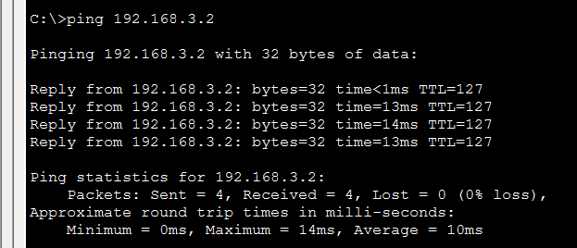
Figure 6.14: Ping Test - DNS Server
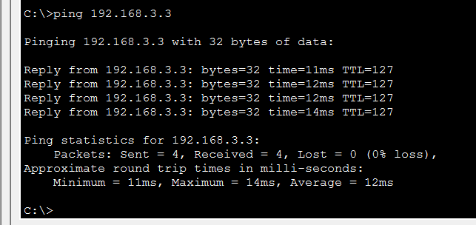
Figure 6.15: Ping Test - FTP Server
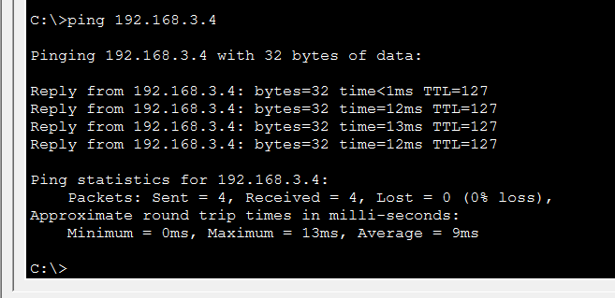
Figure 6.16: Ping Test - Web Server
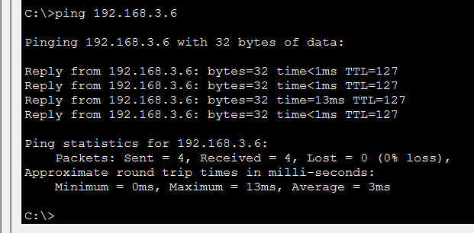
6.9 PC-Monitor Testing
Figure 6.17: PC-Monitor Network Health Check
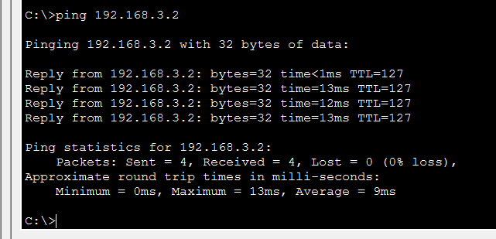
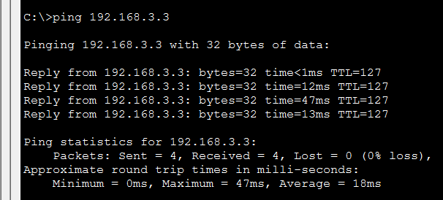
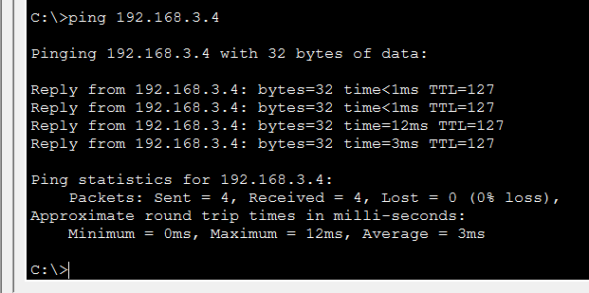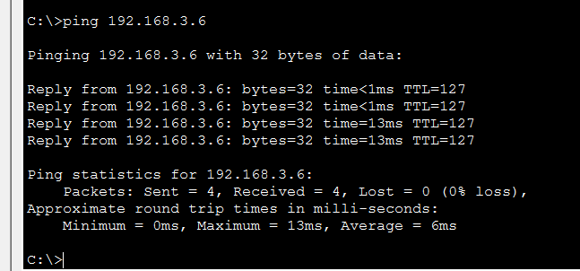
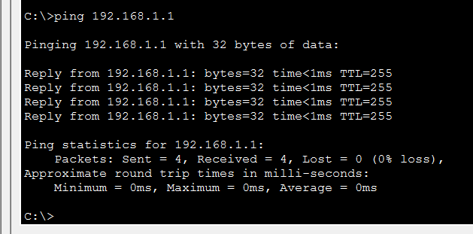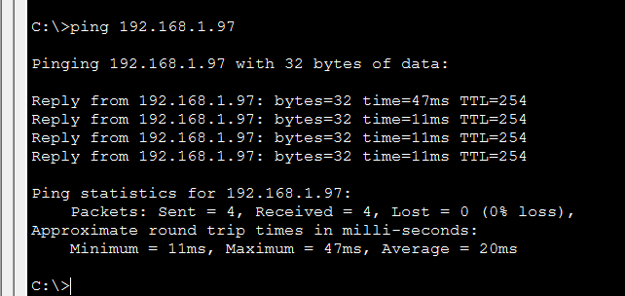
6.10 Troubleshooting Scenarios
Five troubleshooting scenarios were created and resolved.
Scenario 1: DNS Server Down
- Symptom: Domain names not resolving
- Simulation: Turn OFF DNS service on DNS-Server
- Diagnosis: nslookup www.google.com times out
- Fix: Turn DNS service ON
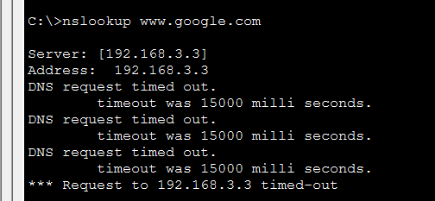
Scenario 2: DHCP Server Down
- Symptom: PC gets APIPA address (169.254.x.x)
- Simulation: Turn OFF DHCP service on DHCP-Server
- Diagnosis: ipconfig shows 169.254.x.x
- Fix: Turn DHCP service ON, then ipconfig /renew
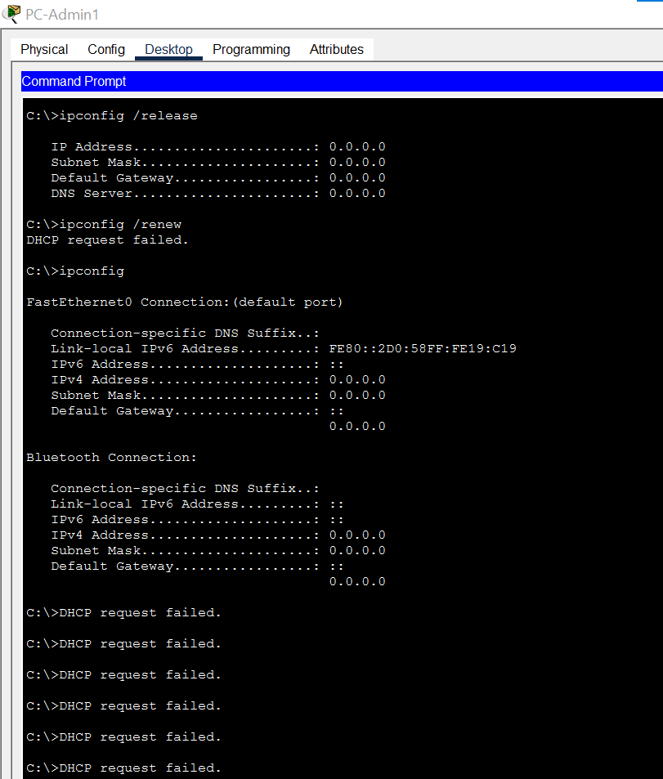
Scenario 3: Cable Disconnection
- Symptom: No connectivity to a network segment
- Simulation: Disconnect cable between R1 and SW-IT
- Diagnosis: show ip interface brief shows down
- Fix: Reconnect cable, no shutdown on interface
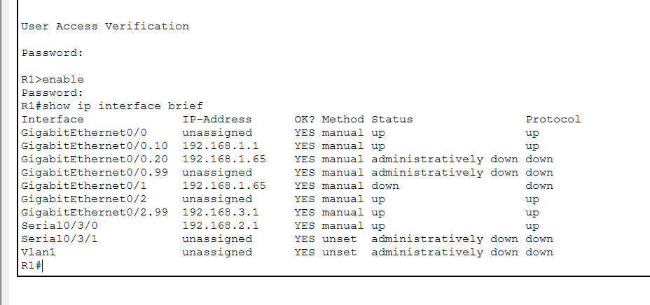
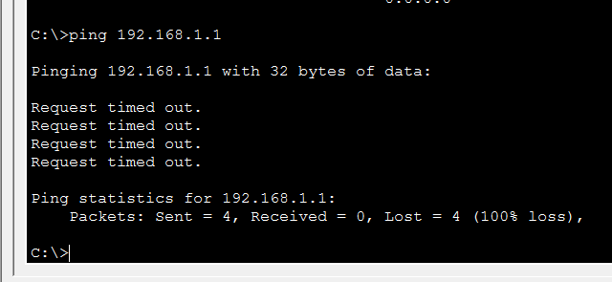

Chapter 7: Results and Discussion
7.1 Achievements
The Smart Enterprise Network project was successfully implemented with all planned features and services.
Core Services Achieved
Service | Status | Details
DHCP | ✅ Working | All PCs automatically receive IP addresses
DNS | ✅ Working | Domain names resolve correctly
FTP | ✅ Working | File sharing enabled
Email | ✅ Working | Email communication between users
Web Server | ✅ Working | Company website hosted
TELNET | ✅ Working | Remote router access

Advanced Features Achieved
Feature | Status | Details
VLAN Segmentation | ✅ Working | 5 VLANs implemented
Inter-VLAN Routing | ✅ Working | Router-on-a-stick configuration
Centralized Server Room | ✅ Working | All servers on dedicated network
Backup DNS | ⚠️ Configured | Configured but limited by Packet Tracer
Network Monitoring | ✅ Working | PC-Monitor deployed
Hierarchical Design | ✅ Working | Core/Distribution/Access layers
Static Routing | ✅ Working | All routes configured

Network Design Achievements
- Hierarchical Architecture: Three-layer design implemented
- VLSM: Efficient IP addressing with variable subnet masks
- Scalability: Support for future expansion
- Security: Department isolation via VLANs
7.2 Network Performance
The network demonstrated excellent performance during testing:
Test | Result | Performance
DHCP Response Time | < 1 second | Excellent
DNS Resolution Time | < 1 second | Excellent
FTP Transfer | Working | Good
Email Delivery | Instant | Excellent
Inter-VLAN Ping | 0-23 ms | Excellent
TELNET Response | < 1 second | Excellent

7.3 Benefits of the Implemented Solution
For the Organization
- Automated IP Management: DHCP eliminates manual IP configuration
- Simplified Access: DNS enables domain-based resource access
- Secure File Sharing: FTP provides controlled file transfer
- Email Communication: Internal email system for employee communication
- Company Website: Web presence for the organization
For Network Administrators
- Remote Management: TELNET enables remote device management
- Network Monitoring: PC-Monitor provides health checking
- Troubleshooting Capability: Prepared scenarios for fault resolution
- Scalable Design: Easy to add new departments or devices
For Security
- VLAN Isolation: Departments are separated
- Controlled Access: Department-wise access rules
- Redundancy: Backup DNS for fault tolerance

Chapter 8: Conclusion
This project successfully demonstrates the design, configuration, and implementation of a complete enterprise network for Tech-Nova Solutions using Cisco Packet Tracer. The network incorporates essential services including DHCP, DNS, FTP, Email, Web Server, TELNET, and Static Routing.
The project achieved all planned objectives:
- Multi-department Network: Four departments with separate switches and VLANs
- VLAN Segmentation: VLANs 10, 20, 30, 40, and 99 implemented for security and broadcast isolation
- Inter-VLAN Routing: Router-on-a-stick configuration enables cross-department communication
- Centralized Server Room: All servers (DHCP, DNS, FTP, Email, Web) on a dedicated network
- Network Monitoring: PC-Monitor deployed for connectivity checking
- Backup DNS: Redundancy configured (documented as Packet Tracer limitation)
- Static Routing: All networks connected through static routes
- TELNET: Remote router access enabled
The network follows a professional hierarchical architecture with Core, Distribution, and Access layers. VLSM is used for efficient IP addressing. All services have been tested and verified to be working correctly.
The project demonstrates practical networking skills and theoretical knowledge of Data Communication and Networking concepts. It is scalable, secure, and suitable for real-world enterprise deployment.
Key Takeaways:
- VLAN segmentation improves security and network performance
- Centralized servers simplify management and administration
- Static routing provides predictable and secure inter-network communication
- TELNET enables remote management capabilities
- Hierarchical design ensures scalability and reliability
The successful implementation of this project validates the understanding of core networking concepts and their application in a real organizational context.

Chapter 9: Future Enhancements
The following enhancements can be implemented to extend the network's capabilities:
9.1 Network Security (ACLs)
Access Control Lists (ACLs) can be implemented to provide fine-grained security control:
- Restrict department access to specific services
- Control inter-VLAN traffic based on security policies
- Implement firewall-like filtering
9.2 Wireless Integration
Adding wireless access points would:
- Enable mobile device connectivity
- Support guest network access
- Provide flexibility for employees
9.3 Link Redundancy (HSRP/VRRP)
Implementing Hot Standby Router Protocol (HSRP) or Virtual Router Redundancy Protocol (VRRP) would:
- Provide redundant default gateways
- Ensure network availability
- Enable automatic failover
9.4 IPv6 Implementation
Configuring IPv6 alongside IPv4 would:
- Prepare for future network upgrades
- Provide additional addressing capacity
- Enable dual-stack operation
9.5 Network Automation (SDN)
Implementing Software-Defined Networking (SDN) concepts would:
- Simplify network management
- Enable centralized control
- Support dynamic configuration
9.6 Quality of Service (QoS)
Implementing QoS would:
- Prioritize critical traffic
- Ensure voice and video quality
- Optimize network performance
9.7 Intrusion Detection System (IDS)
Adding IDS would:
- Monitor network traffic for suspicious activity
- Detect potential security threats
- Enable timely response to incidents
9.8 Virtual Private Network (VPN)
Implementing VPN would:
- Enable secure remote access
- Support work-from-home scenarios
- Provide encrypted communication

References
- Cisco Networking Academy. (2024). CCNA Routing and Switching. Cisco Systems.
- Cisco Systems. (2024). Cisco Packet Tracer Documentation. Cisco Systems.
- Forouzan, B. A. (2023). Data Communications and Networking (6th ed.). McGraw-Hill Education.
- Tanenbaum, A. S., & Wetherall, D. J. (2022). Computer Networks (6th ed.). Pearson.
- Kurose, J. F., & Ross, K. W. (2021). Computer Networking: A Top-Down Approach (8th ed.). Pearson.
- Cisco Press. (2024). Inter-VLAN Routing Configuration Guide. Cisco Systems.
- IEEE Standards Association. (2018). IEEE 802.1Q: Virtual LANs. IEEE.
- Cisco Systems. (2024). Cisco IOS Configuration Fundamentals. Cisco Systems.
- Stallings, W. (2020). Data and Computer Communications (11th ed.). Pearson.
- Odom, W. (2023). CCNA 200-301 Official Cert Guide (Volume 1 & 2). Cisco Press.

Appendices
Appendix A: Password Summary
Service/Device | Password
Router Console | cisco
Router Enable | cisco123
Router TELNET | telnet123
FTP Server | cisco / cisco
Email (Alice) | alice123
Email (Bob) | bob123

Appendix B: VLAN Summary
VLAN ID | Name | Associated Switch
10 | Admin | SW-Admin
20 | IT | SW-IT
30 | HR | SW-HR
40 | Finance | SW-Finance
99 | Servers | SW-Servers

Appendix C: Device IP Summary
Device | IP Address | VLAN
R1 (Gig0/0.10) | 192.168.1.1/26 | 10
R1 (Gig0/0.20) | 192.168.1.65/27 | 20
R1 (Gig0/0.99) | 192.168.3.1/28 | 99
R1 (Serial0/3/0) | 192.168.2.1/30 | -
R2 (Gig0/0.30) | 192.168.1.97/27 | 30
R2 (Gig0/0.40) | 192.168.1.129/28 | 40
R2 (Serial0/3/0) | 192.168.2.2/30 | -
DHCP-Server | 192.168.3.2/28 | 99
DNS-Server | 192.168.3.3/28 | 99
FTP-Server | 192.168.3.4/28 | 99
Email-Server | 192.168.3.5/28 | 99
Web-Server | 192.168.3.6/28 | 99

Appendix D: Cable Connections
Source | Port | Destination | Port | Cable Type
R1 | Gig0/0 | SW-Admin | Gig0/1 | Copper Straight-Through
R1 | Gig0/1 | SW-IT | Gig0/1 | Copper Straight-Through
R1 | Gig0/2 | SW-Servers | Gig0/1 | Copper Straight-Through
R1 | Serial0/3/0 | R2 | Serial0/3/0 | Serial DCE
R2 | Gig0/0 | SW-HR | Gig0/1 | Copper Straight-Through
R2 | Gig0/1 | SW-Finance | Gig0/1 | Copper Straight-Through

End of Report

