Final Project Report – SmartEdu Multi-Campus Network Infrastructure Design & Simulation
- Project Title
SmartEdu Multi-Campus Network Infrastructure Design & Simulation

2. Group Members & Assigned Roles
- Abdullah Akif – Group Leader, WAN Design & OSPF Routing
- M. Zaka – LAN Switching & VLAN Deployment
- Raja Ali Shahid – IP Address Schema
- Faseeh Ahmed Zahoor – Documentation
- Ammar Akhtar Butt – GitHub Repository Management

3. Introduction
This project simulates a complete enterprise-grade multi-campus network for the fictional SmartEdu Institute. The design connects two campuses (Main Campus and City Campus) through a WAN connection supported by OSPF dynamic routing. The network uses a hierarchical design with VLAN segmentation, DHCP-based dynamic addressing, ACL-based security, and controlled Inter-VLAN communication. All configuration, documentation, and version control are managed through a dedicated GitHub repository.

4. Network Topology Overview
The final topology includes:
- 2 interconnected campuses (Main & City) using a WAN serial link.
- Core routers functioning as the backbone of routing and WAN connectivity.
- Layer-2 for departmental distribution.
- Multiple departmental LANs, each represented with color-coded groups.
- Centralized DHCP Server at Main Campus.
- Multiple VLANs, each representing a separate department.
- ACLs applied on router interfaces to control inter-department communication.

Interpreted from the provided topology image:
- The Main Campus contains multiple clusters of PCs grouped logically (Admin, IT, Labs, Faculty).
- The City Campus hosts Student Affairs, Library, and Support departments.
- A large campus LAN is visible at the bottom with multiple switches and department blocks.
- Core routers interconnect all zones and provide WAN routing.

5. Detailed Task Responsibilities
Below is the filled-in content for each team member based on the project proposal and topology.

5.1 Abdullah Akif – WAN Design & OSPF Routing

5.1.1 WAN Design
- The two campuses are connected using a serial WAN link between their respective routers.
- The WAN acts as the backbone for inter-campus communication.
- A hierarchical model is used:
  - Core Layer: WAN Routers
  - Access Layer: Multiple switches per department

5.1.2 OSPF Routing Configuration
- OSPF is implemented for dynamic routing across both campuses.
- Each department subnet is advertised into the OSPF process.
- Multi-area OSPF design is used for future scalability.
- Routing ensures full end-to-end reachability within and across campuses.

5.1.3 Verification
- Successful ping tests were performed between:
  - Main → City Campus
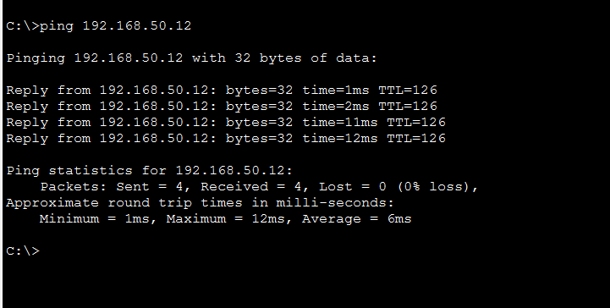
  - Admin → IT
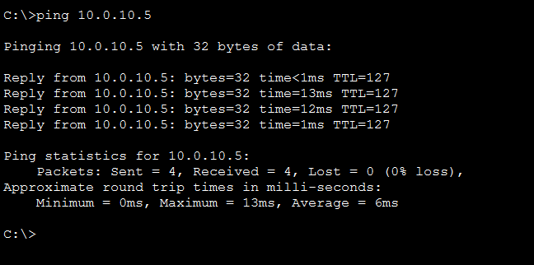
  - Labs → Faculty
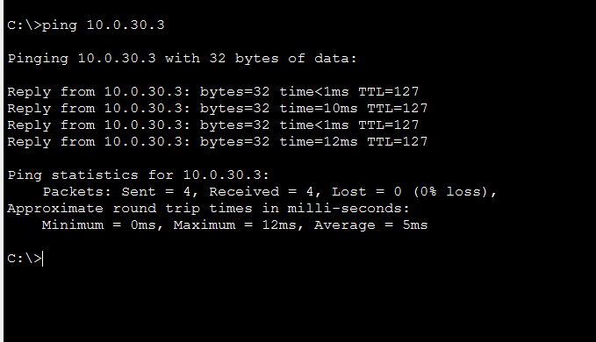

- show ip route and OSPF neighbor verification confirm correct adjacency.
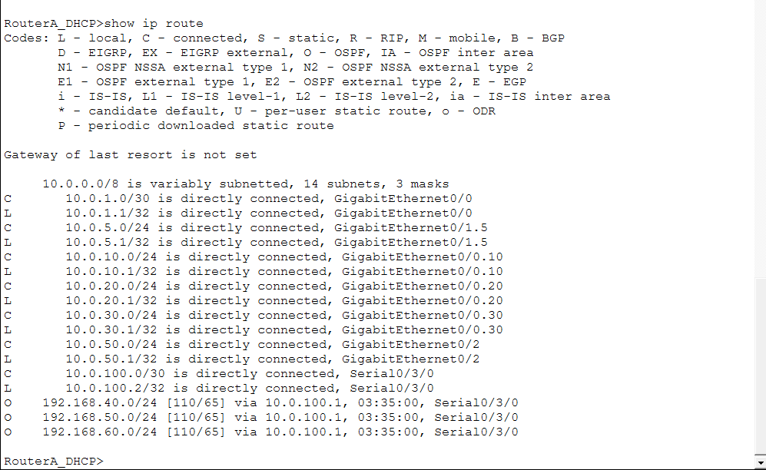

5.2 M. Zaka – LAN Switching + VLAN Deployment

5.2.1 VLAN Design
Based on the proposal:
- VLAN 5 – Admin
- VLAN 10 – IT
- VLAN 20 – Computer Labs
- VLAN 30 – Faculty
- VLAN 40 – Student Affairs (City)
- VLAN 50 – Library & Support (City)
Each department has an isolated broadcast domain.
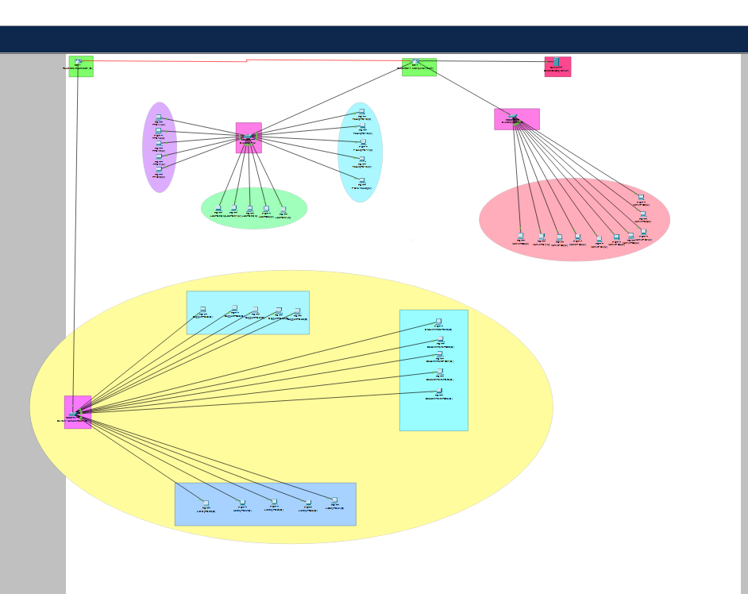

5.2.2 Switch Configuration Tasks
- All PCs connected to access ports mapped to their respective VLANs.
- Inter-switch links configured as 802.1Q trunk ports.
- Switch spanning tree operates in default mode for loop prevention.
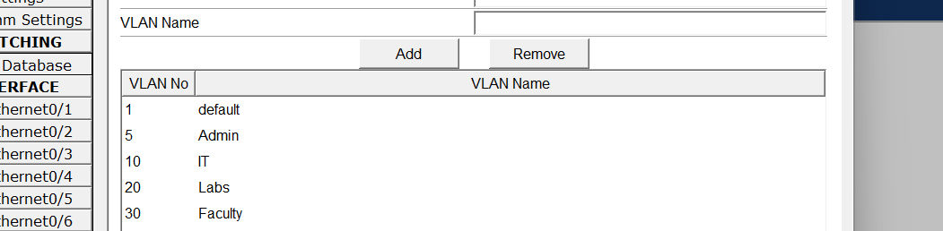

5.2.3 Testing
- PCs within the same VLAN successfully communicate.
- Trunks verified using show interfaces trunk.
- VLAN table validated using show vlan brief.
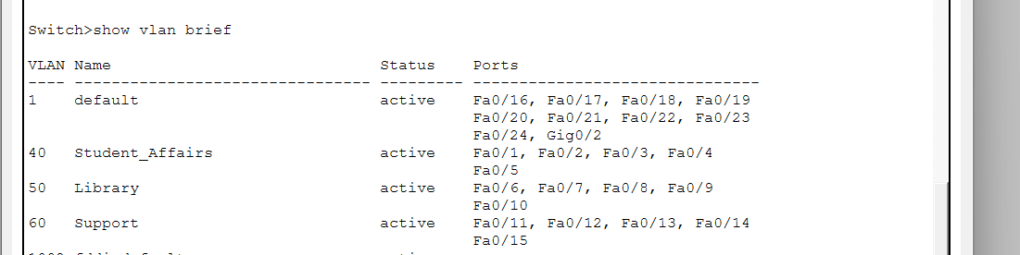

5.3 Raja Ali Shahid – DHCP Server + IP Address Schema

5.3.1 IP Addressing Schema
- A private IP addressing scheme designed using VLSM.
- Each VLAN receives its own subnet.
- Scalability ensured by assigning future-proof subnet sizes.
- DHCP Server located at Main Campus for centralized management.
- DHCP Relay configured on City Campus routers.

5.3.2 DHCP Configuration
- DHCP pools created for all VLANs.
- Default gateway, DNS, and lease times included.
- Excluded ranges reserved for servers, router interfaces, and network devices.
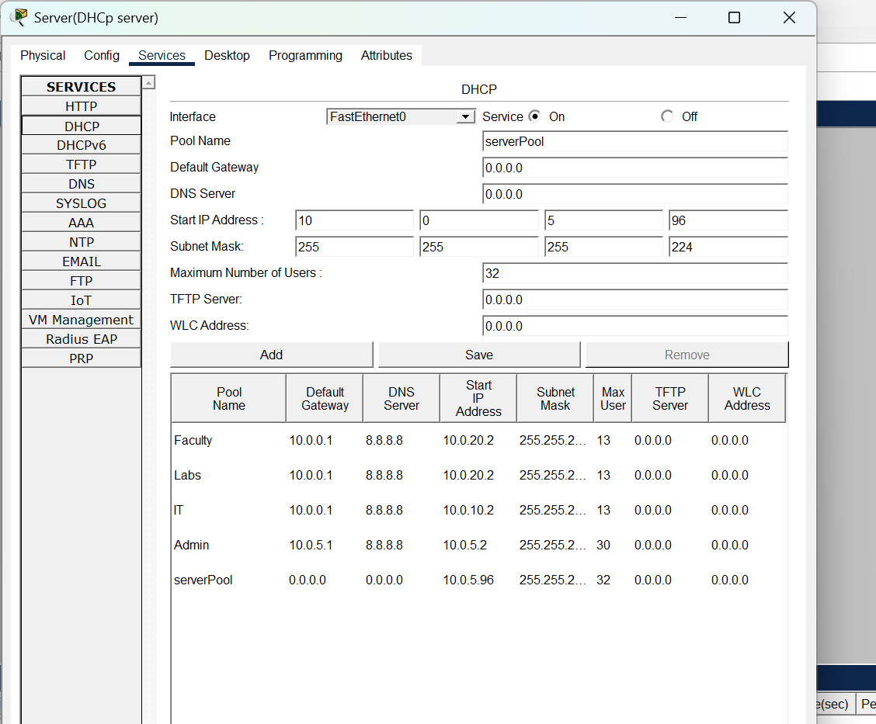

5.3.3 Testing
- All PCs successfully obtained IP addresses automatically.
- ipconfig on end devices verifies correct addressing.
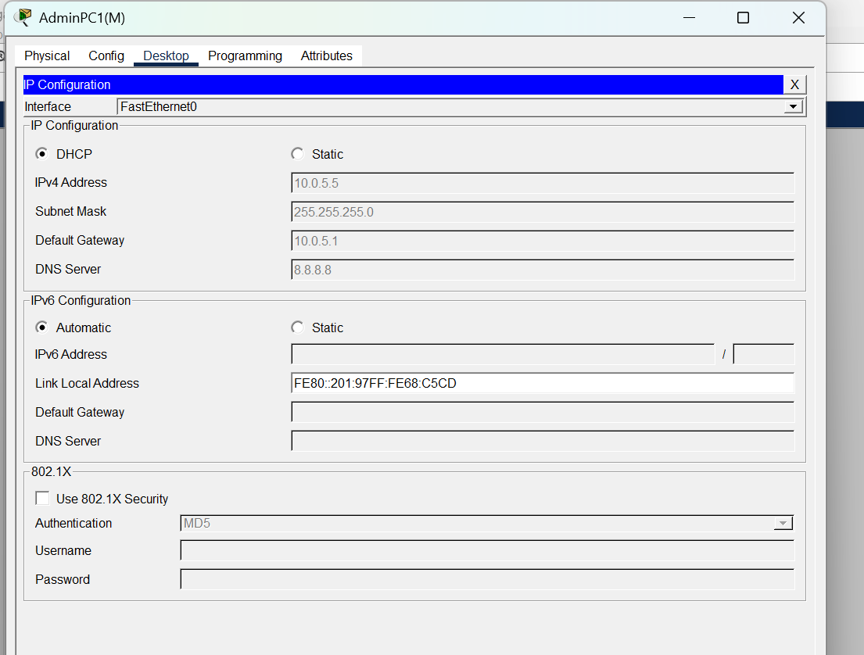

5.4 Faseeh Ahmed Zahoor – Documentation
Collecting details
As explained before in the starting I collected details from all members and cross checked and verify everything

Screenshots & testing artifacts
Take screenshots for every important test. Save in /screenshots with descriptive filenames:
- ping_admin_to_it_main-campus
- traceroute_main_to_city
- ospf_neighbor
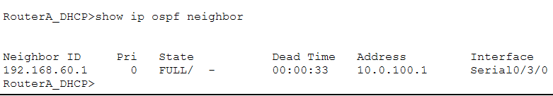

- dhcp_ipallocation_admin
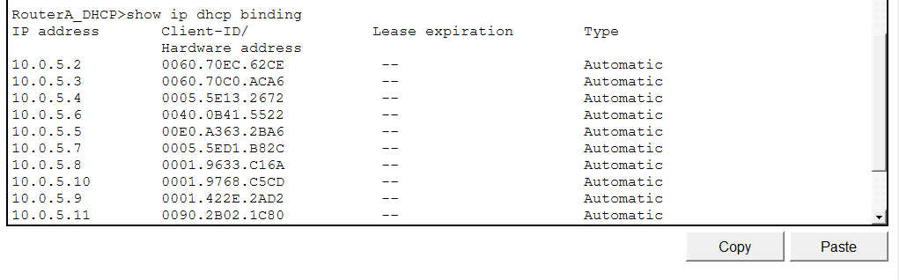

Final Network Testing Summary
Network validation was performed through:
- End-to-end connectivity testing across campuses
- Inter-VLAN reachability where allowed
- DHCP automatic allocation for all devices
- Successful OSPF routing between all routers
All test results confirm that the network is fully functional, scalable.

Contribution matrix & commit log
Create docs/CONTRIBUTION_MATRIX.md with a table:
Member | Role | Files/Configs contributed | % contribution
Abdullah Akif | WAN & DHCP & OSPF | configs/MainRouter... | 20%
M. Zaka | VLANs | configs/switch... | 20%
Raja Ali Shahid | IP plan | docs/addressing | 20%
Faseeh Ahmed | Docs | documentation | 20%
Ammar Akhtar | Repo | README.md | 20%

5.5 Ammar Akhtar Butt – GitHub Repository

Repository setup (assigning name and description)

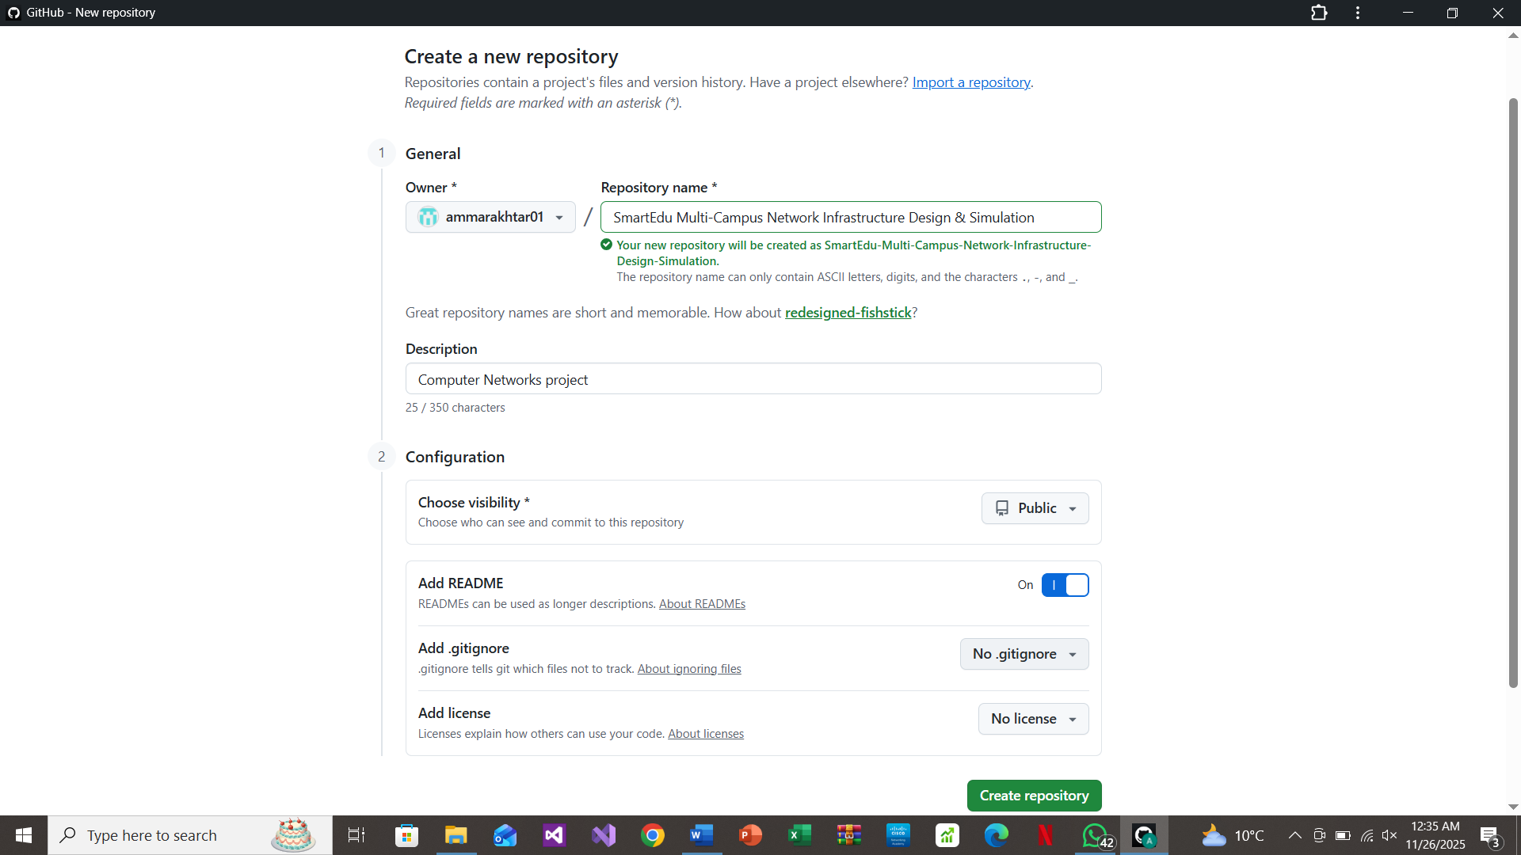

Readme.md editing:

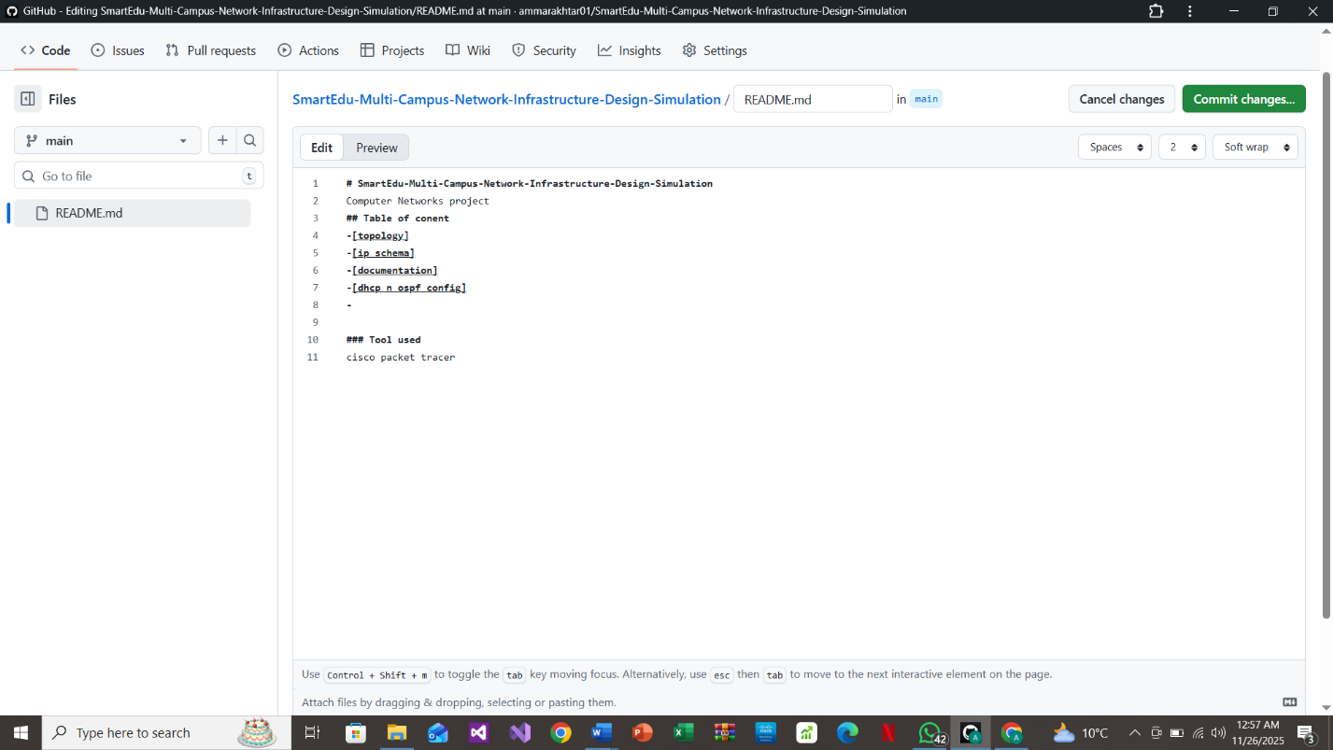

6. Final Network Testing Summary
Network validation was performed through:
- End-to-end connectivity testing across campuses
- Inter-VLAN reachability where allowed
- DHCP automatic allocation for all devices
- Successful OSPF routing between all routers
All test results confirm that the network is fully functional, scalable, and secure.

7. Conclusion
The SmartEdu Multi-Campus network successfully fulfills all technical, administrative, and security requirements. The project demonstrates:
- Robust hierarchical network design
- Efficient VLAN segmentation
- Dynamic routing across multiple campuses
- Strong access control policies for inter-department security
- Centralized and scalable IP management using DHCP
- Professional documentation and repository management
This network is ready for deployment simulation and meets all academic project standards.

