FYP CONNECT



M AMMAR AKHTER (BSE223132)

HASHAM ARSHAD (BSE223150)

ALIZA WASEEM (BSE223154)

Supervised By
MS SABA NAWAZ

Fall 2025
Program Name
Department of Software Engineering
Capital University of Science & Technology, Islamabad
 | Project Report | 

VERSION |  | V X.0 |  |  | NUMBER OF MEMBERS | 3
TITLE | FYP CONNECT
SUPERVISOR NAME |  |  | SABA NAWAZ

MEMBER NAME | REG. NO. | EMAIL ADDRESS
M AMMAR AKHTER | BSE223132 | Bse223132@cust.edu.pk
HASHAM ARSHAD | BSE223150 | Bse223150@cust.edu.pk
ALIZA WASEEM | BSE223154 | Bse223154@cust.edu.pk

MEMBERS’ SIGNATURES
Supervisor’s Signature

Approval Certificate

This project, entitled as “FYP CONNECT ” has been approved for the award of

Bachelors of Science in Software Engineering

Committee Signatures:

Supervisor: __________________________

(Ms. Saba Nawaz)

Project Coordinator: __________________________

(Mr. Ibrar Arshad)

Head of Department: __________________________

(Dr. Nadeem Anjum)

Declaration
We, hereby, declare that “No portion of the work referred to, in this project has been submitted in support of an application for another degree or qualification of this or any other university/institute or other institution of learning”. It is further declared thatthis undergraduate project, neither as a whole nor as a part thereof has been copied out from any sources, wherever references have been provided.

MEMBERS’ SIGNATURES

Acknowledgements
It is usual to thank those individuals who have provided particularly useful assistance, technical or otherwise, during your project. Your supervisor will obviously be pleased to be acknowledged as he or she will have invested quite a lot of time overseeing your progress.

Dedication
The project team hereby, declare that “No portion of the work referred to, in this project has been submitted in support of an application for another degree or qualification of this or any other university/institute or other institution of learning”. It is further declared that this undergraduate project, neither as a whole nor as a part thereof has been copied out from any sources, wherever references have been provided..

Executive Summary
The CUST CONNECT enhances the Final Year Project (FYP) experience for students, supervisors, FYP coordinators, and administrators by addressing common challenges and streamlining final year project processes. For students, the system provides a user-friendly interface to manage their FYP journey. Students view their dashboard, add timetables, select FYP topics, form FYP groups, choose supervisors, and view supervisors’ available slots. Moreover, request changes to topics or technologies and view announcements. Supervisors can update profiles, manage announcements, add available time slots, accept or reject students’ supervision requests, mark attendance, and handle topic and technology change requests. FYP coordinator handles tasks such as creating examiner panels and projects for unregistered students. They also create exam types, questions, and schedules. The Head of Department (HoD) reviews the activities of the FYP coordinator and provides feedback. Administrators manage tasks such as creating FYP terms, departments, programs, faculty, and students. The system simplifies and optimizes the FYP process, improving organization and efficiency for all stakeholders.
In conclusion, the CUST CONNECT represents a significant advancement in the management of final year projects. By offering comprehensive features tailored to the needs of students, supervisors, coordinator, Head of Department and administrator, it ensures a smooth and efficient FYP experience. Ultimately, it contributes to the successful completion of highquality final year projects, benefiting the entire academic community

Table of Contents

Project Work Break Down
The proposed system is divided in such a way that whole team is kept involved throughout the Software Development Life Cycle’s different phases and sub-phases, starting from requirement to implementation, integration and deployment. as shown in Figure 1-1 – Project Breakdown.

Figure 1-1 Work breakdown structure

Project Time Line
The proposed system is divided in such a way that whole team is kept involved throughout the Software Development Life Cycle’s different phases and sub-phases, starting from requirement to implementation, integration and deployment. as shown in Figure 1.2.

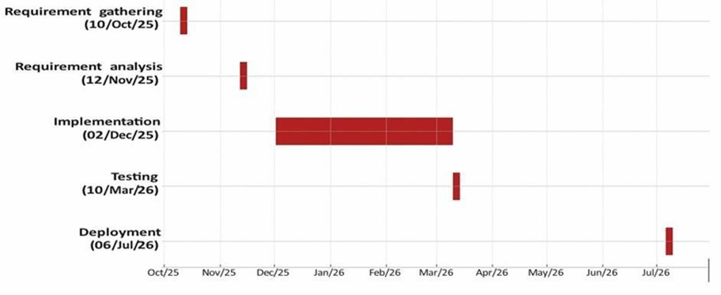
Figure 1-2 Gant Chart

Chapter 2

Requirement Specification and Analysis

Epics
This section presents the epics identified for the proposed Final Year Project Management System. The epics represent the major functional areas of the system and define the high-level requirements that deliver core academic and administrative value. Each epic captures a significant system capability and serves as a foundation for deriving detailed user stories and test cases. The identified epics collectively address the needs of all stakeholders involved in the FYP process, including students, supervisors, coordinators, heads of departments, and administrators.

Epic 1
Epic: Authentication and Account Management
Description: As a system user, I want to securely access and manage my account so that unauthorized access is prevented.

2.1.2. Epic 2
Epic: Student Final Year Project Management
Description: As a student, I want to register and manage my FYP so that my academic project is formally recorded.

2.1.3. Epic 3
Epic: Student Timetable and Attendance Management
Description: As a student, I want to manage my timetable and attendance so that academic activities are tracked.

2.1.4. Epic 4
Epic: Supervisor Supervision Management
Description: As a supervisor, I want to manage supervision requests and student projects so that guidance is effective.

2.1.5. Epic 5
Epic: Examiner Panel and Evaluation Management
Description: As an FYP Coordinator, I want to manage examiner panels and evaluations so that projects are assessed fairly.

2.1.6. Epic 6
Epic: Exam, CLO, and Marks Management
Description: As a coordinator or supervisor, I want to manage exams, CLOs, and marks so that evaluation is structured.

2.1.7. Epic 7
Epic: Announcements and Templates Management
Description: As a coordinator or supervisor, I want to share announcements and templates so that students receive guidance.

2.1.8. Epic 8
Epic: HoD Oversight
Description: As Head of Department, I want to monitor FYP activities so that academic quality is ensured.

2.1.9. Epic 9
Epic: Administrative Academic Setup
Description: As an administrator, I want to manage academic entities so that the system operates correctly.

User-stories
Each epic has its user stories listed separately along with acceptance criteria.

User-story 1
User Story ID | Description | Acceptance Criteria
E1-US1 | As a user, I want to log in using valid credentials so that I can access my dashboard. | Given login page, when valid username and password are entered, then dashboard is displayed.
E1-US2 | As a user, I want to update my profile so that my information remains  accurate. | Given profile page, when updated data is submitted, then profile information is  saved.
E1-US3 | As a user, I want to log out so that my account remains secure. | Given dashboard, when logout is clicked, then user is logged out and  redirected to login page.

2.2.2. User-story 2
User Story ID | Description | Acceptance Criteria
E2-US1 | As a student, I want to register my FYP by entering project, group, and supervisor details. | Given FYP form, when details are submitted, then FYP registration is saved.
E2-US2 | As a student, I want to select a topic offered by a supervisor. | Given available topics, when a topic is selected, then it is assigned to student.
E2-US3 | As a student, I want to propose my own FYP topic. | Given FYP form, when new topic is submitted, then supervisor approval is  requested.
E2-US4 | As a student, I want to request topic or technology changes. | Given existing project, when change request is submitted, then supervisor is notified.
E2-US5 | As a student, I want to view supervision request status. | Given request history, when accessed, then current status is displayed.
E2-US6 | As a student, I want to view examiner panel details. | Given project, when panel  info is requested, then details are displayed.
E2-US7 | As a student, I want to view marks and examiner feedback. | Given evaluation records, when accessed, then marks and feedback are displayed.

2.2.3. User-story 3
User Story ID | Description | Acceptance Criteria
E3-US1 | As a student, I want to upload and manage my timetable. | Given timetable interface, when timetable is uploaded or edited, then it is saved.
E3-US2 | As a student, I want to view my attendance record. | Given attendance page, when accessed, then attendance data is displayed.

2.3.4. User-story 4
User Story ID | Description | Acceptance Criteria
E4-US1 | As a supervisor, I want to accept or reject supervision  requests. | Given pending requests, when accepted/rejected,  then student is notified.
E4-US2 | As a supervisor, I want to upload and manage FYP topics. | Given topic interface, when new topic is submitted, then it is available to students.
E4-US3 | As a supervisor, I want to mark student attendance. | Given class list, when attendance is marked, then records are updated.

2.3.5. User-story 5
User Story ID | Description | Acceptance Criteria
E5-US1 | As an FYP Coordinator, I want to create examiner panels. | Given panel creation form, when details are submitted, then panel is saved.
E5-US2 | As an FYP Coordinator, I want to assign panel members and head. | Given saved panel, when members are assigned, then panel is updated.

2.3.6. User-story 6
User Story ID | Description | Acceptance Criteria
E6-US1 | As a coordinator, I want to define exam types and CLOs. | Given exam setup page, when exam types and CLOs are entered, then  data is saved.
E6-US2 | As a supervisor, I want to enter student marks. | Given student list, when marks are submitted, then marks are recorded in the system.

2.3.7. User-story 7
User Story ID | Description | Acceptance Criteria
E7-US1 | As a coordinator, I want to publish announcements. | Given announcement interface, when message is submitted, then it is visible  to students.
E7-US2 | As a coordinator, I want to upload FYP templates. | Given upload interface, when templates are submitted, then they are  available to students.

2.3.8. User-story 8
User Story ID | Description | Acceptance Criteria
E8-US1 | As HoD, I want to view panels and results. | Given dashboard, when accessed, then panels and results are displayed.

2.3.9. User-story 9
User Story ID | Description | Acceptance Criteria
E9-US1 | As admin, I want to manage terms, programs, and departments. | Given admin panel, when data is updated, then system reflects changes.
E9-US2 | As admin, I want to create system users. | Given user creation form, when details are submitted, then user

Test-cases

Test Case 1
Test ID | US ID | Test Case Description | Inputs | Expected Result
E1-US1-TC1 | E1-US1 | User Login | Valid  username and  password | Dashboard is displayed
E1-US2-TC1 | E1-US2 | Update Profile | Updated user data | Profile is saved  successfully
E1-US3-TC1 | E1-US3 | Logout | Click logout button | User is  logged out and  redirected to login page

2.3.2. Test Case 2
Test ID | US ID | Test Case Description | Inputs | Expected Result
E2-US1-TC1 | E2-US1 | FYP Registration | Project title, group, supervisor | FYP registration saved
E2-US2-TC1 | E2-US2 | Select Supervisor Topic | Selected topic from available list | Topic assigned to student
E2-US3-TC1 | E2-US3 | Propose New Topic | Proposed topic details | Supervisor approval requested
E2-US4-TC1 | E2-US4 | Request  Topic/Technology Change | Change request details | Supervisor notified
E2-US5-TC1 | E2-US5 | View Supervision Status | Access  supervision request page | Current status displayed
E2-US6-TC1 | E2-US6 | View Examiner Panel | Request panel details | Panel details displayed

2.3.3. Test Case 3
Test ID | US ID | Test Case Description | Inputs
E3-US1-TC1 | E3-US1 | Upload Timetable | Timetable file
E3-US2-TC1 | E3-US2 | View Attendance | Access attendance page

2.3.4. Test Case 4
Test ID | US ID | Test Case Description | Inputs
E4-US1-TC1 | E4-US1 | Approve/Reject Request | Supervision request ID
E4-US2-TC1 | E4-US2 | Upload FYP Topics | Topic details
E4-US3-TC1 | E4-US3 | Mark Attendance | Attendance entries

2.3.5. Test Case 5
Test ID | US ID | Test Case Description | Inputs
E5-US1-TC1 | E5-US1 | Create Examiner Panel | Panel name, members
E5-US2-TC1 | E5-US2 | Assign Panel Members | Member details

2.3.6. Test Case 6
Test ID | US ID | Test Case Description | Test ID
E6-US1-TC1 | E6-US1 | Define Exam & CLOs | E6-US1-TC1
E6-US2-TC1 | E6-US2 | Enter Student Marks | E6-US2-TC1

2.3.7. Test Case 7
Test ID | US ID | Test Case Description | Inputs
E7-US1-TC1 | E7-US1 | Publish  Announcement | Announcement text
E7-US2-TC1 | E7-US2 | Upload FYP Template | Template file

2.3.8. Test Case 8
Test ID | US ID | Test Case Description | Inputs
E8-US1-TC1 | E8-US1 | View Panels & Results | Access dashboard

2.3.9. Test Case 9
Test ID | US ID | Test Case Description | Inputs
E9-US1-TC1 | E9-US1 | Manage Terms, Programs,  Departments | Updated details
E9-US2-TC1 | E9-US2 | Create System Users | User information

User Interface Design
Whole system’s user interfaces are described below, with common functionalities in all modules.

2.4.1. Student Module
After Logging in, interface shown in Figure 2 – Login Interface, Student is directed to the dashboard shown in Figure 3 -with only registration tab available.


Figure 2-4 Common GUI elements
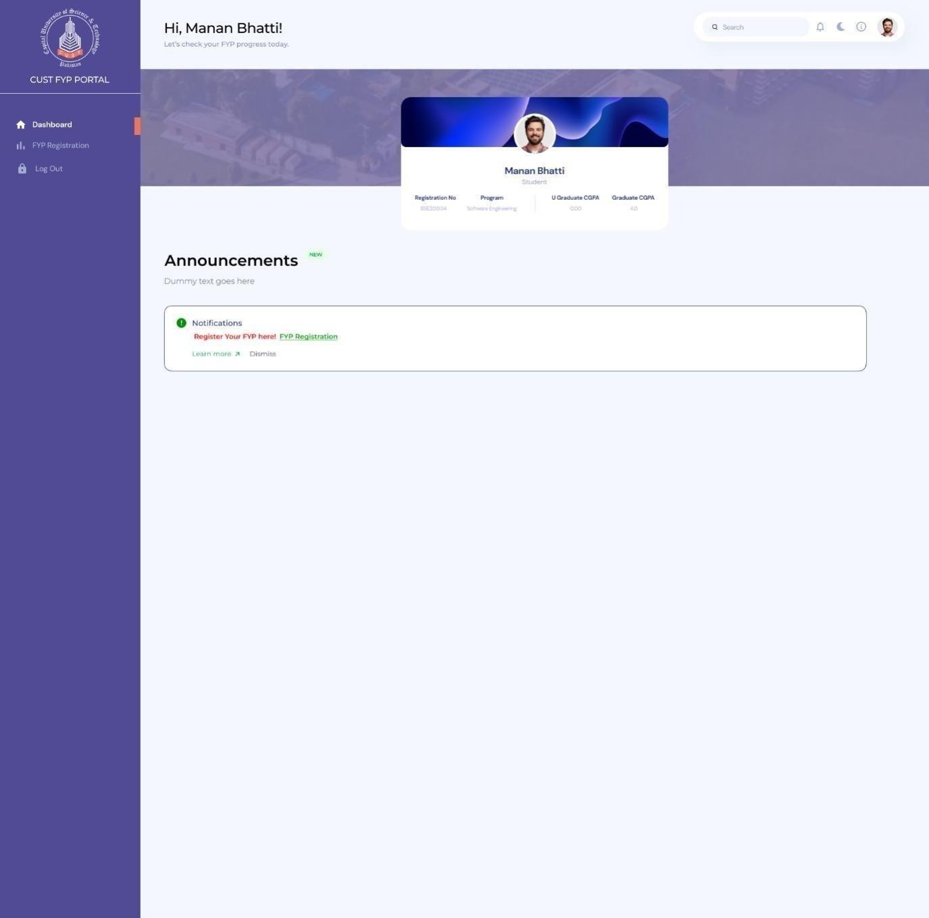

Figure 2-6 Example Login Page UI Design

Here in Figure 3, Students have empty dashboard with only FYP registration option available, from where student’s final year project registration is initiated.

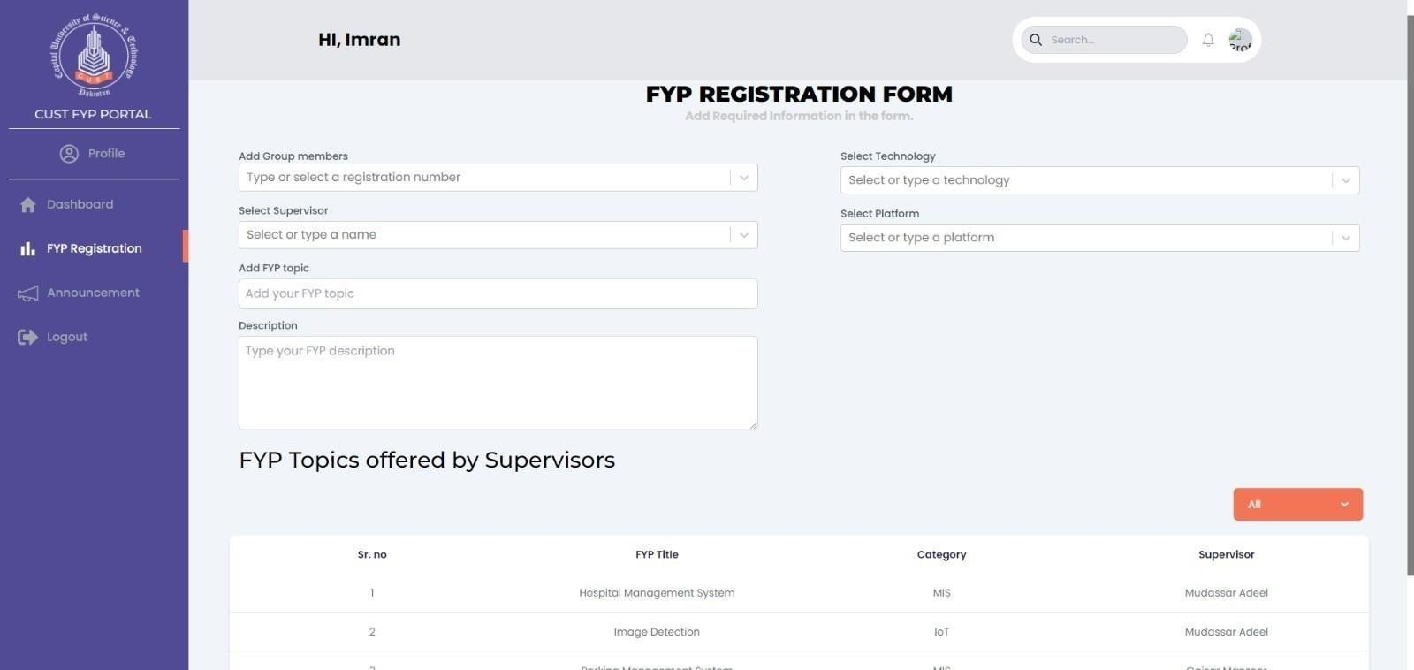
Upon clicking on FYP registration button, form is shown, as in Figure 4 - with fields asking for Group members details, project technology, project supervisor, FYP topic and Description. Also, Students are provided with particular supervisor’s added topics to choose from, during FYP registration process. After adding project details and clicking OK. Supervision request is sent to selected supervisor for this particular project. Refer to the figure below.
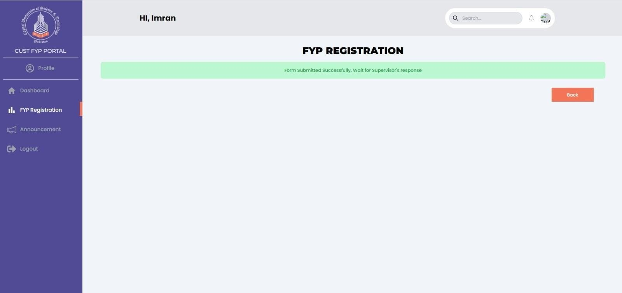

Interface showing supervision request being sent to supervisor for the project’s supervision.

Traceability Matrix
Traceability Matrix is a structured table that establishes the relationship between different artifacts of the system, including Epics, User Stories, Test Cases, and User Interfaces (UIs). It ensures that each epic is broken down into user stories, validated through test cases, and supported by appropriate UI components. This matrix helps maintain consistency, verifies coverage of requirements, and ensures that no functionality is missed during development.
Table 2-4 Traceability Matrix
Epic | User-Story | Test-case | UI
E1 | E1-US1  E1-US2  .  . | E1-US1-TC1  E1-US1-TC2  .  . | E1-US1-UI1  E1-US1-UI2  .  .

Chapter 3

System Design
The design chapter provides the blueprint of the proposed system, bridging the gap between requirements and implementation. It outlines how different components of the system are structured, interact with each other, and support the required functionality. The goal of this chapter is to present a clear and organized design that ensures all user requirements are properly addressed and can be effectively translated into development.
This chapter covers:
- Software Architecture: Describes the high-level architecture of the system (e.g., monolithic, client-server, microservices, or cloud-based), highlighting the main components and their interactions.
- Data Modeling: Represents how data will be structured, stored, and managed. This may include an Entity Relationship Diagram (ERD) with relational schema for SQL databases or JSON/BSON structures for NoSQL databases.
- Workflow Diagrams: Provide activity diagrams, flowcharts, or sequence diagrams for each epic and its related user stories, demonstrating the flow of processes and user interactions.
- Third-Party Dependencies: Lists the external APIs, libraries, or modules that will be integrated into the system to support development and extend functionality.
By covering these aspects, the design chapter ensures that the system’s architecture, data, workflows, and dependencies are clearly documented, creating a strong foundation for the implementation phase.
In addition to these mandatory design artifacts, students are also allowed to include optional diagrams such as Class Diagrams, Sequence Diagrams, or other UML models if they wish to provide a more detailed perspective of their system. These artifacts are not compulsory but may be used to strengthen the design documentation and improve clarity where needed.

Software Architecture
Software architecture is described as the organization or structure of a system, where the system represents a collection of components that accomplish a specific function or set of functions. When getting started with your design, keep in mind the key principles that will help you to create an architecture that adheres to proven principles, minimizes costs and maintenance requirements, and promotes usability and extendibility. The major decisions that you must make, and which help to ensure that you consider all of the important factors as you begin and then iteratively develop your architecture design are
- Determine the Application Type
- Determine the Deployment Strategy
- Determine the Appropriate Technologies
- Determine the Quality Attributes
- Determine the Crosscutting Concerns
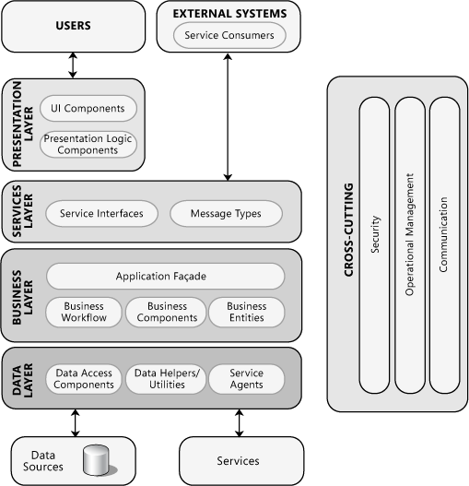
Figure 3-1 Software Architecture Diagram
Fig. 3.1 illustrates common application architecture with components grouped by different areas of concern. You should think of architecture as the strategy for how you will build the system. An architectural “layer” is the top-level logical view, or an abstraction, of your design.

Data Modeling
Data modeling defines how data will be structured, organized, and managed within the system. It ensures that the database design aligns with the system requirements and supports efficient storage, retrieval, and consistency of information. Depending on the type of database selected, students may choose either Relational Databases (SQL) or NoSQL databases.

Relational Databases
Relational Databases organize data into structured tables consisting of rows (records) and columns (attributes). Each table represents an entity, and relationships between tables are established through keys such as primary keys and foreign keys. This model ensures data integrity, consistency, and supports powerful querying using Structured Query Language (SQL). Relational databases are well-suited for applications requiring structured data, complex queries, and strong consistency.
Entity Relationship Diagram
Entity relationship model diagram (ERD) is a conceptual representation of the data in a software system. During detail design this model is mapped in to the physical database model. There are different diagramming conventions available for creating ER diagrams. A sample ERD is shown in Fig. 3.4.
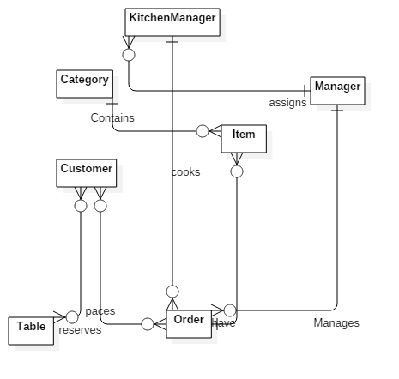

Figure 3-4 Entity Relationship Diagram

Database Schema
A database schema represents the logical configuration of all or part of a relational database. It can exist both as a visual representation and as a set of rules known as integrity constraints that govern a database. These rules are expressed in a data definition language, such as SQL. A database schema indicates how the entities that make up the database relate to one another, including tables, views, stored procedures, and more. A database scheme includes information related to primary and secondary keys, normalization and indexing.
You may present database scheme using front end tool of any DBMS or any other design tools such as Visio or Enterprise Architecture. A sample database scheme is shown in Fig. 3.5.
.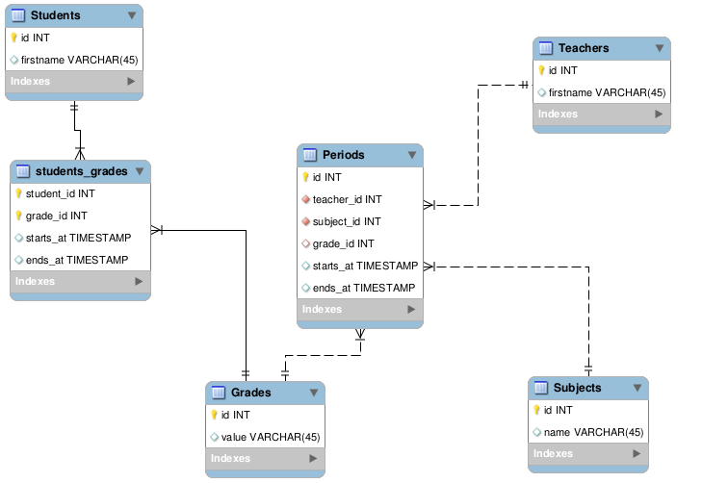
Figure 3-5 Database Schema

NoSQL Databases
Data is represented using a Node Structure (such as JSON or BSON documents). This approach is suitable for systems requiring flexibility, scalability, and schema-less data storage. It allows developers to represent hierarchical, nested, or unstructured data more effectively.
Example (JSON Node Structure for a User in a NoSQL Database)
{
"user_id": "U12345",
"name": "Ali Khan",
"email": "ali.khan@example.com",
"orders": [
{
"order_id": "O1001",
"date": "2025-09-25",
"items": [
{ "product_id": "P10", "name": "Laptop", "price": 1200 },
{ "product_id": "P22", "name": "Mouse", "price": 20 }
]
}
]
}
This JSON structure shows how a user document can contain nested data such as orders and order items without requiring multiple relational tables.

Workflow Diagram
Workflow represents the sequence of activities, actions, or steps carried out to complete a specific process in the system. It shows how tasks are initiated, the order in which they are performed, and how decisions or conditions affect the flow. Workflow diagrams, such as activity diagrams or flowcharts, are commonly used to visually depict these processes, making it easier to understand the logic and interactions within the system.
For example, a simple flow chart of how to play the game, it will also show how many levels are there with what complexity of game play including players, objects, and enemy which is shown in Figure 3.6
Figure 3-6 Example of a gameplay diagram

Third-Parties Depedencies
Third-Party Dependencies refer to external libraries, frameworks, APIs, or modules that are integrated into the system to add functionality or simplify development. Instead of building everything from scratch, these dependencies provide pre-built solutions for common tasks such as authentication, payment processing, data visualization, or communication with external services. Proper documentation of third-party dependencies ensures clarity, maintainability, and transparency in the system design.
Examples of third-party dependencies can be
• Google Maps API – for location and mapping services.
• Firebase Authentication – for user login and authentication.
• Stripe / PayPal SDK – for online payments.

Chapter 4

Software Development
The Implementation section is similar to the Specification and Design section in that it describes the system, but it does so at a finer level of detail, down to the code level. This section is about the realization of the concepts and ideas developed earlier. It can also describe any problems that may have arisen during implementation and how you dealt with them.
Make sure that the system design corresponds to the implementation of the project. If there is no relationship between design and implementation, it may downgrade your score in FYP.
You should also mention any unforeseen problems you encountered when implementing the system and how and to what extent you overcame them. Common problems are:
- Difficulties involving existing software, because of e.g.,
  - Its complexity,
  - Lack of documentation;
- Lack of suitable supporting software
- Overambitious project aims.
A seemingly disproportionate amount of project time can be taken up in dealing with such problems. The Implementation section gives you the opportunity to show where that most of the effort has been spent.

Coding Standards
Describe the indention, declaration,naming convention and statement standard used while coding the project.

Development Environment
In this section you will provide the reason behind using all the existing tools and technologies that you may have used during the development of your project. This includes development environment that you have used. How have you deployed the development environment? What different kind of packages you have used? Are there any third party libraries involved etc?

Software Description
In this section you will identify major modules of the software that you have produced. You will show the class diagram of these major modules for this section. Typical subheadings of this section can be
Login process
Loading Data
Data processing
Report generation
…..
Moreover you will also discuss the logic that you have implemented in the code of those modules with the help of code snippets as shown below in the examples. Do not attempt to describe all the code in the system, and do not include large pieces of code in this section.
- Are especially critical to the operation of the system.
- You feel might be of particular interest to the reader for some reason
- Illustrate a nonstandard or innovative way of implementing an algorithm, data structure, etc.

Snippet 1 (User Story Name)

#define SWAP(type, x, y) \
do { \
type temp;
temp = x;
x = y;
y = temp; \
} while(1)

Description: This function takes 2 arguments. Then we have an infinite loop that swaps the value of the two passed variables.
You are not allowed to include the complete source code of the software how ever you can include important functions of your major modules to discuss the logic of your code.
Test Case (Name)
Execute the Test Case you planned in Chapter 2 by prodiving inputs and then report the finding whether the testcase passed or failed

Table 4-1 Test Case Name
Test ID: (E.g. E1-US1-TC1 etc.) | US ID:
Test Case Description:
Inputs:
Expected Result:
Actual Result:

Snippet 2

#define pop(type, Top) \
type temp;
temp = Top.item;
Top = Top.next;
return temp;

Description: This function pops the top of the stack. It places the top pointer to the next item of the stack and return the popped item.

You are not allowed to include the complete source code of the software how ever you can include important functions of your major modules to discuss the logic of your code.

Test Case (Name)
Execute the Test Case you planned in Chapter 2 by prodiving inputs and then report the finding whether the testcase passed or failed
Table 4-2 Test Case Name
Test ID: (E.g. E1-US1-TC1 etc.) | US ID:
Test Case Description:
Inputs:
Expected Result:
Actual Result:

Chapter 5

Software Deployment
The deployment chapter explains how the developed system is prepared, configured, and made available for use in its intended environment. It covers the steps, tools, and platforms required to deploy the system, ensuring that it runs as expected outside the development setting. This may include details on hosting (local server, cloud, or on-premises), installation procedures, configuration settings, and dependencies required for successful execution. The chapter also highlights any deployment challenges, environment requirements (hardware/software), and guidelines for future scalability and maintenance.

5.1 Installation / Deployment Process Description
In this section you have to provide step-by-step guide for the installation of the software produced with the help of screen shots.

References
All the documents, papers, articles and WebPages that you have taken help from must be cited in the references section

Book
Author(s), Book Title. Place of publication: Publisher, year, volume, page number(s).

Example: [1] W.K. Chen, Linear Networks and Systems. Belmont, CA: Wadsworth, 1993, pp. 123-35.

Webpage
Author(s) and/or organization, date of publish or date the page was last updated, title of web page document, website address that provides a direct link to the document, and the date you last accessed the document
Example: Winston, J 1999, A look at referencing, AAA Educational Services, accessed 20 October 2015, <http://www.aaa.edu.au/aaa.html>. United Nations Web Services 2006,
Research Paper
Author(s), "Article title, Journal Title, vol., no., page number(s), Month year.

Example: [2] G. Pevere, "Infrared Nation, International Journal of Infrared Design, vol. 33, pp. 56-99, Jan. 1979.

If you need to reference any item that is not the the list, you should consult IEEE citation format available at the following link http://library.queensu.ca/book/export/html/5846

Plagiarism Report
Attached plagiarism report here that can be obtained from the library.

Report Approval Certificate
The report of the project, “Title” has been approved based on the following evaluation guideline.
Project Evaluation Guidelines
Artifacts Guidelines
Analysis and Design artifacts are syntactically correct (use-case model, SSDs, domain model, class diagram, SDs, ERDs, Flow charts, Activity Diagram, DFDs)
Consistency and traceability have been maintained among different artifacts
General Guidelines
Formatting (font style, indentation) is according to the FYP template and consistent throughout the document
Captions are added to all the figures and tables. Figure captions must be placed below each figure, and table captions must be provided above the table
Each figure or table is followed by some text describing what it represents

____________________  Name & Signature  (Examiner 1) | ____________________  Name & Signature  (Examiner 2) | ____________________  Name & Signature  (Examiner3)
_______________
Name & Signature
(Supervisor)

Appendix
User Manual of the software

