
Web Technologies and Platforms
Assignment 1
Muhammad ebad Waseem(2428344) | CIS051-2 | CIS051-2

Table of Contents
1. Project Overview and Purpose 2
1.1 Introduction 2
1.2 Problem Statement 2
1.3 Purpose of the System 3
1.4 Target Users 4
2. Requirements, Functionality, and Features 4
2.1 Functional Requirements 4
2.2 Non-Functional Requirements 5
2.3 Key Features of the Web Application 6
3. Prototype and System Design Representation 7
3.1 System Architecture 7
3.2 User Interface Flow 8
3.3 Dashboard Design 8
3.4 Entity Relationship (ER) DIAGRAM 10
4. Use of Web Technologies 10
4.1 HTML 10
4.2 CSS 11
4.3 JavaScript 11
4.4 Backend Technology 11
4.5 Database Management 12
4.6 Authentication and Authorization 12
5. Academic and Professional Considerations 12
6. Relation to Learning Outcomes and Graduate Competencies 13
7. Future Improvements 13
8. Conclusion 13
AI Usage Statement 13
Reference: 14

1. Project Overview and Purpose

1.1 Introduction
The Final Year Project (FYP) is one of the most important academic aspects of an undergraduate program. It is the culmination of students’ academic knowledge, allowing them to apply their theoretical knowledge and skills to solve real-world problems or conduct independent research. The FYP not only tests technical skills but also tests research skills, project management skills, communication skills, and critical thinking.
Because of its academic importance, it is important to manage the FYP life cycle effectively. The FYP life cycle involves proposal submission, allocation of supervisors, monitoring of progress, provision of feedback, final submission, and assessment. Manual management of these processes can lead to operational inefficiencies, communication breakdowns, and administrative hassles.
The proposed project aims to develop a Web-Based Final Year Project Management System that can automate the entire FYP process in an academic institution.

1.2 Problem Statement
Most academic institutions are still using traditional or semi-digital approaches such as email communications, spreadsheets, physical documentation, or individual digital tools to manage Final Year Project (FYP) activities. Although these approaches are acceptable for a small number of students, as the number of students increases, these approaches become less effective. The absence of a unified platform creates a number of operational challenges that affect the efficiency, transparency, and reliability of FYP management.
One of the main challenges is the absence of a centralized data storage platform. When FYP-related data is spread across various sources such as email communications, physical documentation, or various digital sources, it becomes challenging to maintain a unified truth source. For instance, critical data such as FYP proposals, supervisor allocations, feedback, or evaluation is often located at different places.
Another main issue is the miscommunication between various stakeholders such as students, supervisors, or academic administrators. For example, FYP-related communications through email or other means are often prone to miscommunications or misinterpretations. As a result, the student may not clearly understand the FYP requirements or deadlines, or the supervisor may not clearly communicate or maintain records of various communications received from different FYP students.
The monitoring of the progress of the projects is another challenge associated with traditional systems. Since there is a lack of a centralized system, the administrators and supervisors are not always aware of the real-time progress of the projects. It is not always easy to monitor the progress of the projects by tracking whether the students have submitted the proposals and received approvals from the supervisors.

1.3 Purpose of the System
The main aim of the Final Year Project (FYP) Management System is to create an effective digital solution to increase the efficiency, transparency, and accuracy of managing academic projects within an educational institution. The system is intended to eliminate the limitations of traditional manual practices by incorporating an effective web-based environment to include all the stakeholders involved in the FYP Management System.
One of the main aims of the system is to create an effective web-based platform for managing the FYP Management System. The system aims to include all the project-related activities within an online platform, eliminating the use of paper-based documents and digital data. The online platform allows the student to submit the project details, and the supervisor can evaluate the work of the student within one platform. The main aim of the system is to increase the consistency, accuracy, and accessibility of information.
The other significant objective is to enable effective communication between the students, supervisors, and administrators. This is achieved by developing a communication structure within which project information, feedback, and evaluation results are recorded and made available to those who need them. This eliminates the need to rely on other forms of communication, which may not always work effectively.
The other objective of the system is to enable real-time tracking of the progress of projects by the students. This is achieved by allowing the students to view the current status of their projects from the beginning to completion. Supervisors and administrators can view the progress of projects in real-time. This helps them to monitor the progress of projects and act proactively to ensure that projects are not delayed.
Ensuring secure and organized evaluation is another significant objective of the FYP Management System. This is achieved by developing a role-based access control and authentication process that helps protect critical academic information from unauthorized individuals. Supervisors can use the system to give feedback and marks to the students, which helps improve the credibility and reliability of the process.
Another objective of the system is to minimize the administrative effort. Administrative activities like managing users, managing supervisors, managing submissions, etc., are all automated within the system. It reduces the administrative effort to a greater extent, which otherwise would be done manually. It saves time for the administrators to concentrate on higher academic planning activities.
Finally, the system aims to enhance the transparency and accountability of the entire FYP process. All the activities done within the system, like the submissions, feedback, evaluation, project status, etc., are recorded. It provides better clarity to the students about the entire process, to the supervisors about the accountability of the entire process, and to the administrators about the entire process.
The proposed FYP Management System aims to create a better organized, efficient, and secured platform for managing academic projects. It incorporates the best of the current web technologies to create a better academic workflow, which leads to the successful completion of the Final Year Projects within the institution.

1.4 Target Users
The system is intended for three main categories of users:
Students
Students are able to submit project proposals, track the progress of the projects, and get feedback and grades.
Supervisors
Supervisors are able to view the projects assigned to them, give feedback, and track performance.
Administrators
Administrators are able to manage users, assign supervisors to students, and track the overall project activity.
Each category of users has controlled access through role-based authorization.

2. Requirements, Functionality, and Features

2.1 Functional Requirements
Functional requirements describe what the system must do.

2.1.1 Student Functional Requirements
Students should be able to:
Register an account
Securely log in
Submit project title and description
View details of assigned supervisor
View project status (Submitted, Approved, In Progress, Completed)
View supervisor comments
View assigned marks
The above capabilities enable students to effectively monitor their academic progress.

2.1.2 Supervisor Functional Requirements
Supervisors should be able to:
Securely log in
View assigned student projects
View submitted proposals
Submit structured written comments
Assign marks
Change project status
Monitor total supervision load
This will enable effective academic monitoring and assessment.

2.1.3 Administrator Functional Requirements
Administrators must be able to:
Create student and supervisor accounts
Manage user roles
Assign supervisors to projects
View all projects
Monitor progress reports
Delete or update user accounts
The administrator ensures proper coordination and resource allocation.

2.2 Non-Functional Requirements
Non-functional requirements: Ensure system quality.
Security
Secure authentication system
Password hashing
Role-based access control
Usability
Simple and intuitive interface
Easy navigation
Clear dashboard layout
Performance
Fast loading times
Efficient database queries
Scalability
Ability to handle increasing users
Maintainability
Modular code structure
Easy updates and improvements

2.3 Key Features of the Web Application
The system includes:
Secure login and registration
Role-based dashboards
Project submission module
Supervisor feedback system
Marks allocation system
Admin management panel
Centralized database storage
Real-time status updates
These features collectively improve workflow efficiency.

3. Prototype and System Design Representation

3.1 System Architecture
The system architecture is client-server, comprising:
Frontend (User Interface Layer)
Backend (Application Logic Layer)
Database (Data Storage Layer)
Users use web browsers to access the system. The server processes requests, communicating with the database and responding accordingly.
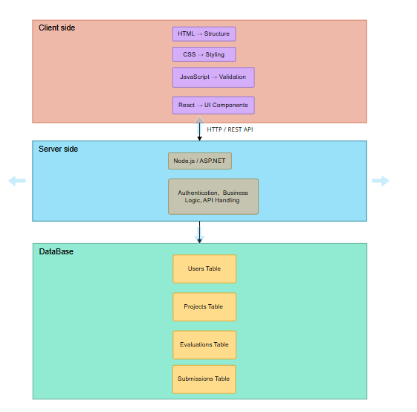
Figure 1: Architecture Diagram

3.2 User Interface Flow
Step 1: Authentication
Users log in with credentials. Depending on roles, they are directed to specific dashboards.
Step 2: Student Submission
Students enter project information using organized forms.
Step 3: Supervisor Evaluation
Supervisors view projects they are assigned to and enter feedback.
Step 4: Administrative Monitoring
Admins assign supervisors and track project allocation.
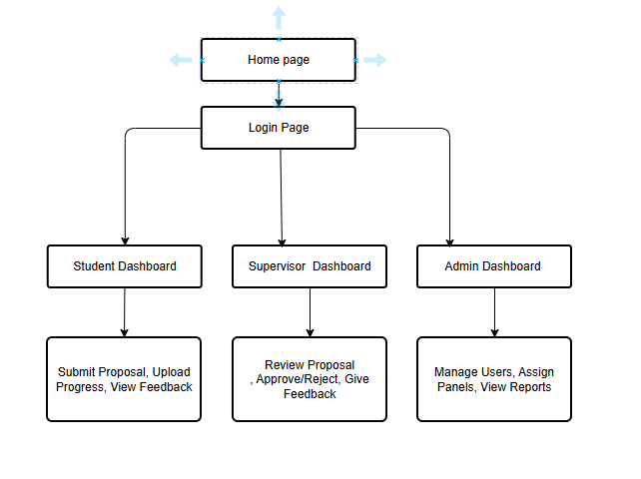
Figure 2: User interface flow

3.3 Dashboard Design
Student Dashboard
Submit Project Form
View Status Section
Feedback & Marks Display
Supervisor Dashboard
List of Assigned Projects
Feedback Submission Form
Marks Entry Field
Admin Dashboard
User Management Table
Supervisor Assignment Form
Project Monitoring Table
The interface is organized with a simple card layout.
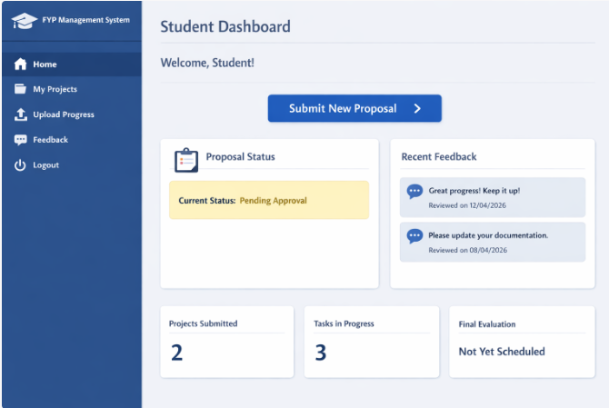
Figure 3: Dashboard Design

3.4 Entity Relationship (ER) DIAGRAM
The Entity Relationship (ER) diagram illustrates the logical structure of the database used in the FYP Management System. It shows the main entities involved in the system and the relationships between them.
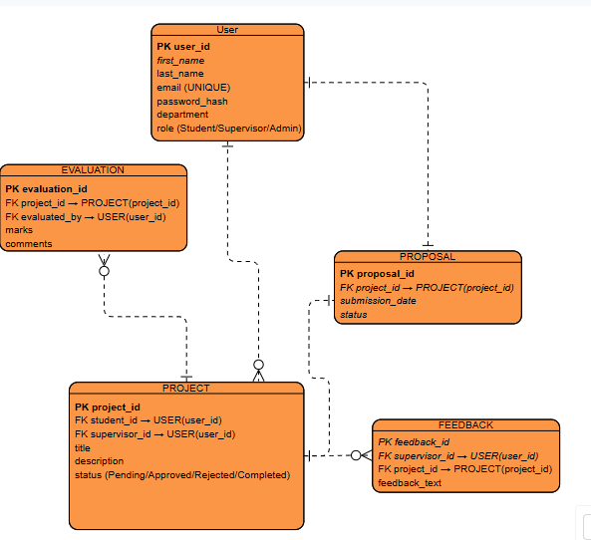
Figure 4: ER Diagram

4. Use of Web Technologies
This section explains how each technology contributes to system development.

4.1 HTML
HTML structures the web pages and defines content elements such as:
Forms
Tables
Headings
Navigation menus
Buttons
HTML provides semantic structure, ensuring accessibility and organization.

4.2 CSS
CSS enhances the visual design by:
Styling dashboards
Improving layout consistency
Creating responsive design
Enhancing user experience
CSS ensures professional appearance and improved usability.

4.3 JavaScript
JavaScript provides interactivity by:
Validating forms before submission
Enhancing dynamic content updates
Improving responsiveness
Handling client-side logic
This reduces server load and improves performance.

4.4 Backend Technology
The backend handles:
Routing
Form processing
Business logic
Authentication
Database communication
Server-side processing ensures secure handling of sensitive data and structured system behavior.

4.5 Database Management
The relational database stores:
User details
Project information
Feedback records
Marks
Status updates
Relationships between tables ensure data consistency and integrity.

4.6 Authentication and Authorization
Security measures include:
Password hashing
Role-based redirection
Session management
Access restriction
These mechanisms protect user data and prevent unauthorized access.

5. Academic and Professional Considerations
The system demonstrates:
Application of full-stack development
Integration of client-side and server-side technologies
Database modeling and management
Secure authentication mechanisms
Structured documentation
The project follows software engineering best practices and structured development methodologies.

6. Relation to Learning Outcomes and Graduate Competencies
This assignment develops:
Digital literacy
Client-side programming skills
Server-side programming knowledge
Problem-solving ability
Critical thinking
Collaboration and communication skills
Adaptability to technical challenges
It aligns with module objectives and prepares students for professional web development roles.
7. Future Improvements
Possible future advancements include
Notification System (Email/SMS)
Advanced analytics dashboard
train upload functionality
Integration with literacy operation systems
Mobile operation interpretation
These advancements would further enhance system functionality and stoner experience.

8. Conclusion
The Web-Based Final Year Project Management System is an efficient online solution for managing academic projects. The system combines various web development technologies such as frontend and backend development, authentication, and database management to improve transparency, efficiency, and accountability.
The project clearly shows in-depth knowledge of web development concepts and meets the requirements of the Web Technologies and Platforms module.

AI Usage Statement
This report was prepared in accordance with the University’s guidelines on the use of Generative Artificial Intelligence (AI). AI tools were used only for limited assistance, including language refinement, structural organization, grammar correction, and idea clarification.
The core content of the assignment — including the project overview, requirements analysis, system design explanation, and discussion of web technologies — was developed independently by the student based on lecture materials, practical sessions, academic research, and personal understanding of the subject.
No AI tool was used to generate complete sections of the assignment without critical review and modification. All technical explanations, system descriptions, and design decisions reflect the student’s own academic work and comprehension.
This submission complies with the academic integrity policies of the University of Bedfordshire.

Reference:
Sommerville, I. (2016). Software Engineering (10th ed.). Pearson Education Limited.
Pressman, R. S., & Maxim, B. R. (2019). Software Engineering: A Practitioner’s Approach (9th ed.). McGraw-Hill Education.
Laudon, K. C., & Laudon, J. P. (2020). Management Information Systems: Managing the Digital Firm (16th ed.). Pearson Education.
W3C. (2023). HTML Living Standard. World Wide Web Consortium.
https://www.w3.org/TR/html52/
W3C. (2023). Cascading Style Sheets (CSS) — Specifications. World Wide Web Consortium.
https://www.w3.org/Style/CSS/
Mozilla Developer Network (MDN). (2024). JavaScript Guide.
https://developer.mozilla.org/en-US/docs/Web/JavaScript/Guide
Flask Documentation. (2024). Flask Web Framework.
https://flask.palletsprojects.com/
SQLAlchemy Documentation. (2024). SQLAlchemy ORM.
https://docs.sqlalchemy.org/
OWASP Foundation. (2023). OWASP Top 10 Web Application Security Risks.
https://owasp.org/www-project-top-ten/

