BAI233051 Muneeb Ur Rehman Practice task

Task 1:
import numpy as np
import matplotlib.pyplot as plt
import seaborn as sns
# Set seed for reproducibility
np.random.seed(42)
# Generate population (non-normal, exponential)
population = np.random.exponential(scale=1, size=10000)
# Plot population
sns.histplot(population, bins=50, kde=True)
plt.title("Original Population (Exponential Distribution)")
plt.show()
# Function to generate sample means
def sample_means(population, sample_size, num_samples=1000):
means = []
for _ in range(num_samples):
sample = np.random.choice(population, size=sample_size)
means.append(np.mean(sample))
return means
# Sample sizes
sample_sizes = [10, 30, 50]
means_10 = sample_means(population, 10)
means_30 = sample_means(population, 30)
means_50 = sample_means(population, 50)
plt.figure(figsize=(15, 5))
plt.subplot(1, 3, 1)
sns.histplot(means_10, bins=30, kde=True)
plt.title("Sample Means (n=10)")
plt.subplot(1, 3, 2)
sns.histplot(means_30, bins=30, kde=True)
plt.title("Sample Means (n=30)")
plt.subplot(1, 3, 3)
sns.histplot(means_50, bins=30, kde=True)
plt.title("Sample Means (n=50)")
plt.tight_layout()
plt.show()

Output:
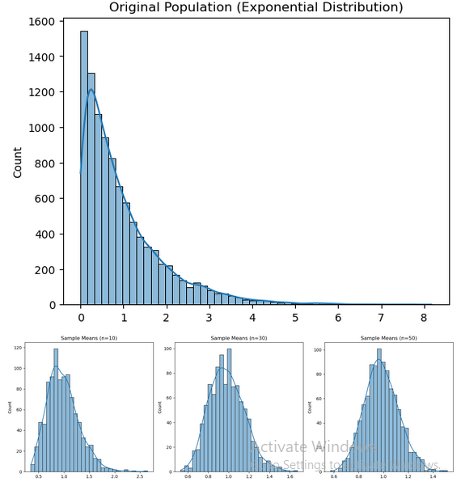

What was the shape of the original population?
The original population followed an exponential distribution, which is:
• Right-skewed
• Not symmetric
• Not normal
How did the distribution change as sample size increased?
• For n = 10 → Slightly skewed, not fully normal
• For n = 30 → More symmetric, starting to look normal
• For n = 50 → Clearly bell-shaped (normal-like)
As sample size increases, the distribution becomes smoother and more symmetric.
At which sample size did the graph look most normal?
n = 50
Explain the result in your own words.
Even though the original data was skewed, when we repeatedly took samples and calculated their means, the distribution of those means started to look normal.
This happens because:
• Averaging reduces randomness
• Larger samples give more stable estimates
This confirms the Central Limit Theorem (CLT), sample means tend to follow a normal distribution regardless of the original population shape.

Task 2:

import numpy as np
import matplotlib.pyplot as plt
import seaborn as sns
np.random.seed(42)
# Create populations (size = 10,000)
uniform_pop = np.random.uniform(low=0, high=1, size=10000)
exponential_pop = np.random.exponential(scale=1, size=10000)
normal_pop = np.random.normal(loc=0, scale=1, size=10000)
# Plot original populations
plt.figure(figsize=(15,5))
plt.subplot(1,3,1)
sns.histplot(uniform_pop, bins=50, kde=True)
plt.title("Uniform Distribution")
plt.subplot(1,3,2)
sns.histplot(exponential_pop, bins=50, kde=True)
plt.title("Exponential Distribution")
plt.subplot(1,3,3)
sns.histplot(normal_pop, bins=50, kde=True)
plt.title("Normal Distribution")
plt.tight_layout()
plt.show()
def sample_means(population, sample_size=30, num_samples=1000):
means = []
for _ in range(num_samples):
sample = np.random.choice(population, size=sample_size)
means.append(np.mean(sample))
return means
# Generate sample means
means_uniform = sample_means(uniform_pop)
means_exponential = sample_means(exponential_pop)
means_normal = sample_means(normal_pop)
plt.figure(figsize=(15,5))
plt.subplot(1,3,1)
sns.histplot(means_uniform, bins=30, kde=True)
plt.title("Sample Means (Uniform)")
plt.subplot(1,3,2)
sns.histplot(means_exponential, bins=30, kde=True)
plt.title("Sample Means (Exponential)")
plt.subplot(1,3,3)
sns.histplot(means_normal, bins=30, kde=True)
plt.title("Sample Means (Normal)")
plt.tight_layout()
plt.show()

Output:

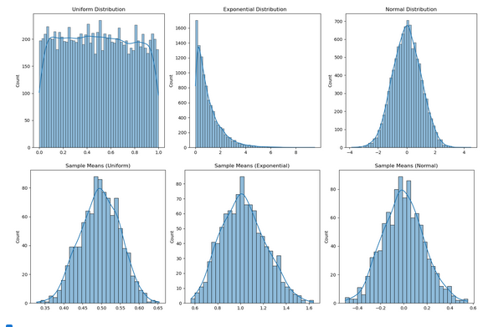

Which population was most skewed initially?
The exponential distribution was the most skewed (right-skewed).
• Uniform → flat
• Normal → symmetric
• Exponential → highly skewed
Did all sampling distributions look similar? Why?
Yes, they became very similar (approximately normal).
Reason:
• According to the Central Limit Theorem (CLT)
• When we take many samples and compute their means:
The distribution of means becomes normal
Regardless of original population shape
Which case reached a perfect normal shape fastest?
The normal distribution population
Reason:
• It was already normally distributed
• So its sampling distribution is naturally normal from the start
What does this experiment prove about CLT?
This experiment proves that,
Even if data is:
• Skewed (exponential)
• Flat (uniform)
The sample means will still form a normal distribution
• Larger samples → more perfect normal shape
• CLT works for any population

