**Basics docker exercises**

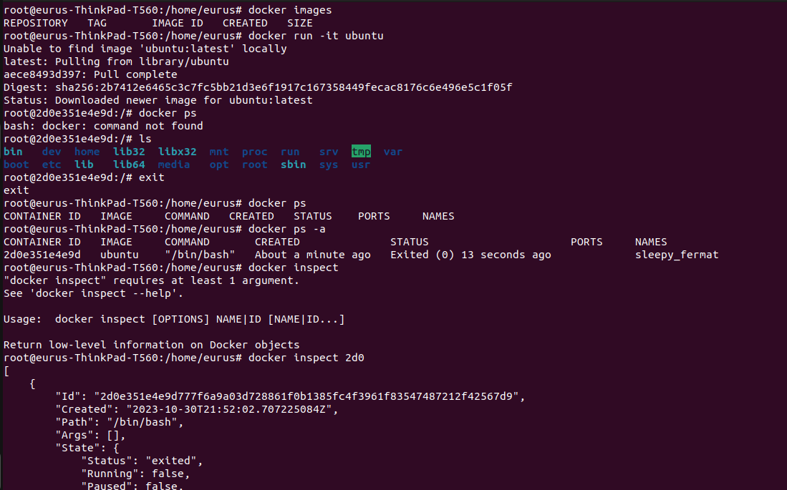

1) docker run -it ubuntu → it looks for the ubuntu image locally and if not found then it downloads it from dockerhub and makes a container out of it, due to -it flag we are logged into that container as well.

2) docker ps → it shows the list of running container

3) docker ps -a → it shows the list of running and stopped container

4) docker images → it shows the images downloaded and available locally

5) docker inspect → it shows the complete information about the machine including metadata, configuration, network settings, mounts and many more in JSON format

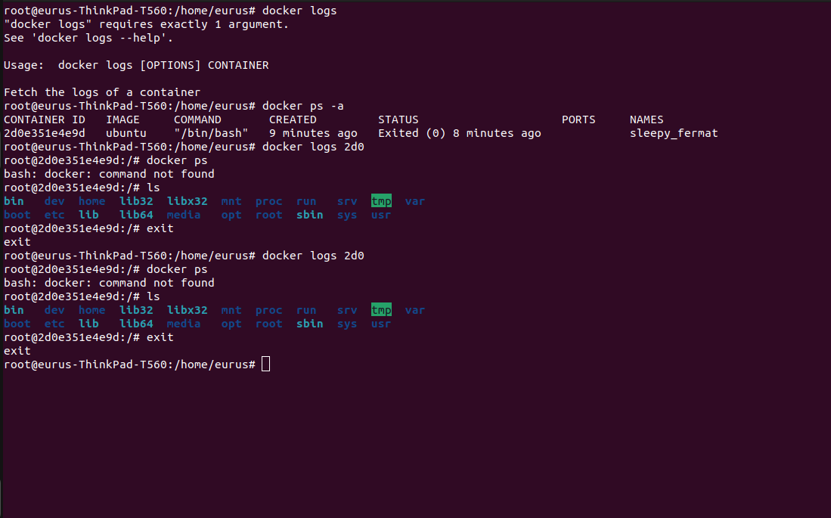

docker logs → it is used to see standard output/ error logs generated by the container.

**Environment variables and Daemonizing**

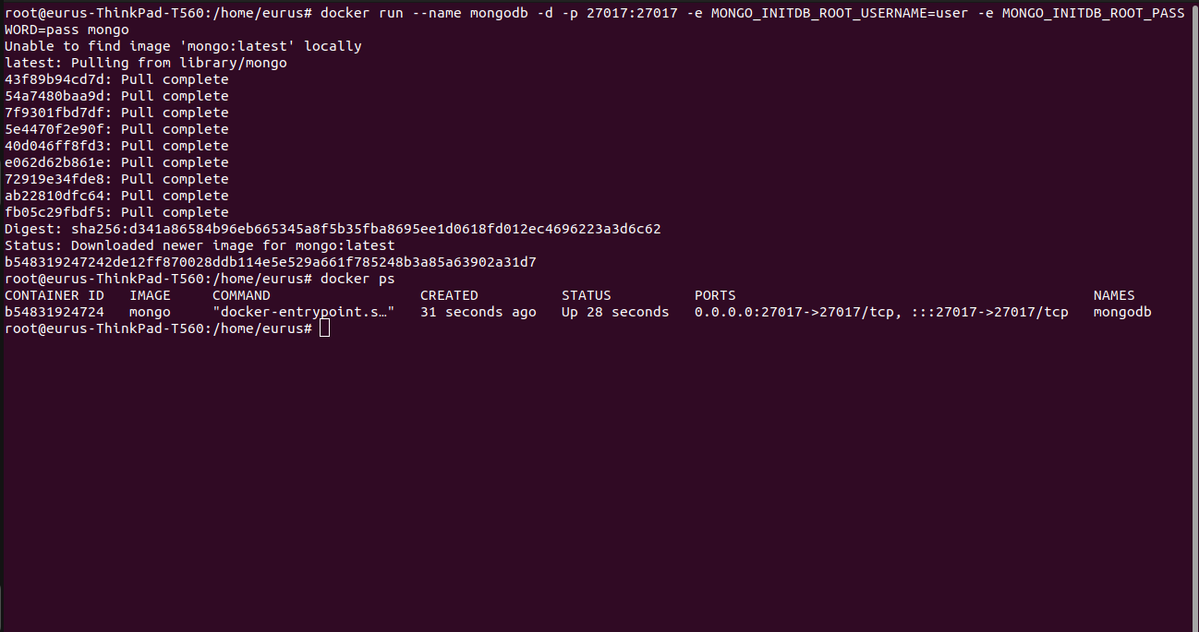

**Volumes and port settings**

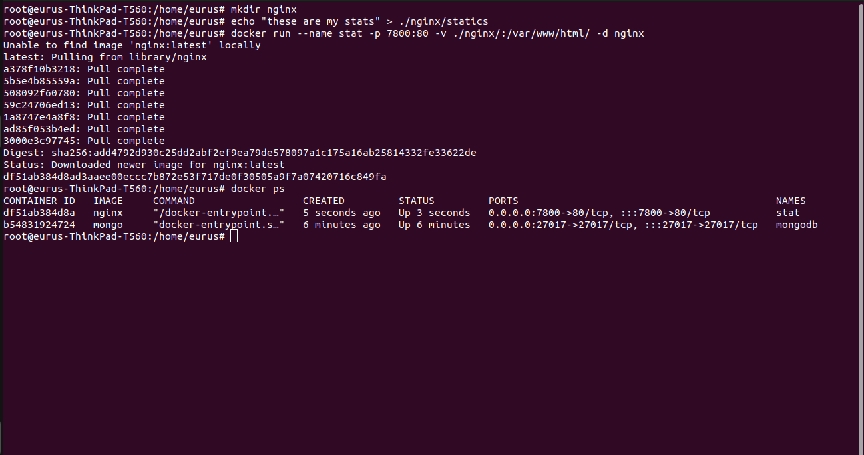

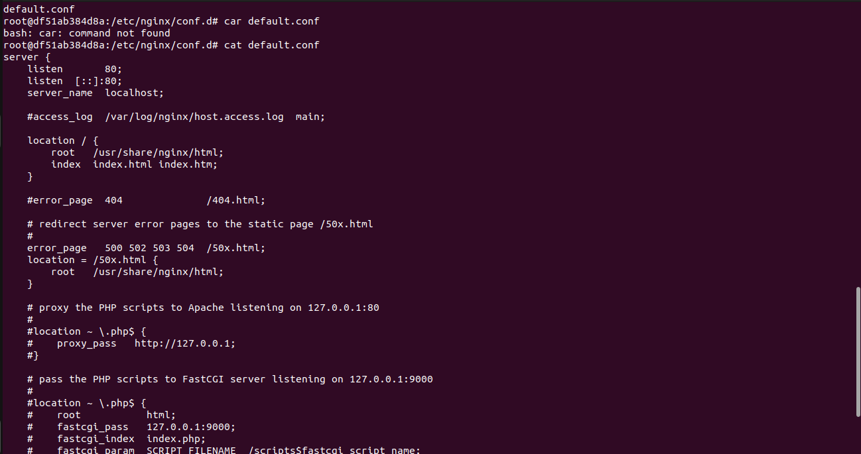

the root is /usr/share/nginx/html so I am moving the files there.



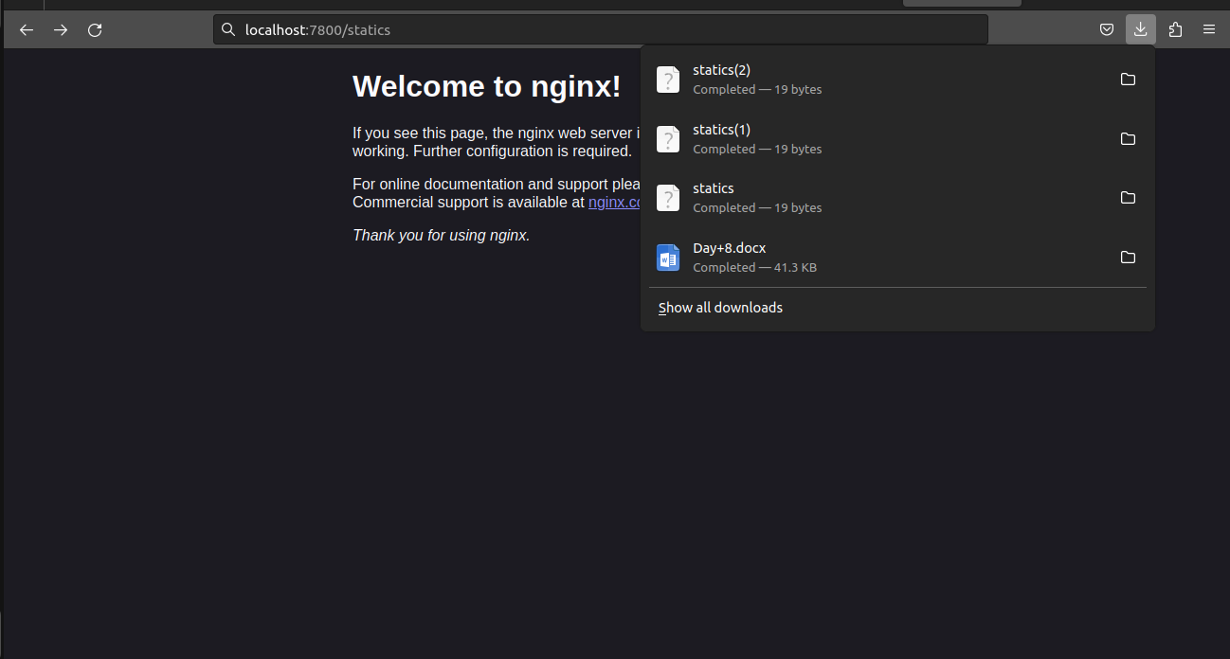

**Docker File**

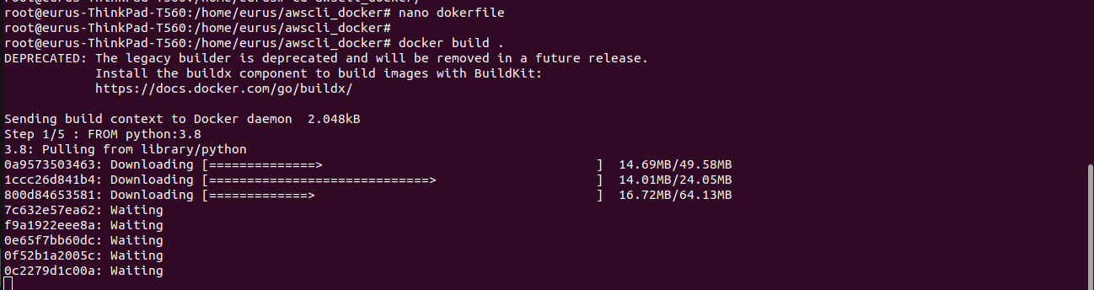

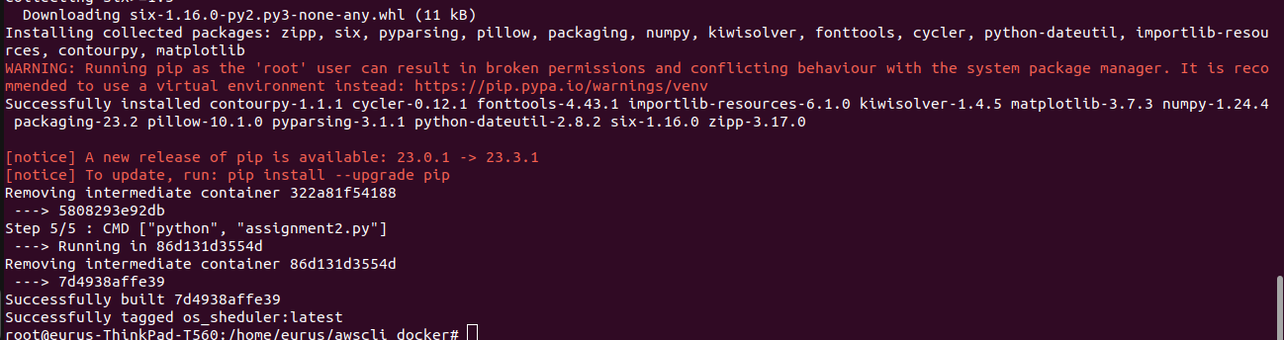

**Docker file content**

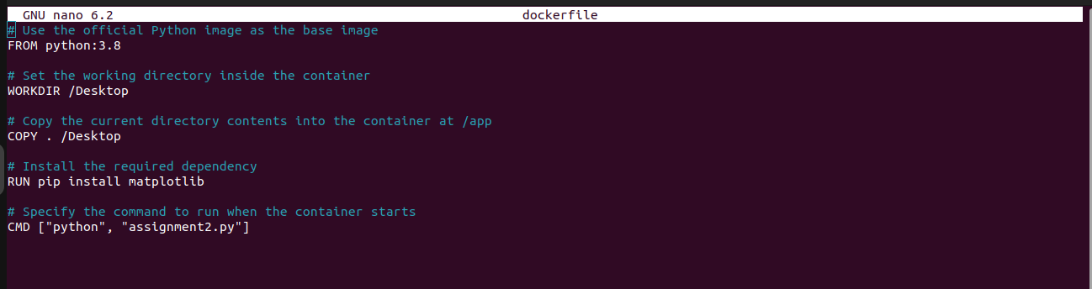

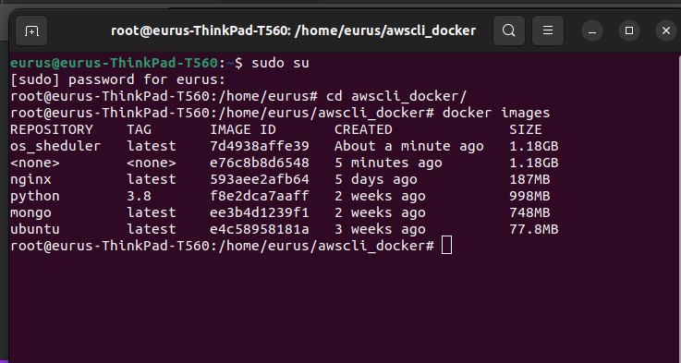

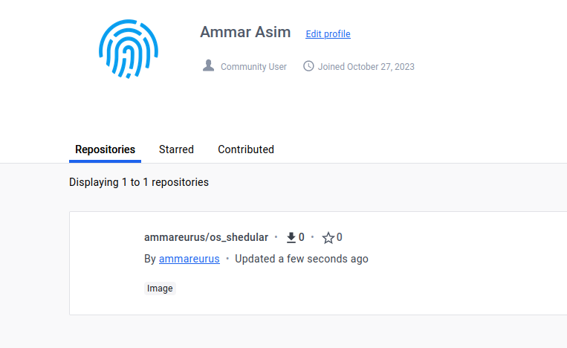

**Docker Compose File**

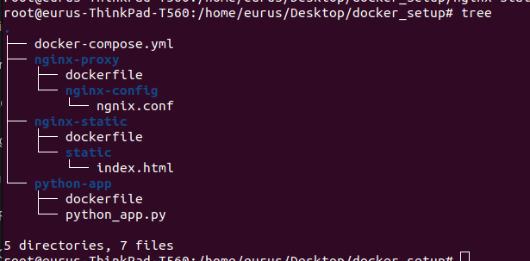

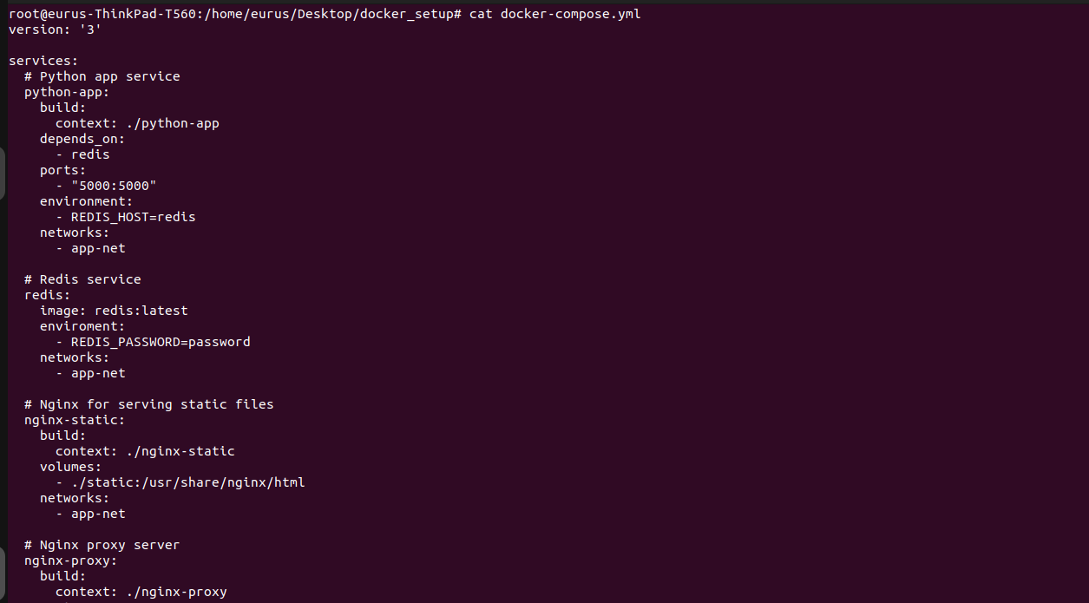

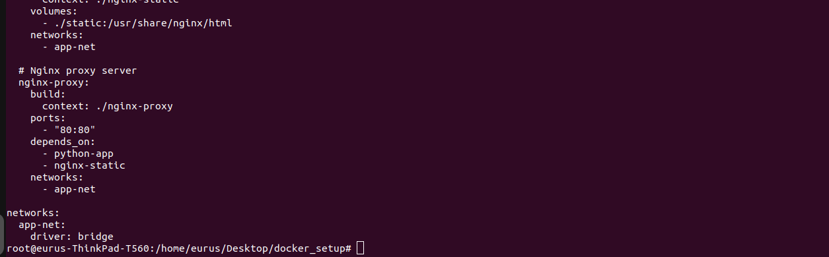

**Python app**

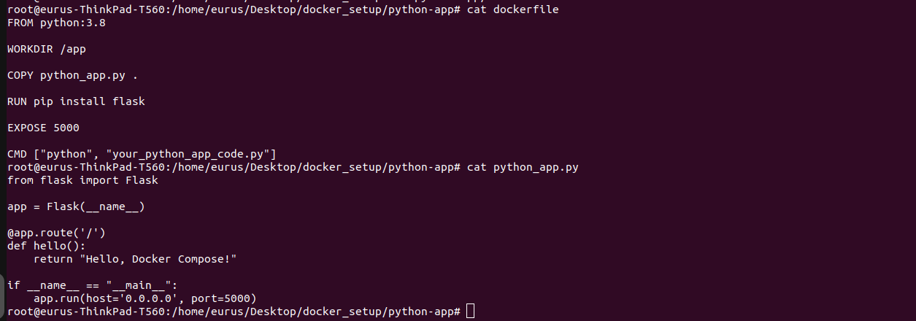

**Ngnix static**

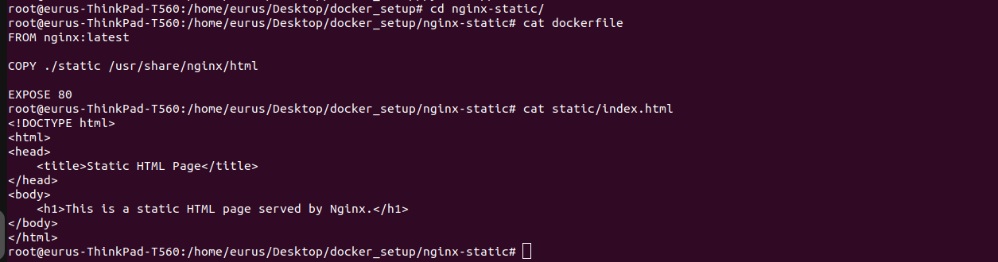

**Ngnix Proxy**

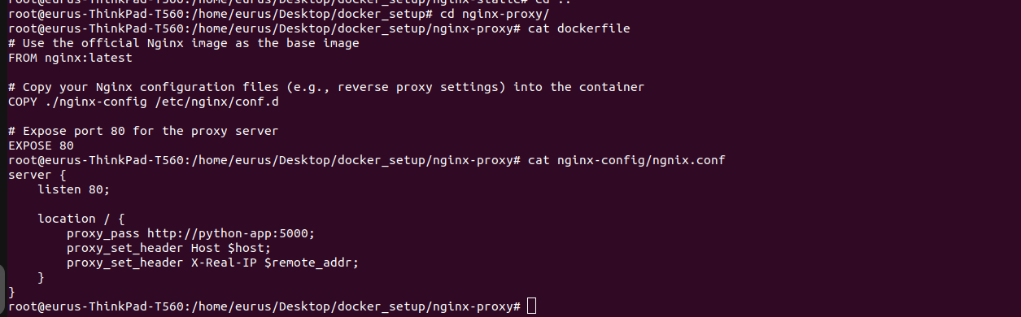

**docker-compose up**

