Summary of accomplishments
In this project we are exploring advanced algorithms for the solution of edge gyrokinetic equations for turbulence simulations of the edge in tokamaks and stellerators. These algorithms are extensions of schemes developed in the fluid dynamics community for the solution of 2D incompressible flow equations[1], and are applicable to a broad variety of problems expressible as a Hamiltonian equation coupled to an elliptic field equation. Examples include 2D incompressible flow, Vlasov-Poisson, drift-kinetic and gyrokinetic equations. The basic scheme is a combination of Discontinuous Galerkin (DG) and Continuous Galerkin (CG) finite-element methods. The DG scheme is used to advance the Hamiltonian dynamics while the CG scheme is used to update the elliptic field equations. Such systems admit two quadratic invariants, energy and a second quantity, known by various names (e.g., enstrophy or entropy) in different contexts. The schemes developed in this project preserve the energy and, with proper choice of numerical flux function, the enstrophy.
In the six months of this project (January-July 2012) we have made significant progress in identifying the numerical scheme and producing an initial implementation to test its accuracy, robustness and efficiency. This progress is summarized below.
- We have created a modular C++ application called Gkeyll (pronounced Jekyll) with interfaces for the creation of various solvers that can be combined for the solution of different problems. Gkeyll uses portable libraries like PetSc, OpenMPI, HDF5, Blitz++ and Boost. The application has an embedded Lua interpreter that allows scripting of solvers from a simple but powerful programming language.
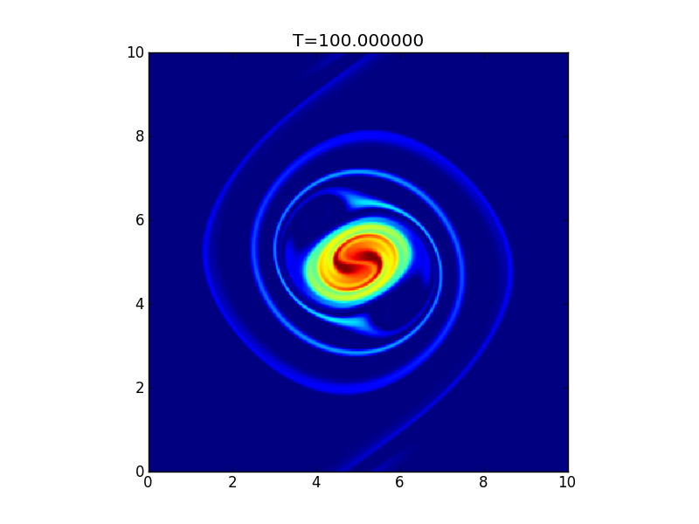
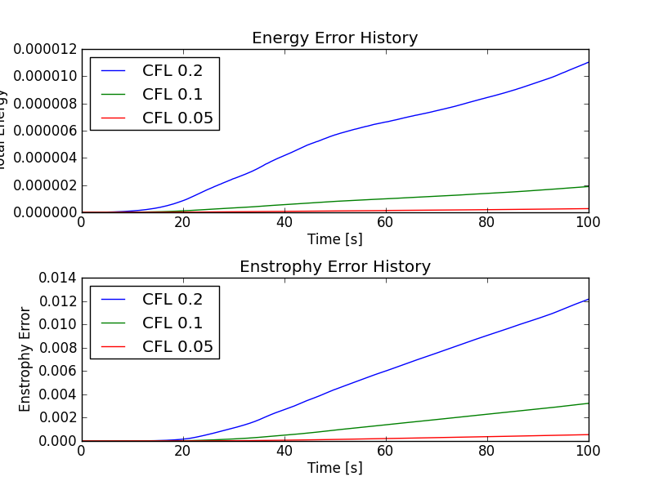

Figure 1. Vortex merger problem with third order scheme (top) showing complex small-scale features in the solution. Also shown are the time histories of the total energy and enstropy with different time-steps. The small energy drop is from the irreversibility in the time-stepping scheme.
- We have implemented second and third order DG and CG schemes in 1D and 2D. We have performed extensive verification of the solvers on problems admitting analytical solutions. As an application we have solved the 2D invicid Euler equations written in stream-function/vorticity form. Figure 1 shows the solution of a vortex merging problem, initialized with two Gaussian vortices. These vortices merge as they orbit around each other, forming complex small-scale features. Tests show that the third order algorithm, formally fifth-order accurate due to spectral properties of the DG scheme, is very efficient and robust, outperforming the second-order scheme both in total number of degrees of freedom as well as run-time. The figure also shows that energy is conserved to the same order as the time-stepping scheme even when using a diffusive, but robust, upwind flux for advection. A central flux allows conservation of enstrophy (in addition to energy), however, the solution shows significant amount of numerical dispersion when the gradients become sharp.
- The solvers were used to evolve the Vlasov equation in 1D/1V combined to either a Poisson equation (modelling perpendicular dynamics in gyrokinetics) or a quasi-neutrality condition (modelling parallel dynamics in gyrokinetics). Tests were performed to check correct phase mixing and particle trapping behaviour in potential wells. Standard problems like linear Landau damping, ion acoustic wave propagation and damping, and two-stream instability were performed and compared to theoretical results. As an example we show the numerically computed damping rates compared to those obtained from roots of Langmuir wave dispersion relation. We have also performed nonlinear Landau damping simulations and have compared to existing results in the literature. Example results are shown in the figure.
- We have implemented an arbitrary order modal DG scheme for the solution of 1D hyperbolic equations. This solver was verified on linear advection equation and will be used to test different limiters to ensure positivity of the distribution function.
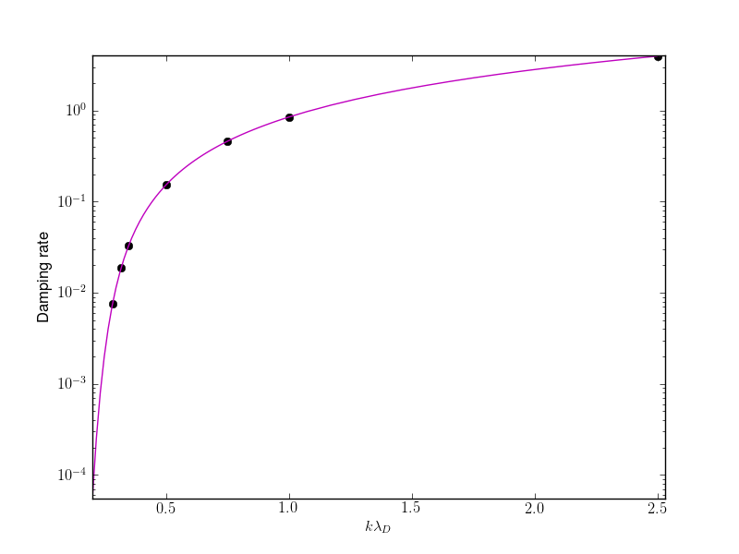
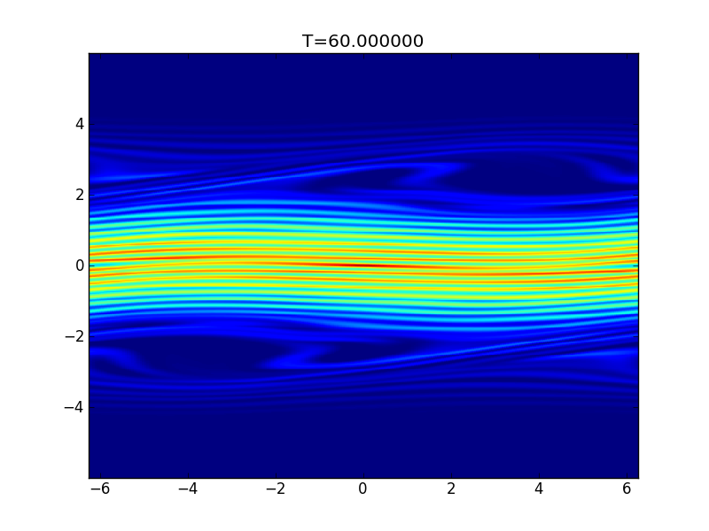

Figure 2. Upper plot shows numerically computed damping rate (black dots) compared to exact values (magenta) for linear Landau damping problem for different wave numbers. The numerical values are within 3% in the weakly damped regime and within 1% in the strongly damped regime. The lower plot shows the distribution function from nonlinear Landau damping problem. Visible are the phase-space holes leading to particle trapping as well as the fine-scale features in the distribution function.

Proposed work plan

In the coming year we plan to explore special velocity space basis functions, collision models, and extend the algorithms to multiple dimensions. We plan to have a 4D axisymmetric/slab code by the end of the next performance period that will enable us to study drift-wave turbulence in slabs as well as neoclassical transport in model tokamak geometries. To achieve these goals we will work on the following tasks.
- We will explore non-polynomial basis functions in velocity space, in particular some form of Maxwellian weighted polynomials. This will allow us to efficiently compute robust solutions even when using very few velocity space grid points.
- A model conservative collision operator will be implemented and used both for collisional processes as well as for hyper-viscosity to eliminate small-scale features in velocity space.
- The grids, data-structures and basis functions will be extended to multiple dimensions to allow the algorithms to work on 4D or 5D phase-space. At present a single-block body fitted grid can be used in Gkeyll. To represent realistic tokamak geometry we will extend the current grids to a multi-block structured grid in physical space while allowing a non-uniform Cartesian mesh in velocity space. For efficient representation in high dimensionality of the kinetic equations we will explore the use of recently developed[2] higher-dimension Serendipity basis functions that significantly reduce the amount of storage and degrees-of-freedom while still preserving high formal accuracy.
- A simple model of neutral/plasma interaction will be added to allow modelling of the effect of neutrals on plasma fuelling as well low-temperature scrape-off-layer phenomena.
- We will benchmark against drift-wave turbulence, neoclassical transport calculations for standard problems as well as compare to results from existing codes.

[1] Jian-Guo Liu and Chi-Wang Shu, Journal of Computational Physics, 160, 577-596 (2000).
[2] Douglas N. Arnold and Gerard Awanou, Foundations of Computational Mathematics, 11, 337-344 (2011)

