COVID 19 Data Analysis

2023-05-13

# Intorduction:

This is the final project for the Data Science as a Field course (DTSA 5301). In this project, we will analyze a COVID-19 dataset available on GitHub. I will guide you through the analysis I have conducted in this project, with a focus on analyzing the US dataset. I will address the following Questions of interest for Washington state.

### Questions of Interest:

* Creating reproducible code that can be verified by my peers.
* Cleaning and analyzing the data to answer the following questions about Washington state:
  + What is the infection rate of COVID-19 per county in Washington state?
  + Which are the top 3 counties in terms of COVID-19 cases?
  + Predicting COVID-19 deaths in Washington state using a linear regression model.

### Before we start:

Please note that this project uses the package tidyverse, if it’s not installed, run the following two commands in R or R-Studio console install.packages("tidyverse"). If this is your first time using RStudio please note that you might also need to install tinytex using the following install.packages("tinytex")

# Project steps

## Step 1: This step involves the following:

1- Import the following libraries:

library(tidyverse)

## ── Attaching core tidyverse packages ──────────────────────── tidyverse 2.0.0 ──  
## ✔ dplyr 1.1.1 ✔ readr 2.1.4  
## ✔ forcats 1.0.0 ✔ stringr 1.5.0  
## ✔ ggplot2 3.4.2 ✔ tibble 3.2.1  
## ✔ lubridate 1.9.2 ✔ tidyr 1.3.0  
## ✔ purrr 1.0.1   
## ── Conflicts ────────────────────────────────────────── tidyverse_conflicts() ──  
## ✖ dplyr::filter() masks stats::filter()  
## ✖ dplyr::lag() masks stats::lag()  
## ℹ Use the conflicted package (<http://conflicted.r-lib.org/>) to force all conflicts to become errors

library(lubridate)  
library(ggplot2)  
library(dplyr)

2- Download the data set from the following source https://raw.githubusercontent.com/CSSEGISandData/COVID-19/master/csse_covid_19_data/csse_covid_19_time_series/

base_url <- ("https://raw.githubusercontent.com/CSSEGISandData/COVID-19/master/csse_covid_19_data/csse_covid_19_time_series/")  
  
# The vector that has all the CSV file names, I'm only interested in the US cases and deaths data sets  
  
csv_file_names <-   
 c("time_series_covid19_confirmed_US.csv",  
 "time_series_covid19_deaths_US.csv")  
  
file_urls <- str_c(base_url, csv_file_names)  
  
Raw_US_Cases <- read_csv(file_urls[1])

## Rows: 3342 Columns: 1154  
## ── Column specification ────────────────────────────────────────────────────────  
## Delimiter: ","  
## chr (6): iso2, iso3, Admin2, Province_State, Country_Region, Combined_Key  
## dbl (1148): UID, code3, FIPS, Lat, Long_, 1/22/20, 1/23/20, 1/24/20, 1/25/20...  
##   
## ℹ Use `spec()` to retrieve the full column specification for this data.  
## ℹ Specify the column types or set `show_col_types = FALSE` to quiet this message.

Raw_US_Deaths <- read_csv(file_urls[2])

## Rows: 3342 Columns: 1155  
## ── Column specification ────────────────────────────────────────────────────────  
## Delimiter: ","  
## chr (6): iso2, iso3, Admin2, Province_State, Country_Region, Combined_Key  
## dbl (1149): UID, code3, FIPS, Lat, Long_, Population, 1/22/20, 1/23/20, 1/24...  
##   
## ℹ Use `spec()` to retrieve the full column specification for this data.  
## ℹ Specify the column types or set `show_col_types = FALSE` to quiet this message.

## Step 2: This step will tidy and/or transform the data to make it ready for the visualization steps:

This step will involve the following:

* Cleaning the US Cases dataset by removing unnecessary data for our analysis and viewing a summary of the data. As you can see in the summary below, the minimum number of cases at the time of importing the dataset has a negative value. To address this, I added a filter to include only cases larger than or equal to 0. Although the filter step can be combined, I am analyzing the data step by step for clarity.

US_cases <- Raw_US_Cases %>%  
 pivot_longer(cols = -(UID:Combined_Key), names_to = "date", values_to = "cases") %>%  
 select(Admin2:cases) %>%  
 mutate(date = mdy(date))%>%  
 select(-c(Lat, Long_))

* Print a summary of the US_cases and make sure that we have what we need.

US_cases <- US_cases %>%  
 filter(cases >= 0)  
  
# Print a summar of the US_cases  
summary(US_cases)

## Admin2 Province_State Country_Region Combined_Key   
## Length:3819903 Length:3819903 Length:3819903 Length:3819903   
## Class :character Class :character Class :character Class :character   
## Mode :character Mode :character Mode :character Mode :character   
##   
##   
##   
## date cases   
## Min. :2020-01-22 Min. : 0   
## 1st Qu.:2020-11-02 1st Qu.: 330   
## Median :2021-08-15 Median : 2272   
## Mean :2021-08-14 Mean : 14088   
## 3rd Qu.:2022-05-28 3rd Qu.: 8159   
## Max. :2023-03-09 Max. :3710586

* US_cases has the following columns:
  + ***Admin2***: County name.
  + ***Province_State***: State.
  + ***Country_Region***: US.
  + ***Combined_Key***: County and state.
  + ***date***: Date in Year-Month-Day format.
  + ***cases***: COVID19 cases.

##### And repeat the same thing for the US Deaths.

US_deaths <- Raw_US_Deaths %>%  
 pivot_longer(cols = -(UID:Population), names_to = "date", values_to = "deaths") %>%  
 select(Admin2:deaths) %>%  
 mutate(date = mdy(date))%>%  
 select(-c(Lat, Long_))  
  
US_deaths <- US_deaths %>%  
 filter(deaths >= 0)  
  
# Print a summary of hte US_deaths  
summary(US_deaths)

## Admin2 Province_State Country_Region Combined_Key   
## Length:3819903 Length:3819903 Length:3819903 Length:3819903   
## Class :character Class :character Class :character Class :character   
## Mode :character Mode :character Mode :character Mode :character   
##   
##   
##   
## Population date deaths   
## Min. : 0 Min. :2020-01-22 Min. : 0.0   
## 1st Qu.: 9917 1st Qu.:2020-11-02 1st Qu.: 4.0   
## Median : 24909 Median :2021-08-15 Median : 37.0   
## Mean : 99604 Mean :2021-08-14 Mean : 186.9   
## 3rd Qu.: 64979 3rd Qu.:2022-05-28 3rd Qu.: 122.0   
## Max. :10039107 Max. :2023-03-09 Max. :35545.0

* US_deaths has the following columns:
  + ***Admin2***: County name.
  + ***Province_State***: State.
  + ***Country_Region***: US.
  + ***Combined_Key***: County and state.
  + ***date***: Date in Year-Month-Day format.
  + ***Population***: County population
  + ***deaths***: COVID19 deaths.
* Finally we need to join the two data sets, we end up with a combined data set named US.

US <- US_cases %>%   
 full_join(US_deaths)

## Joining with `by = join_by(Admin2, Province_State, Country_Region,  
## Combined_Key, date)`

# Pring a summar of the US  
summary(US)

## Admin2 Province_State Country_Region Combined_Key   
## Length:3819903 Length:3819903 Length:3819903 Length:3819903   
## Class :character Class :character Class :character Class :character   
## Mode :character Mode :character Mode :character Mode :character   
##   
##   
##   
## date cases Population deaths   
## Min. :2020-01-22 Min. : 0 Min. : 0 Min. : 0.0   
## 1st Qu.:2020-11-02 1st Qu.: 330 1st Qu.: 9917 1st Qu.: 4.0   
## Median :2021-08-15 Median : 2272 Median : 24909 Median : 37.0   
## Mean :2021-08-14 Mean : 14088 Mean : 99604 Mean : 186.9   
## 3rd Qu.:2022-05-28 3rd Qu.: 8159 3rd Qu.: 64979 3rd Qu.: 122.0   
## Max. :2023-03-09 Max. :3710586 Max. :10039107 Max. :35545.0

* And finally these are the columns of the US:
  + ***Admin2***: County name.
  + ***Province_State***: State.
  + ***Country_Region***: US.
  + ***Combined_Key***: County and state.
  + ***date***: Date in Year-Month-Day format.
  + ***cases***: COVID19 cases.
  + ***Population***: County population
  + ***deaths***: COVID19 deaths.
* Now that we have the data cleaned up a bit, we’ll work on grouping, summarizing and adding new fields that will be very useful when we start visualizing the data.

# Group the data by (Province_State, Country_Region, date) to get the sum of cases, deaths and population, and add deaths per million  
US_by_state <- US %>%   
 group_by(Province_State, Country_Region, date) %>%   
 summarize(cases = sum(cases), deaths = sum(deaths), Population = sum(Population)) %>%   
 mutate(deaths_per_mill = deaths * 1000000 / Population) %>%   
 select(Province_State, Country_Region, date, cases, deaths, deaths_per_mill, Population) %>%   
 ungroup()

## `summarise()` has grouped output by 'Province_State', 'Country_Region'. You can  
## override using the `.groups` argument.

* Let’s print a summary of what we have so far.

summary(US_by_state)

## Province_State Country_Region date cases   
## Length:66294 Length:66294 Min. :2020-01-22 Min. : 0   
## Class :character Class :character 1st Qu.:2020-11-02 1st Qu.: 31115   
## Mode :character Mode :character Median :2021-08-15 Median : 293146   
## Mean :2021-08-15 Mean : 811738   
## 3rd Qu.:2022-05-28 3rd Qu.: 953450   
## Max. :2023-03-09 Max. :12129699   
##   
## deaths deaths_per_mill Population   
## Min. : 0 Min. : 0.0 Min. : 0   
## 1st Qu.: 555 1st Qu.: 490.2 1st Qu.: 1068778   
## Median : 3849 Median :1665.9 Median : 3660113   
## Mean : 10768 Mean : Inf Mean : 5739226   
## 3rd Qu.: 13695 3rd Qu.:2794.0 3rd Qu.: 6892503   
## Max. :101159 Max. : Inf Max. :39512223   
## NA's :1211

* Next we’ll group the data by the Country_Region and Date, so for each date we’ll see how many cases there are.

US_totals <- US_by_state %>%   
 group_by( Country_Region, date) %>%   
 summarize(cases = sum(cases), deaths = sum(deaths), Population = sum(Population)) %>%   
 mutate(deaths_per_mill = deaths * 1000000 / Population) %>%   
 select(Country_Region, date, cases, deaths, deaths_per_mill, Population) %>%   
 ungroup()

## `summarise()` has grouped output by 'Country_Region'. You can override using  
## the `.groups` argument.

US_totals

## # A tibble: 1,143 × 6  
## Country_Region date cases deaths deaths_per_mill Population  
## <chr> <date> <dbl> <dbl> <dbl> <dbl>  
## 1 US 2020-01-22 1 1 0.00300 332875137  
## 2 US 2020-01-23 1 1 0.00300 332875137  
## 3 US 2020-01-24 2 1 0.00300 332875137  
## 4 US 2020-01-25 2 1 0.00300 332875137  
## 5 US 2020-01-26 5 1 0.00300 332875137  
## 6 US 2020-01-27 5 1 0.00300 332875137  
## 7 US 2020-01-28 5 1 0.00300 332875137  
## 8 US 2020-01-29 6 1 0.00300 332875137  
## 9 US 2020-01-30 6 1 0.00300 332875137  
## 10 US 2020-01-31 8 1 0.00300 332875137  
## # ℹ 1,133 more rows

summary(US_totals)

## Country_Region date cases deaths   
## Length:1143 Min. :2020-01-22 Min. : 1 Min. : 1   
## Class :character 1st Qu.:2020-11-02 1st Qu.: 9401880 1st Qu.: 232564   
## Mode :character Median :2021-08-15 Median : 36845902 Median : 618029   
## Mean :2021-08-15 Mean : 47080800 Mean : 624563   
## 3rd Qu.:2022-05-27 3rd Qu.: 84083678 3rd Qu.:1006626   
## Max. :2023-03-09 Max. :103802702 Max. :1123836   
## deaths_per_mill Population   
## Min. : 0.003 Min. :332875137   
## 1st Qu.: 698.652 1st Qu.:332875137   
## Median :1856.639 Median :332875137   
## Mean :1876.268 Mean :332875137   
## 3rd Qu.:3024.033 3rd Qu.:332875137   
## Max. :3376.149 Max. :332875137

## Step 3: Visualize and analyze the data:

* We start by graphing the data in the of US_totals which will show the total cases and deaths per day.

US_totals %>%   
 ggplot(aes(x = date, y = cases)) +   
 geom_point(aes(color = "cases")) +   
 geom_point(aes(y = deaths, color = "deaths")) +   
 scale_y_log10() + theme(legend.position = "bottom", axis.text.x = element_text(angle = 90)) +   
 labs(title = "COVID19 in US", x = "Date", y = "Cases/Deaths")

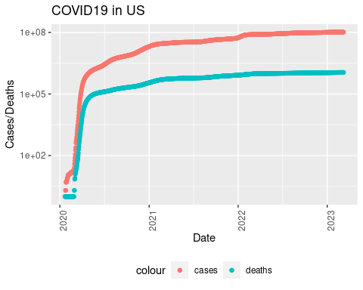

* We will now introduce additional variables to track the daily new cases and new deaths. These values will be calculated by subtracting the current number of deaths from the corresponding figure recorded one week prior. This specific choice of a one-week interval allows for a smoother graph representation.

lag_value = 7  
  
US_totals <- US_totals %>%   
 mutate(new_cases = cases - lag(cases, lag_value), new_deaths = deaths - lag(deaths, lag_value))   
  
US_totals %>%  
 ggplot(aes(x = date, y = new_cases)) +   
 geom_line(aes(color = "new_cases")) +   
 geom_point(aes(color = "new_cases")) +   
 geom_line(aes(y = new_deaths, color = "new_deaths")) +   
 geom_point(aes(y = new_deaths, color = "new_deaths")) +   
 scale_y_log10() +   
 theme(legend.position = "bottom", axis.text.x = element_text(angle = 90)) +   
 labs(title = "COVID19 in US - 1 Week Lag", x = "Date", y = "New Cases/Deaths")

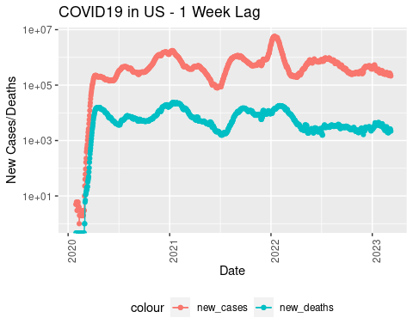

* Let’s now visualize the data with a 30-day lag.

lag_value = 30  
  
US_totals <- US_totals %>%   
 mutate(new_cases = cases - lag(cases, lag_value), new_deaths = deaths - lag(deaths, lag_value))   
   
US_totals %>%  
 ggplot(aes(x = date, y = new_cases)) +   
 geom_line(aes(color = "new_cases")) +   
 geom_point(aes(color = "new_cases")) +   
 geom_line(aes(y = new_deaths, color = "new_deaths")) +   
 geom_point(aes(y = new_deaths, color = "new_deaths")) +   
 scale_y_log10() +   
 theme(legend.position = "bottom", axis.text.x = element_text(angle = 90)) +   
 labs(title = "COVID19 in US - 1 Month Lag", x = "Date", y = "New Cases/Deaths")

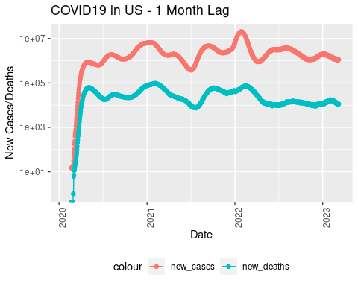

* Additionally, let’s explore the yearly increase, considering that we now have data spanning multiple years. We will examine the increase in cases per year. What I noticed in the graph below is that it looks like there is a substantial decrease in the number of deaths.

lag_value = 365  
  
US_by_state <- US_by_state %>%   
 mutate(new_cases = cases - lag(cases, lag_value), new_deaths = deaths - lag(deaths, lag_value))   
  
US_totals <- US_totals %>%   
 mutate(new_cases = cases - lag(cases, lag_value), new_deaths = deaths - lag(deaths, lag_value))   
   
US_totals %>%  
 ggplot(aes(x = date, y = new_cases)) +   
 geom_line(aes(color = "new_cases")) +   
 geom_point(aes(color = "new_cases")) +   
 geom_line(aes(y = new_deaths, color = "new_deaths")) +   
 geom_point(aes(y = new_deaths, color = "new_deaths")) +   
 scale_y_log10() +   
 theme(legend.position = "bottom", axis.text.x = element_text(angle = 90)) +   
 labs(title = "COVID19 in US - 1 Year Lag", x = "Date", y = "New Cases/Deaths")

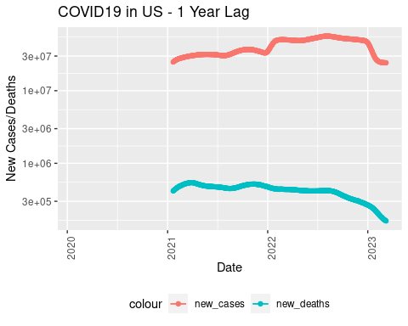

* Now, let’s shift our focus to Washington state. As we examine the graphs below, we can see that Washington state is following the same overall trend as depicted earlier for the entire United States.

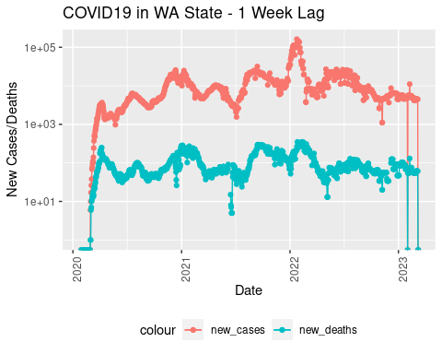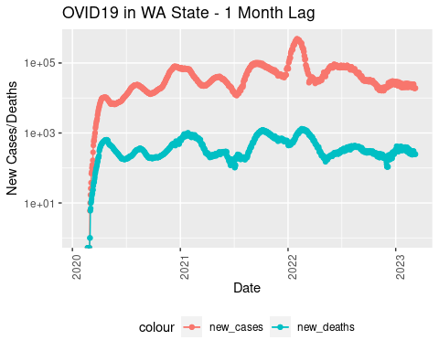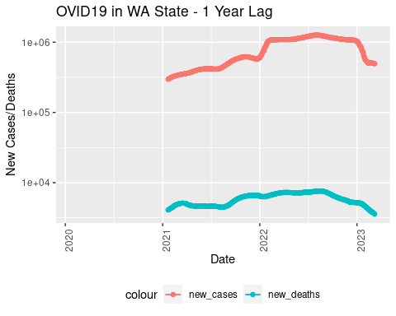

* Let’s proceed by grouping the counties and aggregating the number of cases. In addition, I’ll apply a filter to exclude some data from Washington state, such as “Unassigned” and “Out of WA,” as they seem to contain some missing data.

# Filter Washington state only, and remove "Unassigned" and "Out of WA" data.  
WA_state <- US %>%  
 filter(Province_State == "Washington") %>%  
 filter(Admin2 != "Unassigned") %>%  
 filter(Admin2 != "Out of WA") %>%  
 mutate(new_cases = cases - lag(cases), new_deaths = deaths - lag(deaths), death_rate = deaths/cases)   
  
# Check the data.  
tail(WA_state)

## # A tibble: 6 × 11  
## Admin2 Province_State Country_Region Combined_Key date cases Population  
## <chr> <chr> <chr> <chr> <date> <dbl> <dbl>  
## 1 Yakima Washington US Yakima, Wash… 2023-03-04 83734 250873  
## 2 Yakima Washington US Yakima, Wash… 2023-03-05 83734 250873  
## 3 Yakima Washington US Yakima, Wash… 2023-03-06 83734 250873  
## 4 Yakima Washington US Yakima, Wash… 2023-03-07 83734 250873  
## 5 Yakima Washington US Yakima, Wash… 2023-03-08 83734 250873  
## 6 Yakima Washington US Yakima, Wash… 2023-03-09 83734 250873  
## # ℹ 4 more variables: deaths <dbl>, new_cases <dbl>, new_deaths <dbl>,  
## # death_rate <dbl>

# Group by counties   
WA_state_by_counties <- WA_state %>%  
 group_by(Admin2) %>%  
 summarize(total_cases = sum(cases),   
 total_deaths = sum(deaths),   
 Population = sum(Population),   
 ) %>%  
 ungroup()   
  
# Print a summary of the data we have so far and make sure it's good  
summary(WA_state)

## Admin2 Province_State Country_Region Combined_Key   
## Length:44577 Length:44577 Length:44577 Length:44577   
## Class :character Class :character Class :character Class :character   
## Mode :character Mode :character Mode :character Mode :character   
##   
##   
##   
##   
## date cases Population deaths   
## Min. :2020-01-22 Min. : 0 Min. : 2225 Min. : 0.0   
## 1st Qu.:2020-11-02 1st Qu.: 437 1st Qu.: 22425 1st Qu.: 6.0   
## Median :2021-08-15 Median : 3463 Median : 66768 Median : 42.0   
## Mean :2021-08-15 Mean : 20702 Mean : 195254 Mean : 194.6   
## 3rd Qu.:2022-05-28 3rd Qu.: 15105 3rd Qu.: 204390 3rd Qu.: 174.0   
## Max. :2023-03-09 Max. :549865 Max. :2252782 Max. :3512.0   
##   
## new_cases new_deaths death_rate   
## Min. :-549865.0 Min. :-3512.000 Min. :0.0000   
## 1st Qu.: 0.0 1st Qu.: 0.000 1st Qu.:0.0080   
## Median : 0.0 Median : 0.000 Median :0.0113   
## Mean : 1.9 Mean : 0.019 Mean :0.0146   
## 3rd Qu.: 15.0 3rd Qu.: 0.000 3rd Qu.:0.0152   
## Max. : 19214.0 Max. : 45.000 Max. :2.0000   
## NA's :1 NA's :1 NA's :2230

summary(WA_state_by_counties)

## Admin2 total_cases total_deaths Population   
## Length:39 Min. : 249039 Min. : 935 Min. :2.543e+06   
## Class :character 1st Qu.: 2176342 1st Qu.: 27812 1st Qu.:2.566e+07   
## Mode :character Median : 6996800 Median : 82129 Median :7.632e+07   
## Mean : 23663006 Mean : 222468 Mean :2.232e+08   
## 3rd Qu.: 21871165 3rd Qu.: 196412 3rd Qu.:1.906e+08   
## Max. :248811536 Max. :2077113 Max. :2.575e+09

* Let’s create a visualization by graphing the population and the total number of cases per county. This will provide a clear visual representation of how the cases are distributed across different counties based on their respective populations.

# First we need to pivot the data so we can group the Population and the total cases together  
WA_state_by_counties_pivoted <- WA_state_by_counties %>%   
 pivot_longer(cols=c('total_cases', 'Population'), names_to='variable',   
 values_to="value")  
  
WA_state_by_counties_pivoted

## # A tibble: 78 × 4  
## Admin2 total_deaths variable value  
## <chr> <dbl> <chr> <dbl>  
## 1 Adams 28237 total_cases 3293622  
## 2 Adams 28237 Population 22840569  
## 3 Asotin 44704 total_cases 2835680  
## 4 Asotin 44704 Population 25811226  
## 5 Benton 335603 total_cases 33040240  
## 6 Benton 335603 Population 233617770  
## 7 Chelan 107028 total_cases 12740435  
## 8 Chelan 107028 Population 88239600  
## 9 Clallam 78786 total_cases 6689251  
## 10 Clallam 78786 Population 88389333  
## # ℹ 68 more rows

# Graph both the total number of cases and deaths by county.  
WA_state_by_counties_pivoted %>%   
 ggplot(aes(fill=variable, x = Admin2, y = value)) +   
 geom_bar(position="dodge", stat="identity") +  
 theme(axis.text.x = element_text(angle = 90, vjust = 0.5, hjust=1)) +  
 labs(title = "Cases/Deaths per county in Washington", x = "County", y = NULL)

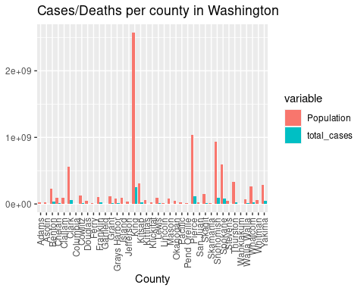

* Next, we will proceed to display the infection rate per county and highlight the top 3 counties. This visualization allows us to identify the counties with the highest infection rates and gain insights into the distribution of COVID-19 cases across different regions.

# Calulate the rate of infection   
WA_state_by_counties <- WA_state_by_counties %>%  
 mutate(infection_rate = total_cases * 100/ Population)  
  
# Print the max infection rate to make sure mutate worked.  
max(WA_state_by_counties$infection_rate)

## [1] 19.27053

WA_state_by_counties_pivoted <- WA_state_by_counties %>%   
 pivot_longer(cols=c('total_cases', 'infection_rate'), names_to='variable',   
 values_to="value")  
  
WA_state_by_counties_pivoted

## # A tibble: 78 × 5  
## Admin2 total_deaths Population variable value  
## <chr> <dbl> <dbl> <chr> <dbl>  
## 1 Adams 28237 22840569 total_cases 3293622   
## 2 Adams 28237 22840569 infection_rate 14.4   
## 3 Asotin 44704 25811226 total_cases 2835680   
## 4 Asotin 44704 25811226 infection_rate 11.0   
## 5 Benton 335603 233617770 total_cases 33040240   
## 6 Benton 335603 233617770 infection_rate 14.1   
## 7 Chelan 107028 88239600 total_cases 12740435   
## 8 Chelan 107028 88239600 infection_rate 14.4   
## 9 Clallam 78786 88389333 total_cases 6689251   
## 10 Clallam 78786 88389333 infection_rate 7.57  
## # ℹ 68 more rows

top_3_counties <- WA_state_by_counties %>%   
 arrange(desc(infection_rate)) %>%   
 top_n(3, infection_rate)  
  
WA_state_by_counties %>%   
 arrange(WA_state_by_counties, desc(infection_rate)) %>%  
 ggplot(aes(x = Admin2, y = infection_rate)) +   
 geom_bar(stat="identity") +  
 geom_point(data = top_3_counties, aes(x = Admin2, y = infection_rate, color = "top 3"), size = 2) +  
 scale_color_manual(name = "", values = c("top 3" = "red")) +  
 theme(axis.text.x = element_text(angle = 90, vjust = 0.5, hjust=1)) +  
 ylim(0, 30)+  
 labs(title = "COVID19 in US", x = "County", y = "Infection Rate")

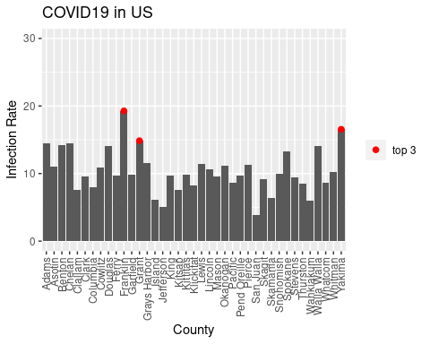

* To predict the number of COVID-19 deaths based on the reported cases, we will employ a linear regression model. By utilizing this linear model, we can predict the deaths based on the cases.

# Let's see if we can predict the deaths per thousand   
WA_state <- US %>%  
 filter(Province_State == "Washington", cases > 0, Population > 0) %>%  
 group_by(Admin2) %>%  
 summarize(deaths = max(deaths),   
 cases = max(cases),  
 Population = max(Population),  
 cases_per_thousand = cases * 1000 /Population,  
 deaths_per_thousand = deaths * 1000 /Population,  
 ) %>%  
 ungroup()  
   
WA_state

## # A tibble: 39 × 6  
## Admin2 deaths cases Population cases_per_thousand deaths_per_thousand  
## <chr> <dbl> <dbl> <dbl> <dbl> <dbl>  
## 1 Adams 45 5647 19983 283. 2.25  
## 2 Asotin 86 5606 22582 248. 3.81  
## 3 Benton 539 62042 204390 304. 2.64  
## 4 Chelan 196 24171 77200 313. 2.54  
## 5 Clallam 209 15809 77331 204. 2.70  
## 6 Clark 1047 111985 488241 229. 2.14  
## 7 Columbia 18 751 3985 188. 4.52  
## 8 Cowlitz 424 27341 110593 247. 3.83  
## 9 Douglas 87 13333 43429 307. 2.00  
## 10 Ferry 34 1825 7627 239. 4.46  
## # ℹ 29 more rows

# let's model the data   
model <- lm(deaths_per_thousand ~ cases_per_thousand, data = WA_state)  
  
summary(model)

##   
## Call:  
## lm(formula = deaths_per_thousand ~ cases_per_thousand, data = WA_state)  
##   
## Residuals:  
## Min 1Q Median 3Q Max   
## -1.6549 -0.6804 -0.2842 0.6227 2.2245   
##   
## Coefficients:  
## Estimate Std. Error t value Pr(>|t|)   
## (Intercept) 1.262704 0.625170 2.020 0.0507 .  
## cases_per_thousand 0.005464 0.002549 2.144 0.0387 *  
## ---  
## Signif. codes: 0 '***' 0.001 '**' 0.01 '*' 0.05 '.' 0.1 ' ' 1  
##   
## Residual standard error: 0.9021 on 37 degrees of freedom  
## Multiple R-squared: 0.1105, Adjusted R-squared: 0.08644   
## F-statistic: 4.595 on 1 and 37 DF, p-value: 0.0387

WA_state_with_predictions <- WA_state %>% mutate(pred=predict(model))  
  
WA_state_with_predictions

## # A tibble: 39 × 7  
## Admin2 deaths cases Population cases_per_thousand deaths_per_thousand pred  
## <chr> <dbl> <dbl> <dbl> <dbl> <dbl> <dbl>  
## 1 Adams 45 5647 19983 283. 2.25 2.81  
## 2 Asotin 86 5606 22582 248. 3.81 2.62  
## 3 Benton 539 62042 204390 304. 2.64 2.92  
## 4 Chelan 196 24171 77200 313. 2.54 2.97  
## 5 Clallam 209 15809 77331 204. 2.70 2.38  
## 6 Clark 1047 111985 488241 229. 2.14 2.52  
## 7 Columb… 18 751 3985 188. 4.52 2.29  
## 8 Cowlitz 424 27341 110593 247. 3.83 2.61  
## 9 Douglas 87 13333 43429 307. 2.00 2.94  
## 10 Ferry 34 1825 7627 239. 4.46 2.57  
## # ℹ 29 more rows

WA_state_with_predictions %>%  
 ggplot() +   
 geom_point(aes(x = cases_per_thousand, y = deaths_per_thousand), color = "red") +   
 geom_point(aes(x = cases_per_thousand, y = pred), color = "blue") +  
 labs(title = "Linear Model - WA State - Predicting deaths per thousand", x = "Cases per thousand", y = "Deaths per thousand")

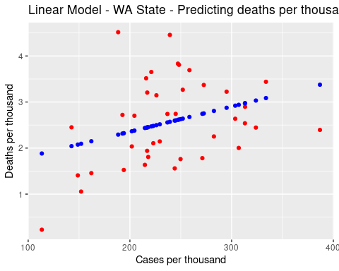

## Conclusion

* Based on the infection rate, the top 3 counties are Franklin, Grant, and Yakima.
* The number of deaths shows a downward trend. It would be valuable to incorporate additional data such as vaccination records to evaluate the potential positive impact of vaccines.
* Although the linear regression model fits the data, a more appropriate model, such as logistic regression, may better capture the underlying patterns.

## Bias

1- It is crucial to approach the analysis of such data/reports with caution, as they can be subject to various biases. Questions arise regarding the data collection process, such as who is responsible for gathering the data and whether there are established data compliance protocols in place. Are the reported deaths accurately documented across all counties? Additionally, we must consider the accuracy of data entry and potential inconsistencies. If certain groups, counties, or regions are systematically favored in the data collection process, sampling bias can be introduced. Similarly, selective reporting of data can introduce reporting bias, impacting the overall analysis.

2- Another important consideration is to focus on rates rather than absolute numbers. Comparing the number of cases or deaths between different regions or counties without considering the infection or death rates can lead to erroneous conclusions. It is essential to assess the rate of infection and/or deaths to make informed decisions and avoid misinterpretations based solely on the raw numbers.