A brief survey on data science skills market

A few vital questions when it comes to job hunt: How to hack the demand and supply equilibrium in skills markets to position yourself the best.? What skills you should target.? What keywords you should use in your resume.? What are the hot skills the market is yearning for.?   
  
Here is the simplest case study on how data science can answer all of these questions. [Indeed.com](http://indeed.com/) is one of the biggest job portals in the world. A crawler can easily give you a few thousand sample resumes and job adverts from this website. Running python code on top of these datasets will not only answer all of those questions but also will help you ask the right questions. Of course, you can talk about your findings right in your CV if it helps sell yourself better.

Following is a summary of charts extracted from the datasets. Datasets are provided with the GitHub repository here : <https://github.com/ammarisme/survey-on-data-science-skills>

Given below is my favorite one. Hope it’s self explanatory.

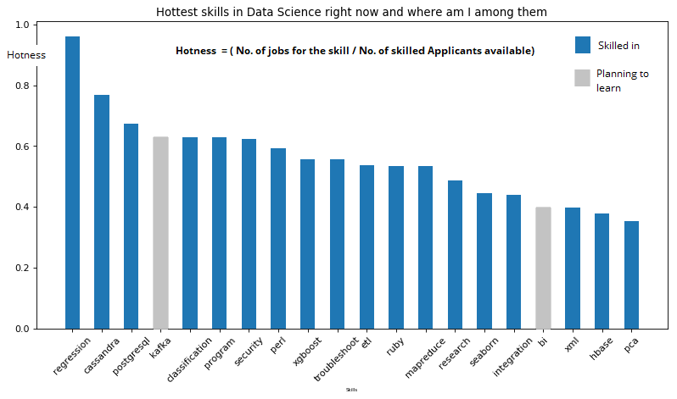

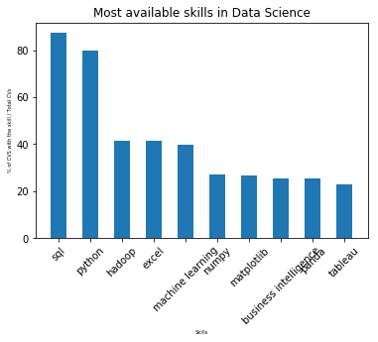Given below is the set of skills found in resumes of most candidates. It doesn’t mean these skills worth less than others. What’s a Data Scientist CV without Python in it.?

Here

Here is an interesting one. These are the skills that was mentioned the most in job adverts. Python was mentioned in 600 job adverts out of 1000 adverts.! R is less popular than Python. You can draw a lot of insights from this chart and use them to highlight your skills in the resume.

