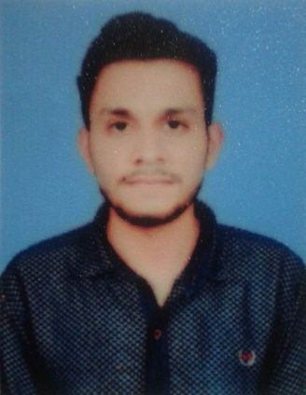
Amar Javaid

Address: House #18 Block 21/24 main road Sargodha.
Contact # +92 3020662962
Email: bcs07183077@student.uol.edu.pk

Objective

To pursue a career in financial planning and risk management by combining the element of existing and future economical and financial condition in line with education background and acquired professional skills and utilize knowledge in management

Personal Information

Name : Amar Javaid
Father’s Name : Javaid Iqbal
Date of Birth : 24-11-1998
CNIC# : 38403-0234537-3
Domicile : Sargodha
Religion : Islam
Nationality : Pakistani

Education Qualification

Computer Network Technician : Punjab Board of Technical Education Lahore.
BSCS : The University of Lahore Sargodha Campus (7th Semester Continue…)
Intermediate : The Reader Group of College Sargodha (2016-2018)
Matric : From Sargodha Board. (2014-2016)

Skills

- HTML/CSS/SASS/BOOTSTRAP
- React.JS
- MS Word
- Power Point

Languages

- English
- Urdu
- Punjabi

