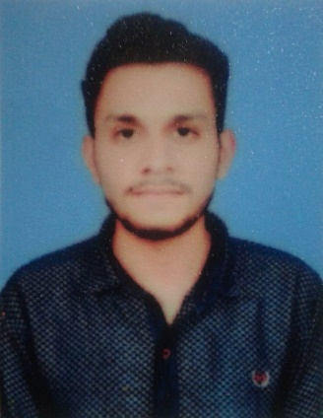 ***Amar Javaid***

**Address:** House **#18** Block **21/24** main road **Sargodha.**

**Contact #** +92 3020662962

**Email:** bcs07183077@student.uol.edu.pk

Objective

To pursue a career in financial planning and risk management by combining the element of existing and future economical and financial condition in line with education background and acquired professional skills and utilize knowledge in management

Personal Information

**Name :** Amar Javaid

**Father’s Name :** Javaid Iqbal

**Date of Birth :** 24-11-1998

**CNIC# :** 38403-0234537-3

**Domicile :** Sargodha

**Religion :** Islam

**Nationality :** Pakistani

Education Qualification

**Computer Network Technician :** Punjab Board of Technical Education Lahore.

**BSCS :** The University of Lahore SargodhaCampus **(7th Semester Continue…)**

**Intermediate :** The Reader Group of College Sargodha **(2016-2018)**

**Matric :** From Sargodha Board. **(2014-2016)**

Skills

* HTML/CSS/SASS/BOOTSTRAP
* React.JS
* MS Word
* Power Point

Languages

* English
* Urdu
* Punjabi