**Management Console:**

Search capabilities for:

* Palestinian_Localities_WestBank
* Settlements

**Left side:**

* [Area A, Area B, Area C]

Palestinian Villages,

Green Line - line in green

Settlements

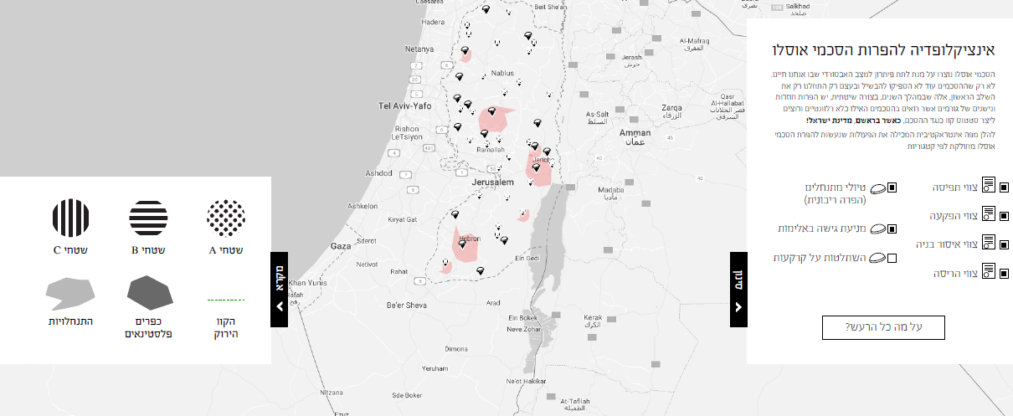

Green Line

Palestinian Localities

Israeli Settlements

**Right Side:**

Layers:

Area_b_violations

Area_B__Demolitions

Polygons that need an Area A and B category in the symbology:

* ExpropriationOrders
  + AB - Red
  + All -
* NoConstructionOrderRoads
  + AB - Red
  + All -
* No Construction OrderBarrier
* Seizure Order

These are all point layers displayed independently.

We should be able to turn them on or off

Very simple white background

And a text box that pulls from a file with 3 difrent languages

And a link to for english <https://www.keremnavot.org/english-about>

for Hebrew <https://www.keremnavot.org/about>

for Arabic - <https://www.keremnavot.org/arabi-about>

**Add button: under symbology:**

<https://www.keremnavot.org/> 