Ammar Kandil 900202041 Assignment 3 Report

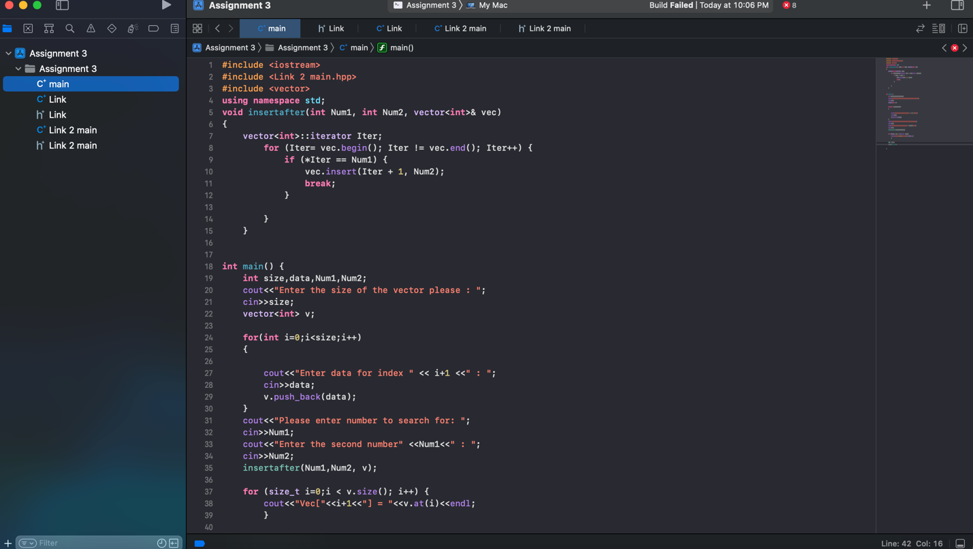

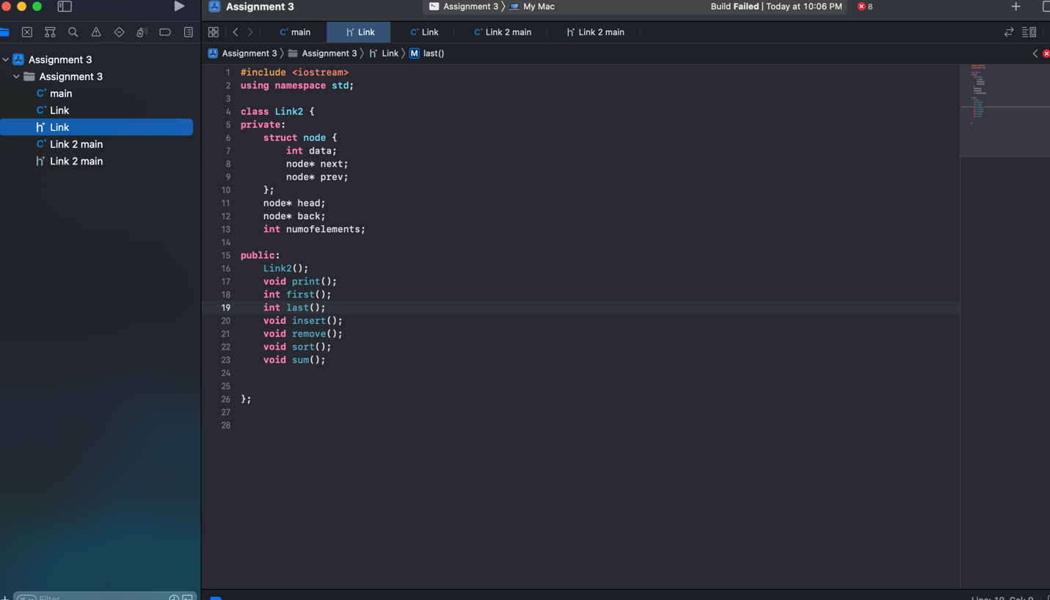

Comments:

The problem is in the #including the h file, one of the classes; however, everything else is good.