DENSO-LMS ENGINEERING DOCUMENTATION | DOC-BE-01
Dokumentasi Backend API (Backend-LMS-Admin-Teacher)
Arsitektur Server Express 5, Keamanan, 86 Endpoint API, Workflow Persetujuan Materi, Antrean Job AES-256-GCM, SSE & Dual-DB Sync
Runtime & Framework | Node.js + Express 5 (server.js), Port default :3001
Basis Data | SQL Server DX_LMS_AdminTeacher (node-mssql, 18 tabel) + MySQL 8+ dls_student (mysql2/promise, 12 tabel)
Cakupan API | 86 Endpoint Express (/api/v1/* + /health) di 13 file router (src/routes/*.js)
Referensi Uji | postman/DENSO-LMS-Backend.postman_collection.json & postman/DENSO-LMS-Local.postman_environment.json
Sumber Diagram | docs/uml/04..08-*.drawio & docs/uml/DENSO-LMS-Complete-Diagrams.drawio

1. Ringkasan Arsitektur & Struktur Kode
Layanan Backend-LMS-Admin-Teacher bertindak sebagai API gateway utama bagi portal Admin & Teacher (React PWA :5173), portal Reviewer eksternal (/review/:token), serta titik integrasi SSO, Forum, dan Notifikasi SSE bagi portal NATIVE-LMS-Student (:8082). Seluruh basis kode disusun modular dalam 41 berkas di direktori src/:
Lapisan / Direktori | Berkas Utama | Tanggung Jawab Teknis
Entry & Config (src/) | server.js, config/database.js, config/env.js | Inisialisasi Express 5, Helmet, CORS credentials, connection pool mssql & mysql2, shutdown hook.
Middleware (src/middleware/) | auth.js, errors.js, rate-limit.js, pagination.js, material-upload.js, forum-upload.js | Validasi JWT/cookie dls_sso, guard peran, pembatasan laju 4 tingkat, unggah 250MB + magic-bytes inspector, pagination.
Routers (src/routes/) | 13 berkas router (auth, dashboard, courses, material-workflow, quizzes, enrollments, grades, users, reviewers, forum, notifications, jobs, settings) | Validasi payload Zod .strict(), pengecekan origin staf/penulisan, orkestrasi 86 endpoint /api/v1/*.
Services (src/services/) | 19 berkas layanan domain & worker (auth, student-auth, student-sync, quiz-store, course-enrollments, admin-jobs, dll.) | Logika otentikasi dual-DB, aturan workflow materi, worker antrean terenkripsi, outbox email, SSE emitters.

2. Keamanan, Validasi Unggahan & Rate Limiting
• **Helmet & CORS Terikat Origin:** Menggunakan helmet() dengan crossOriginResourcePolicy: cross-origin serta CORS ber-kredensial yang dikunci ke FRONTEND_ORIGIN dan STUDENT_APP_URL.
• **Otentikasi Ganda & Cookie SSO:** authenticate() membaca header Authorization: Bearer <token> dengan fallback cookie HttpOnly dls_sso (HS256, issuer denso-lms-api, audience denso-lms-clients). Endpoint khusus seperti POST /enrollments/recommendations, /grades, /notifications, /quizzes, dan /auth/*mode mewajibkan guard trustedWriteOrigin / trustedStaffOrigin.
• **Rate Limit 4 Tingkat (middleware/rate-limit.js):** apiLimiter (300 req / 1 mnt), writeLimiter (90 req / 15 mnt untuk non-GET), loginLimiter (8 req / 15 mnt pada /auth/login), uploadLimiter (20 req / 15 mnt), serta limiter khusus forum (forumUploadLimiter) dan notifikasi (sendLimiter).
• **Inspeksi Berkas Magic-Bytes:** materialUpload membatasi berkas hingga 250 MB (pdf, mp4, mp3, png, jpg, webp, dokumen Office); forumImageUpload membatasi gambar diskusi hingga 5 MB dan memprosesnya melalui sharp (forum-image.js).
3. Katalog Endpoint API (13 Domain Router)
Domain & Prefix | Jml | Akses Role | Daftar Endpoint Utama
Health (/health) | 1 | Publik | GET /health
Auth (/api/v1/auth) | 6 | Publik / Auth | POST /login, POST /student-mode (teacher), POST /teacher-mode (student shadow), GET /me, PUT /profile, POST /logout
Dashboard (/api/v1/dashboard) | 4 | Admin, Teacher | GET /summary, GET /courses, GET /activity/events (SSE), GET /activity
Courses (/api/v1/courses) | 7 | Admin, Teacher | GET /, POST /, PUT /:id/trainer (admin), GET /:id/sessions, GET /:id/detail, POST /:id/sessions, POST /sessions/:sessionId/materials (410 deprecated)
Material Workflow (/api/v1/material-workflow) | 18 | Admin, Teacher, Reviewer, Student | GET /reviewers, /trainers, POST /sessions/:id/submissions, GET|PUT|DELETE /submissions/:id, /admin-reject, /send-review, POST /links/:token/consume, GET|POST /reviewer/..., POST /submissions/:id/publish, GET|DELETE /published, GET /published/:id/file
Quizzes (/api/v1/quizzes) | 5 | Admin, Teacher | GET /, GET /:courseCode, POST|PUT|DELETE /:courseCode (CRUD ke MySQL course_quizzes & course_quiz_questions)
Enrollments (/api/v1/enrollments) | 4 | Admin, Teacher | GET /options (teacher), GET /requests, POST /recommendations (teacher), POST /:requestId/decision (admin approve/reject)
Grades (/api/v1/grades) | 4 | Admin, Teacher | GET / (read snapshot), PATCH /:npk/:courseCode, DELETE /:npk/:courseCode (admin reset), POST /:npk/:courseCode/notify
Users (/api/v1/users) | 4 | Admin, Teacher | GET /, POST / (admin), PUT /:npk, DELETE /:npk (Teacher hanya mengelola Student)
Reviewers (/api/v1/reviewers) | 4 | Admin | GET /, POST /, PUT /:npk, DELETE /:npk (terkunci jika masih punya review aktif)
Forum (/api/v1/forum) | 12 | Admin, Teacher, Student | GET /events (SSE), GET /management/courses|threads, PATCH /management/sessions/:c/:s, POST /management/threads, GET|POST /courses/:c/sessions/:s..., GET /threads/:id, POST /threads/:id/replies, PATCH /:id/status, POST /likes, GET /uploads/:filename
Notifications (/api/v1/notifications) | 6 | Admin, Teacher, Student | GET /unread-count, GET /events (SSE), GET /, POST / (broadcast + popup + email outbox), POST /read-all, POST /:id/read
Jobs (/api/v1/jobs) | 7 | Admin, Teacher | GET /, POST /records/delete (admin), POST /users, GET /:id/events, GET /:id/stream (SSE), POST /:id/stop, POST /:id/resume
Settings (/api/v1/settings) | 4 | Publik / Admin | GET /runtime-config, GET /api, PUT /api, POST /api/student-sync

4. Layanan Inti, Antrean Job, SSE & Dual-DB Sync
• **Workflow Materi 5 Status (material-workflow-rules.js):** Status pending_admin mengunci edit Teacher (Admin masih dapat mengedit); pending_review mengunci keduanya; rejected membuka kembali izin PUT untuk revisi; approved menunggu Admin memanggil POST /submissions/:id/publish yang menjalankan transaksi penulisan dbo.course_materials dan memicu syncStudentNow().
• **Magic-Link Portal Reviewer (review-mail.js):** Undangan review membuat token acak yang disimpan sebagai hash **SHA-256** (dbo.material_review_links) dengan TTL kedaluwarsa serta status single-use (used_at). Konsumsi link menukar token menjadi JWT ber-scope reviewer_portal berdurasi 2 jam.
• **Antrean Job Terenkripsi AES-256-GCM (admin-jobs.js):** Item massal (impor/buat pengguna via user-job-handler.js dan penghapusan masal via record-delete-job-handler.js) dienkripsi memakai kunci SHA256(JWT_SECRET) (payload_ciphertext, iv, tag). Pekerjaan berjalan satu item per siklus sehingga perintah stop aman di batas item dan resume melanjutkan sisa payload terenkripsi tanpa duplikasi.
• **Kanal SSE & Outbox Email (notification-mail.js, account-mail.js):** Server menyediakan 4 stream SSE (dashboard/activity/events, forum/events, notifications/events, jobs/:id/stream) dengan batas 2-3 koneksi per pengguna. Pengiriman email notifikasi diantrekan pada dbo.lms_notification_email_outbox dengan mekanisme retry via Nodemailer SMTP.
• **Jembatan Sinkronisasi Dual-DB (student-sync.js):** syncOnce() mereplikasi courses, course_sessions, dan course_materials (mengubah file_path menjadi URL stream /material-workflow/published/:id/file dan menonaktifkan materi terhapus lewat is_active = 0) ke MySQL, sekaligus melakukan reverse-sync progres belajar, status enrollment, dan quiz_score dari MySQL ke dbo.student_progress_snapshots.
5. Diagram UML Backend-LMS-Admin-Teacher
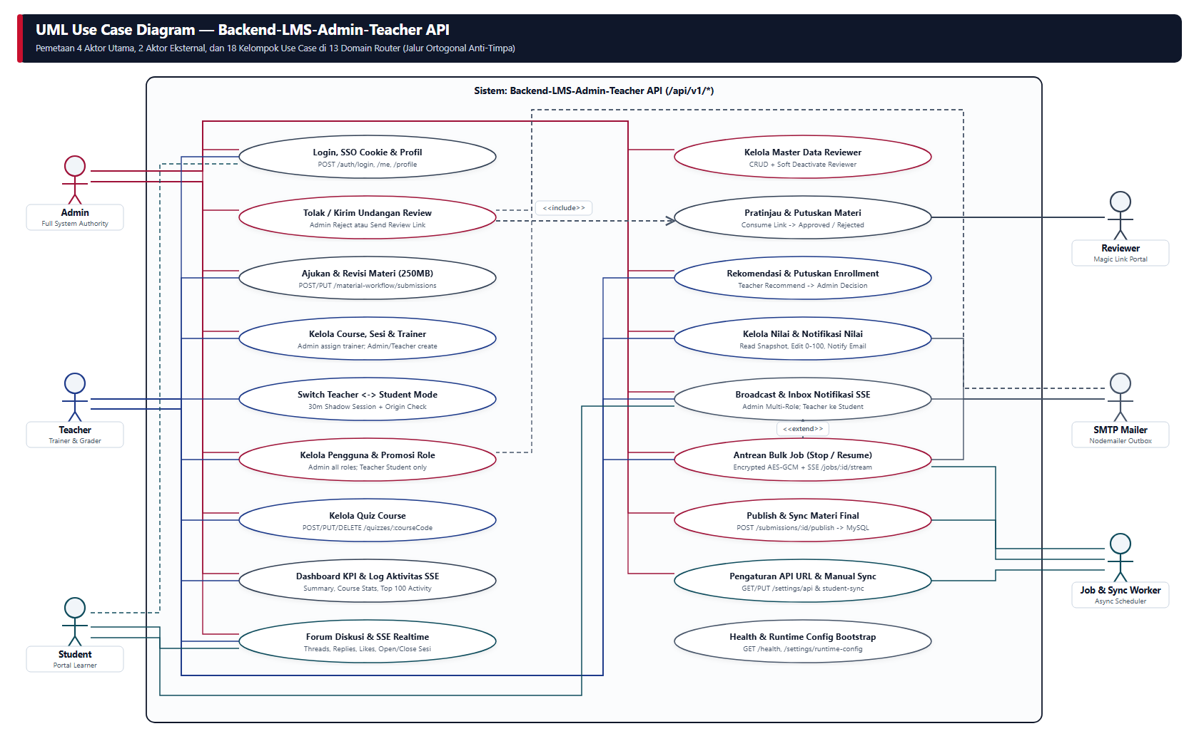
Gambar 1. UML Use Case Diagram Backend-LMS-Admin-Teacher (6 Aktor & 18 Kelompok Use Case) | Sumber Draw.io: docs/uml/04-backend-usecase.drawio
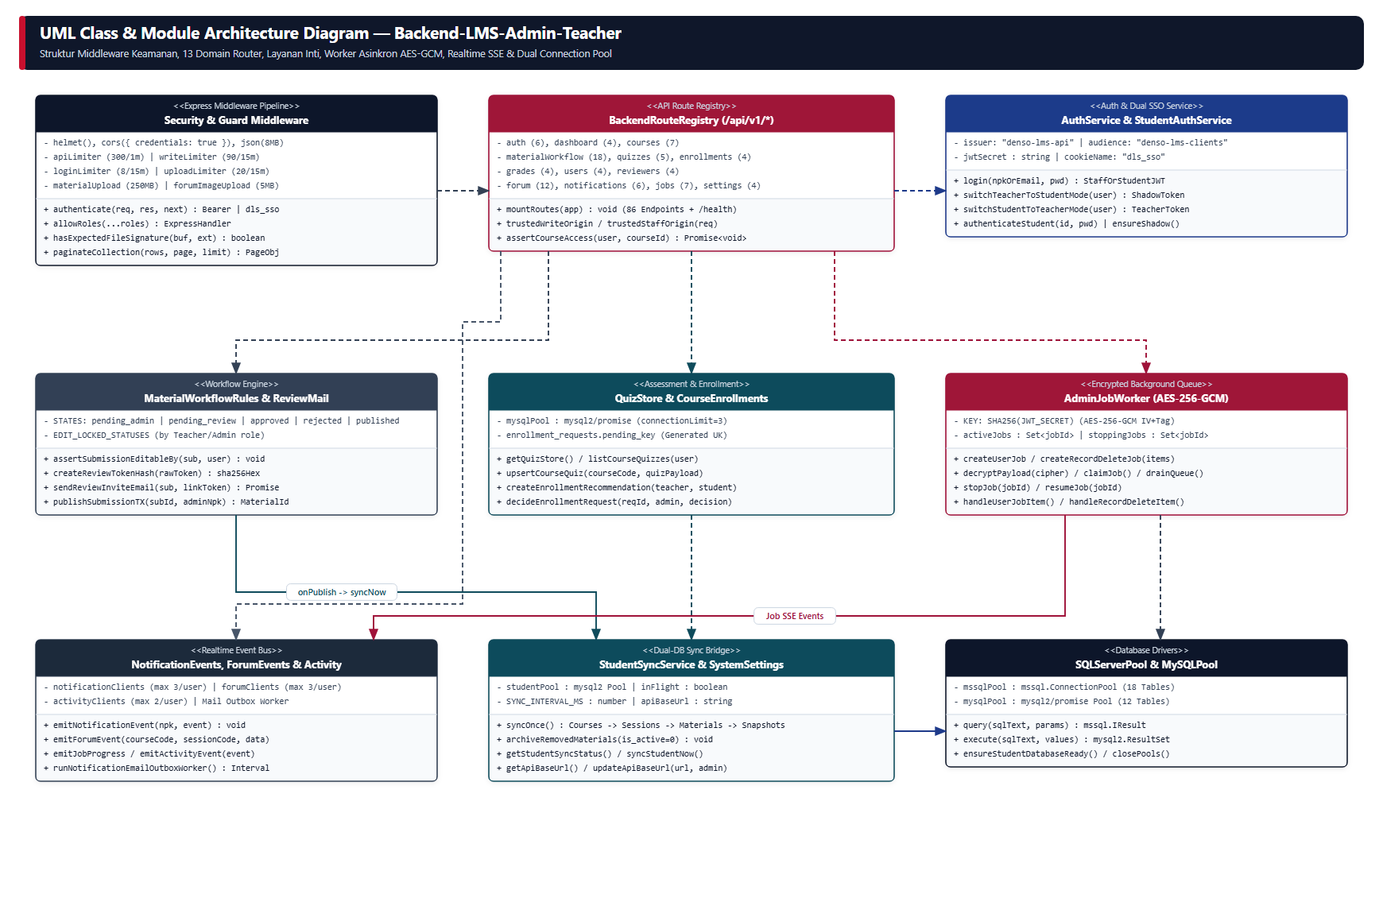
Gambar 2. UML Class & Module Architecture Backend Express 5 | Sumber Draw.io: docs/uml/05-backend-class-diagram.drawio
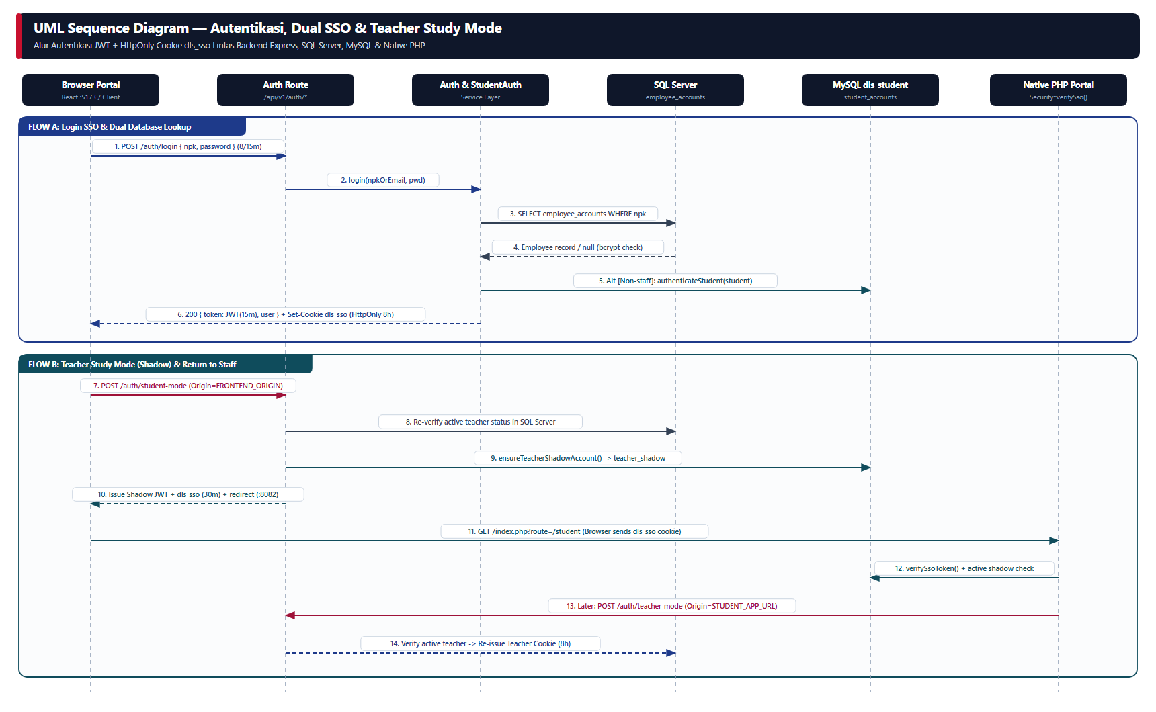
Gambar 3. UML Sequence Autentikasi Dual-DB, Cookie SSO dls_sso & Teacher Study Mode | Sumber Draw.io: docs/uml/06-backend-sequence-auth-sso.drawio
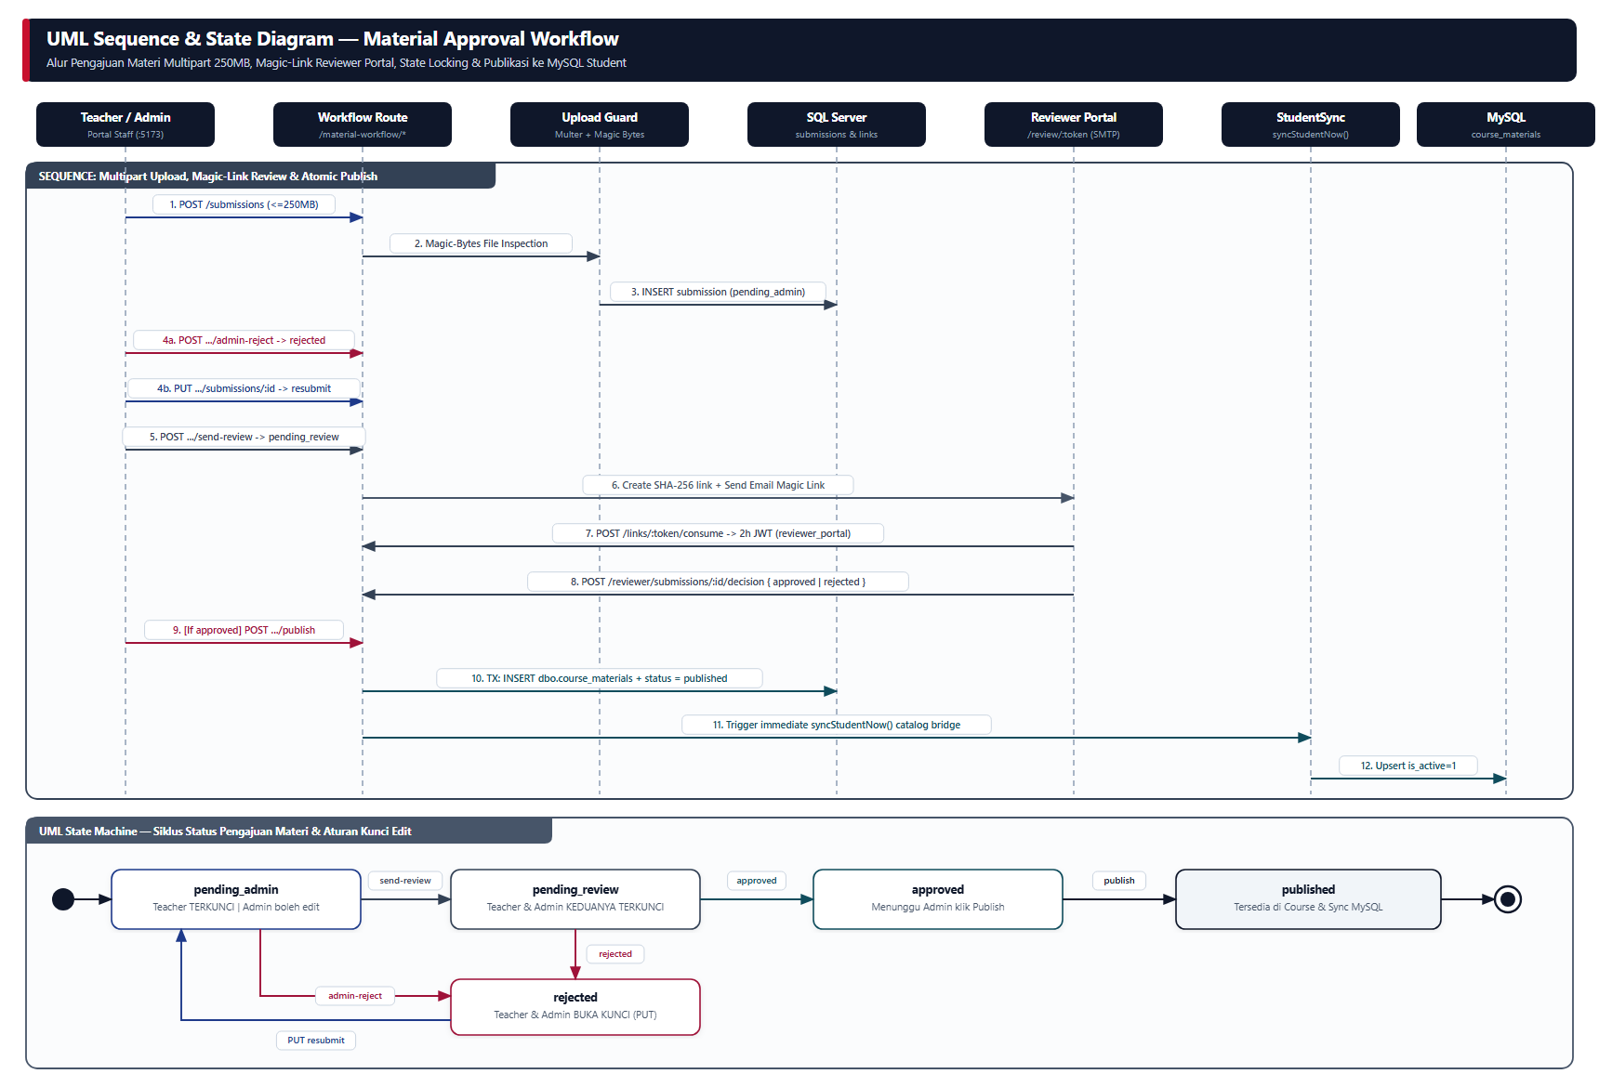
Gambar 4. UML Sequence & State Machine Workflow Pengajuan Materi 250MB | Sumber Draw.io: docs/uml/07-backend-sequence-material-workflow.drawio
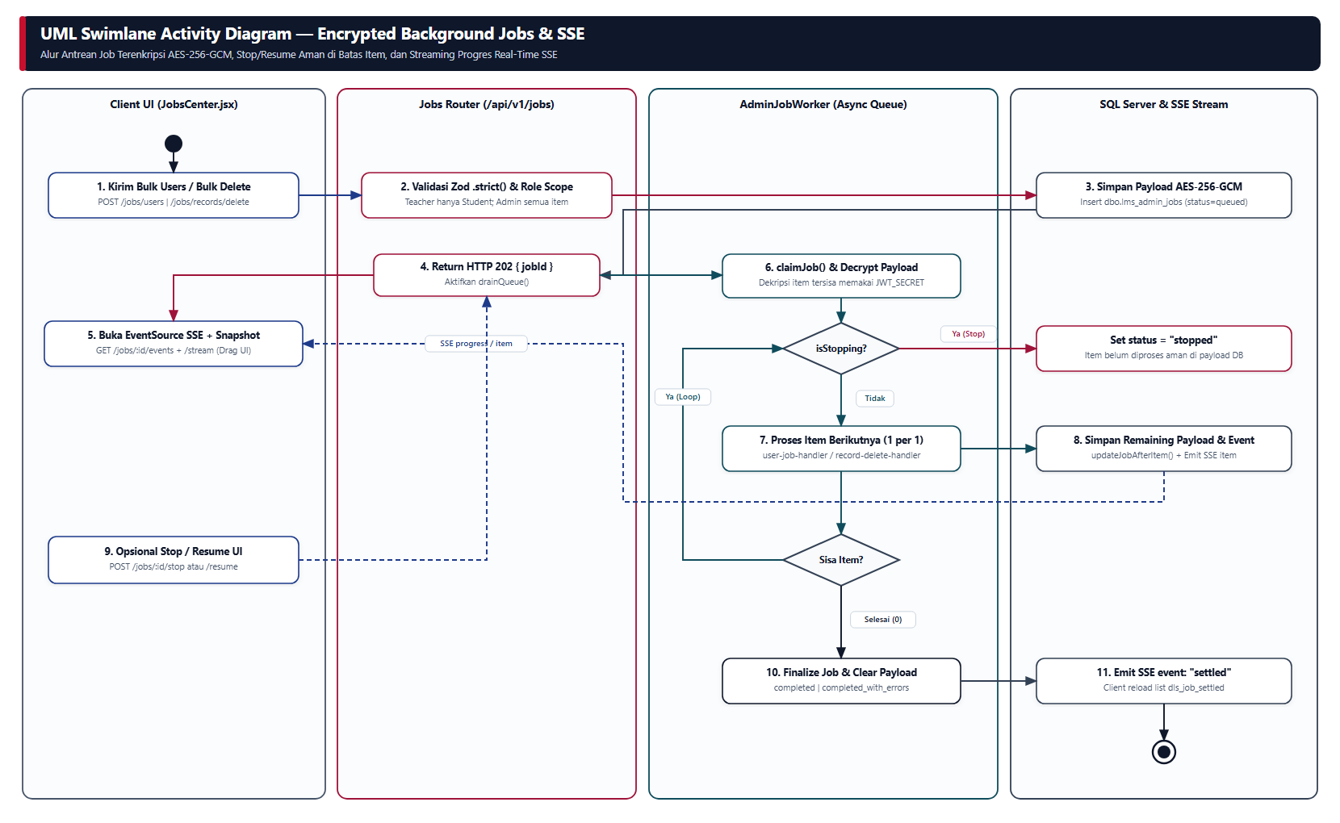
Gambar 5. UML Swimlane Activity Antrean Job Terenkripsi AES-256-GCM & SSE Streaming | Sumber Draw.io: docs/uml/08-backend-activity-jobs-sse.drawio

