DENSO-LMS ENGINEERING DOCUMENTATION | DOC-NS-03
Dokumentasi Portal Student (NATIVE-LMS-Student)
Arsitektur PHP 8+ MVC Native, Keamanan Header & CSRF, Middleware Rate Limit 180/60s, Gate Enrollment, Quiz Lock & API JSON
Runtime & Port | PHP 8+ Native MVC (index.php, api/index.php), default port lokal :8082
Basis Data Langsung | MySQL 8+ dls_student melalui PDO native prepared statements (emulate = false)
Integrasi Eksternal | Backend Express :3001 via shared cookie dls_sso (HS256), Forum API, Notifikasi SSE & Teacher Mode Switch
Struktur Kode | 15 Controller (Auth + 14 Student), 20 View Templates, 4 Core classes, 6 includes, 5 UI components, 7 file uji
Sumber Diagram | docs/uml/09..11-*.drawio & docs/uml/DENSO-LMS-Complete-Diagrams.drawio

1. Arsitektur Core, Keamanan & Middleware (`index.php`, `Core/`, `includes/`)
NATIVE-LMS-Student dibangun menggunakan pola MVC ringan tanpa framework berat untuk menjamin latensi rendah, kontrol penuh atas query PDO MySQL, dan keamanan eksekusi berbasis allowlist:
Komponen | Berkas | Mekanisme & Spesifikasi Teknis
Front Controller | index.php, public/router.php | Menyetel timezone Asia/Jakarta, header keamanan ketat (Content-Security-Policy, HSTS, X-Frame-Options: DENY), dan meneruskan eksekusi ke middleware + router.
Middleware & Rate Limit | Core/DX_LMS_M_Request_Middleware.php | Memeriksa batas permintaan sesi (180 request dalam jendela 60 detik via enforceSessionRateLimit()) sebelum routing.
Router & Route Catalog | Core/DX_LMS_M_Router.php, Core/DX_LMS_M_Route_Catalog.php | Memetakan tepat **17 rute Student terotentikasi** serta rute Auth (/login, /logout, /teacher-mode).
Base Controller | Core/DX_LMS_M_Controller.php | Memuat view melalui regex allowlist aman (findViewFile()) di 12 folder modul untuk mencegah path traversal.
Security & DB | includes/Security.php, includes/Database.php, includes/Config.php | Session strict mode, generasi/verifikasi token **CSRF** di setiap POST form, dekode token SSO verifySsoToken() & validasi akun aktif ssoStudentAccountState() (termasuk akun teacher_shadow 30 menit).

2. Peta Rute, Controller (`15`) & View (`20`)
Rute URL (`?route=...`) | Controller & Method | Template View (`Views/`)
/login, /logout, /teacher-mode | Auth/DX_LMS_M_Auth (login, processLogin, logout, teacherMode) | Auth/DX_LMS_M_Auth_Login.php, Logout_Confirm.php
/student | Dashboard/DX_LMS_T_Student_Dashboard@index | Student/Dashboard/DX_LMS_T_Student_Dashboard.php
/student/courses | Courses/DX_LMS_M_Student_Course@index | Student/Courses/DX_LMS_M_Student_Course.php
/student/courses/filters | Courses/DX_LMS_M_Student_Filters@index | Student/Courses/DX_LMS_M_Student_Filters.php
/student/course/detail | Courses/DX_LMS_M_Student_Course_Detail@index | Course_Detail.php atau **Course_Access.php** (gate terkunci)
/student/learning | Learning/DX_LMS_T_Student_Learning@index | Student/Learning/DX_LMS_T_Student_Learning.php
/student/quiz | Learning/DX_LMS_T_Student_Quiz@index | Student/Learning/DX_LMS_T_Student_Quiz.php
/student/nilai | Grades/DX_LMS_T_Student_Nilai@index | Student/Grades/DX_LMS_T_Student_Nilai.php
/student/riwayat & /detail | History/DX_LMS_T_Student_Riwayat & _Detail | Student/History/DX_LMS_T_Student_Riwayat.php & _Detail.php
/student/forum/category, /new, /thread | Forum/DX_LMS_T_Student_Forum_{Category,New,Thread} | Student/Forum/DX_LMS_T_Student_Forum_{Category,New,Thread}.php
/student/notifikasi | Notifications/DX_LMS_T_Student_Notifikasi@index | Student/Notifications/DX_LMS_T_Student_Notifikasi.php
/student/profil, /detail, /pengaturan, /bantuan | Profile/DX_LMS_M_Student_Profil (index, detail, pengaturan, bantuan) | Student/Profile/DX_LMS_M_Student_Profil*.php (4 template)

3. Alur Bisnis Kritis, Live->Demo Model & JSON API
• **Adapter Model Live -> Demo (Models/Student/DX_LMS_M_Student_Data.php & includes/StudentApi.php):** Seluruh metrik kursus, statistik dashboard, dan nilai memprioritaskan query PDO live MySQL melalui StudentApi.php dan baru memakai dataset demo terstruktur bila catatan belum tersedia atau mode demo diaktifkan.
• **Server-Side Access Gate (publishedStudentCourse()):** Ketika Student membuka /student/course/detail, /learning, atau /quiz pada kursus yang belum berstatus active di course_enrollments, controller langsung menolak materi/ujian dan menampilkan DX_LMS_M_Student_Course_Access.php untuk pengajuan akses ber-CSRF (apiRequestStudentCourseAccess() ke course_enrollment_requests).
• **Pelacakan Progres & Kunci Ujian Tunggal:** Penandaan materi selesai (apiCompleteStudentMaterial()) melakukan upsert ke material_progress dan menghitung ulang persentase course_enrollments.progress. Halaman /student/quiz hanya membuka soal setelah semua materi aktif selesai dan belum ada baris pada course_quiz_attempts. Pengiriman jawaban dinilai di server dalam transaksi tunggal lalu menyetel course_enrollments.quiz_score secara permanen (kunci 1x).
• **Navigasi Bersama, Sidebar Search & Teacher Banner:** includes/components/DX_LMS_M_Header.php menampilkan tombol cepat *Kembali ke Portal Teacher* bagi sesi teacher_shadow serta badge notifikasi SSE; DX_LMS_M_Student_Bottom_Nav.php menyediakan pencarian menu sidebar konsisten + indikator tanggal hari/bulan/tahun berjalan pada sidebar.
• **API JSON Read-Only Same-Origin (api/index.php):** Menyediakan 3 resource GET ber-paginasi (Pagination.php): ?resource=me, ?resource=dashboard, dan ?resource=courses yang dilindungi session login/SSO Student.
• **Suite Pengujian Otomatis (tests/):** Mencakup runner tests/run.php beserta skenario test.feature.routes.php dan 5 uji keamanan (csrf-session, output, pagination, router, sso).
4. Diagram UML NATIVE-LMS-Student
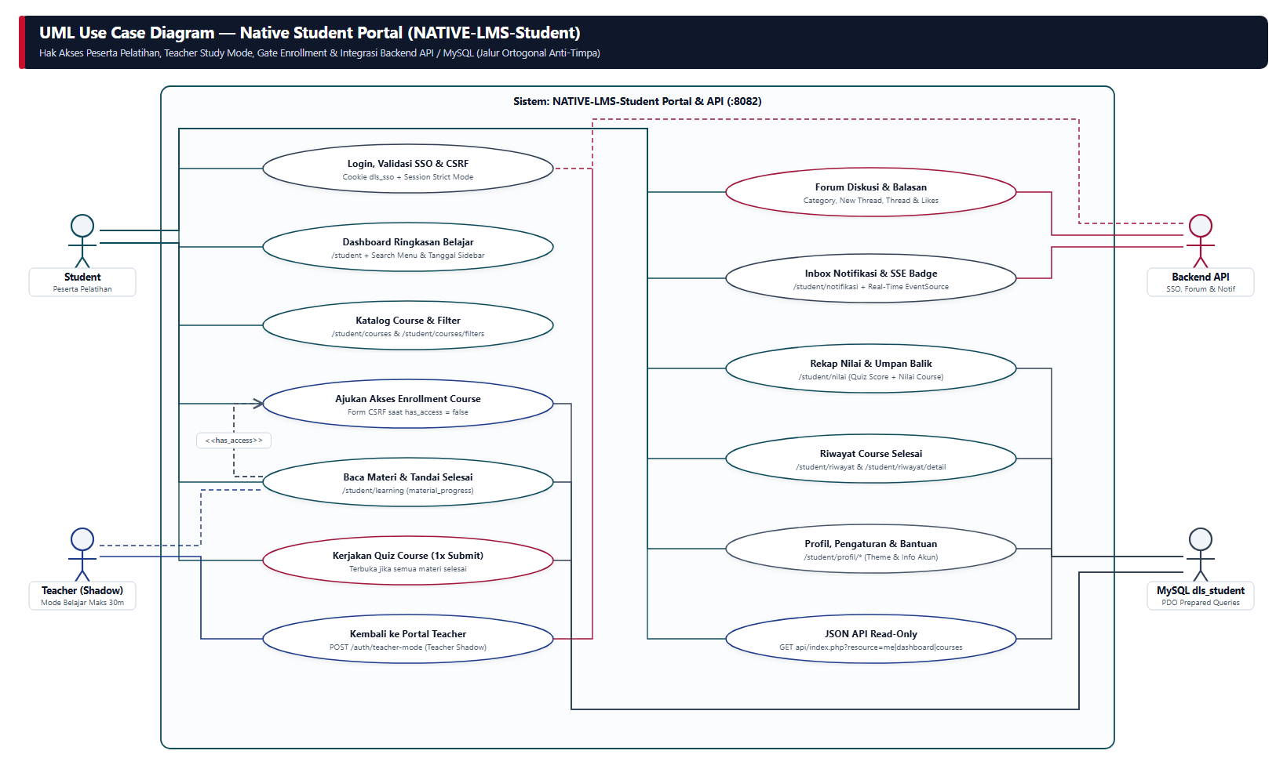
Gambar 1. UML Use Case Portal Student & Integrasi Backend API / MySQL | Sumber Draw.io: docs/uml/09-student-usecase.drawio
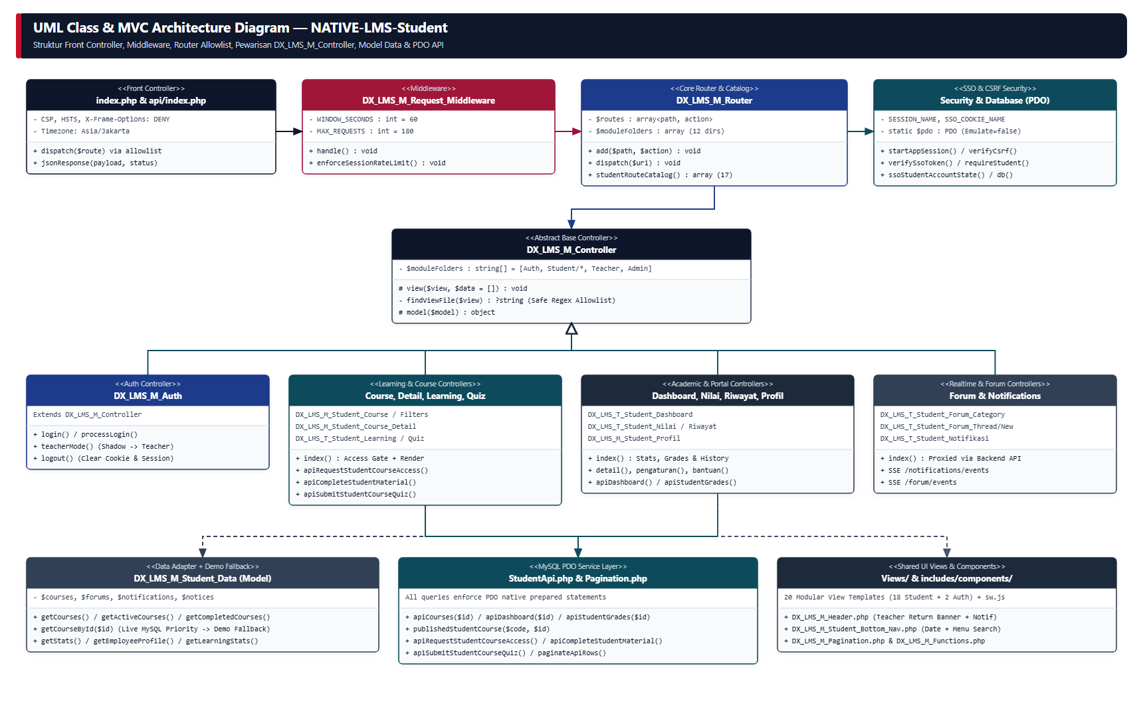
Gambar 2. UML Class & Arsitektur MVC NATIVE-LMS-Student | Sumber Draw.io: docs/uml/10-student-class-mvc.drawio
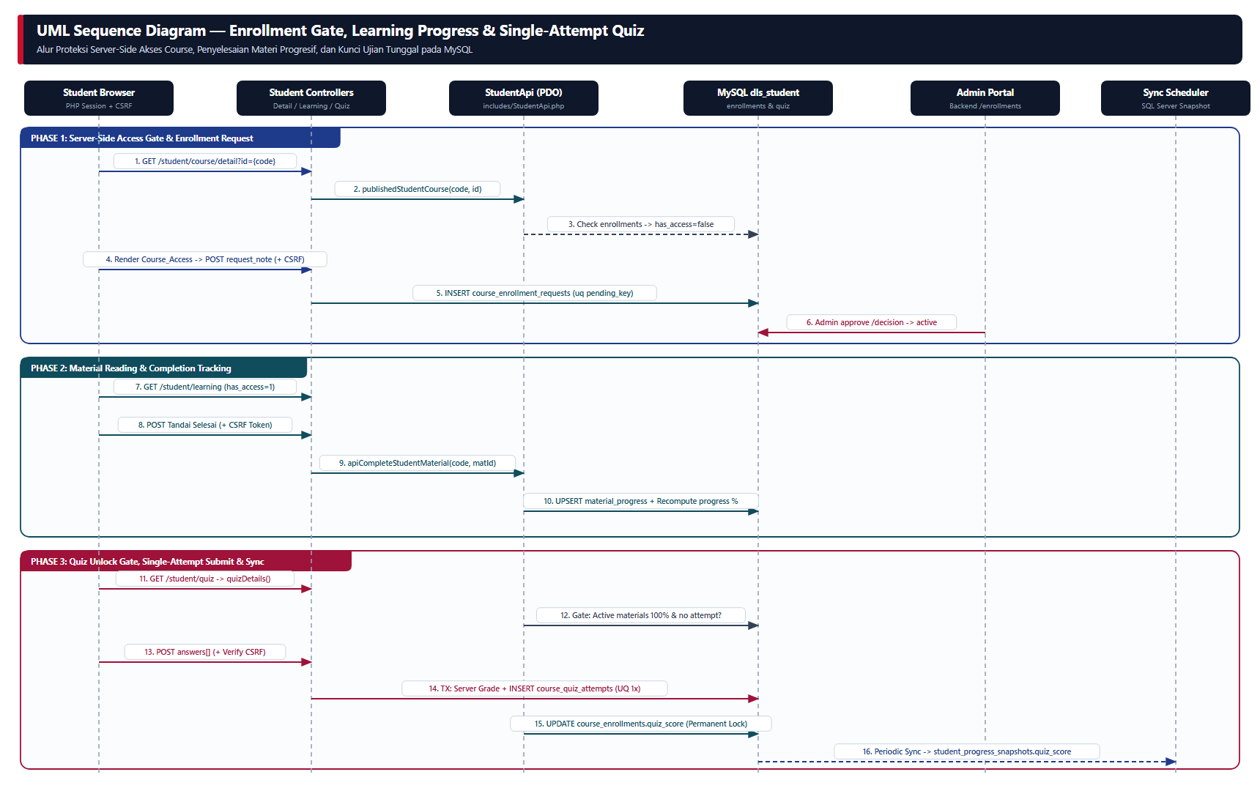
Gambar 3. UML Sequence Enrollment Gate, Material Tracking & Kunci Quiz Tunggal | Sumber Draw.io: docs/uml/11-student-sequence-learning-quiz.drawio

