DENSO-LMS ENGINEERING DOCUMENTATION | DOC-SDD-04
Software Design Document (SDD) & Dual-Database ERD DENSO-LMS
Spesifikasi Arsitektur 3-Tier, Batas Kepercayaan, Alur Data Lintas Modul & Skema Lengkap 18 Tabel SQL Server + 12 Tabel MySQL 8+
Sistem | DENSO-LMS Terpadu (Backend-LMS-Admin-Teacher, Frontend-LMS-Admin-Teacher, NATIVE-LMS-Student)
Database Utama | SQL Server DX_LMS_AdminTeacher — **18 Tabel Domain** (23 skrip migrasi 2026_10_25_000001..23)
Database Student | MySQL 8+ dls_student — **12 Tabel Domain** (17 skrip migrasi 2026_10_25_000001..17)
Protokol Integrasi | REST API (/api/v1/*), SSE EventStreams (4 kanal), Shared JWT Cookie dls_sso, Periodic Dual-DB Sync
Sumber Diagram | docs/uml/01-sdd-system-architecture.drawio, 02-sdd-dataflow-integration.drawio, 03-erd-dual-database.drawio

1. Software Design Document (SDD): Konteks, Arsitektur & Batas Kepercayaan
Dokumen Desain Perangkat Lunak (SDD) ini menetapkan pemisahan beban kerja antara manajemen konten/tata kelola staf (SQL Server + Express + React) dan eksekusi belajar bervolume tinggi bagi peserta pelatihan (MySQL 8+ + Native PHP) tanpa mengekspos kredensial basis data internal ke klien:
• **Tier 1 — Client Portals & Browser Boundary:** Tiga antarmuka web independen (React PWA :5173, Portal Reviewer /review/:token, Native Student PHP :8082) dilengkapi PWA Service Worker yang secara eksplisit melarang caching payload /api/, /uploads/, SSE, dan token otentikasi.
• **Tier 2 — Application Servers & Security Perimeter:** Express Gateway menerapkan Helmet, CORS berbasis whitelist origin, pembatasan laju berlapis (300/m umum, 90/15m tulis, 8/15m login, 20/15m upload), inspeksi magic-bytes berkas, serta validasi Zod .strict(). Native PHP menjalankan firewall sesi 180 req/60 detik, header anti-clickjacking X-Frame-Options: DENY, dan CSRF token di semua mutasi.
• **Trust Boundary SSO & Shadow Account:** Otentikasi lintas portal memakai signed JWT HS256 dalam cookie HttpOnly dls_sso. Khusus Teacher yang melakukan pratinjau belajar, Backend menerbitkan shadow account terisolasi di MySQL (account_type = 'teacher_shadow') berumur 30 menit agar histori belajar siswa asli tidak tercampur.
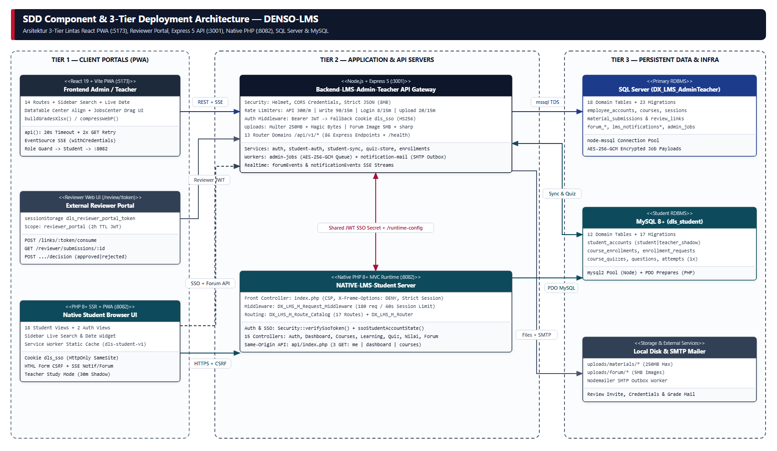
Gambar 1. Arsitektur 3-Tier Deployment & Komponen DENSO-LMS | Sumber Draw.io: docs/uml/01-sdd-system-architecture.drawio
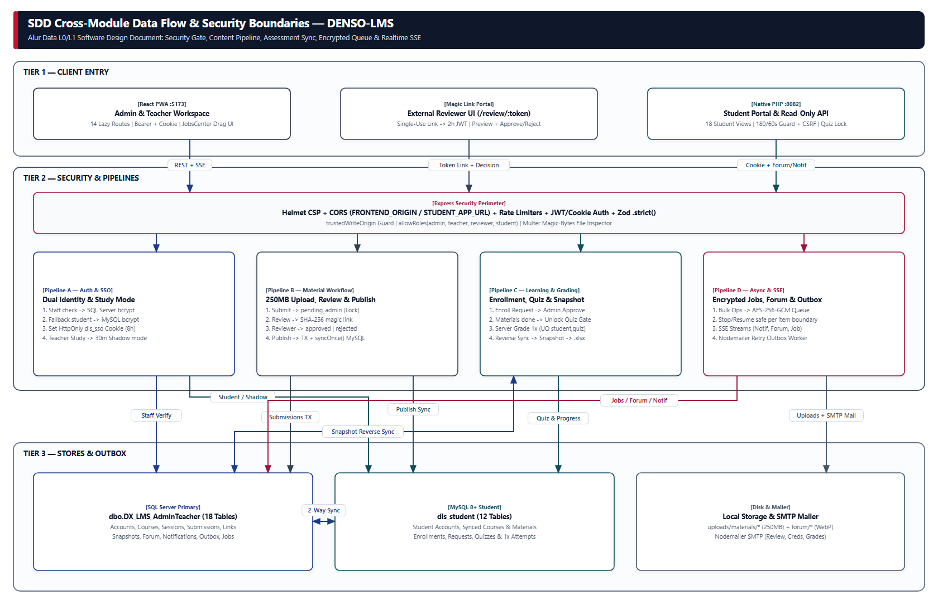
Gambar 2. SDD Alur Data Lintas Subsistem (Auth, Workflow Materi, Assessment & Async Queue) | Sumber Draw.io: docs/uml/02-sdd-dataflow-integration.drawio
2. Entity Relationship Diagram (ERD) — SQL Server (`DX_LMS_AdminTeacher`, 18 Tabel)
Seluruh skema SQL Server dikelola secara idempoten melalui **23 file migrasi** (database/migrations/sqlserver/2026_10_25_000001..23) dan tabel kendali schema_migrations:
Tabel Domain (`dbo.*`) | Kunci Utama & Relasi Kritis | Fungsi Bisnis Utama
employee_accounts | PK employee_npk, UK email | Master akun Admin, Teacher, Reviewer & Student staf (termasuk dept, jabatan, status aktif).
courses | PK course_id, UK course_code, FK created_by, FK assigned_trainer_npk | Katalog kursus induk & penugasan trainer oleh Admin.
course_sessions | PK session_id, FK course_id | Struktur sesi/bab terurut (sort_order) per kursus.
course_materials | PK material_id, FK session_id | Materi final terpublikasi lintas 7 format (text|video|pdf|image|document|audio|link).
material_submissions | PK submission_id, FK session_id, FK submitted_by | Antrean pengajuan & revisi materi (pending_admin|pending_review|rejected|approved|published).
material_review_links | PK link_id, FK submission_id, FK reviewer_npk | Tautan review sekali pakai ber-hash **SHA-256** (token_hash, expires_at, used_at).
student_progress_snapshots | PK snapshot_id, UK (student_npk, course_code) | Snapshot progres belajar, status kelulusan, quiz_score, nilai akhir 0..100, feedback & penilai.
activity_logs | PK activity_id, FK employee_npk | Jejak audit terpadu aksi sistem & dashboard feed.
forum_threads, forum_replies, forum_likes, forum_session_settings | FK course_code, UQ likes (target_type, target_id, npk) | Forum diskusi per kursus/sesi, status moderasi, lampiran gambar terkompresi, & kunci buka/tutup sesi.
lms_notifications & lms_notification_reads | PK notification_id, reads (notification_id, npk) | Pengumuman peran/targeted, prioritas, flag modal show_popup, & status baca per NPK.
lms_notification_email_outbox | PK outbox_id, FK notification_id | Antrean pengiriman email asinkron beserta jumlah percobaan & pesan galat terakhir.
lms_admin_jobs & lms_admin_job_events | PK job_id, FK event (job_id, item_no) | Antrean bulk user & bulk delete terenkripsi **AES-256-GCM** (payload_ciphertext, iv, tag) + event log per item.
lms_system_settings | PK setting_key | Penyimpanan konfigurasi runtime dinamis termasuk URL dasar API aktif.

3. Entity Relationship Diagram (ERD) — MySQL 8+ (`dls_student`, 12 Tabel)
Seluruh skema MySQL dikelola oleh **17 file migrasi** (database/migrations/mysql/2026_10_25_000001..17) beserta schema_migrations:
Tabel Domain (`dls_student`) | Kunci & Batasan Unik (Constraint) | Fungsi & Mekanisme Integritas
student_accounts | PK student_id, UK npk, UK email | Akun peserta pelatihan dengan account_type ENUM('student','teacher_shadow').
courses, course_sessions, course_materials | UK course_code, source_session_id, source_material_id | Replika katalog sinkron; materi terhapus di-soft-archive (is_active = 0) tanpa merusak histori belajar.
course_enrollments | PK enrollment_id, FK student_id, FK course_id | Penjaga gerbang akses kursus (active|completed), progres %, quiz_score, score, grade_feedback.
course_enrollment_requests | PK request_id, UK **pending_key** (generated col) | Menampung permintaan akses Student & rekomendasi Teacher; kolom pending_key mencegah ganda saat status pending.
material_progress | PK progress_id, UK (student_id, material_id) | Status penyelesaian membaca/menonton per materi oleh masing-masing Student.
course_quizzes | PK quiz_id, UK course_id | Satu definisi kuis per course (passing_score 0-100, status draft|published|archived).
course_quiz_questions | PK question_id, UK (quiz_id, sort_order) | Daftar soal pilihan ganda berurut beserta kunci jawaban server-side.
course_quiz_attempts | PK attempt_id, **UQ (quiz_id, student_id)** | Mengunci pengerjaan kuis **maksimal 1 kali** per peserta pada level constraint RDBMS.
activity_logs, login_rate_limits | PK activity_id | PK ip_hash CHAR(64) | Log aktivitas Student serta pencatatan batas percobaan gagal login per hash IP.

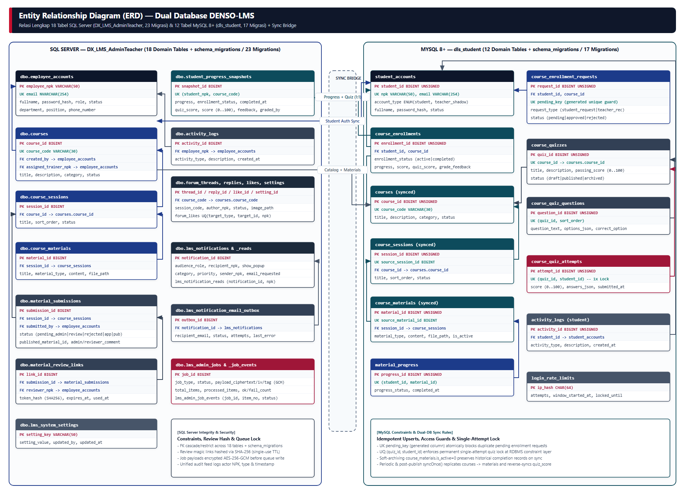
Gambar 3. Entity Relationship Diagram (ERD) Dual Database SQL Server & MySQL 8+ Beserta Jalur Sync Bridge | Sumber Draw.io: docs/uml/03-erd-dual-database.drawio
4. Strategi Migrasi Ganda & Resolusi Konflik Sync
Idempoten & Resolusi Konflik: 1) Penambahan skema baru wajib lewat file migrasi bernomor urut di kedua folder database/migrations/{sqlserver,mysql}/. 2) Arah otoritas master katalog (courses -> sessions -> materials) selalu berasal dari SQL Server ke MySQL dengan pencocokan source_session_id & source_material_id. 3) Arah otoritas aktivitas belajar (progress, enrollment_status, quiz_score) berasal dari MySQL ke dbo.student_progress_snapshots, sementara nilai akhir manual (score & grade_feedback) dapat disunting Admin/Teacher dan di-push balik ke course_enrollments.

