OPERATING SYSTEMS

ASSIGNMENT 04

# Muhammad Ammar Manzoor

**221331**

# Comparative Analysis of Android and macOS based on Operating System Concepts

## Introduction :

This report presents a comparative analysis of two major operating systems, Android (a mobile operating system) and **m**acOS (a desktop/laptop operating system). The comparison is based on key operating system concepts, including process management, memory management, file system structure, security mechanisms, and scheduling strategies. The analysis presents insights from recent research.

***ARTICLE:***  
[A Comparative Study of Operating Systems: Case of Windows, UNIX, Linux, Mac, Android and iOS](https://www.researchgate.net/profile/Adedoyin-Odumabo/publication/372400705_A_Comparative_Study_of_Operating_Systems_Case_of_Windows_UNIX_Linux_Mac_Android_and_iOS/links/64b41d62c41fb852dd7b65e1/A-Comparative-Study-of-Operating-Systems-Case-of-Windows-UNIX-Linux-Mac-Android-and-iOS.pdf)

## Process Management :

Android employs a Linux-based kernel for process management, utilizing mechanisms such as preemptive multitasking and inter-process communication (IPC) via Binder. Processes are grouped into foreground, background, and service categories to optimize resource allocation. **m**acOS, on the other hand, relies on the XNU kernel, which combines Mach and BSD elements. It supports robust multitasking and IPC methods, including Mach messages and shared memory, making it suitable for high-performance computing tasks.

## Memory Management :

Memory management in Android involves techniques such as paging and swapping, tailored to mobile devices' limited resources. The Dalvik and ART runtimes provide garbage collection, ensuring efficient memory use. **m**acOS utilizes advanced memory management features like virtual memory, dynamic memory allocation, and memory compression, enhancing performance in resource-intensive scenarios.

**Android :**

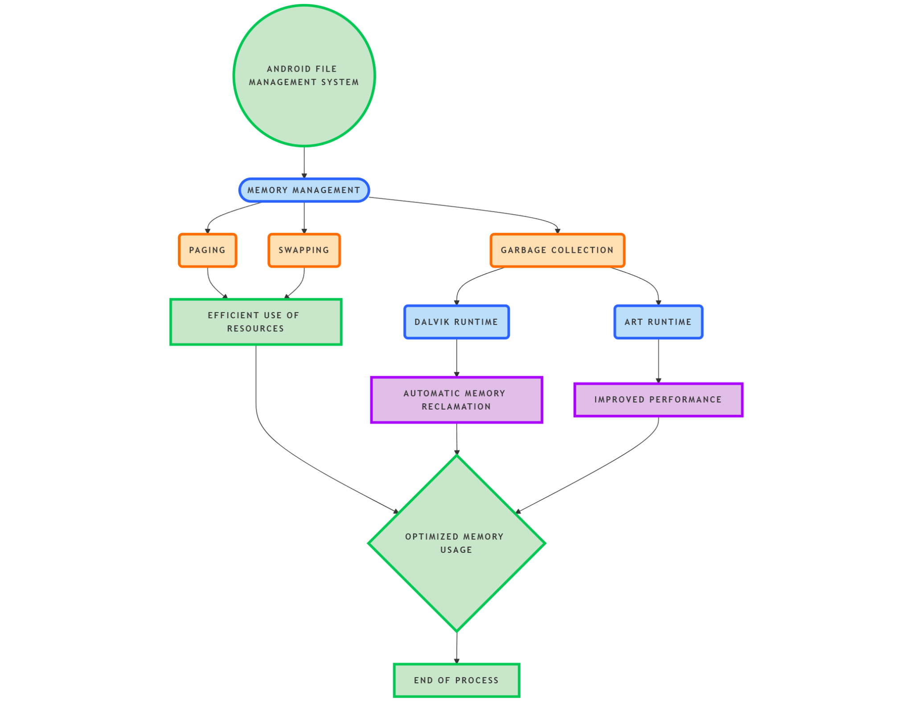

**macOS :**

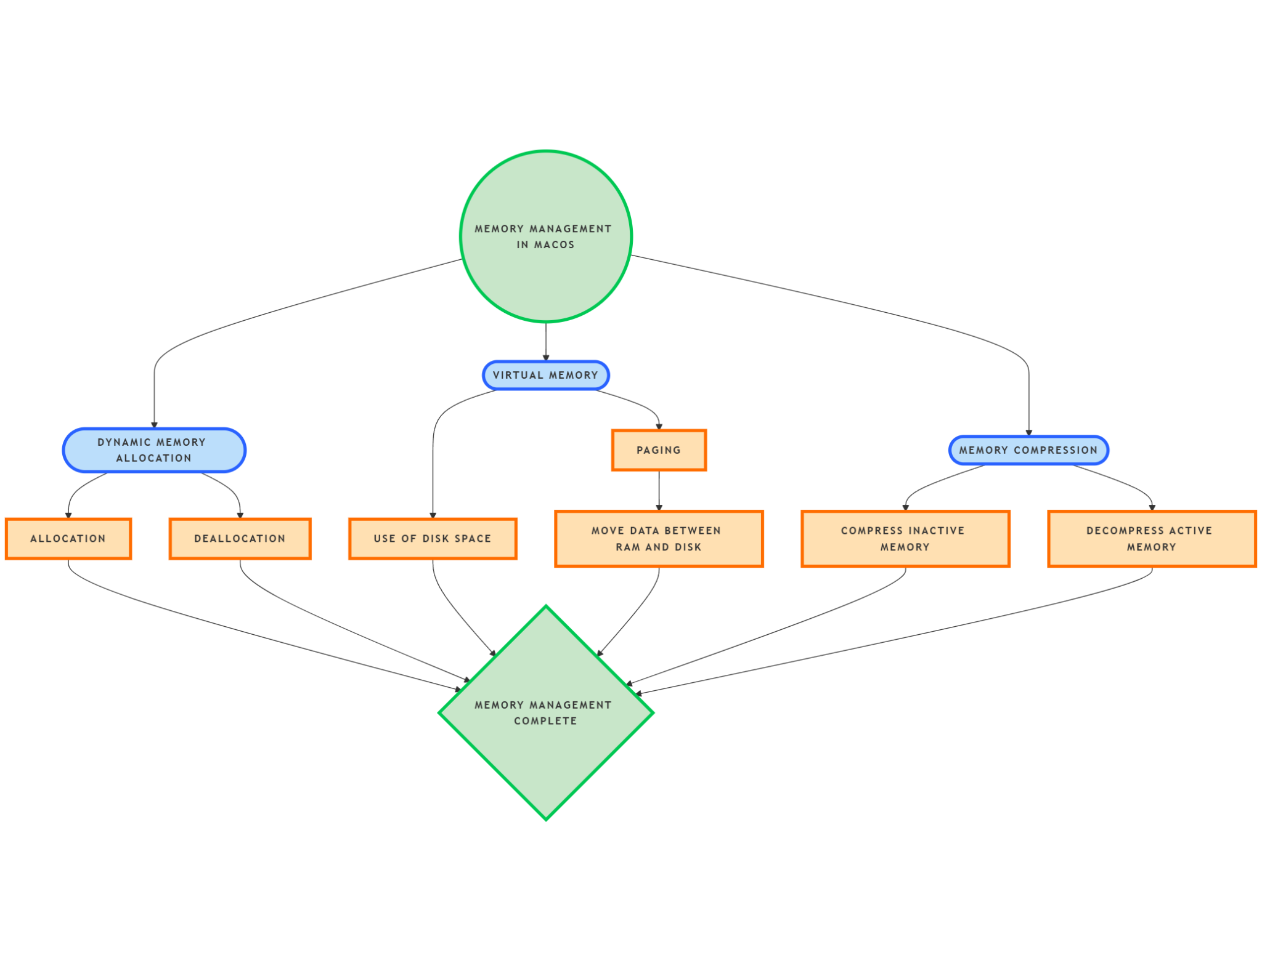

## File System :

Android typically uses the ext4 file system, designed for high reliability and performance on flash storage. It supports journaling and metadata management. **m**acOS employs APFS, a modern file system optimized for solid-state drives (SSDs). APFS provides features like snapshots, cloning, and strong encryption, offering superior performance and data integrity.

## Security :

Android emphasizes user-level security through application sandboxing, permissions, and encryption. The OS's open-source nature allows for extensive customization but also introduces security challenges. **m**acOS prioritizes system-level security, integrating features like Gatekeeper, FileVault, and secure boot. Its closed ecosystem reduces vulnerability to external threats.

## Scheduling :

Android uses the Completely Fair Scheduler (CFS) from the Linux kernel, designed for fairness and efficiency in managing diverse workloads. **m**acOS employs a hybrid scheduling algorithm, combining priority-based preemptive scheduling with real-time capabilities, ensuring responsiveness and optimal resource use.

## Conclusion :

The comparative analysis reveals that Android's design deals with the constraints and needs of mobile devices, focusing on efficiency and user-centric features. **m**acOS, in contrast, is engineered for performance and security, meeting the demands of professional and creative users. Understanding these differences can guide users and developers in choosing or optimizing an operating system for specific applications.