WallahGPT — Complete Architecture Diagrams Reference
Document Version: 1.0
Date: March 2026
Project: WallahGPT In-Silico Drug Discovery & Omics Platform
Author: ZeroKost Engineering
Status: Final
This document contains all 12 derived and advanced architecture diagrams for the WallahGPT platform, organized into two categories: - Category 2 — Implicit / Hidden Diagrams (Diagrams 7–12): Derived from the codebase structure and data flows. - Category 3 — Advanced / Marketing Diagrams (Diagrams 13–18): High-value platform positioning and reliability views.

CATEGORY 2 — IMPLICIT / HIDDEN DIAGRAMS

Diagram 7: AI Pipeline Diagram

LLM + Parser + Fallback Flow
This diagram shows the complete AI inference pipeline inside every controller (P1Controller, P2Controller, P3Controller). It maps directly to the code in controllers/p{1,2,3}_controller.py and llm/.
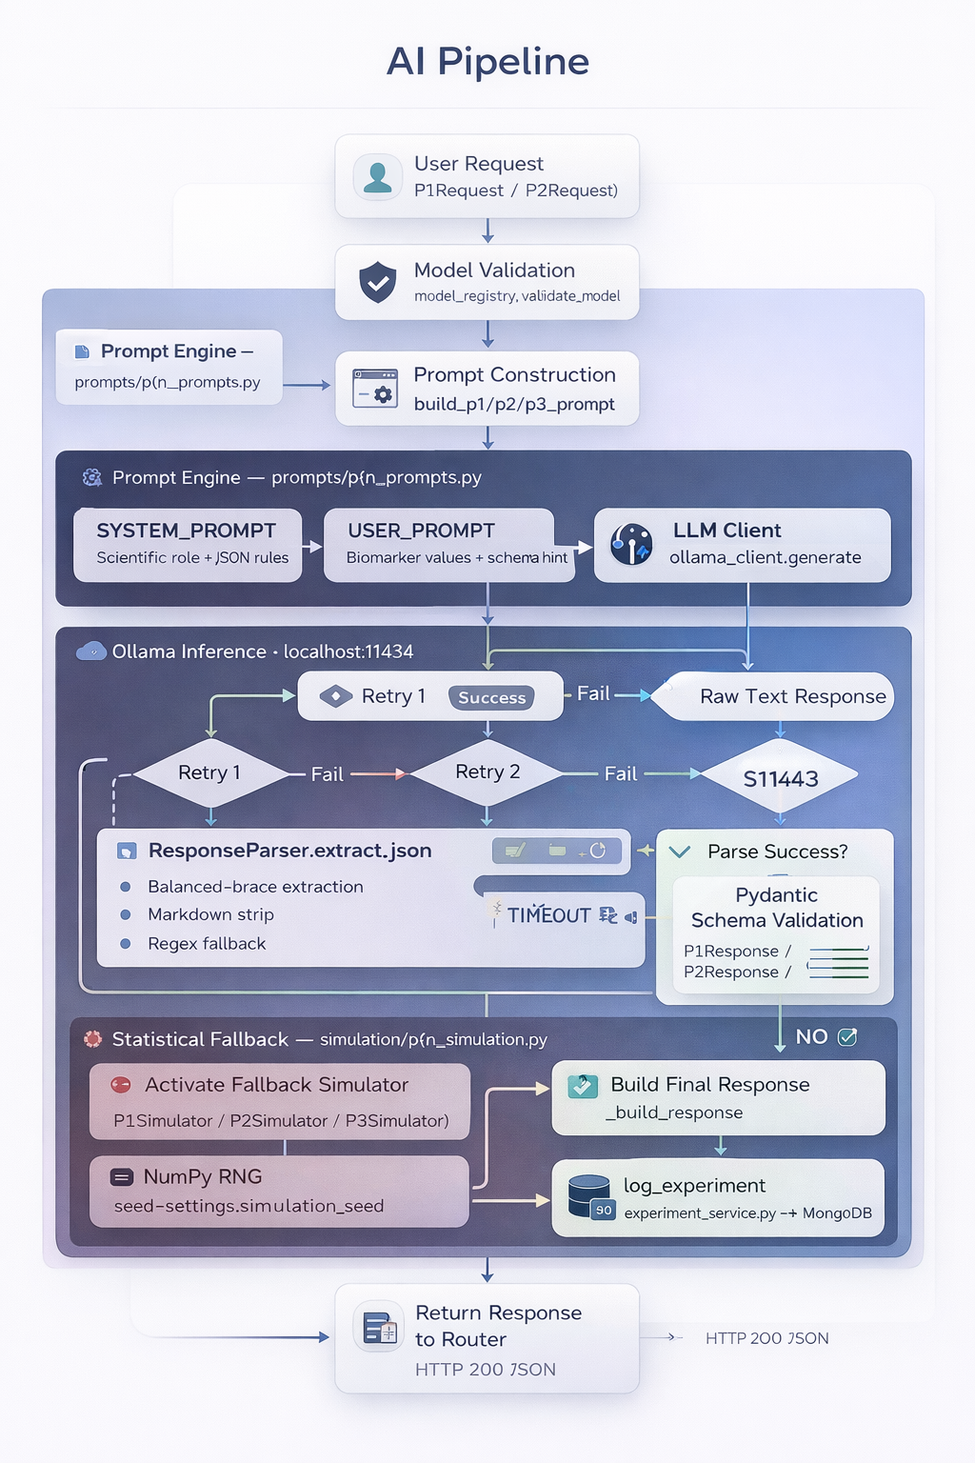

Diagram 8: Module Architecture Diagram

WallahGPT as a Three-Module System
Each module is fully independent — its own router, controller, prompt, schema, simulator, and frontend panel — yet shares common infrastructure.
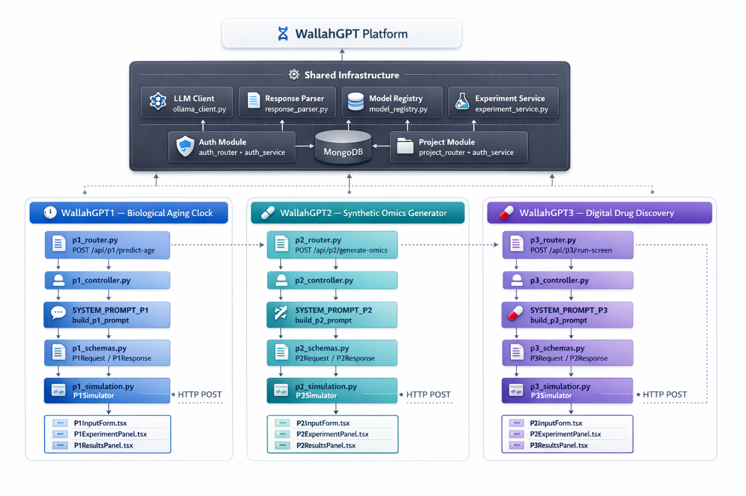

Diagram 9: LLM Interaction Diagram

Prompt → Model → Output → Parser
A focused view of the single-turn LLM conversation structure used in every WallahGPT experiment.
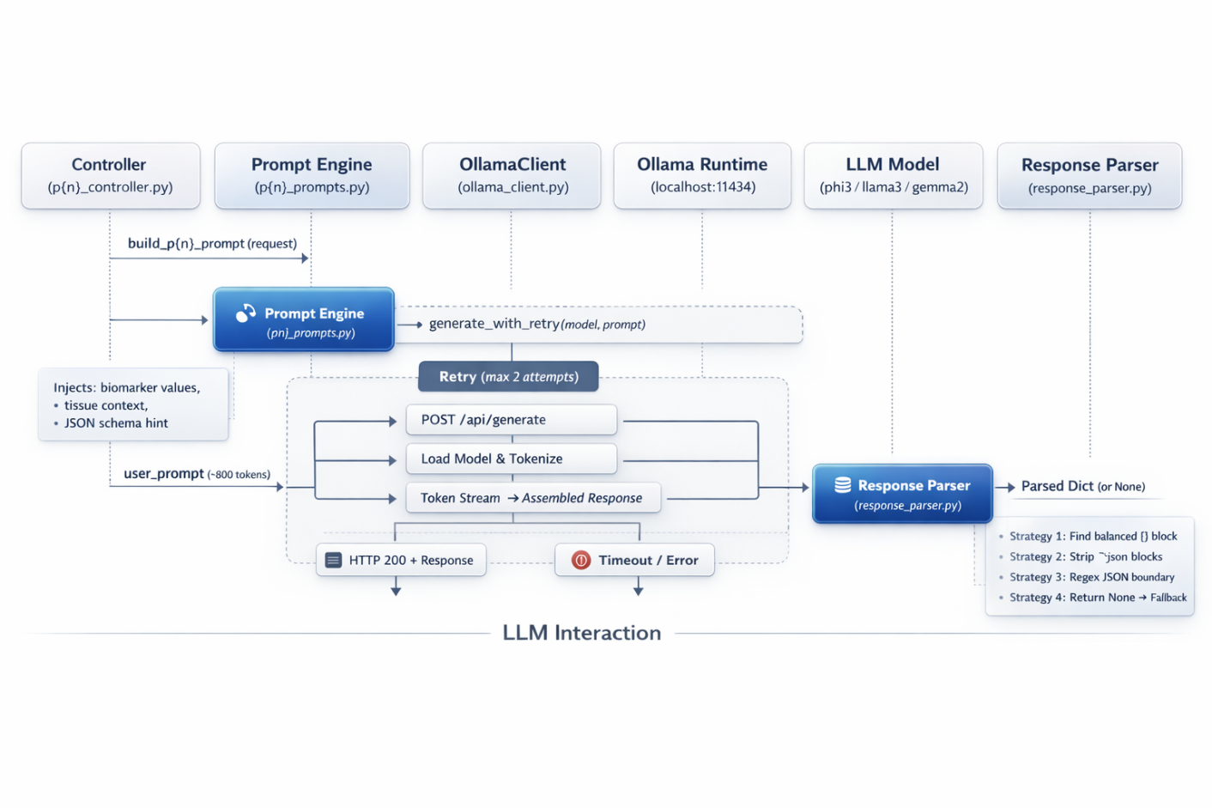

Diagram 10: Experiment Lifecycle Diagram

Create → Run → Process → Store → Retrieve → Visualize
The full state machine of a single WallahGPT experiment from user intent to visualized insight.
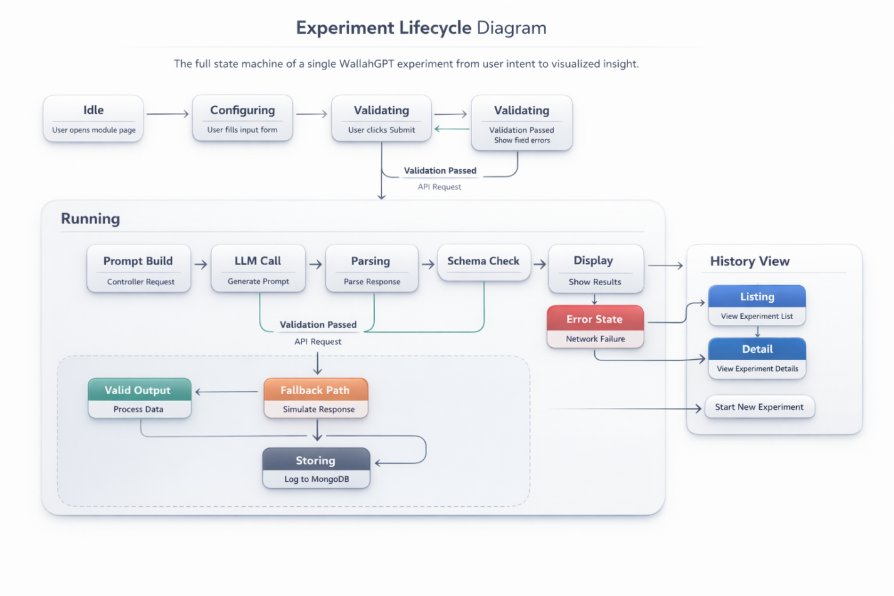

Diagram 11: API Flow Diagram

Frontend → Axios → FastAPI → Router → Controller
Shows the complete HTTP request journey from UI interaction through all backend middleware layers to the controller response.
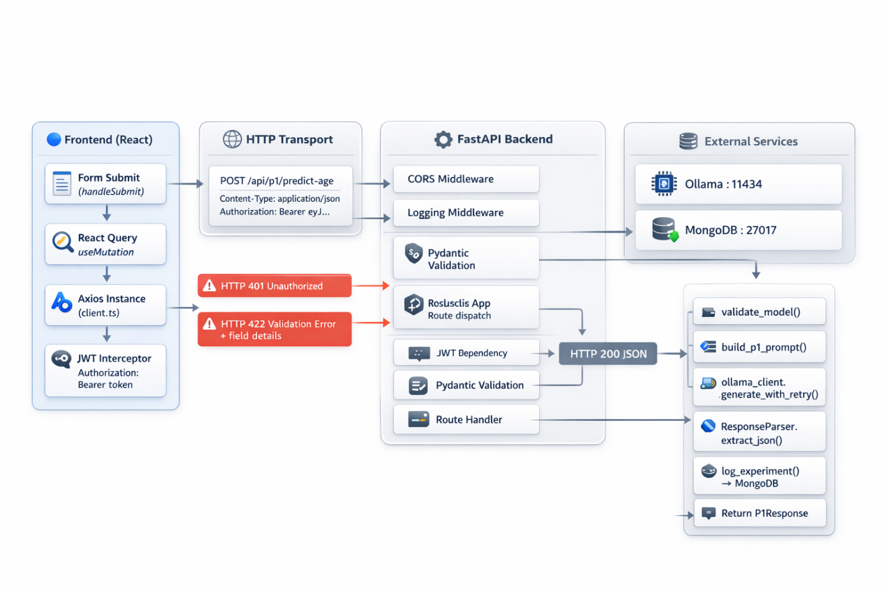

Diagram 12: Data Flow Diagram (DFD)

How Data Moves Across the Entire System
A level-1 DFD showing all data stores, data flows, and processes in the WallahGPT system.
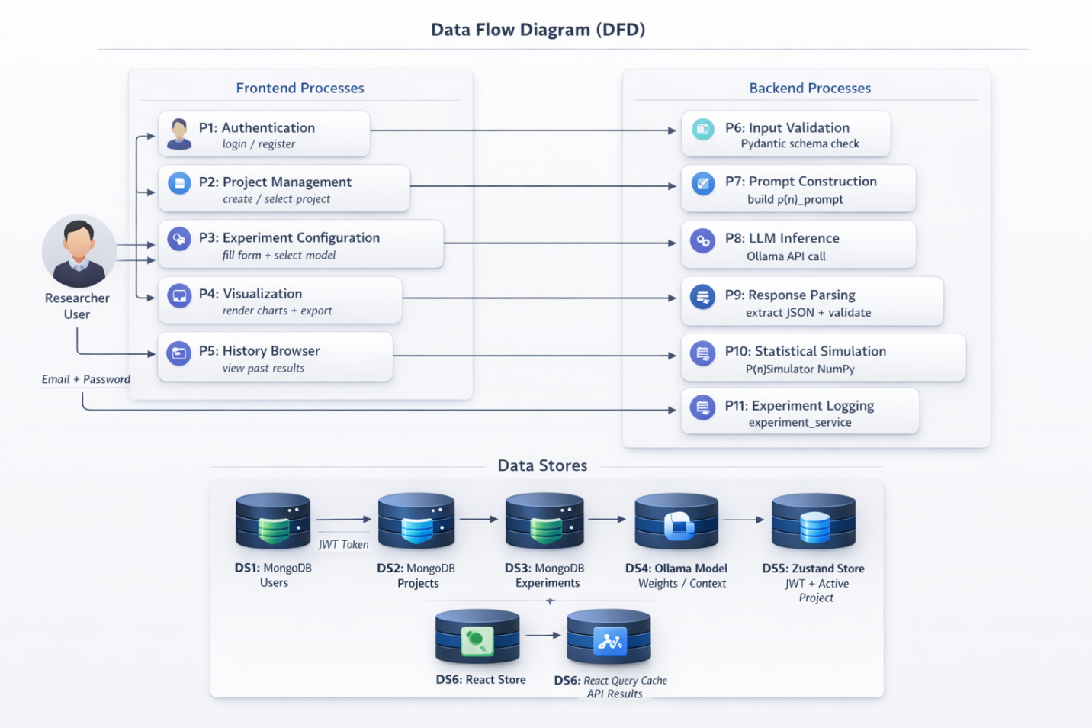

CATEGORY 3 — ADVANCED / MARKETING DIAGRAMS

Diagram 13: AI Operating System View

WallahGPT as a Scientific AI Platform
This positions WallahGPT not as a single application, but as a platform — an AI Operating System for computational biology — with pluggable modules, a shared intelligence layer, and extensibility for future scientific domains.
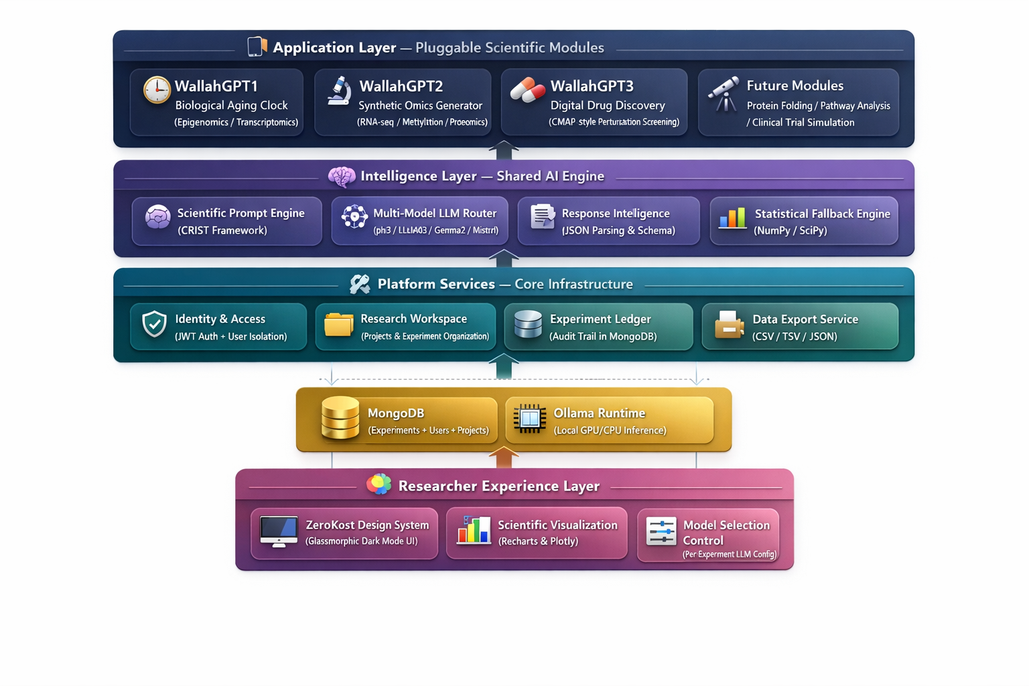

Diagram 14: Scientific Workflow Diagram

From Raw Biological Question to Actionable Insight
This shows the researcher’s journey through the platform and the scientific transformation at each stage.
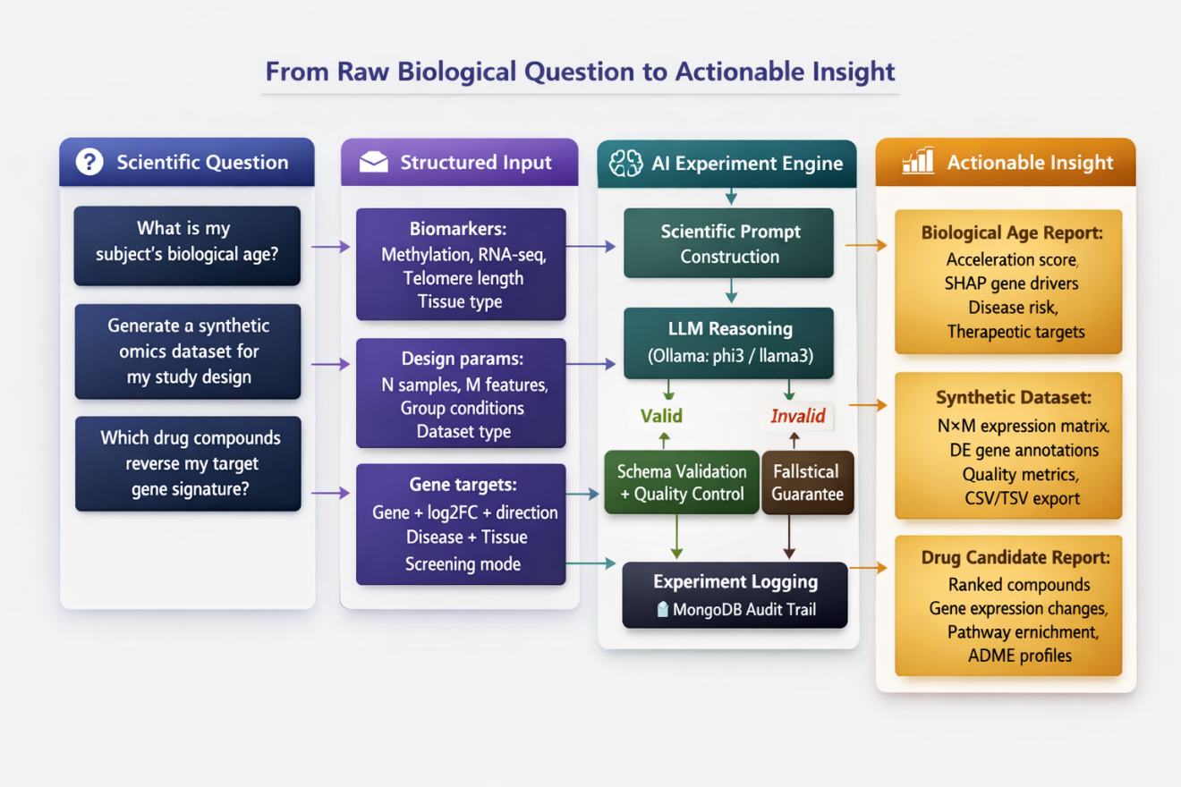

Diagram 15: Reliability Architecture Diagram

The Fallback System — Always-On Guarantee
WallahGPT is designed to never return an error to the researcher. This diagram shows the three-layer reliability architecture.
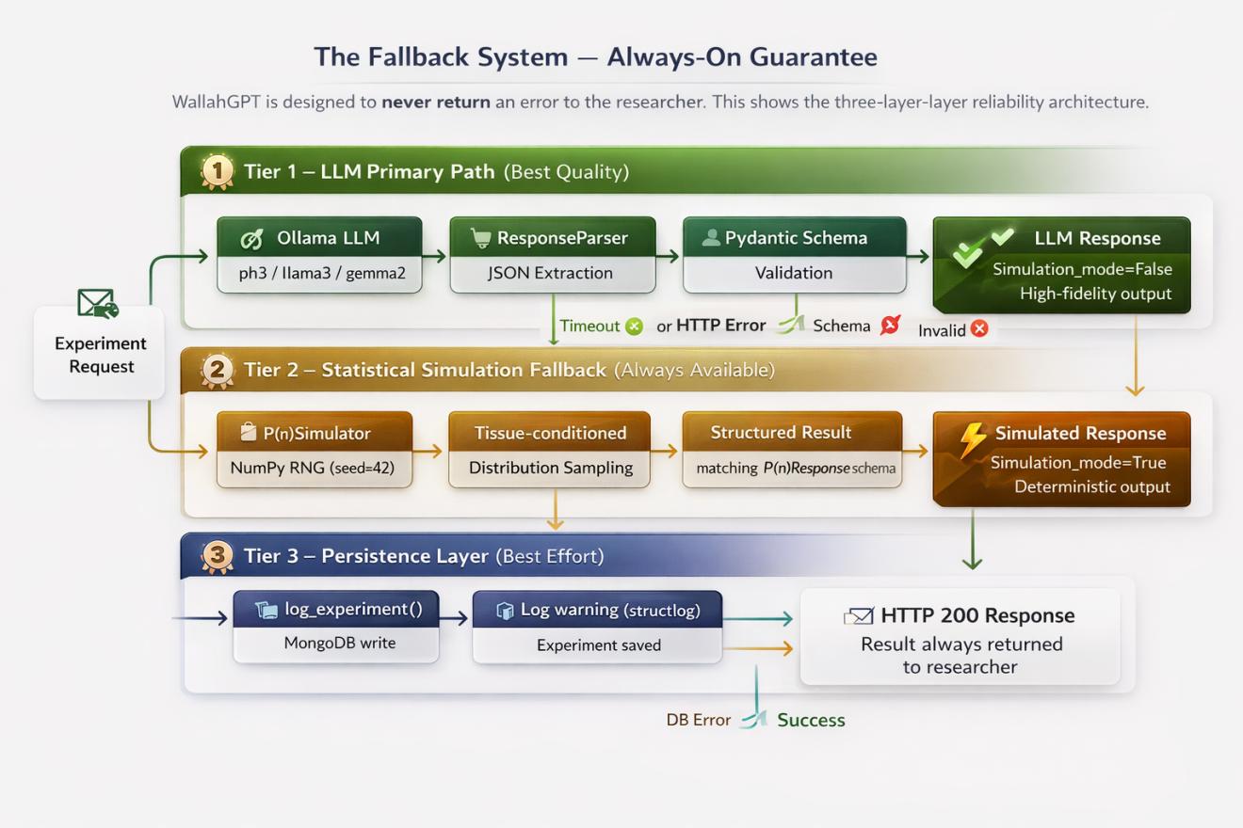

Diagram 16: Multi-Model Strategy Diagram

Model Selection Layer — LLM Choice Architecture
WallahGPT exposes a per-experiment model selection layer via the ModelSelectorWidget frontend component and the model_registry backend, enabling researchers to trade off speed vs. scientific fidelity.
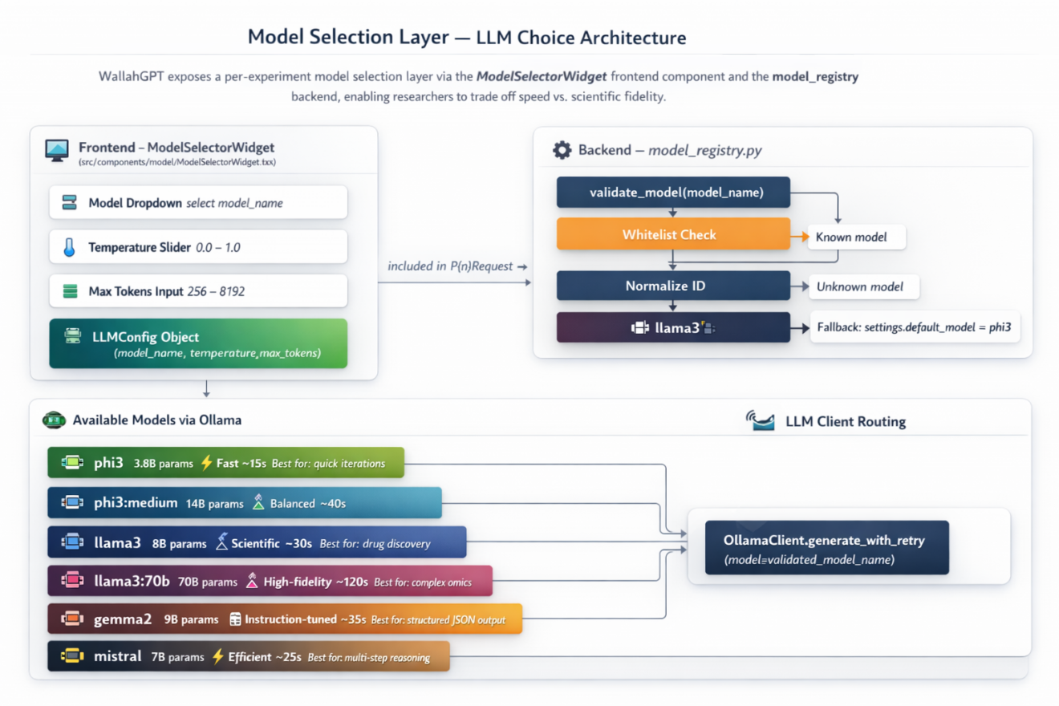

Diagram 17: Performance Flow Diagram

LLM vs. Simulation Latency — Time-to-Result
Shows the wall-clock time breakdown for each path through the system, helping researchers understand response time expectations.
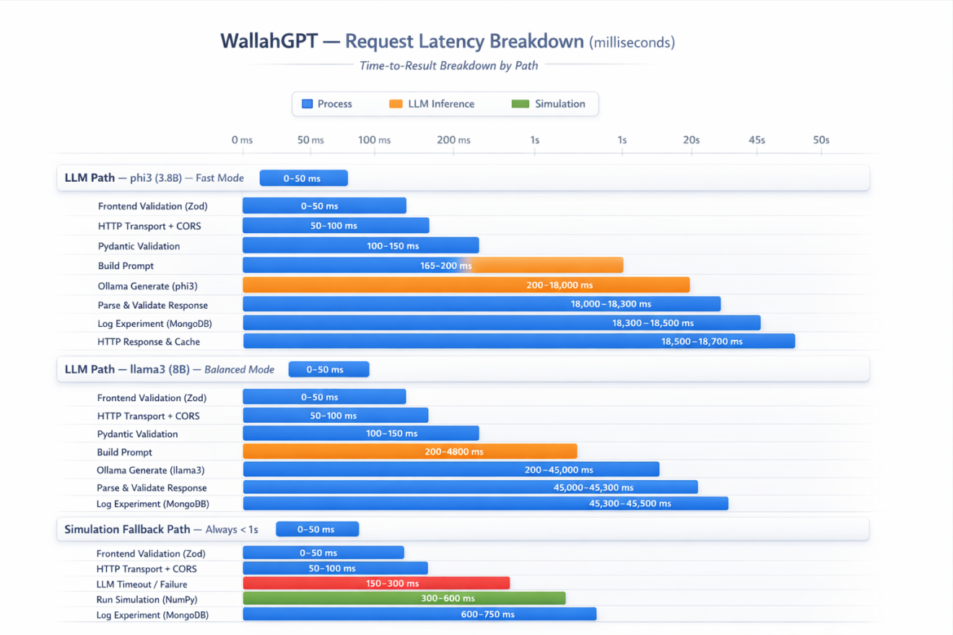

Latency Summary Table
Path | Model | Typical P50 | Typical P95 | Notes
LLM — phi3 | 3.8B | 15–20s | 35s | Default; good for fast iteration
LLM — phi3:medium | 14B | 35–50s | 80s | Higher reasoning quality
LLM — llama3 | 8B | 25–45s | 70s | Best scientific accuracy balance
LLM — llama3:70b | 70B | 90–120s | 180s | Highest fidelity (needs GPU)
LLM — gemma2 | 9B | 30–40s | 65s | Best JSON formatting compliance
LLM — mistral | 7B | 20–35s | 55s | Fast + strong multi-step reasoning
Simulation Fallback | — | < 500ms | < 1s | Always available, deterministic

Diagram 18: Security Architecture Diagram

JWT, Validation, Isolation — Defence in Depth
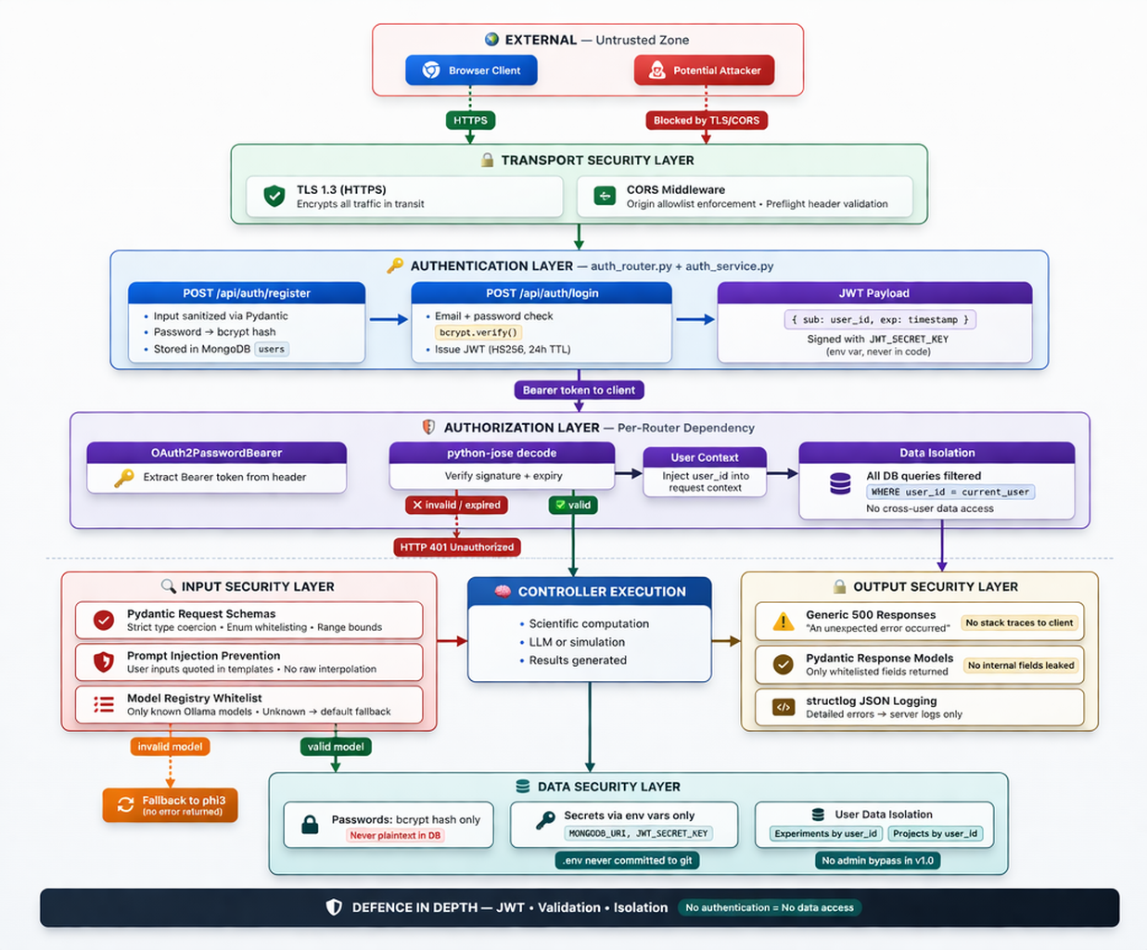

Quick Reference: All 18 Diagrams
# | Diagram | Location | Category
1 | High-Level Architecture | Technical Architecture Doc | Core
2 | Layer Architecture | Technical Architecture Doc | Core
3 | Request Sequence (P1) | Technical Architecture Doc | Core
4 | Database ERD | Technical Architecture Doc | Core
5 | Frontend Component Tree | Technical Architecture Doc | Core
6 | Local Deployment Topology | Technical Architecture Doc | Core
7 | AI Pipeline (LLM + Parser + Fallback) | This Document | Implicit
8 | Module Architecture (P1/P2/P3 + shared infra) | This Document | Implicit
9 | LLM Interaction (Prompt → Model → Parser) | This Document | Implicit
10 | Experiment Lifecycle State Machine | This Document | Implicit
11 | API Flow (FE → Axios → FastAPI → Controller) | This Document | Implicit
12 | Data Flow Diagram (DFD Level-1) | This Document | Implicit
13 | AI Operating System Platform View | This Document | Marketing
14 | Scientific Workflow (Question → Insight) | This Document | Marketing
15 | Reliability Architecture (3-Tier Fallback) | This Document | Marketing
16 | Multi-Model Strategy (LLM Selection Layer) | This Document | Marketing
17 | Performance Flow (LLM vs. Simulation Latency) | This Document | Marketing
18 | Security Architecture (JWT + Isolation + Validation) | This Document | Marketing
End of WallahGPT Architecture Diagrams — v1.0

