WallahGPT — Technical Architecture Document
Document Version: 1.0
Date: March 2026
Project: WallahGPT In-Silico Drug Discovery & Omics Platform
Author: ZeroKost Engineering — Systems Architecture
Status: Approved

1. System Overview
WallahGPT is a full-stack, AI-powered computational biology platform built on a decoupled microservice-style architecture. It comprises:
- A React + TypeScript SPA (frontend) — bundled with Vite for development.
- A FastAPI (Python) asynchronous REST API (backend) — handles all business logic and LLM orchestration.
- A MongoDB NoSQL database — stores users, projects, and experiment records.
- An Ollama local inference server — runs open-source LLMs (Phi-3, Llama 3, etc.) locally.
The three core AI modules (WallahGPT1, WallahGPT2, WallahGPT3) are independently routed but share the same LLM client infrastructure, prompt engine, simulation fallback layer, and experiment logging service.

High-Level Architecture Diagram
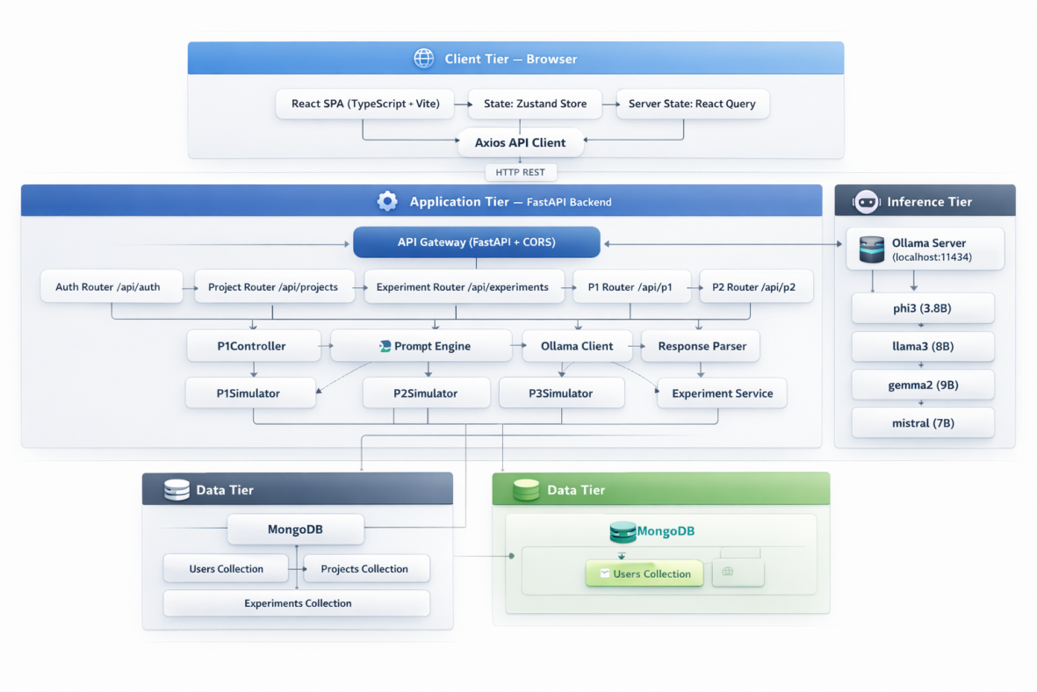

3. Layer Architecture Diagram
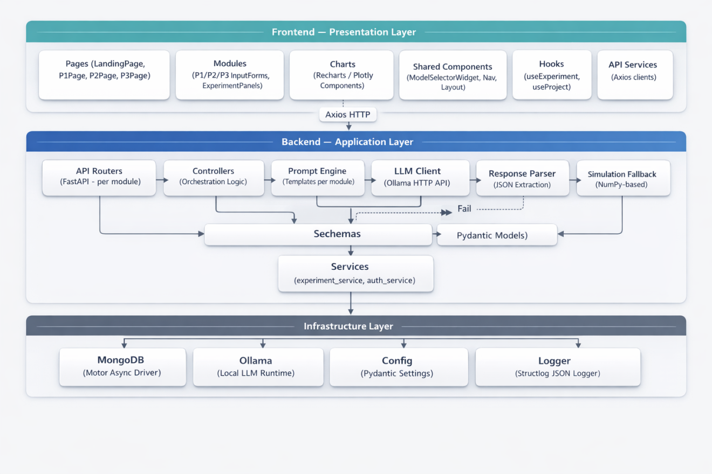

4. Request Sequence Diagram

4.1 WallahGPT1 — Full Experiment Flow
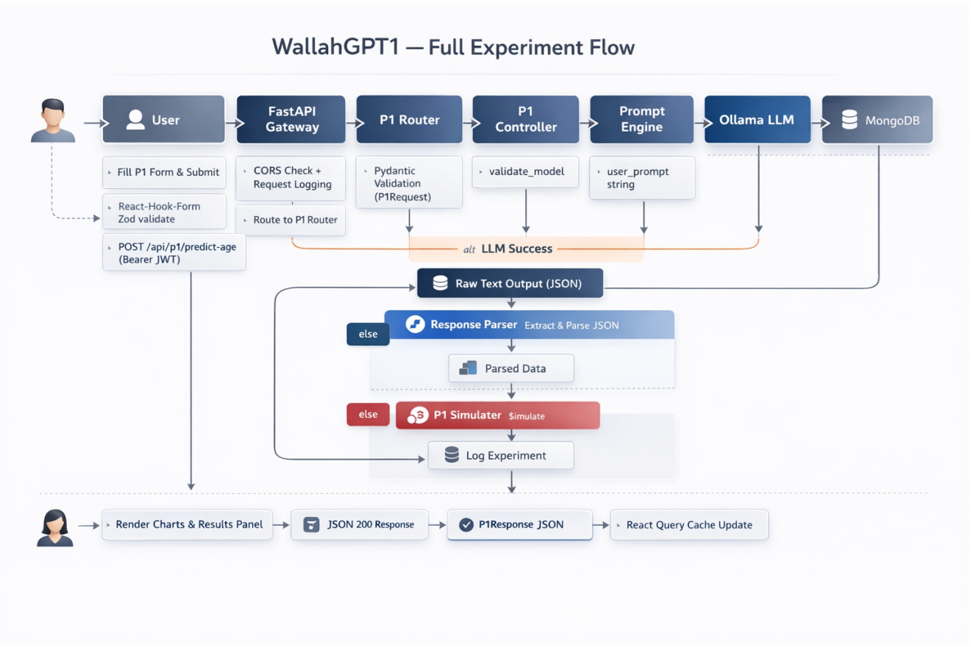

5. Database Schema Design

5.1 Collections Overview

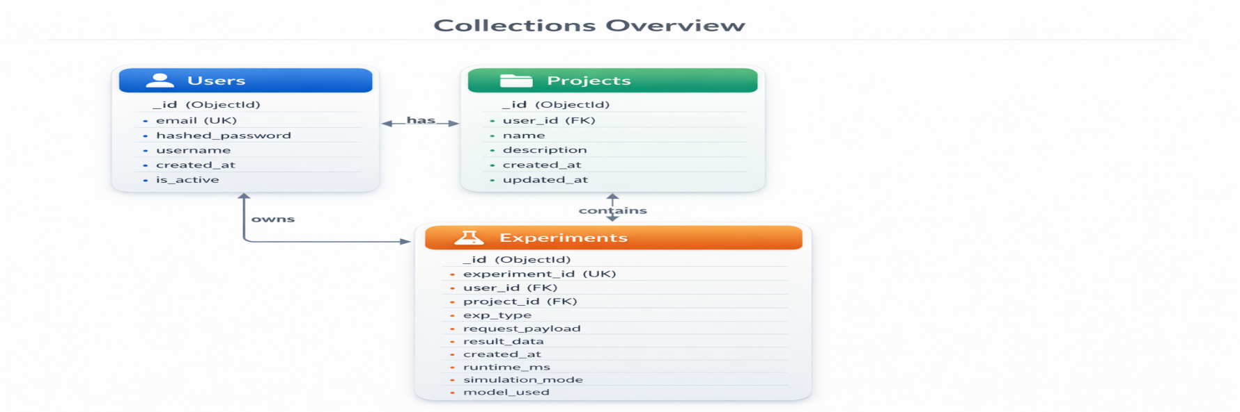

5.2 Experiment Document Example (P1)
{
"_id": "ObjectId(...)",
"experiment_id": "e4a2b1c3-...-uuid4",
"user_id": "user_abc123",
"project_id": "proj-1",
"exp_type": "p1",
"request_payload": {
"experiment_name": "Brain Aging Study 01",
"chronological_age": 55.0,
"tissue_type": "Brain",
"methylation_level": 0.72,
"llm_config": { "model_name": "phi3", "temperature": 0.3 }
},
"result_data": {
"predicted_biological_age": 62.4,
"age_acceleration_score": 7.4,
"age_acceleration_class": "accelerated",
"shap_genes": [{"gene": "FOXO3", "importance": 0.87, "direction": "down"}],
"simulation_mode": false,
"runtime_ms": 18420
},
"created_at": "2026-03-24T10:30:00Z"
}

6. API Endpoint Map

6.1 Authentication
Method | Endpoint | Auth | Description
POST | /api/auth/register | No | Register new user
POST | /api/auth/login | No | Login, receive JWT
GET | /api/auth/me | JWT | Get current user info

6.2 Projects
Method | Endpoint | Auth | Description
POST | /api/projects | JWT | Create project
GET | /api/projects | JWT | List all user projects
GET | /api/projects/{id} | JWT | Get single project
DELETE | /api/projects/{id} | JWT | Delete project

6.3 Experiments
Method | Endpoint | Auth | Description
GET | /api/experiments | JWT | List all user experiments
GET | /api/experiments/{id} | JWT | Get experiment by ID

6.4 WallahGPT1 (Biological Aging)
Method | Endpoint | Auth | Description
POST | /api/p1/predict-age | JWT | Run biological age prediction
GET | /api/p1/experiments | JWT | List P1 experiment history
GET | /api/p1/experiments/{id} | JWT | Get P1 experiment result

6.5 WallahGPT2 (Synthetic Omics)
Method | Endpoint | Auth | Description
POST | /api/p2/generate-omics | JWT | Generate synthetic omics dataset
GET | /api/p2/experiments | JWT | List P2 experiment history
GET | /api/p2/experiments/{id} | JWT | Get P2 experiment result
GET | /api/p2/download/{id} | JWT | Download full matrix as CSV/TSV

6.6 WallahGPT3 (Drug Discovery)
Method | Endpoint | Auth | Description
POST | /api/p3/run-screen | JWT | Run in-silico drug screen
GET | /api/p3/experiments | JWT | List P3 experiment history
GET | /api/p3/experiments/{id} | JWT | Get P3 experiment result

6.7 System
Method | Endpoint | Auth | Description
GET | /api/health | No | Health check + Ollama status

7. Frontend Architecture

7.1 Application Component Tree

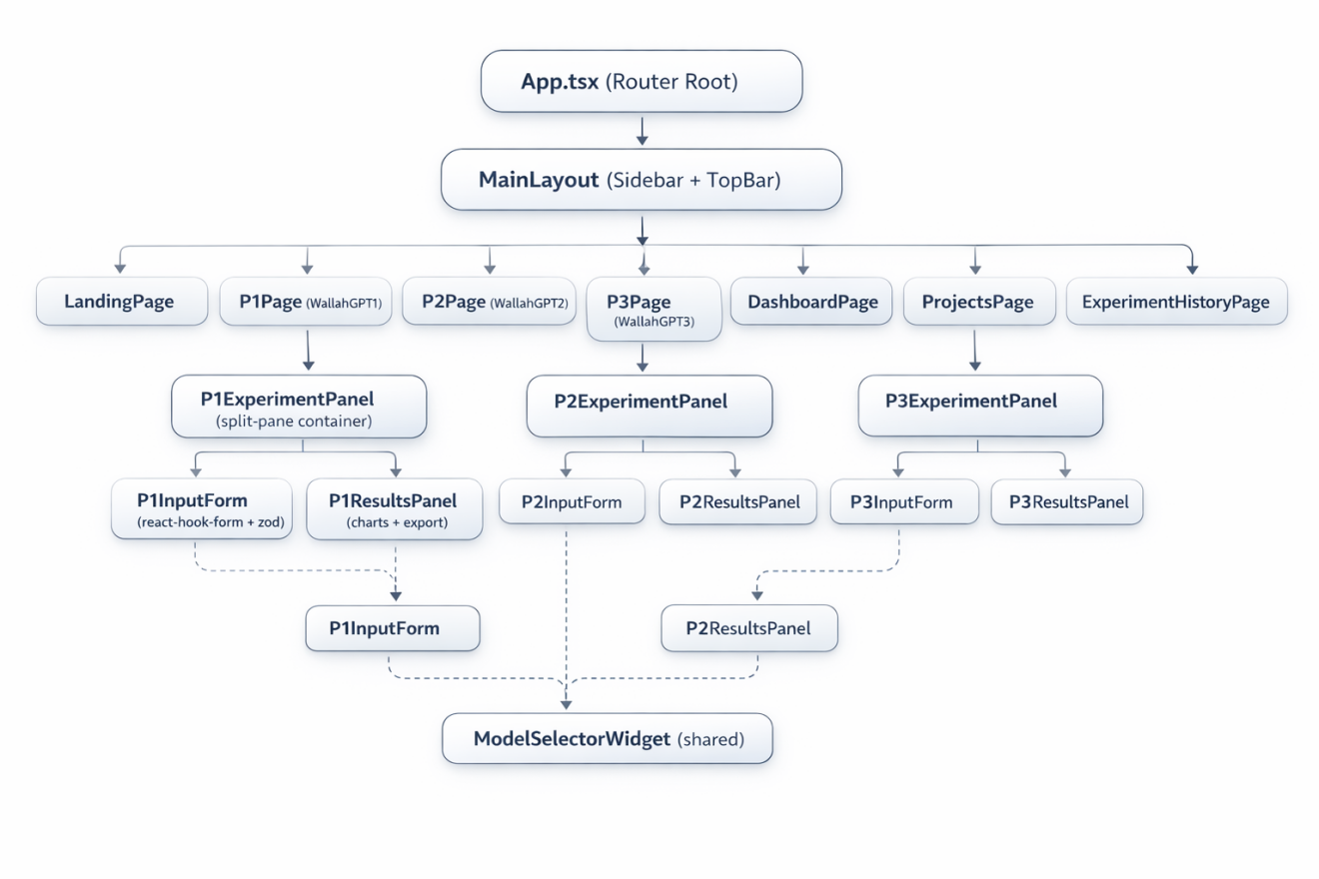

7.2 State Management Architecture
Store | Technology | Responsibility
authStore | Zustand | JWT token, current user, login/logout
projectStore | Zustand | Active project selection
experimentStore | Zustand | Current experiment status (running / idle)
Server Data Cache | React Query | All API responses — P1/P2/P3 results, project list, history

7.3 API Client Structure (src/api/)
File | Description
client.ts | Axios instance with base URL, JWT interceptor, error handling
p1Api.ts | runP1Experiment(), getP1Experiment(), listP1Experiments()
p2Api.ts | runP2Experiment(), downloadOmicsDataset()
p3Api.ts | runP3Experiment(), getP3Experiment()
authApi.ts | login(), register(), getMe()
projectApi.ts | createProject(), listProjects(), deleteProject()

8. Backend Internal Architecture

8.1 Backend Module Map
PreciousGPT_Backend_Code/
├── main.py # FastAPI app, router registration, middleware, lifespan
├── config.py # Pydantic Settings (env vars: MONGO_URI, OLLAMA_URL, etc.)
├── database.py # Motor async MongoDB connection (connect/close)
│
├── api/ # FastAPI Routers (HTTP layer only)
│ ├── auth_router.py
│ ├── project_router.py
│ ├── experiment_router.py
│ ├── p1_router.py
│ ├── p2_router.py
│ ├── p3_router.py
│ └── health_router.py
│
├── controllers/ # Business logic orchestration
│ ├── p1_controller.py # P1: validate → prompt → LLM → parse → fallback → log
│ ├── p2_controller.py # P2: validate → prompt → LLM → parse → fallback → log
│ └── p3_controller.py # P3: validate → prompt → LLM → parse → fallback → log
│
├── prompts/ # Prompt templates (SYSTEM + USER per module)
│ ├── p1_prompts.py
│ ├── p2_prompts.py
│ └── p3_prompts.py
│
├── llm/ # LLM abstraction layer
│ ├── client_factory.py # Returns OllamaClient instance
│ ├── ollama_client.py # HTTP calls to Ollama API with retry
│ ├── response_parser.py # JSON extraction from raw LLM text
│ └── model_registry.py # Whitelisted model validation
│
├── simulation/ # Deterministic statistical fallback engines
│ ├── p1_simulation.py
│ ├── p2_simulation.py
│ └── p3_simulation.py
│
├── schemas/ # Pydantic request/response models
│ ├── p1_schemas.py
│ ├── p2_schemas.py
│ ├── p3_schemas.py
│ └── common_schemas.py
│
├── services/ # Database interaction services
│ ├── experiment_service.py # log_experiment(), get_experiment(), list_experiments()
│ ├── auth_service.py # register_user(), authenticate_user(), create_token()
│ └── project_service.py # CRUD for projects
│
└── utils/
└── logger.py # structlog JSON structured logger

8.2 Configuration & Environment Variables
Variable | Required | Default | Description
MONGODB_URI | Yes | — | MongoDB connection string
OLLAMA_BASE_URL | Yes | http://localhost:11434 | Ollama server URL
DEFAULT_MODEL | No | phi3 | Default LLM model
JWT_SECRET_KEY | Yes | — | Secret for JWT signing
JWT_ALGORITHM | No | HS256 | JWT algorithm
SIMULATION_SEED | No | 42 | NumPy RNG seed for fallback
ALLOWED_ORIGINS | No | * | CORS origins
LOG_LEVEL | No | INFO | Logging verbosity

9. Deployment Architecture

9.1 Local Development Topology

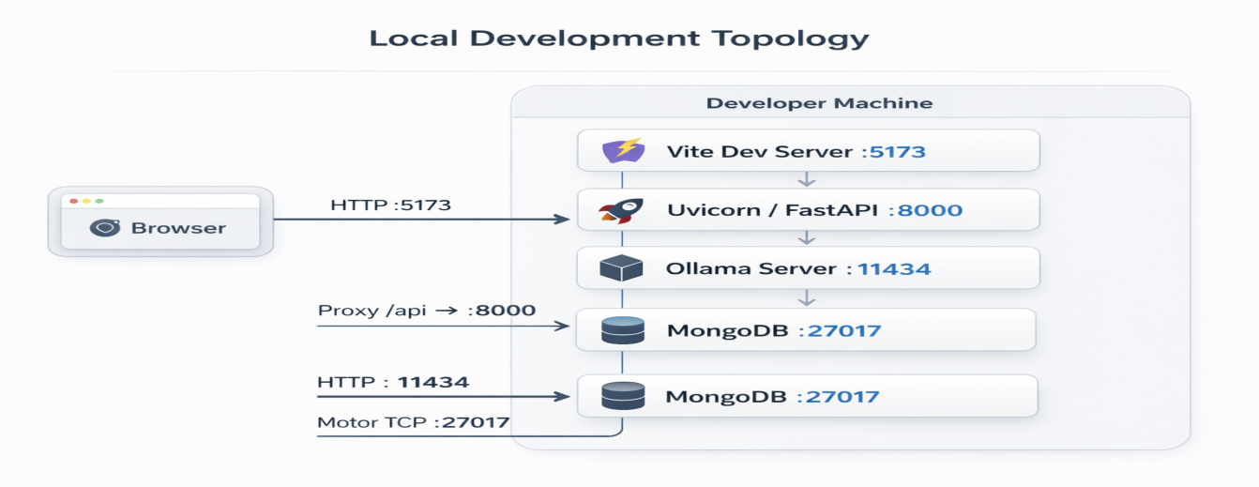

9.2 Production-Ready (Future) Topology
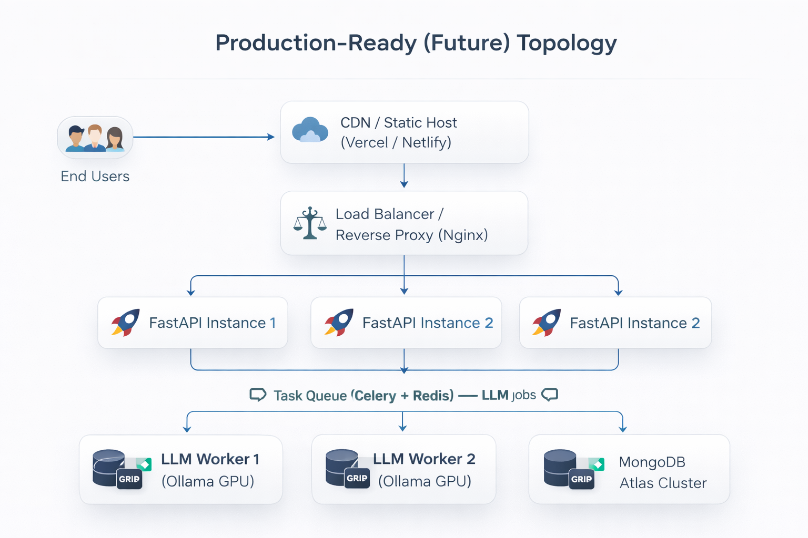

10. Security Architecture
Layer | Control | Implementation
Transport | HTTPS | TLS termination at reverse proxy
Authentication | JWT Bearer | HS256 signed tokens, 24h expiry
Authorization | User isolation | user_id filter on all DB queries
Password Storage | bcrypt | passlib[bcrypt] with auto-salting
Input Validation | Pydantic | Strict schema validation on all request bodies
CORS | Configurable | ALLOWED_ORIGINS env var
LLM Injection | Prompt sanitization | User inputs quoted/escaped in prompt templates
Error Leakage | Generic 500 responses | Detailed errors only in server logs
API Secrets | Environment variables | Never committed to source code

11. Performance Characteristics
Metric | Target | Notes
LLM inference (phi3, 3.8B) | 15–40 seconds | Depends on hardware
LLM inference (llama3, 8B) | 30–90 seconds | Higher quality, slower
Statistical fallback | < 500ms | Pure Python NumPy
MongoDB query latency | < 50ms | Indexed on user_id, project_id
Frontend initial load | < 2s | Vite code splitting + lazy routes
API validation error | < 10ms | Pydantic synchronous validation

12. Technology Stack Summary
Component | Technology | Version | Purpose
Frontend Framework | React | 18.x | Component-based UI
Language (FE) | TypeScript | 5.x | Type safety
Build Tool | Vite | 5.x | Fast HMR dev server
Styling | TailwindCSS | 3.x | Utility-first CSS
Animation | Framer Motion | 11.x | Scientific UI transitions
State | Zustand | 4.x | Global client state
Server State | React Query (TanStack) | 5.x | API caching & sync
Forms | React Hook Form + Zod | 7.x / 3.x | Validated form handling
Charts | Recharts + Plotly.js | latest | Scientific visualization
HTTP Client | Axios | 1.x | JWT-intercepted API calls
Backend Framework | FastAPI | 0.110+ | Async REST API
Language (BE) | Python | 3.10+ | Type-hinted backend logic
DB Driver | Motor (async PyMongo) | 3.x | Non-blocking MongoDB
Database | MongoDB | 7.x | Document store
LLM Runtime | Ollama | latest | Local open-source LLM
Data Validation (BE) | Pydantic v2 | 2.x | Schema enforcement
Logging | structlog | latest | Structured JSON logs
Password Hashing | passlib[bcrypt] | latest | Secure auth
Auth Tokens | python-jose | latest | JWT creation/validation
End of Technical Architecture Document — WallahGPT v1.0

